

AI Engagement System
Advisory and Execution Proposal for Springline

PREPARED BY
Devlin Liles, with David O'Hara, Fractional AI Officer | Improving
June 1, 2026

Executive Summary
Springline is building a federated CPA, advisory, and wealth platform at roughly $200 to $220 million of run rate across twelve standalone deals, and the AI decisions made over the next eighteen months will shape both how the firms operate and how the next investment partner values the platform. AI is asymmetric. A sequential, enterprise-software rollout will not capture the upside, and it will not produce a story that survives diligence. Springline needs an AI program that is sequenced, governed, and legible to investors from the first quarter.
We propose an engagement system, not a project. Improving runs a Fractional AI Officer advisory cadence paired with fail-fast execution pods. The advisory track sets strategy, sequences the roadmap, and produces the board and diligence narrative. The execution track puts the highest-value initiatives into production and proves their ROI with real numbers. The two tracks share one operating rhythm and one decision gate, so every dollar of investment is tied to evidence and every initiative lands in a clear place in the investor story.
Quarter one delivers a five-year AI strategy, a three-year roadmap, the prioritized big rocks, and the first implement-now initiatives selected in discovery and already in motion, funded through a horizon model that releases capital in evidence-gated tranches and produces an exit-ready snapshot at any review gate.

Why This, Why Now
Springline operates a federated set of acquired firms moving toward a regionalized model, with data and security consolidating on Snowflake and a single Microsoft 365 tenancy. Competition in the CPA and advisory roll-up space is intense, and many competitors are deploying AI without discipline. Springline's advantage is the opposite: a credible, sequenced program that produces measurable operating gains before close and a defensible roadmap after it.
The constraint that shapes everything is the federated environment. Acquired firms run different systems and sit at different levels of maturity, and tooling is constrained by enterprise commitments such as Microsoft 365, Workday, and Snowflake. A single monolithic AI plan will not survive contact with that variability. The program has to be modular, evidence-driven, and easy to govern across firms that joined at different times.
The Engagement System
The engagement is built as a closed loop that runs every quarter and tightens over time. Strategy sets direction. Sequencing turns direction into prioritized initiatives. Pilots validate the highest-value initiatives under a capped, fail-fast budget. Evidence from those pilots decides what scales and what gets killed. The narrative track translates that evidence into the board and diligence story. The next quarter starts from sharper inputs.
Two tracks, one rhythm
The advisory track is a Fractional AI Officer retainer tied to quarterly deliverables. It owns strategy, architecture decisions, governance, sequencing, and the investor narrative. It gives Springline senior AI leadership without a full-time executive hire, and it scales up or down by quarter as the program matures.
The execution track is project-based delivery run in small pods. Pods stand up the implement-now initiatives, instrument them, and report hard numbers. Execution is deliberately decoupled from advisory so that strategy is never bottlenecked by delivery and delivery is never unmoored from strategy.
Decision gates
Every initiative passes through the same gate. A pilot runs against a stated hypothesis and a capped budget. At the gate, the evidence decides: scale it, redesign it, or kill it. Scaled work is then scoped and priced from validated pilot data, so Springline commits enterprise spend against proof rather than projection. This is how the program avoids getting deep into a large investment before value is established.
Operating Principles
Improving works model-agnostic within the hyperscalers and maintains active advisory relationships with five primary partners: OpenAI, Anthropic, Microsoft, Google, and AWS. We route to the right model for the job and avoid lock-in to any single provider, which matters as model pricing shifts and early subsidies recede.
We budget to fail fast. Initiatives are validated under tight, capped pilots before any scaled commitment, so the program proves value cheaply rather than discovering a dead end after a large spend. The cap for each pilot is set in its program bid, alongside the program's ROI hypothesis.
We run two parallel portfolios. The efficiency portfolio targets hard ROI: hours saved, cost reduced, cycle time cut. The innovation portfolio targets upside: proposal velocity, win rate, and new service capacity. Both feed the same diligence narrative, which is why an authentic strategy and a performative one are the same document when the work is done right. We also design around a known reality: enterprise-secured AI tools such as Microsoft Copilot and Cowork typically trail frontier capabilities by roughly two and a half to three months, so we sequence accordingly.
AI Maturity: From Doing to Directing
Improving runs every engagement against a single maturity model. It has eight stages grouped into three waves, and the axis that moves a firm up the curve is trust. As trust increases, people shift from doing the work to directing the systems that do it. The model gives Springline one shared language for where each acquired firm sits today and where the program is taking it.
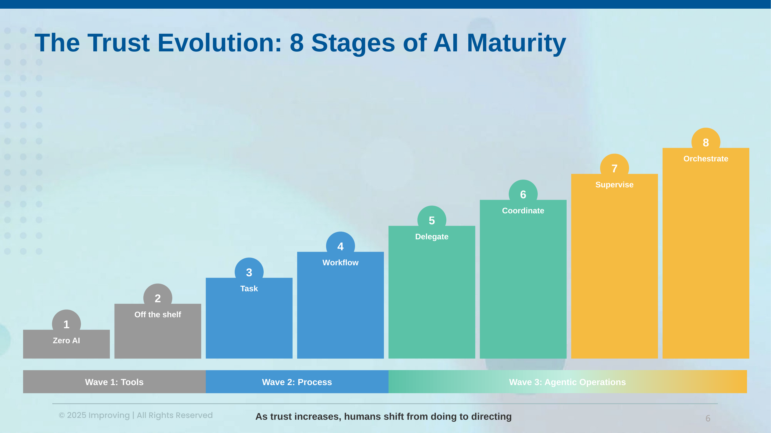

Wave 1, Tools, covers Stage 1 Zero AI and Stage 2 Off the shelf. This is where most acquired firms start, using Microsoft 365 and Copilot out of the box. Stage 2 is already paid for through existing licensing, so it is the floor, not the goal.
Wave 2, Process, covers Stage 3 Task and Stage 4 Workflow, and it is the engagement's near-term center of gravity. Horizon 1 Run operates at Stage 3: single-purpose task agents that own one well-scoped task without line-by-line approval. Horizon 2 Scale operates at Stage 4: task agents composed into governed workflows, the stage where audit trails, boundary enforcement, error handling, and approval gates become infrastructure rather than overhead. Stage 4 is the governance gate, and the program does not cross it until that foundation is in place.
Wave 3, Agentic Operations, covers Stage 5 Delegate through Stage 8 Orchestrate. This is Horizon 3 Reinvent and the future state: agents that are delegated to, coordinated, supervised, and orchestrated at scale, with people directing rather than executing. It delivers the platform-wide leverage and the strongest diligence story, and it depends entirely on the governance spine built in Wave 2.
The leverage is in the middle of the curve. Stage 2 is already covered by existing Microsoft 365 and Copilot licensing, and Stage 5 and beyond require orchestration infrastructure Springline does not yet need. The near-term return concentrates at the Stage 2-to-3 and Stage 3-to-4 boundaries, which is exactly where Horizon 1 and Horizon 2 operate.
The Horizon Funding Model
Springline should not budget AI against a fixed exit date. The exit can move, and a plan anchored to a single close becomes wrong the moment timing shifts. We fund AI the way capital-disciplined, PE-backed operators fund innovation: as a portfolio drawn from a defined pool rather than a string of single bets, released by horizon in evidence-gated tranches. Value compounds continuously, spend optimizes at every gate, and an exit hooks in wherever it lands.
Each horizon is a funding envelope, not a date-locked phase. Innovation dollars come out of the pool, not the operating budget, and the bar is portfolio return, not single-experiment return. Small experiments earn the next round. Wins draw the next tranche. Losses inform the next selection. Initiatives move across horizons as they mature, and capital flows to whichever horizon is producing the best return at each gate.
Horizon | What it funds | Funding model
H1 - Run | Operational efficiency and task agents with hard, near-term ROI | Fixed-fee setup plus capped fail-fast pilots; targets self-funding from savings
H2 - Scale | Workflow automation rolled across firms, once governed | Time and Materials, released from validated H1 evidence
H3 - Reinvent | Client-facing growth bets and new service lines with asymmetric upside | Small option-sized probes from a protected pool; few graduate, each cheap to test
Where to play: a bi-modal ROI bar
Position on the adoption curve sets the ROI bar, and Springline's bet is bi-modal. Efficiency initiatives, the back-office document and operations work, play at the proven end of the curve. Their return is hard-capped by the labor cost of the function, so the right move is to let the platforms Springline already runs, Microsoft 365 and Copilot, Snowflake, and Workday, harden, then absorb the gain at a lower cost basis. Growth initiatives such as proposal velocity, win rate, and new advisory capability play further left. They carry a higher ROI bar and a higher failure rate, which is acceptable because the gain absorbs into elastic demand: a more effective advisory bench wins more work rather than shrinking the bench. The reference bar for a fundable initiative is a five-to-ten-times return within twelve months, set higher for growth bets to pay for their failure rate.
Return is measured with a planned-hire offset rather than headcount reduction. As Springline consolidates and regionalizes, AI investment is scored by the planned hires it avoids and the capacity it frees across acquired firms, which broadens roles instead of cutting them. This is the honest ROI math for a talent-constrained, fast-consolidating platform, and it is the number investors can underwrite.
Evidence-gated tranches
Capital is committed in tranches, not up front. Every initiative enters under a fail-fast cap and must clear its ROI gate to draw the next tranche. At each gate the evidence decides: fund the next tranche, scale it, pause it, or kill it. Freed capital reallocates to the highest-yielding horizon. A target portfolio mix guides allocation, weighted toward Run early and tilting toward Scale and Reinvent as savings accrue and underwrite the later horizons.
Incremental review and delivery
Two cadences run the model. A quarterly portfolio gate resets the envelopes across horizons and refreshes the roadmap. A monthly initiative gate releases tranches against evidence. Every gate produces both a deliverable and a funding decision, so review and delivery are the same act.
The exit-ready snapshot
Because review is continuous and evidence-based, the model emits an exit-ready snapshot at any gate. The snapshot classifies the live portfolio by realization state, not by a guessed exit date.
State | Definition | Role in diligence
Realized | In production and producing measured value | Proof the platform already operates with AI leverage
In-flight | Funded and live with early signal | Evidence of momentum and a working delivery engine
Optioned | Designed and costed, ready to fund on demand | A defensible roadmap with known economics and triggers

Exit timing is an input, not a constraint. At month nine, fifteen, or twenty-four the snapshot is current and defensible, and pre-deal versus post-deal sequencing falls directly out of which tranches have been released.
Commercials: a retainer plus per-program bids
The commercial structure is deliberately light. Springline funds a flat Fractional AI Officer retainer of $20,000 per quarter. The retainer runs the model: strategy, sequencing, architecture and governance decisions, the review gates, and the board and investor narrative. It is the only standing fee.
Execution is funded program by program. Each program is bid on its own, and every bid carries an explicit ROI hypothesis as part of the funding structure. The hypothesis names the expected return, the metric, and the twelve-month bar, and it is the same hypothesis the evidence gate tests before the next tranche is released. Springline never funds a program without a stated return it is underwriting, and never scales one that fails to clear its own hypothesis. This keeps the standing cost small and ties every execution dollar to a return defined before the work starts.
Quarterly Deliverables
The advisory track produces a defined set of deliverables each quarter. Quarter one is the foundation and is the basis for the early-June kickoff. Later quarters deepen execution and refresh the strategy and narrative as evidence comes in.
Quarter | Deliverables | Outcome
Q1 (kickoff) | Five-year AI strategy; three-year roadmap; prioritized big rocks; first implement-now initiatives selected and started; reference architecture v1; governance baseline; diligence narrative v1 | Strategy set, pilots running, board story drafted
Q2 | Pilot evidence and gate decisions; scaled-work scoping from validated data; governance hardened for stage four; narrative refresh with early wins | Validated ROI, first scale decisions, sharpened story
Q3 | Scaled rollout of proven initiatives; next wave designed; architecture and model-routing updates; diligence pack updated | Operating gains compounding, roadmap extended
Q4 / ongoing | Program review against KPIs; strategy refresh; readiness pack for investor conversations | Investor-ready position with a running track record

Implement-Now Pilots
The first H1 tranche funds a small set of implement-now pilots. We do not pre-name them. Discovery workshops with firm and department leaders surface the candidates, and each is scored against the bi-modal ROI bar before it is funded, so the program commits to evidence rather than to a list drawn up before the work starts.
Each pilot is a stage-three task agent that delivers visible value quickly, carries manageable governance, and produces the kind of hard number that strengthens the diligence story. Each runs against a stated hypothesis under a capped, fail-fast budget set in its program bid, with a named owner and a gate. Pilots that clear the gate graduate into H2 scaling. Pilots that do not are killed cheaply and inform the next selection.
Architecture and Governance
Given the Microsoft 365 tenancy and the Snowflake consolidation already underway, we anchor the enterprise AI architecture on Azure and Microsoft Foundry, with Snowflake as the governed data foundation. On top of that anchor we run a model-agnostic orchestration layer that routes work to the right model, including Anthropic and OpenAI, without binding Springline to a single provider. This keeps enterprise controls and data residency intact while preserving access to the best available capability.
Governance is a precondition for scale, not an afterthought. Before stage four workflow automation expands, we put in place audit logging, data-privacy controls, HR and policy compliance, and human-owned approval points. The federated structure makes this non-negotiable: firms joined at different times with different practices, and a single governance spine is what lets automation cross firm boundaries safely.
Investor and Diligence Narrative
The narrative track maps AI investment to operating gains and growth levers, and it sequences clearly between what is delivered before a deal and what follows it. The exit-ready snapshot is the structure investors see: realized, in-flight, and optioned, generated from real funding and delivery evidence at whatever gate the exit lands on. Because the plan is grounded in pilot evidence and a portfolio ROI bar, the story Springline tells in diligence is the same story the firm is actually living, which is what makes it credible under scrutiny.
Improving and Springline share an arm's-length, pure B2B relationship. The engagement is governed by NDA boundaries and strict confidentiality, and it remains independent of any shared sponsor relationship. We will help Springline state that independence clearly to its team and its stakeholders.
Measurement and KPIs
Every initiative carries metrics before it starts. Efficiency initiatives report hours saved, cost reduction, and cycle time. Innovation initiatives report proposal velocity, win rate, and recovered capacity. At the program level we track initiatives by bucket, pilots validated versus killed, and progress against the three-year roadmap, so leadership and the board always have a current, honest read.
Engagement Model, Team, and Cadence
The advisory retainer runs on a quarterly cadence with weekly working sessions. David O'Hara serves as Springline's Fractional AI Officer and owns strategy, sequencing, architecture and governance decisions, and the board and investor narrative. Delivery teams are built to purpose for each build cycle: an AI lead paired with embedded engineers, sized to the work in front of them and reformed as the portfolio moves between horizons.
Role | Responsibility
Fractional AI Officer (David O'Hara) | Strategy, sequencing, architecture and governance decisions, board and investor narrative
AI Lead (per build cycle) | Owns a build cycle end to end: design, delivery, instrumentation, and the gate
Embedded Engineers (per build cycle) | Build, instrument, and roll out pilots and workflows alongside Springline's teams

Each build cycle is staffed to purpose. Embedded coaching and role-based enablement follow a defined team-to-engineer ratio of no more than three teams or 24 people per embedded engineer. Specialist depth in security, data, or compliance is pulled into a cycle when the work calls for it rather than carried as standing overhead.
Assumptions and What We Need From Springline
The pace of the program depends on a few inputs from Springline. We assume timely access to department and firm leaders for discovery, to Snowflake and Microsoft 365 administrators for environment provisioning, and to security, legal, and HR for governance input. We assume active participation in the monthly initiative gates and the quarterly portfolio gate. Cost drivers, including role seniority and allocation, number of pilot teams, and embedded-coaching duration, shape each program bid. Beyond the flat quarterly retainer, pricing is set per program with its ROI hypothesis, as described under the Horizon Funding Model.
Why Improving
Improving brings a defined AI maturity model, genuine model-agnostic depth across the five major providers, and a practitioner culture that shows up with answers rather than slideware. We pair senior advisory with delivery pods that leave Springline's teams stronger, and we tie every quarter to concrete deliverables rather than open-ended hours. The result is an AI program that produces real operating gains and an investor story Springline can defend. It's what we do.

