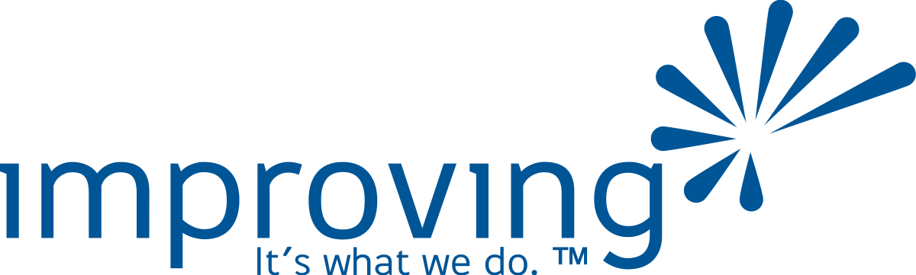

AI Leadership Transformation Program
Proposed Engagement · Everbridge

PREPARED BY
Improving
June 2026

Executive Summary
Everbridge has executive mandate, the right tooling, and a clear deadline: the October Windsor offsite, where every senior leader is expected to arrive with a working AI solution they built and can explain.
This is not a training problem. It is a transformation problem with a deadline. The risk is not that leaders won't learn — it's that they'll learn plenty and still not build anything. Improving's proposed program is designed around the build, not the curriculum.
By Windsor, every participating leader will have (1) a working AI solution built on Everbridge's own platform and data, and (2) a plan for how they lead their team through adoption of it when they return home.

What We Heard
In our conversation with Cara Antonacci, a clear picture emerged of where Everbridge stands and what this engagement needs to accomplish.
Everbridge is already ahead
Most organizations at this stage are still in the cultural and communication phase — fighting freeze. Everbridge has done that work. There is executive mandate at the highest level, an AI fluency model in place, active pilots across OpenAI, Gemini, and AWS, and an internal LLM platform launching in June. The gap is not awareness or appetite. It is execution.
The Windsor deadline is real
Dave Wagner's vision for October is specific: every leader builds an actual AI tool — not a prototype concept, not a slide deck — and the Windsor session showcases what was built, captures what the organization learned, and accelerates adoption. The pre-work leading up to Windsor is where the building happens. Windsor itself is where it becomes organizational knowledge.
The leadership dimension matters as much as the build
Cara was explicit: this program cannot only develop individual AI fluency. Leaders need to leave knowing how to bring their teams along — how to evolve workflows, set new expectations, and lead adoption when they return from Windsor. Both outcomes are required.
How We Designed This Program
Four principles shape every decision in this engagement.
The build is the curriculum
Every session, every Office Hours touchpoint, every 1:1 exists to advance each leader's specific AI solution. Not hypothetical use cases — real ones, owned from day one.
Leaders, not developers
No coding required. The tools leaders will use — GPT builders, workflow automators, and agent platforms — are accessible without engineering expertise. The skill this program develops is judgment: knowing what to build, how to scope it, and when it's good enough.
Two outcomes, not one
Each leader arrives at Windsor with a working AI solution and a team adoption plan. Both get showcased. A build without a plan for how it lives in the organization is a demo. A plan without a build is aspiration. Both are required.
Cohort accountability
Leaders are assigned to cohort groups of 12–15, deliberately mixed by function. They share progress, surface blockers, and pressure-test each other's work throughout the build process — not just with Improving coaches.
Engagement Structure
The program runs from late June through the Windsor offsite in October, structured in four phases.
PROGRAM JOURNEY · JULY – OCTOBER 2026
JUNE |  | JULY |  | JULY – SEPT |  | OCTOBER
Intake &  Cohort Setup | → | Session 1  Shared Foundation | → | Office Hours  & Coaching | → | Windsor  Showcase
Leaders complete intake. Cohorts assigned. Coaches briefed. |  | 4-hour full-group session. Shared language. Build targets set. |  | Topical sessions, 1:1s, and Windsor rehearsals. |  | Leaders demo builds. Org learnings captured. Adoption accelerated.

Pre-Program: Leader Intake and Cohort Assignment (Late June)
Before Session 1, each participating leader completes a structured intake covering their domain, their biggest workflow friction point, their current AI comfort level, and an initial hypothesis for what they might build. Improving reviews the intakes, assigns leaders to cohort groups, and assigns a dedicated coach to each cohort. Leaders arrive at Session 1 with a named problem, not a blank page.
Session 1: Shared Foundation (4 Hours, July)
All ~70 leaders participate together. This is the program's anchor — the one time the full group is in the same room. The shared language and mental models built here are what make the Office Hours and Windsor showcase work.
This is not an AI survey or executive overview. It is a working session. Leaders interact with AI tools throughout — building, not watching.
Hour | Topic | What Leaders Do
Hour 1 | How AI Actually Works (for Leaders) | Build a shared mental model — how models reason, where they fail, how Everbridge's tools fit together.
Hour 2 | The Language of Building | Learn and practice the vocabulary the rest of the program runs on: prompt engineering, GPTs vs. automations vs. agents.
Hour 3 | Finding Your Build Target | Map a real workflow friction point, stress-test it as an AI use case, and narrow toward a build hypothesis.
Hour 4 | Commitments and Cohort Launch | Each leader states their build hypothesis to their cohort. Coaches give first-pass feedback.

Office Hours: July through September
After Session 1, support shifts to Office Hours — a pre-set schedule of touchpoints leaders join based on where they are and what they need. Every session is on the calendar from day one. Nothing is mandatory except the Windsor rehearsal.
Topical Sessions (60 minutes each — open to all leaders)
- OH-1 (Late July) — Use Case Stress Test: Is what you're building the right problem?
- OH-2 (Early August) — Prompting for Your Use Case: Applied prompt engineering for real builds in progress.
- OH-3 (Late August) — Leading the Change: How to bring your team along. Each leader drafts a team adoption plan.
- OH-4 (Early September) — Build Clinic: Open working time with coaches to unblock and finalize.
1:1 Sessions (30 minutes — bookable anytime July–September)
Each Improving coach carries a standing block of availability. Leaders book when they hit a blocker, need a design review, or want direct input before a group session.
Windsor Rehearsals (30 minutes per leader — September)
Every leader books a rehearsal slot — the one non-optional touchpoint in this phase. They run through their Windsor presentation with a coach: a 5-minute build demo plus a 2-minute team adoption plan. No one arrives unrehearsed.
Windsor Offsite (October, UK)
Improving facilitates a dedicated session within the Windsor day-and-a-half format. The session has two acts: a showcase of what was built across the full leadership group, and a working session on leading the next wave of adoption back at home. Detailed agenda available upon request.
Technology Considerations
Everbridge's tooling foundation is a significant advantage for this program. The builds leaders create should live on platforms the organization already owns and governs — not on personal accounts that don't survive role changes.
The Everbridge Profile — the internal LLM platform launching June 2026 — is the natural home for this program's builds. It has organizational data connected, IT governance in place, and agent and automation features that match what leaders will be building.

Before Session 1 is finalized, Improving will need alignment on three questions: which platform leaders will build on, what organizational data they can access during the build phase, and where completed builds will live after Windsor.
Engagement Team
Role | Person
Executive Sponsor | David O'Hara · Improving
Account Executive | Derek Nwamadi · Improving
AI Practice Lead | TBD · Improving
Cohort AI Coaches | TBD · Improving (2–3)
Windsor Facilitators | TBD · Improving (1–2)
Client Sponsor | Cara Antonacci · Chief People Officer, Everbridge

Investment
Pricing is structured by program component, allowing Everbridge to select the level of support that fits the engagement.
Component | Description | Investment
Pre-Program Intake + Cohort Setup | Structured intake for all leaders, cohort assignments, coach briefings
Session 1: Shared Foundation | 4-hour full-group session, all ~70 leaders
Office Hours — Topical Sessions | 4 × 60-min group sessions (July–September)
Office Hours — 1:1 Sessions | 30-min bookable sessions, standing coach availability
Windsor Rehearsals | 30-min individual rehearsal per leader (September)
Windsor Facilitation | On-site facilitation, Windsor UK (October)

Why Improving
Improving has been helping organizations close the gap between AI strategy and AI execution for years. We have seen what makes these programs work — and what makes them stall. The leaders who show up at Windsor with something real will be the ones who had structured support, peer accountability, and a clear build target from the first session.
We are practitioners, not vendors. We work alongside your leaders — not in front of them. And we design programs around outcomes, not content delivery.
Improving. It's what we do.

