

Installation Instructions



Keyboard App Builder: Installation Instructions

© 2024, SIL International

Last updated: 18 June 2024

You are free to print this manual for personal use and for training workshops.

The latest version is available at
http://software.sil.org/keyboardappbuilder/resources/

and on the Help menu of Keyboard App Builder.

Contents

1. Introduction 4
2. Windows Installation 4
2.1. Installing Keyboard App Builder 5
2.2. Installing Java Development Kit (JDK) 5
2.2.1. Installing the JDK using the Install JDK wizard 5
2.2.2. Installing the JDK from the Azul website 5
2.3. Installing Android Software Development Kit (SDK) 7
2.3.1. Downloading the Android SDK packages from the internet 7
2.3.2. Copying the Android SDK files from someone else 8
3. Linux Installation 10
3.1. Add SIL repository for Ubuntu 10
3.2. Installing all packages from the Internet 11
3.3. Downloading the Android SDK files prior to package installation 11
3.3.1. Downloading the Android SDK files 11
3.3.2. Provide zip files during the package install 11
3.4. Installing without Android SDK 12
3.5. Automating Android SDK installation 12
4. How to build your first app 13

Introduction
Keyboard App Builder does what its name suggests: it helps you to build customized keyboard apps for smartphones and tablets. A keyboard app allows users to add a system keyboard to their device, enabling them to type in their language within other apps such as Gmail, Facebook and WhatsApp.

The keyboards are created using Keyman Developer (https://keyman.com/developer/).

To build an app, you specify the Keyman keyboard layouts and lexical models to use, the app name, fonts, colours, about box information, illustrations, and the icons. Keyboard App Builder will package everything together and build the customized app for you. You then install it on your mobile device, send it to others by Bluetooth or Wi-Fi transfer app, share it on microSD memory cards and publish it to app stores on the Internet.

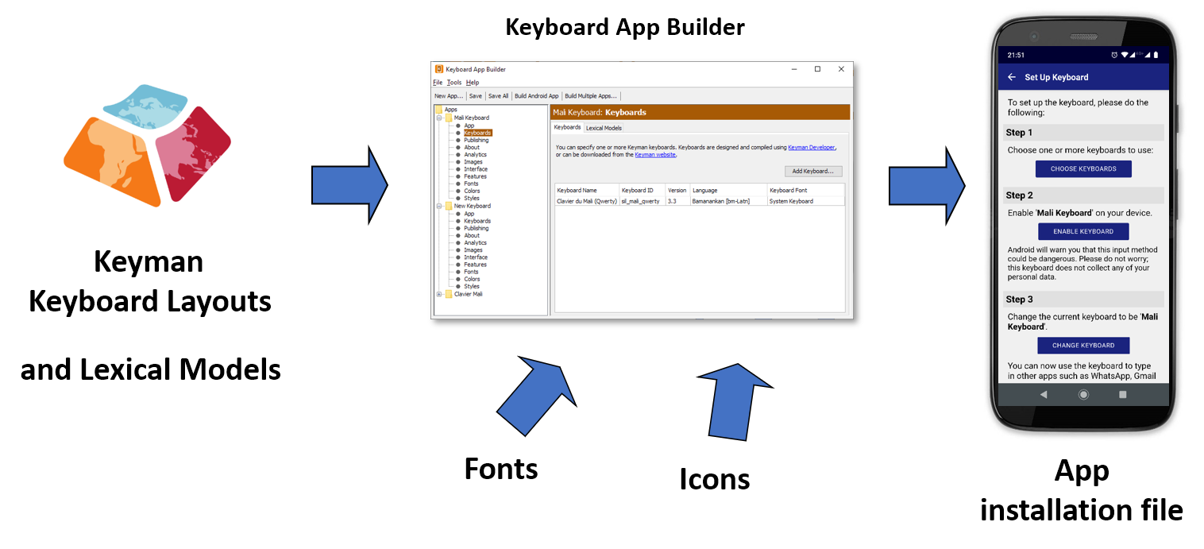
To install Keyboard App Builder on Windows, please follow the instructions in section 2. For Linux, please find the instructions in section 3.

Windows Installation
In order to run Keyboard App Builder on Windows, you need to have three components installed on your computer:
- Keyboard App Builder (KAB)
- Java Development Kit (JDK)
- Android Software Development Kit (SDK)

Here are more details on installing each of these three components.

Installing Keyboard App Builder
To install the Keyboard App Builder program, do the following:
- Go to the Download page of the Keyboard App Builder website: http://software.sil.org/keyboardappbuilder/download
- Download the latest setup program for Windows.
- Run the setup program, Keyboard-App-Builder-x.x-Setup.exe, to install Keyboard App Builder on your computer.

Installing Java Development Kit (JDK)
You will need version 17 of the Java Development Kit (JDK) to build apps. There are two ways of installing it:
- Use the Install JDK wizard within Keyboard App Builder (see section 2.2.1), or
- Download the JDK setup file from the Azul website and run the installer (see section 2.2.2).

Installing the JDK using the Install JDK wizard
The easiest way to install the Java Development Kit (JDK) is to use the Install JDK wizard within Keyboard App Builder:
- Launch Keyboard App Builder.
- Click the Install JDK button on the welcome page (or select Tools Install JDK from the main menu).
- Follow the instructions in the wizard to download and install the JDK.
If the JDK was installed successfully, skip section 2.2.2 and go to section 2.3 to install the Android SDK.

Installing the JDK from the Azul website
We recommend you use Zulu, which is a free distribution of OpenJDK from Azul.
- Go to the Download Zulu Builds of OpenJDK website:

https://www.azul.com/downloads/?version=java-17-lts&os=windows&architecture=x86-64-bit&package=jdk#zulu

There are many downloads on this page, but the above link will filter the ones you see (Java Version: Java 17 LTS; Operating System: Windows; Architecture: x86 64-bit; Java Package: JDK).

- Scroll down the page until you see the downloads:

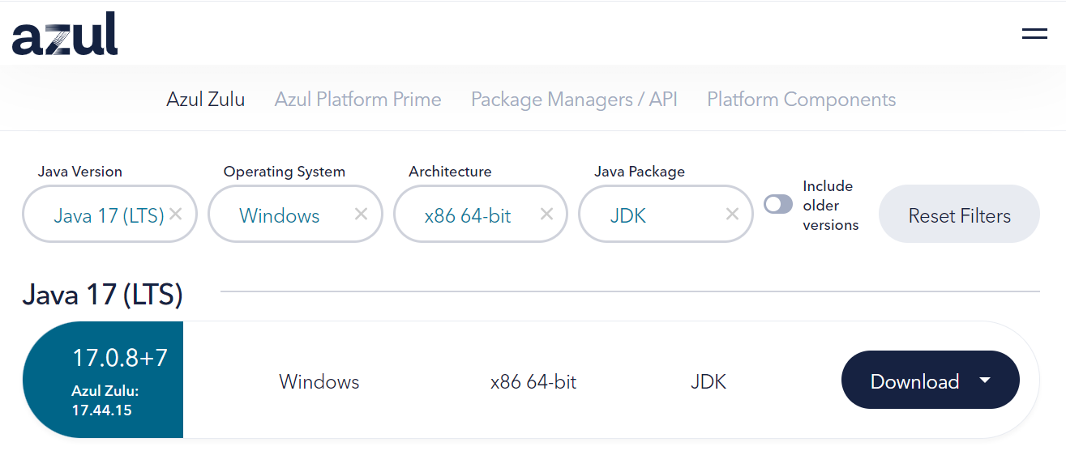

- You have a choice between a zip file and an msi file. Download the .msi file since it comes with its own installer program.

The file you download will have a filename something like this:
zulu17.44.15-ca-jdk17.0.8-win_x64.msi

- Double-click the msi file and follow the instructions in the installation wizard to install it. By default, the .msi installer will install the JDK to the following folder:
C:\Program Files\Zulu\zulu-17\

Important: If you change the JDK install folder to something other than the default folder, you will need to remember the location of the folder so you can tell Keyboard App Builder where to find the JDK.

Installing Android Software Development Kit (SDK)
The third component needed for Android app development is the Android Software Development Kit (SDK). There are two ways of installing the Android SDK:
- Online: Download the Android SDK packages from the internet:
Use the Android SDK Installation wizard to download and install the command line tools and three additional packages. This method will require an internet connection.
See 2.3.1 for more details.
- Offline: Copy the Android SDK files from someone else:
If you know someone who has already downloaded and installed the Android SDK, you can copy all the files from them.
This method is especially useful in a training workshop where several people need to install the SDK but have limited internet bandwidth.
See 2.3.2 for more details.

Downloading the Android SDK packages from the internet
To install the Android SDK from the internet:

- Launch Keyboard App Builder.

- Click the Install Android SDK button on the welcome page (or select Tools Install Android SDK from the main menu).

- Follow the instructions on each page of the Install Android SDK wizard to download each of the Android SDK packages and install them.

When you are asked to specify a target folder, a good place is C:\sdk.

Four packages will be downloaded and installed:
- Command line tools,
- Build Tools,
- Platform Tools, and
- Platform API.

If the installation was successful, you will see the version numbers displayed in green.

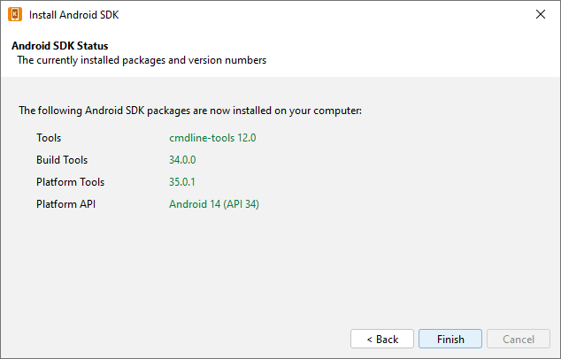

If any of the Build Tools, Platform Tools or Platform API is listed as “Not Found” (displayed in red), go to Tools Settings, select the Android SDK tab, and click the Install Packages button to install them.

Click the Check Installation button to confirm that all the packages have been installed correctly.

You can skip section 2.3.2 and go straight to section 2.4.

Copying the Android SDK files from someone else
If you know someone who has already downloaded and installed the Android SDK and is successfully building apps with it, you can copy all of their Android SDK files to a folder on your computer.
You need to look for the top-level Android SDK folder, such as c:\sdk, and copy the whole folder and its contents to your computer. A location such as c:\sdk is good. If it makes it easier, you can zip the folders and then unzip them onto your computer.
Note that there is no setup program to run. Copying the files from one computer to another is sufficient.

Tip: A typical Android SDK folder can be quite large (over 1 GB, depending on which additional packages have been installed). To build an app, you do not actually need all of the Android SDK files. If you want to cut down the number of files, here is a list of the essential and optional folders:

Android SDK Folder | Required for building apps?
cmdline-tools (or tools) | Yes
build-tools | Yes (you only need the sub-folder for the latest version)
platforms | Yes (you only need android-34)
platform-tools | Yes
add-ons | No
docs | No
emulator | No, unless you want to use an emulator
extras | No
licenses | Yes
sources | No
system-images | No, unless you want to use an emulator
temp | No

Linux Installation
To run Keyboard App Builder on Linux, you need to have 3 components installed on your computer:
- Keyboard App Builder
- OpenJDK Java Development Kit (JDK)
- Android Software Development Kit (SDK)

Packages are built for Ubuntu-based distributions (including Wasta-Linux) and are available in the SIL repository for Ubuntu. The package for Keyboard App Builder already includes the dependencies on the package for OpenJDK and a package that will download the Android SDK from the internet and install it.

You have the following installation options for how the Android SDK is installed:
- Follow the instructions in section 3.2 to download everything directly from the Internet.
- Follow the instructions in section 3.3 to download the Android SDK files prior to installing the packages.
- Follow the instructions in section 3.4 if you already have the Android SDK installed and you do not want another copy installed.

Add SIL repository for Ubuntu
To install packages from the SIL repository for Ubuntu, the repository must be added to the APT sources.

Note: Wasta-Linux already includes configuration for the SIL repository for Ubuntu and so you can skip this section.

If you are using another Ubuntu-based distribution, please follow the instructions below (from the section “Enable access to SIL software and fonts in Ubuntu” on https://packages.sil.org).

- Open a Terminal window.

- Add the repository security key:
(wget -O- https://packages.sil.org/keys/pso-keyring-2016.gpg | sudo tee /etc/apt/trusted.gpg.d/pso-keyring-2016.gpg)&>/dev/null

- Add source:
(. /etc/os-release && sudo tee /etc/apt/sources.list.d/packages-sil-org.list>/dev/null <<< "deb http://packages.sil.org/$ID $VERSION_CODENAME main")

Installing all packages from the Internet

To install all the required software from the command line, type:
sudo apt-get update
sudo apt-get install -y keyboard-app-builder

Note: Wasta-Linux does not automatically install recommended packages. To get everything installed, also install android-sdk-installer.
sudo apt-get install -y keyboard-app-builder android-sdk-installer

Downloading the Android SDK files prior to package installation
The android-sdk-installer package simplifies downloading and installing the Android SDK. Its default behaviour is to download the appropriate files from Google’s Android software repository during the install. If this would be a problem due to bandwidth usage during the install, the files can be downloaded prior to installation.

Downloading the Android SDK files
On a computer connected to the internet, use the following command line instructions to create a new folder and download 4 zip files (approximately 400MB).
mkdir -p ~/Downloads/android-sdk-zips
cd ~/Downloads/android-sdk-zips
wget -ci http://bit.ly/android-sdk-urls

Note: the -c option will allow the downloads to be resumed if it fails part way through the download.

Provide zip files during the package install
Use debconf to pre-seed the package with the location of the files and install the package.
echo android-sdk-installer android-sdk-installer/dldir string ~/Downloads/android-sdk-zips | sudo debconf-set-selections
sudo apt-get install android-sdk-installer
echo android-sdk-installer android-sdk-installer/dldir string | sudo debconf-set-selections

Installing without Android SDK
The android-sdk-installer package is a recommended package for the keyboard-app-builder package. If the Android SDK is already installed, Keyboard App Builder can use the current installation.
sudo apt-get update
sudo apt-get install keyboard-app-builder --no-install-recommends

Set the ANDROID_HOME environment variable to the path of the Android SDK installation to allow Keyboard App Builder to find it automatically. Otherwise you can use the Tools Settings dialog in Keyboard App Builder to specify the path.

Automating Android SDK installation
The android-sdk-installer will prompt you to accept the license for the Android SDK. To automate the installation (e.g. in an Ansible playbook), pre-seed the answer to this question.
echo android-sdk-installer android-sdk-installer/accepted-android-sdk-eula boolean true | sudo debconf-set-selections
sudo apt-get install android-sdk-installer

How to build your first app
To build your first app with Keyboard App Builder, follow the instructions in the first chapter of the document ‘Keyboard App Builder – 2 Building Apps’.

