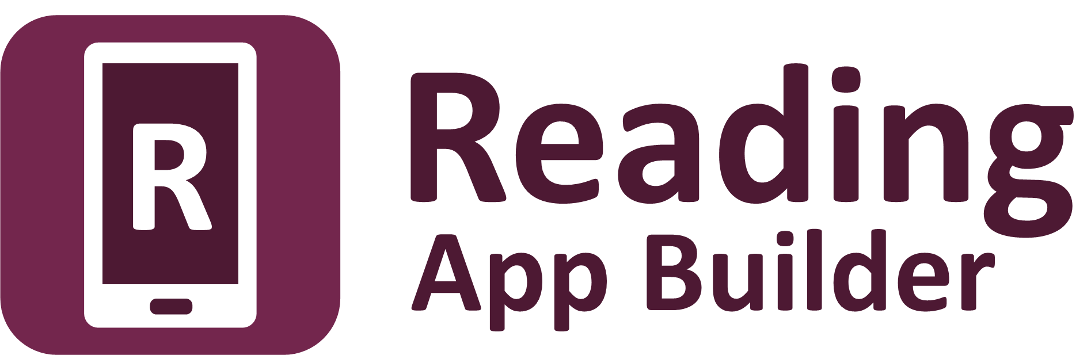

**Installation Instructions**

Reading App Builder: Installation Instructions

© 2024, SIL International

*Last updated: 17 June 2024*

You are free to print this manual for personal use and for training workshops.

The latest version is available at

<http://software.sil.org/readingappbuilder/resources/>

and on the Help menu of Reading App Builder.

**Contents**

1. Introduction 4

2. Windows Installation 4

2.1. Installing Reading App Builder 5

2.2. Installing the Java Development Kit (JDK) 5

2.2.1. Installing the JDK using the Install JDK wizard 5

2.2.2. Installing the JDK from the Azul website 6

2.3. Installing the Android Software Development Kit (SDK) 7

2.3.1. Downloading the Android SDK packages from the internet 7

2.3.2. Copying the Android SDK files from someone else 8

2.4. Installing aeneas for audio-text synchronization 9

3. Linux Installation 12

3.1. Add SIL repository for Ubuntu 12

3.2. Installing all packages from the Internet 13

3.3. Downloading the Android SDK files prior to package installation 13

3.3.1. Downloading the Android SDK files 13

3.3.2. Provide zip files during the package install 13

3.4. Installing without Android SDK 14

3.5. Automating Android SDK installation 14

4. How to build your first app 15

# Introduction

Reading App Builder does what its name suggests: it helps you to build customized reading apps for smartphones and tablets. You can use it to make apps containing picture books, health and community development materials, song books, illustrated stories and libraries of easy-to-read books for new readers – each with the option of synchronizing text and audio, highlighting each phrase as it is read. The app menus, icon, splash screen and colors can all be customized for your language and culture.

You specify the text and audio files, the app name, the fonts, the colours, the about box information and the icons. Reading App Builder will package everything together and build the customized app for you. You then install it on your mobile device, send it to others by Bluetooth or Wi-Fi transfer app, share it on microSD memory cards and publish it to app stores on the Internet.

**Word documents**

**or Bloom books**

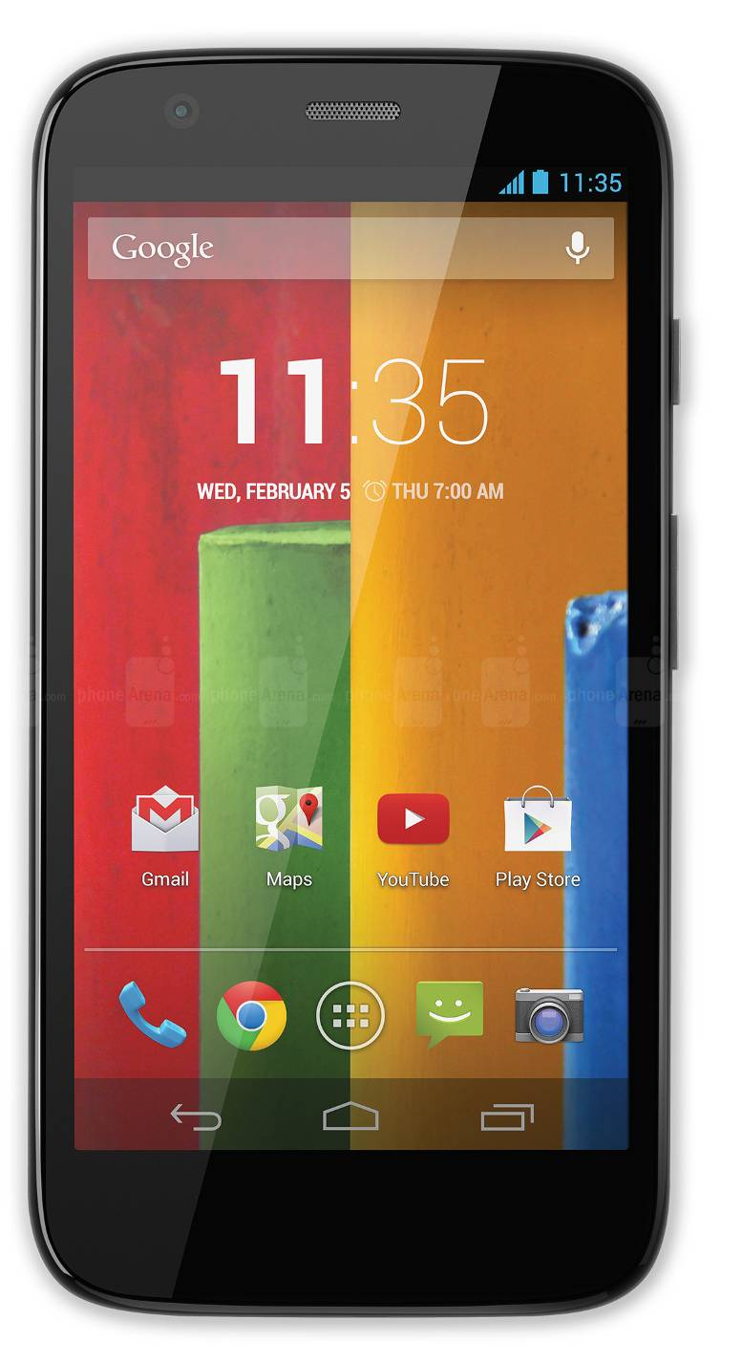

**App for smartphones   
and tablets**

**Audio files**

**Icons**

**Fonts**

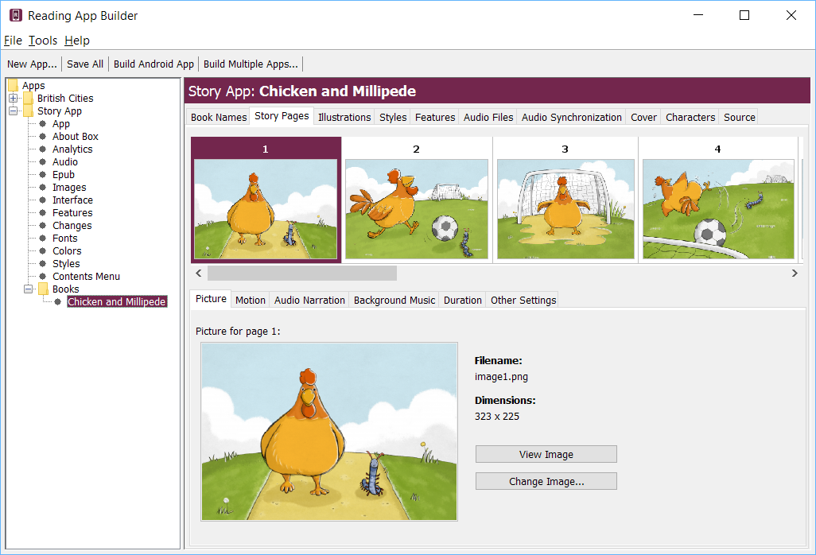

To install Reading App Builder on **Windows**, please follow the instructions in section 2. For **Linux**, please find the instructions in section 3.

For **Mac**, you can find the installation instructions in the document **Installing and Building Apps on a Mac**.

# Windows Installation

To run Reading App Builder on Windows, you need to have 3 components installed on your computer:

1. Reading App Builder
2. Java Development Kit (JDK)
3. Android Software Development Kit (SDK)

There is an optional fourth component to install if you want to synchronize text and audio:

1. Aeneas audio-text synchronization tool.

Here are more details on installing each of these three components.

## Installing Reading App Builder

To install the Reading App Builder program, do the following:

1. Go to the **Download** page of the Reading App Builder website: <http://software.sil.org/readingappbuilder/download>
2. Download the latest setup program for Windows.
3. Run the setup program, **Reading-App-Builder-x.x-Setup.exe**, to install Reading App Builder on your computer.

## Installing the Java Development Kit (JDK)

You will need version 17 of the Java Development Kit (JDK) to build apps. There are two ways of installing it:

* Use the Install JDK wizard within Reading App Builder (see section 2.2.1), or
* Download the JDK setup file from the Azul website and run the installer (see section 2.2.2).

### Installing the JDK using the Install JDK wizard

The easiest way to install the Java Development Kit (JDK) is to use the Install JDK wizard within Reading App Builder:

1. Launch **Reading App Builder**.
2. Click the **Install JDK** button on the welcome page (or select **Tools** ⮚ **Install JDK** from the main menu).
3. Follow the instructions in the wizard to download and install the JDK.

If the JDK was installed successfully, skip section 2.2.2 and go to section 2.3 to install the Android SDK.

### Installing the JDK from the Azul website

We recommend you use Zulu, which is a free distribution of OpenJDK from Azul.

1. Go to the **Download Zulu Builds of OpenJDK** website:

<https://www.azul.com/downloads/?version=java-17-lts&os=windows&architecture=x86-64-bit&package=jdk#zulu>

There are many downloads on this page, but the above link will filter the ones you see (Java Version: Java 17 LTS; Operating System: Windows; Architecture: x86 64-bit; Java Package: JDK).

1. Scroll down the page until you see the downloads:

1. You have a choice between a zip file and an msi file. **Download the .msi file** since it comes with its own installer program.

The file you download will have a filename something like this:

**zulu17.44.15-ca-jdk17.0.8-win_x64.msi**

1. **Double-click the msi file** and follow the instructions in the installation wizard to install it. By default, the .msi installer will install the JDK to the following folder:

C:\Program Files\Zulu\zulu-17\

**Important**: If you change the JDK install folder to something other than the default folder, you will need to remember the location of the folder so you can tell Reading App Builder where to find the JDK.

## Installing the Android Software Development Kit (SDK)

The third component needed for Android app development is the Android Software Development Kit (SDK). There are two ways of installing the Android SDK:

1. **Online: Download the Android SDK packages from the internet:**   
   Use the Android SDK Installation wizard to download and install the command line tools and three additional packages. This method will require an internet connection.

See 2.3.1 for more details.

1. **Offline: Copy the Android SDK files from someone else:**  
   If you know someone who has already downloaded and installed the Android SDK, you can copy all the files from them.

This method is especially useful in a training workshop where several people need to install the SDK but have limited internet bandwidth.

See 2.3.2 for more details.

### Downloading the Android SDK packages from the internet

To install the Android SDK from the internet:

1. Launch **Reading App Builder**.
2. Click the **Install Android SDK** button on the welcome page (or select **Tools** ⮚ **Install Android SDK** from the main menu).
3. Follow the instructions on each page of the **Install Android SDK** wizard to download each of the Android SDK packages and install them.

When you are asked to specify a target folder, a good place is **C:\sdk**.

Four packages will be downloaded and installed:

* Command line tools,
* Build Tools,
* Platform Tools, and
* Platform API.

If the installation was successful, you will see the version numbers displayed in green.

If any of the Build Tools, Platform Tools or Platform API is listed as “Not Found” (displayed in red), go to **Tools** ⮚ **Settings**, select the **Android SDK** tab, and click the **Install Packages** button to install them.

Click the **Check Installation** button to confirm that all the packages have been installed correctly.

You can skip section 2.3.2 and go straight to section 2.4.

### Copying the Android SDK files from someone else

If you know someone who has already downloaded and installed the Android SDK and is successfully building apps with it, you can copy all of their Android SDK files to a folder on your computer.

You need to look for the top-level Android SDK folder, such as **c:\sdk**, and copy the whole folder and its contents to your computer. A location such as c:\sdk is good. If it makes it easier, you can zip the folders and then unzip them onto your computer.

Note that there is no setup program to run. Copying the files from one computer to another is sufficient.

**Tip**: A typical Android SDK folder can be quite large (over 1 GB, depending on which additional packages have been installed). To build an app, you do not actually need all of the Android SDK files. If you want to cut down the number of files, here is a list of the essential and optional folders:

| **Android SDK Folder** | **Required for building apps?** |
| --- | --- |
| cmdline-tools (or tools) | Yes |
| build-tools | Yes (you only need the sub-folder for the latest version) |
| platforms | Yes (you only need android-34) |
| platform-tools | Yes |
| add-ons | No |
| docs | No |
| emulator | No, unless you want to use an emulator |
| extras | No |
| licenses | Yes |
| sources | No |
| system-images | No, unless you want to use an emulator |
| temp | No |

## Installing aeneas for audio-text synchronization

Reading App Builder uses a tool called **aeneas** to synchronise text and audio.

To set up **aeneas** on Windows, there are several programs and modules to download and install: FFmpeg, eSpeak, Python and aeneas. These are installed with a single setup program.

1. Go to the **Download** page on the Reading App Builder website <http://software.sil.org/readingappbuilder/download/> and download the latest aeneas setup program for Windows. You will find it under the heading **Audio Synchronization Tools**.
2. The filename will be something like **aeneas-windows-setup-1.7.3.exe**.
3. Double-click the file you have downloaded to start the installation wizard.

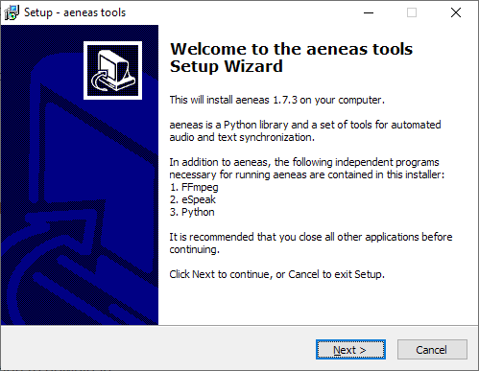

1. Follow the instructions in the wizard. You can accept all the defaults.
2. On the **Select Components** page, you need the **Full Installation** which should be selected by default.

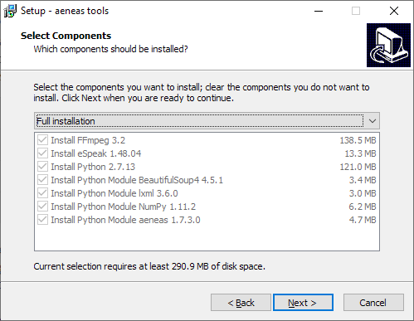

1. On the **Ready to Install** page, click **Install**.

You will see the wizard running several different installers: for FFmpeg, eSpeak, Python. It will also install three Python modules.

Before the wizard completes, you should see a command box appear for a few seconds which verifies the aeneas installation.

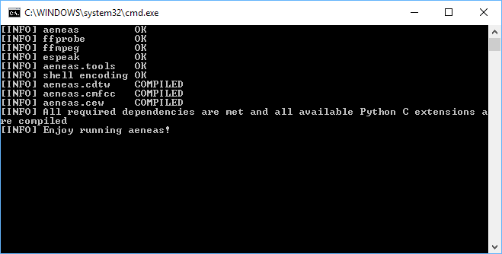

**Important**: If Reading App Builder was open while you installed aeneas, close it and start it again to ensure that it picks up the changes to your Path settings.

# Linux Installation

To run Reading App Builder on Linux, you need to have 3 components installed on your computer:

1. Reading App Builder
2. OpenJDK Java Development Kit (JDK)
3. Android Software Development Kit (SDK)

Packages are built for Ubuntu-based distributions (including [Wasta-Linux](https://www.wastalinux.org/)) and are available in the [SIL repository for Ubuntu](https://packages.sil.org/). The package for Reading App Builder already includes the dependencies on the package for OpenJDK and a package that will download the Android SDK from the internet and install it.

You have the following installation options for how the Android SDK is installed:

1. Follow the instructions in section 3.2 to download everything directly from the Internet.
2. Follow the instructions in section 3.3 to download the Android SDK files prior to installing the packages.
3. Follow the instructions in section 3.4 if you already have the Android SDK installed and you do not want another copy installed.

## Add SIL repository for Ubuntu

To install packages from the SIL repository for Ubuntu, the repository must be added to the APT sources.

Note: **Wasta-Linux** already includes configuration for the SIL repository for Ubuntu and so you can skip this section.

If you are using another **Ubuntu-based distribution**, please follow the instructions below (from the section “Enable access to SIL software and fonts in Ubuntu” on [https://packages.sil.org](https://packages.sil.org/)).

1. Open a Terminal window.
2. Add the repository security key:

(wget -O- https://packages.sil.org/keys/pso-keyring-2016.gpg | sudo tee /etc/apt/trusted.gpg.d/pso-keyring-2016.gpg)&>/dev/null

1. Add source:

(. /etc/os-release && sudo tee /etc/apt/sources.list.d/packages-sil-org.list>/dev/null <<< "deb http://packages.sil.org/$ID $VERSION_CODENAME main")

## Installing all packages from the Internet

To install all the required software from the command line, type:

sudo apt-get update

sudo apt-get install -y reading-app-builder

Note: **Wasta-Linux** does not automatically install recommended packages. To get everything installed, also install android-sdk-installer.

sudo apt-get install -y reading-app-builder android-sdk-installer

## Downloading the Android SDK files prior to package installation

The **android-sdk-installer** package simplifies downloading and installing the Android SDK. Its default behaviour is to download the appropriate files from Google’s Android software repository during the install. If this would be a problem due to bandwidth usage during the install, the files can be downloaded prior to installation.

### Downloading the Android SDK files

On a computer connected to the internet, use the following command line instructions to create a new folder and download 4 zip files (approximately 400MB).

mkdir -p ~/Downloads/android-sdk-zips

cd ~/Downloads/android-sdk-zips

wget -ci http://bit.ly/android-sdk-urls

Note: the -c option will allow the downloads to be resumed if it fails part way through the download.

### Provide zip files during the package install

Use **debconf** to pre-seed the package with the location of the files and install the package.

echo android-sdk-installer android-sdk-installer/dldir string ~/Downloads/android-sdk-zips | sudo debconf-set-selections

sudo apt-get install android-sdk-installer

echo android-sdk-installer android-sdk-installer/dldir string | sudo debconf-set-selections

## Installing without Android SDK

The **android-sdk-installer** package is a recommended package for the **reading-app-builder** package. If the Android SDK is already installed, Reading App Builder can use the current installation.

sudo apt-get update

sudo apt-get install reading-app-builder --no-install-recommends

Set the ANDROID_HOME environment variable to the path of the Android SDK installation to allow Reading App Builder to find it automatically. Otherwise you can use the **Tools** ⮚ **Settings** dialog in Reading App Builder to specify the path.

## Automating Android SDK installation

The **android-sdk-installer** will prompt you to accept the license for the Android SDK. To automate the installation (e.g. in an Ansible playbook), pre-seed the answer to this question.

echo android-sdk-installer android-sdk-installer/accepted-android-sdk-eula boolean true | sudo debconf-set-selections

sudo apt-get install android-sdk-installer

# How to build your first app

To build your first app with Reading App Builder, follow the instructions in the first chapter of the document *‘Reading App Builder – 2 Building Apps’*.