

**Using Audacity for   
Audio-Text Synchronization**



Scripture App Builder: Using Audacity for

Audio-Text Synchronization

© 2017, SIL International

*Last updated: 5 December 2017*

You are free to print this manual for personal use and for training workshops.

The latest version is available at

<http://software.sil.org/scriptureappbuilder/resources/>

and on the Help menu of Scripture App Builder.

**Contents**

1. Introduction 4

2. Getting Started 7

2.1. Phrase Lists 7

2.2. Installing Audacity 8

3. Producing Timing Files 9

4. Timing Labels Assistant 14

5. Usability Tips 15

5.1. Tip #1: Change the keyboard binding for the spacebar 15

5.2. Tip #2: Change the keyboard binding for adding a label 16

6. FAQ 19

6.1. How can I change the punctuation characters which are recognised as ‘end of phrase’ marks? 19

6.2. How can I get the app to highlight text in chapters without any verse numbers? 19

6.3. Can I get the app to split on commas for some verses and not others? 20

6.4. How can I get it to highlight section headings? 21

6.5. How can I define text-audio highlighting for book introductions? 21

6.6. There are parts of the audio where I don’t want any text highlighted. How can I turn off the highlighting for a few moments between verses? 22

6.7. I’d like to give someone else the task of creating timing files. Is there any way of them testing these without needing to know how to build the app? 22

7. Appendix – How to Install Audacity 24

# Introduction

To add audio-text synchronization to apps built with Scripture App Builder, you need to create a **timing file** to go alongside each audio MP3 file. The timing files provide the information the app needs to highlight phrases in the text as the audio is playing.

You can choose between three different methods to create the timing files:

1. **Audacity**: listen to an audio file in the Audacity audio editor and lay down a labels track, placing a label at the start of each phrase.
2. **aeneas**: an automated method of synchronizing text and audio.
3. **HearThis**: record the audio line by line using HearThis and export timing files at the same time as producing the MP3 files

This document takes you through the first of these methods: using Audacity to create the timing files. Instructions on the other two methods can be found in the user manuals *Using HearThis for Audio Recording* and *Using aeneas for Audio-Text Synchronization*.

**PLEASE NOTE**:   
Many users of Scripture App Builder are finding that **aeneas** is providing very accurate synchronization results, so we do recommend you try it out. Synchronising the text and audio of a whole New Testament could take you a month using Audacity, but less than an hour using aeneas!

**One timing file for each audio file**

To synchronize audio and text in your app, you will need:

* one MP3 audio file and one timing file per chapter, or
* one MP3 audio file and one timing file per picture story book.

For example, if you have a book ‘Matthew’ with 28 chapters, you will need 28 audio files and 28 timing files. If you have a picture story book with 8 pages, you need a single audio file which covers all 8 pages together with a single timing file.

Example: if you have an audio file for Matthew chapter 1, MAT_01.mp3, you need to create a corresponding timing file, e.g. MAT_01.txt.

Note: If you have several audio files per chapter or several chapters in one audio file, you will need to concatenate or split your files to create files of one chapter each before creating the timing files. This could be done in Audacity.

**Timing levels**

You can choose the level at which the text is highlighted:

* verse by verse, or
* phrase by phrase.

There is also the possibility of splitting a phrase into smaller units.

**Verse by verse highlighting** will highlight a complete verse at once: from the current verse number up to just before the next verse number.

A verse-by-verse timing file will look like this:

8.252945 8.252945 1

16.401422 16.401422 2

27.235258 27.235258 3

33.809408 33.809408 4-5

66.545898 66.545898 6

74.952265 74.952265 7

96.749997 96.749997 8

111.571459 111.571459 9

127.398309 127.398309 10

130.636807 130.636807 11

149.545453 149.545453 12

157.938255 157.938255 13

172.479752 172.479752 14

190.809003 190.809003 15

206.453448 206.453448 16

217.292729 217.292729 17

229.985550 229.985550 18

The first and second columns indicate the time in seconds. The third column contains the verse number.

**Phrase by phrase highlighting** will highlight phrases within a verse. Phrases can be between punctuation marks, e.g. up to the next “.” or “,”. You can define the set of punctuation characters that mark the end of a phrase. Individual poetic lines can also be highlighted one by one, for example in a psalm or a song.

A phrase-by-phrase timing file will look like this:

3.188682 3.188682 1a

7.415084 7.415084 1b

12.934091 12.934091 1c

16.746603 16.746603 2a

19.829615 19.829615 2b

20.905796 20.905796 2c

21.884018 21.884018 3a

22.858863 22.858863 3b

25.613723 25.613723 4a

27.108508 27.108508 4b

30.192832 30.192832 4c

31.388587 31.388587 4d

32.683989 32.683989 5a

36.440027 36.440027 5b

38.297624 38.297624 5c

or like this:

3.188682 3.188682 1

7.415084 7.415084

12.934091 12.934091

16.746603 16.746603 2

19.829615 19.829615

20.905796 20.905796

21.884018 21.884018 3

22.858863 22.858863

25.613723 25.613723 4

27.108508 27.108508

30.192832 30.192832

31.388587 31.388587

32.683989 32.683989 5

36.440027 36.440027

38.297624 38.297624

As in verse-by-verse timing files, the number represents the verse. The lines without verse numbers represent the mid-verse phrase breaks.

In early versions of Scripture App Builder, it was necessary to specify phrases using 1a, 1b, 1c (the first, second and third phrases in verse 1). But now it is sufficient to leave the timing label blank between verses and SAB will fill in the a, b, c when it reads in the file.

**Word level highlighting**: If you want to split a phrase after one or more words, you can use word-level highlighting for that phrase. For this, the labels in the timing files should contain an underscore and then the index of the word, e.g.

**1_4** starts at the 4th word of verse 1  
**2a_5** starts at the 5th word of phrase 2a  
**2a_9** starts at the 9th word of phrase 2a

A timing file with word-level phrase breaks might look like the following example:

3.188682 3.188682 1

7.415084 7.415084 1_4

12.934091 12.934091 1_11

16.746603 16.746603 2a

17.356305 17.356305 2a_5

18.853311 18.853311 2a_9

19.829615 19.829615 2b

20.905796 20.905796 2c

21.884018 21.884018 3

22.858863 22.858863

25.613723 25.613723 4a

27.108508 27.108508 4b

28.839213 28.839213 4b_6

29.158316 29.158316 4b_10

30.192832 30.192832 4c

31.388587 31.388587 4d

32.683989 32.683989 5

36.440027 36.440027

38.297624 38.297624

# Getting Started

## Phrase Lists

To help you identify when to mark a timing break, we recommend you create *Phrase Lists*. These will arrange the phrases line by line for you.

To create phrase lists for each of the chapters in your app:

1. Launch **Scripture App Builder**.
2. Navigate to the **Book Collection** page for your app.
3. Go to the **Audio Synchronization** tab.
4. Click on **Create Phrase Lists** and follow the instructions in the wizard.

A set of Word documents (.docx), comma-separated files (.csv) or tab-separated files will be created, one for each chapter.

A phrase list document looks like the following:

**Matiyu 2**

(Matthew 2)

|  |  |
| --- | --- |
| 1 | Isa hayandi Betelehem, |
|  | Žude gandaa ra, |
|  | kokoyoo kaŋ se i ga nee Herod zamanoo ra. |
|  | Handaray bayraykoyniyaŋ ne ka hun waynahunay ka kaa Žerizalem, |
| 2 | i nee: |
|  | «Man Alyahuudey kokoyoo kaŋ hayandi? |
|  | Ir dii nga handaraa waynahunay. |
|  | Ir kaa ka sujudʼa se.» |
| 3 | Kaŋ kokoyoo Herod maa woo, |
|  | a zalba, |
|  | de Žerizalem kul zalbʼa bande. |
| 4 | A na jamaa sargari juwalkey jineborey nda Citaaboo baykey marga hala i ma nga bayrandi nongoo kaŋ ra Almasihu ga hima ka hayandi. |
| 5 | I nee a se: |
|  | «Betelehem kaŋ goo Žude, |
|  | zama hayaa ne kaŋ annaboo nʼa hantum: |

Each row in the phrase list document represents a separate timing phrase which will need to be marked.

You can define which characters are recognised as phrase ending characters in the **Features** ⮚ **Audio** page of Scripture App Builder. By default, it is: a full stop/period (.), a question mark (?), an exclamation mark (!), a colon (:) and a comma (,).

## Installing Audacity

Install the **Audacity** sound-editing program if you do not already have it. Please see **Appendix: How to install Audacity**.



# Producing Timing Files

1. Launch Audacity.
2. Open the MP3 file using **File** ⮚ **Open** on the main menu.
3. If the file is stereo with two tracks, it can be helpful to reduce it to mono for this process so it doesn’t take up so much room on your screen. Do this with **Tracks** ⮚ **Stereo Track to Mono**.
4. Zoom in a couple of times so it is easier to see the gaps between the audio waveforms.

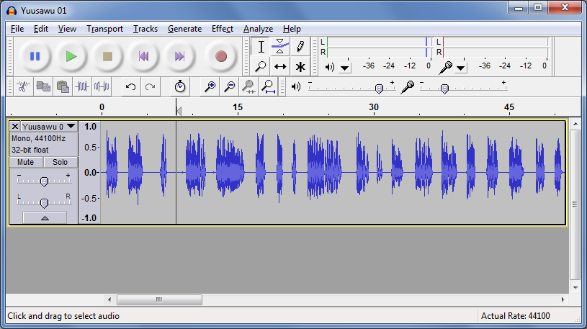

1. Have the Scripture text or Phrase List open to the chapter you will be listening to.

*You could display the text in a different window (i.e. have Audacity take up the left part of the screen and the Scripture text on the right, or have the screens arranged at the top and bottom of the screen), but this can be awkward since you will need to scroll the text from time to time and then click in the Audacity window to give it focus again. While you are doing this you might lose your place and miss a verse break. What can work better is if you have a printed text in front of you or if the text is already on a smartphone or tablet. Then you can concentrate more fully on the text and avoid the complication of switching between windows.*

1. Move the cursor to just before the beginning of the first verse (i.e. after any titles or chapter headings).
2. Place the first label marker using **CTRL-B**. A label track will be created.

*If you are using a Mac, the shortcut to use is* ***Command B****.*

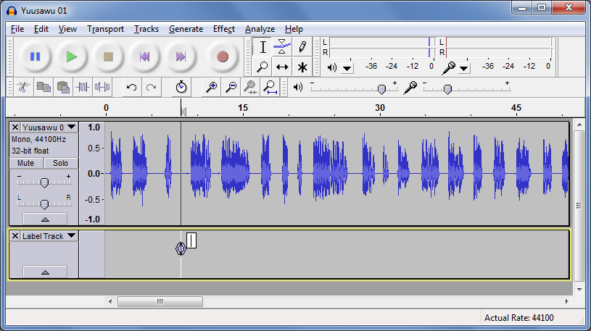

1. Type the number “1” in this first label. This indicates that “verse 1 starts here”.

*The cursor should already be in the label, so you just need to press the “1” key after pressing CTRL+B above.*

1. Press ‘Play’ to start listening to the audio. As you listen, place a label at each timing break (phrase or verse level) using **CTRL-M**.

*You don't really need to look at Audacity for this. Just follow the text closely and keep pressing CTRL-M at the verse breaks.*

*If you are using a Mac, the shortcut to use is* ***Command*** *. – that is Command and period (.) together.*

|  |  |  |
| --- | --- | --- |
|  | **Windows** | **Mac** |
| Add Label At Selection  *(at cursor position when paused)* | CTRL-B | Command B |
| Add Label At Playback Position  *(at current position when playing audio)* | CTRL-M | Command . |

*Default key mappings for adding labels*

***Usability Tip:*** *Instead of pressing two keys together (CTRL-M) to add a label, it is easier if you reassign the key binding to be a single key, such as F1. See Section 4: Usability Tips for more details on how to do this.*

1. When you get to the start of a new verse, type the verse number into the label while the audio is still playing.

*If you are quick, you’ll find there is no need to stop the audio for this. The cursor is in the new label already so all you have to do is type the numbers. If you miss typing a verse number, you can always come back to it at the end.*

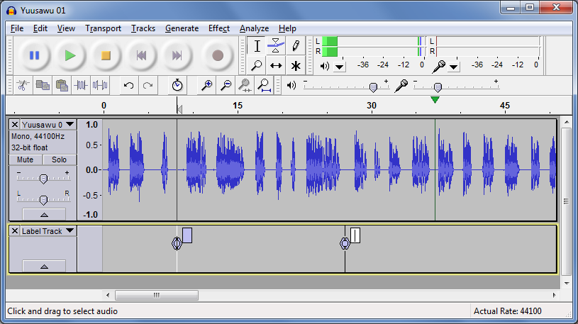

If you lose your way, stop playback, move back a few seconds and press play again.

To delete a label you have placed by accident, press the **DELETE** key when the label is selected.

1. When you have finished placing labels for the whole chapter, go back to each label :
   1. Move it slightly if you missed the middle of the blank section between verses. Do this by dragging the circle in the middle of the marker.
   2. Type verse numbers into the labels that come at the start of verses (if you didn’t do this earlier):
      * "1" for the label before the first verse,
      * "2" for the label before the second verse,
      * "6-7" for bridged verses, etc.

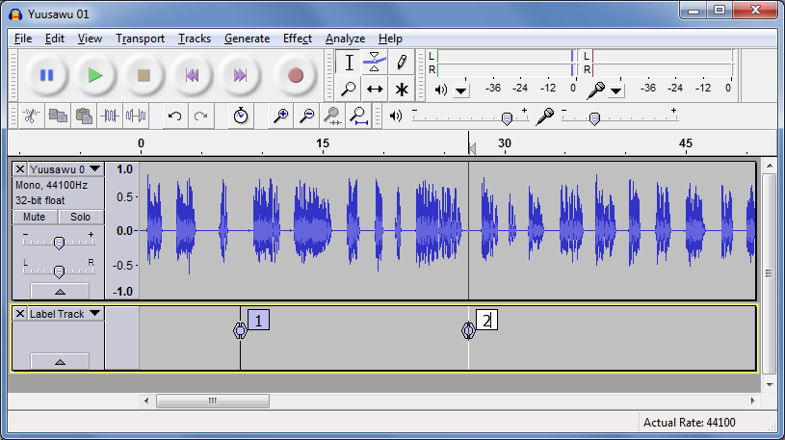

*Another way of adding label captions is via* ***Tracks*** ⮚ ***Edit Labels...*** *This is an easier way to add verse numbers quickly. You can also delete unwanted labels here.*

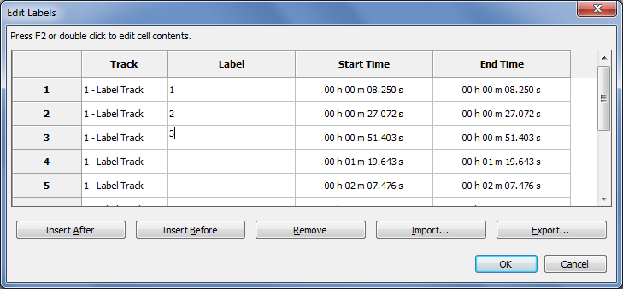

During this process you will be able to see if you have missed out a verse somewhere or if you have added an unwanted marker that needs to be deleted.

1. Export the label track to a text file using **File** ⮚ **Export Labels...**   Choose a name such as LANG-GEN-01.txt (for Genesis chapter 1), LANG-GEN-02.txt (for Genesis chapter 2), etc., where LANG is the name of the language.
2. Open the timing file in a text editor such as Notepad. You should see something like this:

3.188682 3.188682 1

7.415084 7.415084

12.934091 12.934091

16.746603 16.746603 2

19.829615 19.829615

20.905796 20.905796

21.884018 21.884018 3

22.858863 22.858863

25.613723 25.613723 4

27.108508 27.108508

30.192832 30.192832

31.388587 31.388587

32.683989 32.683989 5

36.440027 36.440027

38.297624 38.297624

1. The three columns are *From*, *To* and *Label*. Make sure all the verse numbers are present. If you have missed out a verse number somewhere, fix it in the text file or within Audacity and export again.

The timing file is now ready to be used in an app.

# Timing Labels Assistant

If you are using Audacity in Windows, there is a helpful utility program that will make marking labels significantly easier. It is called **Timing Labels Assistant (TLA)**.

TLA is built with [AutoHotKey](http://www.autohotkey.com/) to simulate keystrokes in Windows. It allows you to specify a phrases file and will insert the label name (1a, 2b, etc.) for you automatically when you press the key to add the next label.

You can find it here: <https://github.com/indiamcq/timing-labels-assistant>

Download the zip file, **Timing-Labels-Assistant_v1.2.29.zip** (or a later version), and unzip it to a writable folder on your computer (i.e. not in Program Files). The main TLA executable is called **Timing-Labels-Assistant.exe**.

To use TLA:

1. Run the **Create Phrase Lists** wizard within Scripture App Builder to create a set of tab-delimited .phrases files for the book chapters you want to synchronize. That’s the 3rd option in the choice of file types.
2. Open **Audacity** with the audio file to be synchronised and zoom into the waveform 2-3 times.
3. Launch **Timing-Labels-Assistant.exe**.
4. Choose the .phrases file corresponding to the audio file you have open in Audacity. It will be opened for you in Notepad.
5. Arrange Notepad to the side of your Audacity window so you can see both.
6. Start playing the audio.
7. Press the **TAB** key or the **+** key on the numeric keyboard to place a marker. (This much easier than pressing CTRL+M). The markers will appear in the order they are in the .phrases file.

If markers do not appear when you press TAB or +, check that CTRL+M is still associated with the command **Add Label at Playback Position**. See section 5.2 for more details.

1. You will hear a beep when the list of markers comes to an end.

To restart from a given label:

* Click on the icon in the taskbar and select **Restart timing at label…**.
* Enter the label you want to start from, e.g. 3b.
* Press **OK** and continue from step 6 above.

To exit:

* Click on the icon in the taskbar and select **Exit**.

# Usability Tips

## Tip #1: Change the keyboard binding for the spacebar

By default, the spacebar is assigned to Play/Stop. This is good, but the problem is that if you stop somewhere and then start again, the playback goes back to the original start position rather than playing from where you stopped.

To modify this:

1. Go to **Edit** ⮚ **Preferences** ⮚ **Keyboard**.
2. Select the line **Play/Stop and Set Cursor**. To find this quickly, type ‘play/stop’ into the Search field at the top.

You are looking for the line that ends with ‘…and Set Cursor’ rather than simply ‘Play/Stop’.

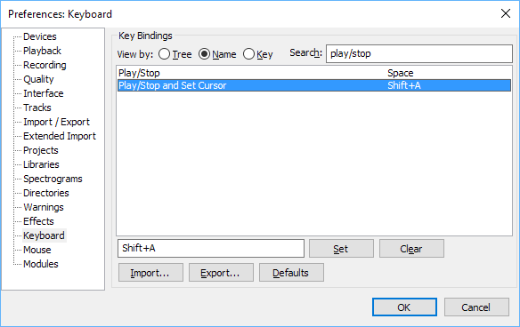

1. Change the key binding for this line to Space (rather than Shift+A).
2. Press **Set**.
3. You will be asked if you want to make the change. Click **OK** to do this.

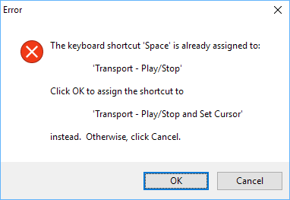

1. Click **OK** to save the changes to the Preferences.

## Tip #2: Change the keyboard binding for adding a label

Instead of pressing two keys together (**CTRL-M**) to add a label, it is easier if you reassign the key binding to be a single key, such as **F1**. Then you have one hand free to type the labels.

NOTE: This tip is only useful if you are not using *Timing Labels Assistant (TLA)*. If you are using TLA, you need to keep CTRL-M as the key combination to add a label.

To change the keyboard binding for adding a label:

1. Go to **Edit** ⮚ **Preferences** ⮚ **Keyboard**.
2. Select the line **Add Label at Playback Position**. To find this quickly, type ‘add label’ into the Search field at the top.

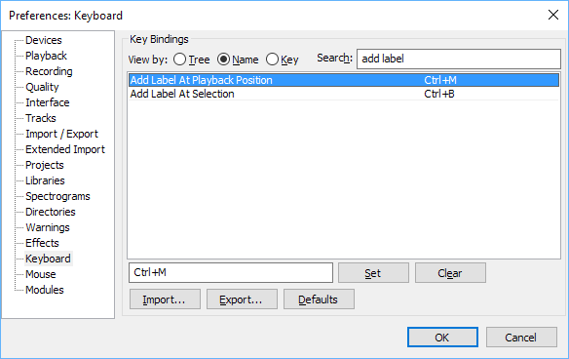

1. Type the key you want to use instead of **CTRL-M**, such as **F1**.
2. Press **Set**.

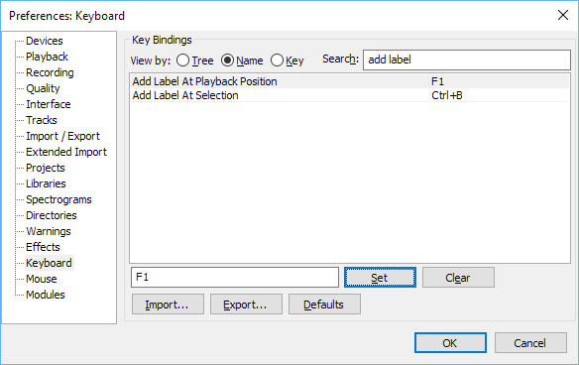

1. If the keyboard shortcut you have chosen is already in use for another function, you will be asked if you want to make the change. Click **OK** to do this.

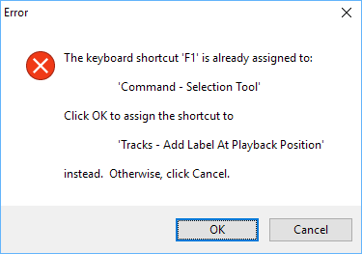

1. Click **OK** to save the changes to the Preferences.

# FAQ

## How can I change the punctuation characters which are recognised as ‘end of phrase’ marks?

You can define which characters are recognised as phrase ending characters in the **Features** ⮚ **Audio** page of Scripture App Builder.

You can add Unicode characters here using the format \uABCD where ABCD is the hexadecimal Unicode code point, e.g. \u061F for an Arabic question mark, \u1362 for an Ethiopic full stop.

## How can I get the app to highlight text in chapters without any verse numbers?

If you have a non-Scripture text such as a song book or another kind of reading book, you will not normally have verse numbers. To highlight phrases and lines, label the first phrase or line as “a”, the second as “b”, the third as “c”, etc.

***Example:***

\c 10

\s An Fa Ala, Dubatigi

\q An Fa Ala, Dubatigi,

\q An bɛ barika da i ye,

\q Ka i tanu, ka i bato,

\q I ka kan ni bonya ye.

\b

\q2 Kuma duman kɛ ne da la,

\q2 Ka ne Kisibaa ko fɔ.

\q2 Aleluya! Aleluya!

\q2 Yesu ye ne kunmabɔ.

In this song, label the audio as follows:

* An Fa Ala, Dubatigi, **(labelled as “a”)**
* An bɛ barika da i ye, **(labelled as “b”)**
* Ka i tanu, ka i bato, **(labelled as “c”)**
* I ka kan ni bonya ye. **(labelled as “d”)**
* Kuma duman kɛ ne da la, **(labelled as “e”)**
* Ka ne Kisibaa ko fɔ. **(labelled as “f”)**
* Aleluya! **(labelled as “g”)**
* Aleluya! **(labelled as “h”)**
* Yesu ye ne kunmabɔ. **(labelled as “i”)**

Note that the “Aleluya! Aleluya!” line is split in two because of the phrase-ending exclamation mark in the middle.

For a longer chapter, you will soon run out of letters of the alphabet. When you get to “z”, the next label you need to use is “aa”, then “ab”, “ac”, “ad”, etc. When you get to “az”, the next label you need to use is “ba”, then “bb”, “bc”, “bd”, etc. In other words, this follows a similar naming convention to the column names in a spreadsheet.

## Can I get the app to split on commas for some verses and not others?

You might want to use phrase level highlighting to split up some of the verses and most of the time might be sufficient to split on full stops/periods, question marks and exclamation marks. But in a few verses it would be good if the app can split on commas.

For those verses where you would like the app to split on commas, simply add a comma at the end of the first phrase level label for the verse, e.g. “3,” or “6,” etc. The app will then split that specific verse by commas as well as the other phrase-ending characters you have defined.

***Example:***

\v 1 Yesu ya se Zhude fiige ki ni, Bɛtilɛhɛmu ni, saannaa Hɛrɔdi caŋa ɲii ni. Wu nizexhɔgɔ ki na, a wɔrɔɔ cɛvɛɛ pii di ba na yìri Kilɛ-nɔhɔ na, na nɔ Zheruzalɛmu ni.

\v 2 A pʼi yegeŋɛ pye na: «Yawutuu wo saan we wʼa se nimɛ ge, mii wu wa wɛ? Wèe ya wu wɔrɔ ɲa, na wèe yaha Kilɛ-nɔhɔ ke na, na ba di ba wu pɛlɛ.»

In this chapter, verse 1 can be split into two sections, split by the “.” in the middle:

* Yesu ya se Zhude fiige ki ni, Bɛtilɛhɛmu ni, saannaa Hɛrɔdi caŋa ɲii ni.
* Wu nizexhɔgɔ ki na, a wɔrɔɔ cɛvɛɛ pii di ba na yìri Kilɛ-nɔhɔ na, na nɔ Zheruzalɛmu ni.

Or, alternatively, it can be split into six sections, split by both “.” and “,”:

* Yesu ya se Zhude fiige ki ni, **(labelled as “1,”)  *– notice the comma after 1a here***
* Bɛtilɛhɛmu ni,
* saannaa Hɛrɔdi caŋa ɲii ni.
* Wu nizexhɔgɔ ki na,
* a wɔrɔɔ cɛvɛɛ pii di ba na yìri Kilɛ-nɔhɔ na,
* na nɔ Zheruzalɛmu ni.

Unless the comma has been added to the normal phrase-ending characters in **Features** ⮚ **Audio,** verse 2 will revert to being treated as a whole (labelled as “2”) or split into three with the normal characters. It can be split into six sections if you begin with the label “2,”.

## How can I get it to highlight section headings?

In some audio files, the section headings are read out by the narrator as well as the verses. To include them in the highlighting, use labels ‘s1’, ‘s2’, ‘s3’, etc., where ‘s1’ is the first section heading, ‘s2’ is the second section heading and so on.

Note that the ‘s’ is lower-case and there is no space between the ‘s’ and the number.

Use this same method for other types of headings, e.g. use ‘d’ as the prefix for \d headings, ‘sp’ as the prefix for \sp headings, ‘is’ for \is, etc.

For **section headings in picture story books**, add the page number before the label, e.g. 1s1, 1s2, 1s3 for section headings on the first page; 2s1, 2s2, etc. for section headings on the second page.

## How can I define text-audio highlighting for book introductions?

Book introductions do not have verse numbers, so use the procedure outlined in FAQ 2 and 3 above, i.e. using phrase-level highlighting with ‘a’, ‘b’, ‘c’, etc.

Sub headings within introductions are labelled as described in FAQ 4 above, i.e. ‘is1’, ‘is2’, etc.

On the Audio tab for books in Scripture App Builder, audio and timing files for introductions need to be marked as Chapter “0”.

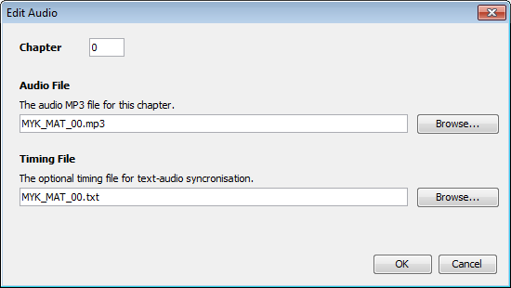

## There are parts of the audio where I don’t want any text highlighted. How can I turn off the highlighting for a few moments between verses?

You might want to turn off text highlighting during musical interludes or sound effects. To do this, you need to give the labels a range, rather than being at a single point.

Here is an example:

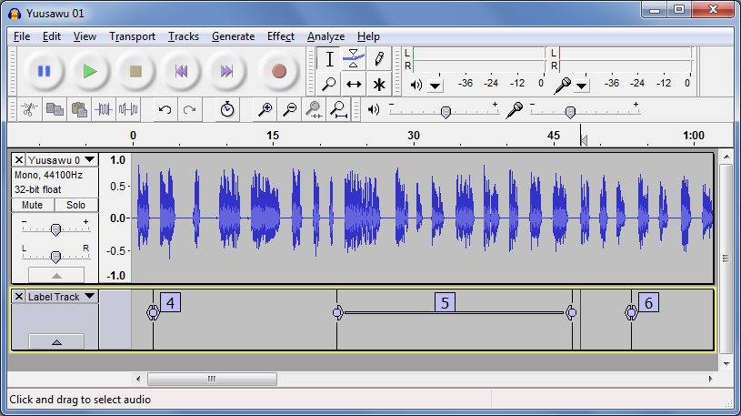

In the above timing file:

* Verse 4 highlighting will start at the 4 label and end at the beginning of the 5 label (as normal).
* Verse 5 highlighting will start at the initial point of the 5 label range and continue until the end of the 5 label range.
* Nothing will be highlighted between the end of the 5 label range and the 6 label.
* Verse 6 highlighting will start at the 6 label.

To create a label range, drag the < or > part of the label marker.

## I’d like to give someone else the task of creating timing files. Is there any way of them testing these without needing to know how to build the app?

Yes, if you have chosen Audio Distribution by external folder or download, the MP3 files will be in a folder on the SD card. The app will look for a corresponding timing file in this folder if it doesn’t already have a timing file packaged inside the APK.

The timing filename in this case should be same as the mp3 file, but with the **.txt** extension rather than **.mp3**.

So, for example, if you have a file such as **MYK_MAT_01.mp3** in the folder, you can put the file **MYK_MAT_01.txt** in the same place and the app should recognise it.

Using this method, others can work on providing timing files for the app and test them, without needing to rebuild the app. Once the timing files are working, you can rebuild the app and package them inside the apk. They are very small so should not increase the size of the apk significantly.

# Appendix – How to Install Audacity

1. Download the latest Audacity installation program from the Audacity website:   
     
    [**http://www.audacityteam.org**](http://www.audacityteam.org)

For version 2.2.0, the filename is **audacity-win-2.2.0.exe**. It is 19 MB in size.

It might be that a newer version than 2.2.0 is available. If so, download this newer version instead.

1. Double-click **audacity-win-2.2.0.exe** to start the installation.
2. Select English as the language to use :

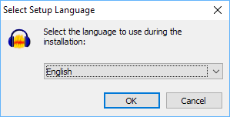

The Setup Wizard opens:

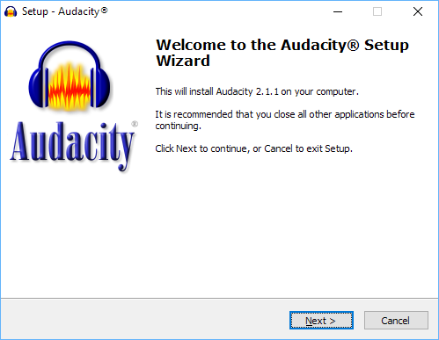

1. Click **Next** to continue.

A page of licence information will appear:

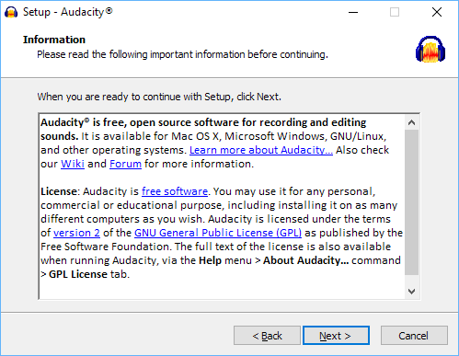

1. Click **Next** to continue.

You will see the page **Select Destination Location**:

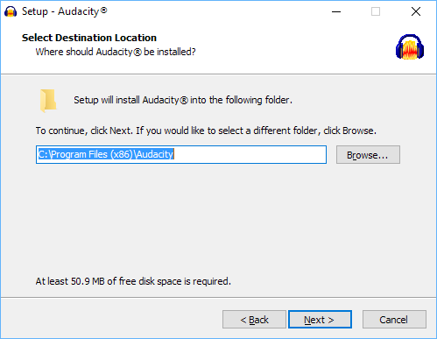

1. The suggested location in which to install Audacity is normally fine, so click **Next**.

You’ll see the **Select Additional Tasks** page:

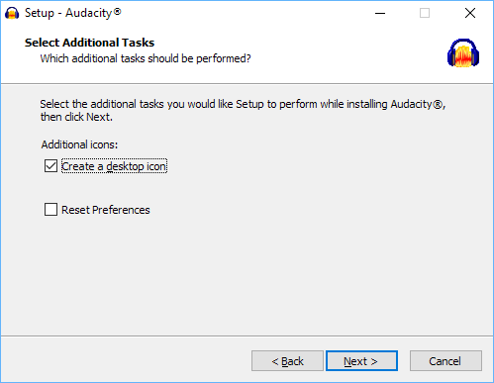

1. Click **Next** to continue.

You’ll then see the **Ready to Install** page:

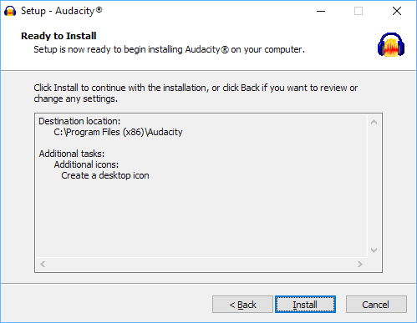

1. Click **Install** to begin the installation.

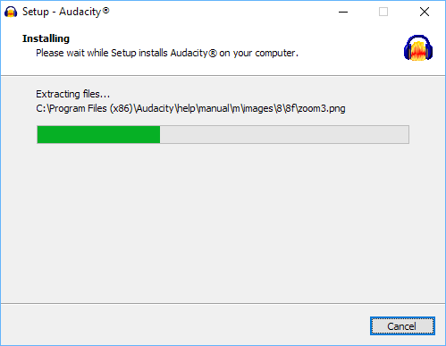

When the installation is complete, you will see a page of information:

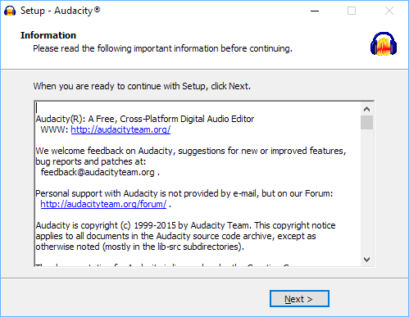

1. Click **Next** to continue.

You will then see the final page of the Setup Wizard:

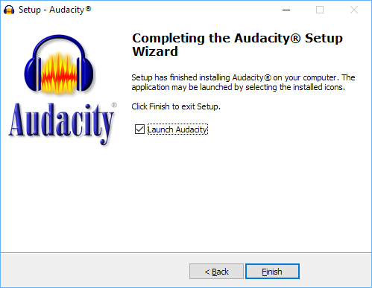

1. Click **Finish** to close the Setup Wizard and launch Audacity.

Audacity is now ready to use.