

Building Apps



Keyboard App Builder: Building Apps

© 2023, SIL International

Last updated: 19 July 2023

You are free to print this manual for personal use and for training workshops.

The latest version is available at

<http://software.sil.org/keyboardappbuilder/resources/>

and on the Help menu of Keyboard App Builder.

**Contents**

1. Preparing content for your app 4

2. How to build your first app 4

3. Installing the app on your phone 6

4. App Creation Basics 10

4.1. How should I choose the app package name? 10

4.2. Do I have to create a new keystore for each app, or can I reuse the same keystore for several of my apps? 11

4.3. Can I build apps when I do not have internet access? 11

5. Home and Setup Screens 11

5.1. Home Screen 11

5.2. Setup Screen 12

6. Navigation Drawer 17

7. Distribution 17

# Preparing content for your app

Before you build an app with Keyboard App Builder (KAB), you need:

* a **Keyman keyboard layout file** (.kmp).

and optionally:

* a **Keyman lexical model file** (.model.kmp), for predictive text and autocorrect.

These files are created using **Keyman Developer** (<https://keyman.com/developer/>).

It is possible to include more than one keyboard layout in a single app.

# How to build your first app

To build your first app with Keyboard App Builder:

1. Launch **Keyboard App Builder** from its icon on the desktop.
2. Click **New App** on the toolbar. The New App wizard will appear.
3. On the first page of the wizard titled **App Name**, specify the **App Name**, such as “Dogon Keyboard”, “Mamara Keyboard”, etc.

This is the main title of your app and will be seen by the user. Do not include underscores or hard to understand abbreviations.

Click **Next** to move to the next page.

1. On the page of the wizard titled **Package**, specify the **Package Name**, a dot-separated string which uniquely identifies your app.

More details about choosing a good package name can be found in section *4.1. How should I choose the app package name?*

Click **Next** to move to the next page.

1. On the next page of the wizard titled **Keyboard**, click **Browse…** and select the Keyman keyboard layout file you want to use in the app.

Click **Next** to move to the next page.

1. On the next page of the wizard titled **Lexical Model**, click **Browse…** and select the Keyman lexical model file you want to use in the app. This is optional; you do not need to specify a lexical model.

Click **Next** to move to the next page.

1. On the page of the wizard titled **Color Scheme**, choose the app color scheme.

Click **Next** to move to the next page.

1. On the page of the wizard titled **Default Interface Language**, choose the language you want users to see when they first enter the app. This can be the current system language.

Click **Next** to move to the next page.

1. On the page of the wizard titled **Interface Languages**, choose the app interface languages that the user can choose between.

Click **Next** to move to the next page.

1. On the page of the wizard titled **Icon**, choose the application launcher icon. You can select one of the images in the table or if you have your own PNG image files for the icon, click **Browse** and select them.

Click **Next** to move to the next page.

1. On the page of the wizard titled **Signing**, you need to specify the keystore and alias to use to sign the app. An app must be signed in this way so that it can installed on an Android device.

If you do not already have a keystore file (which you are unlikely to have if this is your first time using the program):

1. Click **Create KeyStore**.
2. Enter a new filename for the keystore, such as “keystore1” or something like that. Specify a password. Click **Next** to continue.
3. Enter an alias name for a key to create within your new keystore, such as “key”. Specify a password, which can be the same as the password you entered on the previous page. Click **Next** to continue.
4. On the **Certificate Issuer** page, provide details of your organisation in at least one of the fields. Click **Next** to continue.
5. A new keystore will be created for you. Click **Close**.
6. Back on the **Signing** page of the New App wizard, you need to specify the keystore password, select the alias and enter the alias password (just as you entered them in the step above).

Click **Next** to continue.

1. On the page of the wizard titled **Project**, you can enter modify the project name and add an optional description of the app project. Neither of these will be visible to the user of your app. They are just for your own use and might help you distinguish between multiple app projects.

Click **Next** to continue. The New App wizard will close, and the app definition will be added to the tree view on the left of the screen.

1. Take a look at each of the app configuration pages by selecting them in the tree view on the left. Look in each of the tabs on each page to verify that you have the settings you want. You can always go back to them later to change them if you find you need to make modifications to fonts, colors, styles, etc.
2. When you have finished configuring the app, click the **Build Android App** button on the toolbar at the top of the screen.

If something is not configured correctly for the build to work, you will be notified of this.

1. A black command box will appear. Wait about a minute while the app is compiled.

The first time the build process is run, the compiler needs to connect to the internet to download some files. After this, subsequent app builds will not require internet access. See **Tools** ⮚ **Settings…** ⮚ **Build Settings** to turn on offline mode after the first app build.

1. If the build succeeds, you will have a new APK file – the installation file for an Android app.

The next section describes how to copy this APK file to your phone and launch the app.

# Installing the app on your phone

In the above section, you have seen how to compile an Android app. The result is an APK file, the installation file for an Android app. You now need to copy this APK file to your phone, install it and launch the app.

Here is how to do this:

1. Connect your Android phone to your computer using a **USB data cable**.

(Sometimes you get cheap USB cables that can only charge a phone but cannot transfer data, so make sure you have the right kind of cable.)

1. Ensure that **Developer Options** ⮚ **USB Debugging** is enabled on your phone. By default, on new phones, Developer Options is turned off. This is how you can enable it:
   1. Open the **Settings** menu of your phone.
   2. Scroll down to the bottom of the menu and tap on **About Phone**.
   3. Find the **Build Number**. This could be on the About Phone page, or under a sub-menu such as ‘Software Information’.
   4. Tap on the Build Number **seven times**. As you do this, you will see a series of messages appearing: “You are now 3 steps away from being a developer”, “You are now 2 steps away from being a developer”, “You are now 1 step away from being a developer”, “You are now a developer!”.

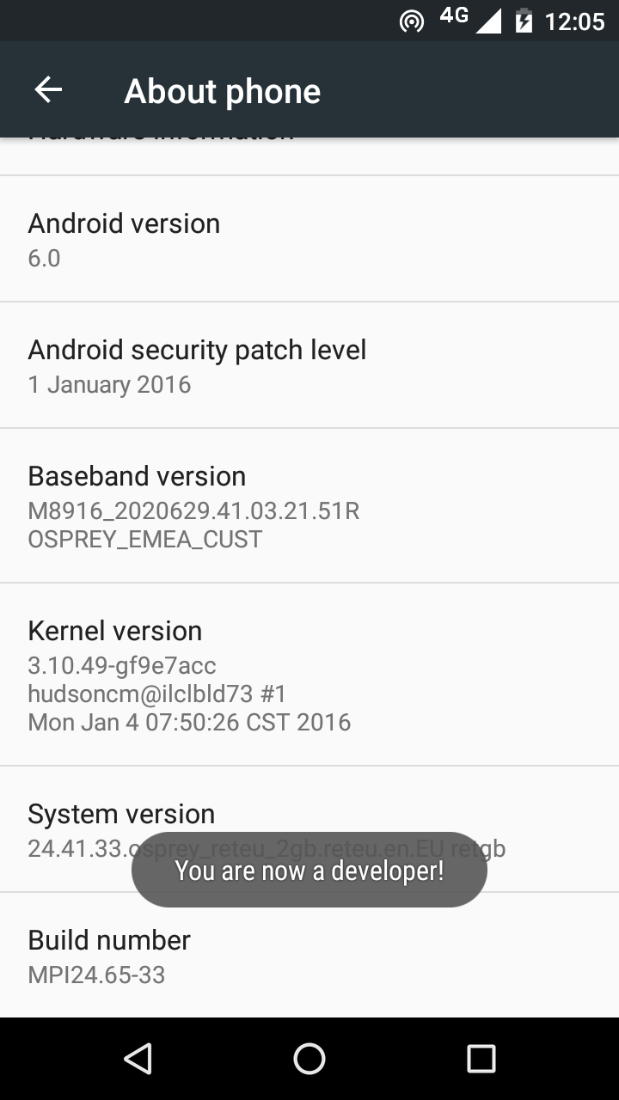

* 1. Now return to the Configuration menu of your phone. Look for the Developer Options menu item. You might see **Developer Options** above the **About Phone** menu item. If you do not see it here, it could be in **System** settings, under **Advanced**. Different phones place Developer Options in different places, so look around your Configuration menu until you find it.

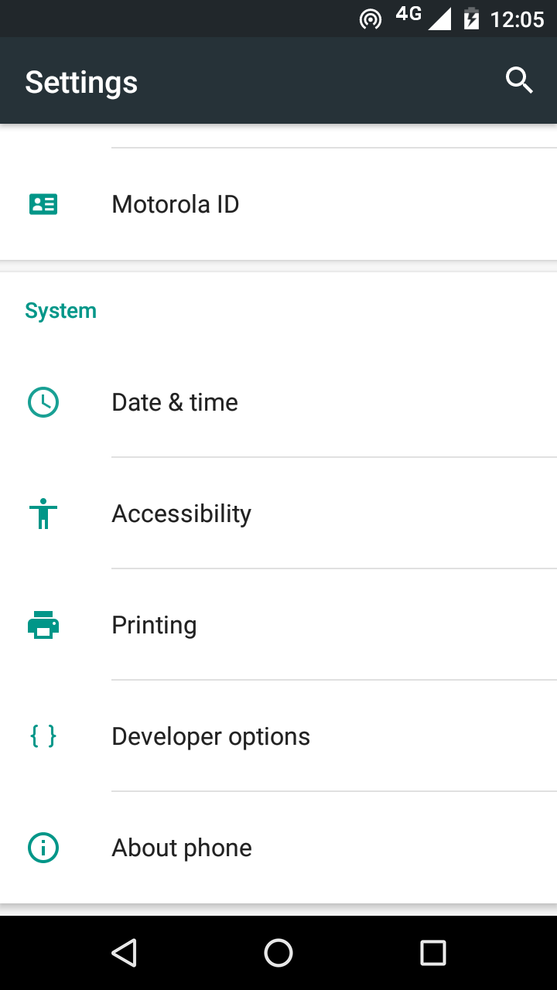

* 1. Tap on **Developer Options** and ensure that it is turned on.
  2. Scroll down the Developer Options page and find **USB Debugging**. Enable this setting.

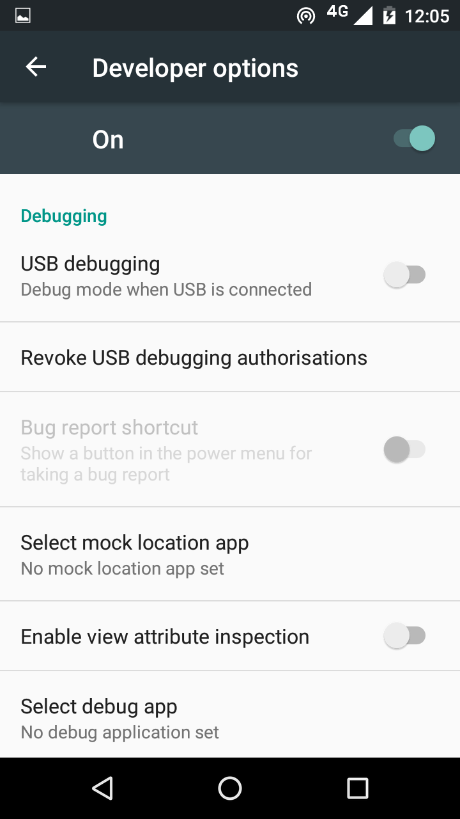

When you do this, you will probably get a message “Allow USB Debugging?”. Tap **OK**.

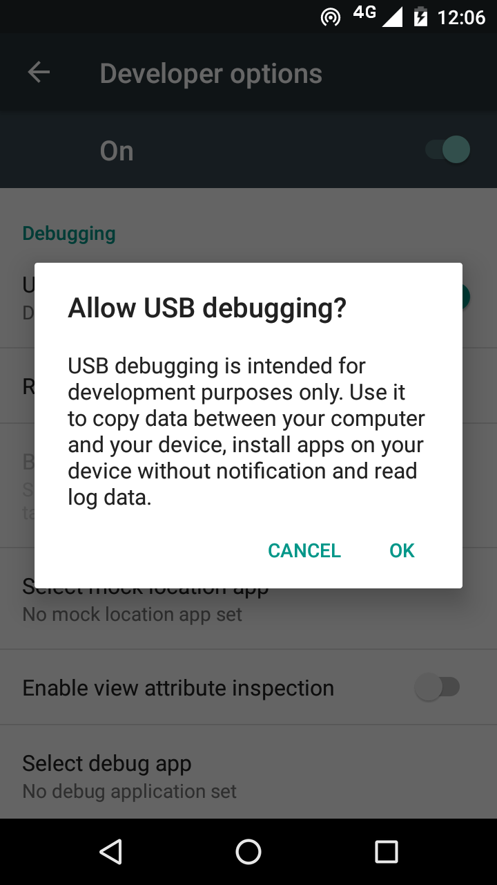

If you see a message box like this, tap **OK**:

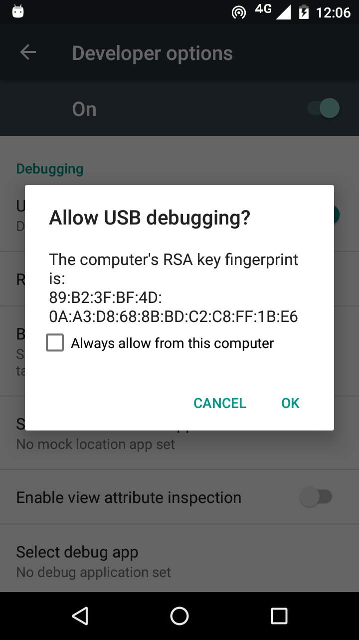

1. In Keyboard App Builder, click the **Install APK** button on the toolbar at the top right of the screen.

A command window will open and the APK file will be copied to your phone, installed and the app will be launched.

If this does not work, look at the command window to see if there is an error message. If you see a message such as “No devices/emulators found”, it means that your phone and computer are not connected correctly or that you have not enabled USB debugging on your phone.

Note:

Described above is a two-step process: **Build App** and then **Install APK**. If you prefer, you can tell Keyboard App Builder to do this in one step, i.e. for the APK to be installed and launched automatically after building an app. See **Tools** ⮚ **Settings…** ⮚ **After Build** to enable this feature.

# App Creation Basics

## How should I choose the app package name?

The standard for an app package name is to begin with the reversed web address of the publishing organisation, e.g. if it is SIL, the package name could begin with:

org.sil

and will be followed by something identifying the language, country, and type of publication, e.g.

org.sil.niger.keyboard

If you work for a university or linguistics organisation, you might have standards to follow for package names, so please contact your digital publications coordinator for advice on this.

Once you publish your app on an app store, you cannot change its package name later if you want users to continue to receive updates. The package name uniquely identifies the app in the Android world. Those who install the app will be able to find its package name on their device. It will also appear in the web address for your app if you make it available on Google Play.

If you are building apps for **test purposes** on your devices, you can use a package name beginning with com.example, e.g.

com.example.test.app123

But remember to change it before you publish the app.

## Do I have to create a new keystore for each app, or can I reuse the same keystore for several of my apps?

You can use the same keystore and key alias for all or several of your apps.

See here for more details:

<http://developer.android.com/tools/publishing/app-signing.html>

## Can I build apps when I do not have internet access?

The first time you build an app, you will need to be connected to the internet otherwise the compiler will fail. After that you can set the 'offline' version in **Settings** so you can work offline.

# Home and Setup Screens

There are two main screens in an app built with Keyboard App Builder:

* the Home screen, and
* the Setup screen.

## Home Screen

The Home screen is shown when the user launches the app. It contains an optional picture at the top, followed by a heading and some introductory text. Below this is the **Set Up Keyboard** button, and then some more text.

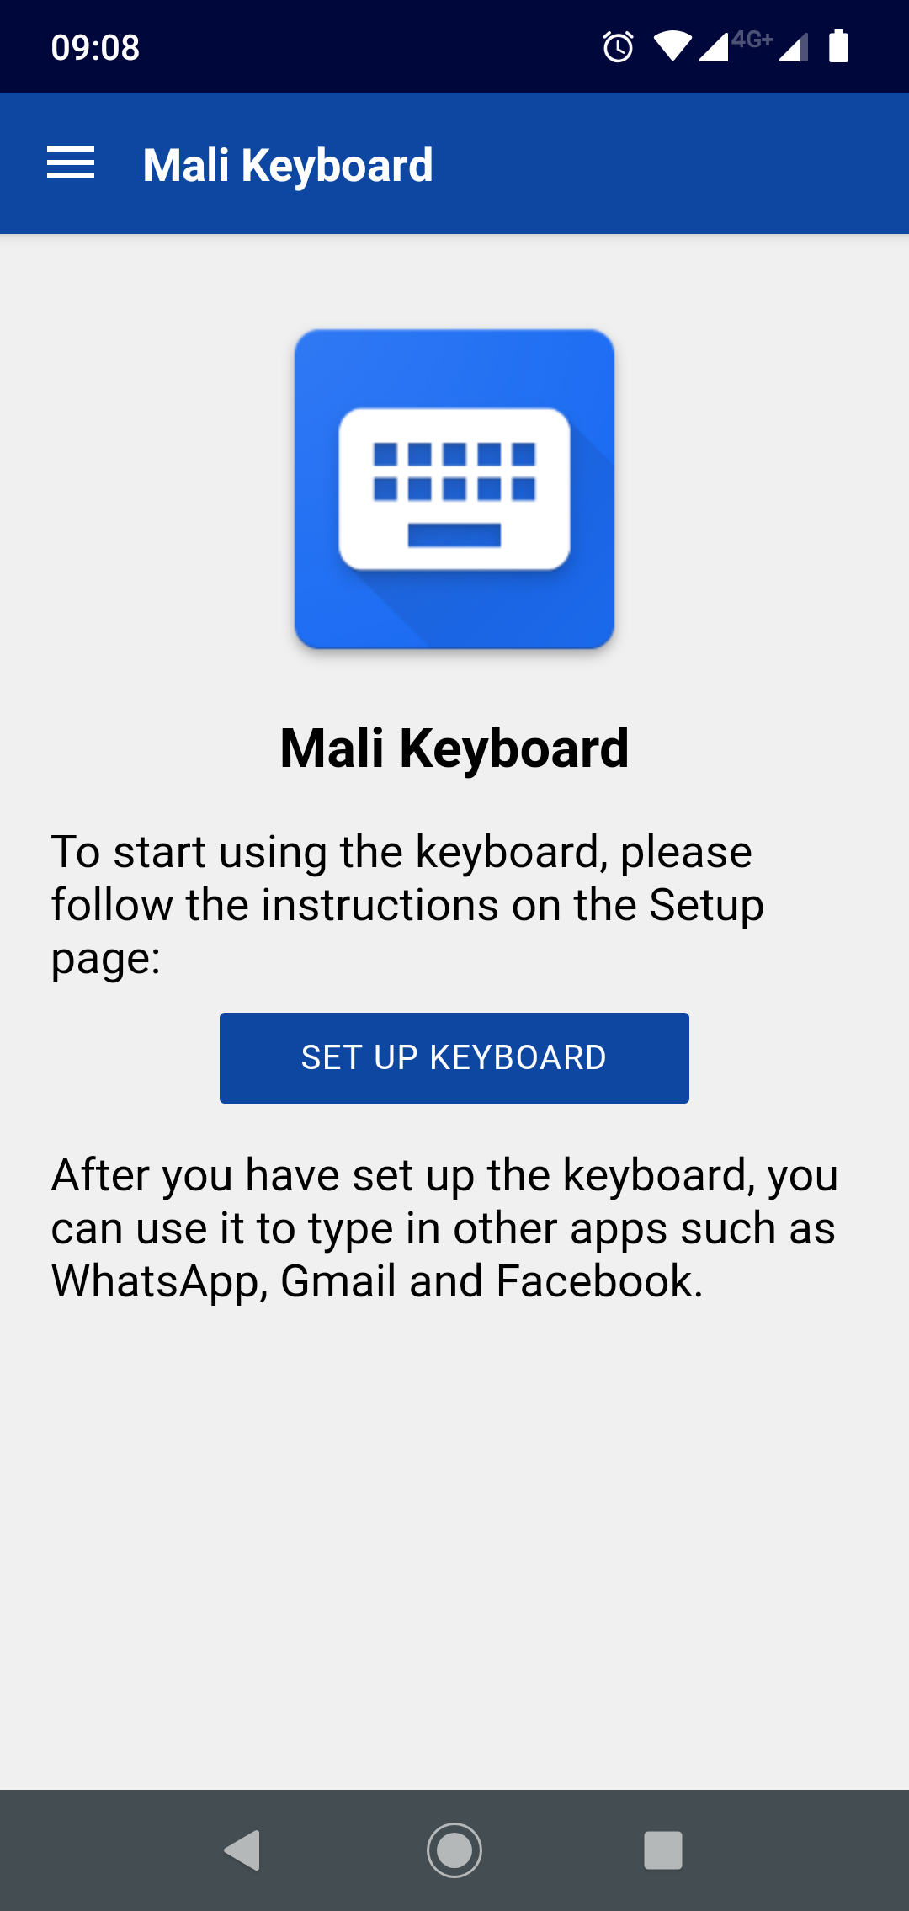

To configure the image and text on the Home screen, select **Screens** from the tree view on the left of the KAB program window and select the **Home Screen** tab. Follow the instructions on the screen.

## Setup Screen

The Setup screen is shown after the user taps the **Set Up Keyboard** button on the Home screen. It contains some introductory text and then two or three steps.

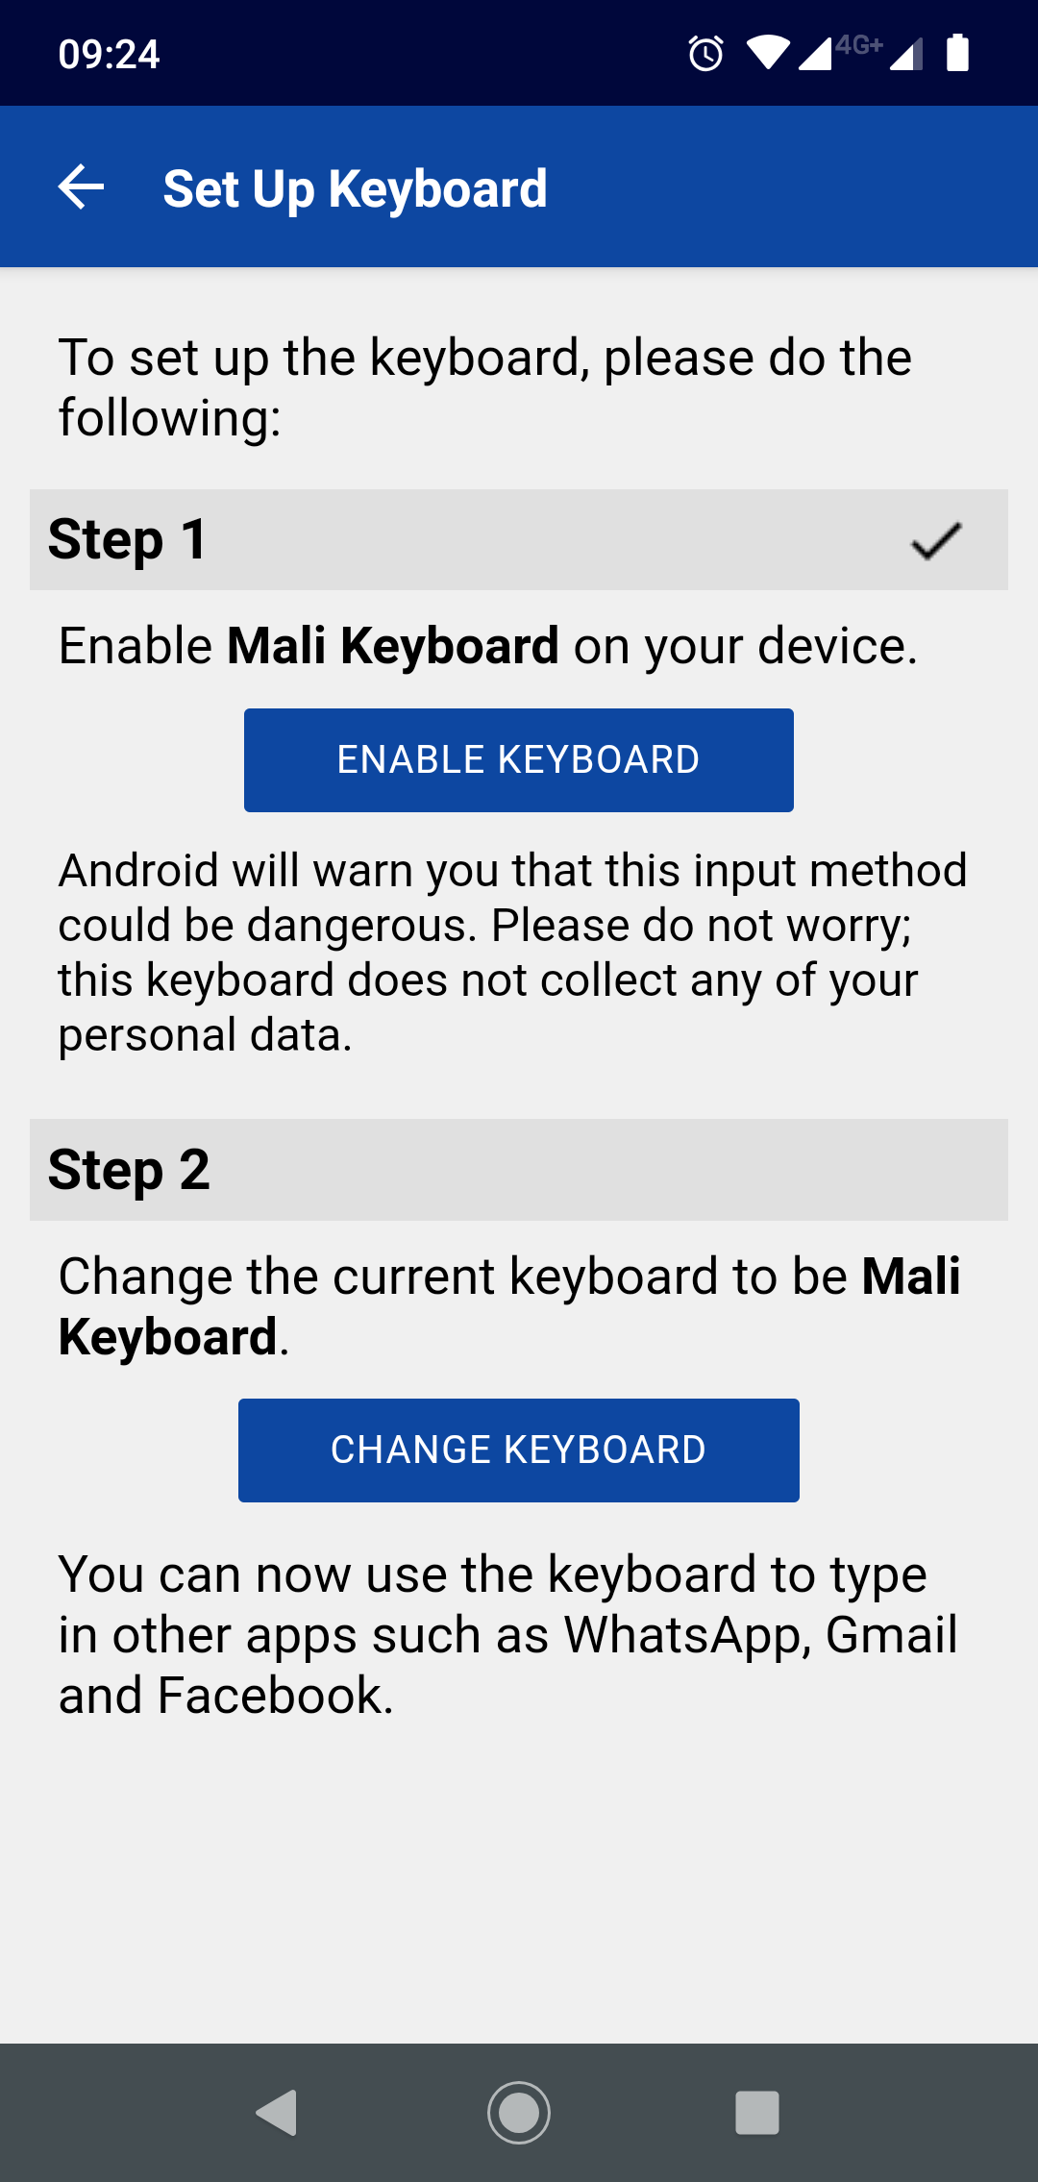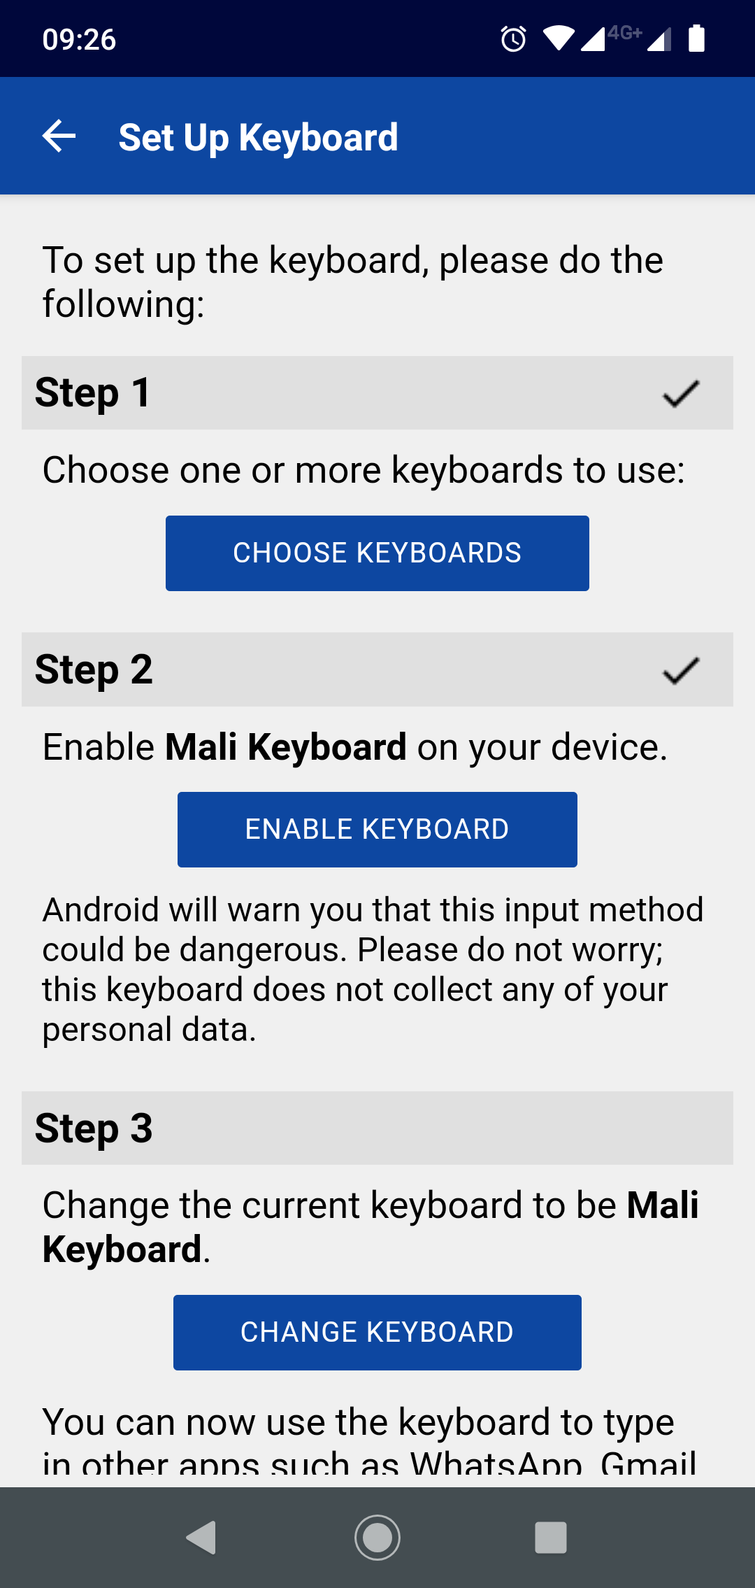

Whether you see two or three steps will depend on how many keyboards you have added to the app:

|  |  |
| --- | --- |
| Only one keyboard layout | More than one keyboard layout |
| **Step 1:** Enable keyboard  **Step 2:** Change keyboard | **Step 1:** Choose keyboard  **Step 2:** Enable keyboard  **Step 3:** Change keyboard |

To configure the image and text on the Setup screen, select **Screens** from the tree view on the left of the KAB program window and select the **Setup Screen** tab. Follow the instructions on the screen.

Choose Keyboard

When the user taps the **Choose Keyboards** button, the Choose Keyboards screen will appear. One or more keyboards should be chosen.

For example, in the image below, the app allows the user to choose between a QWERTY and an AZERTY keyboard layout.

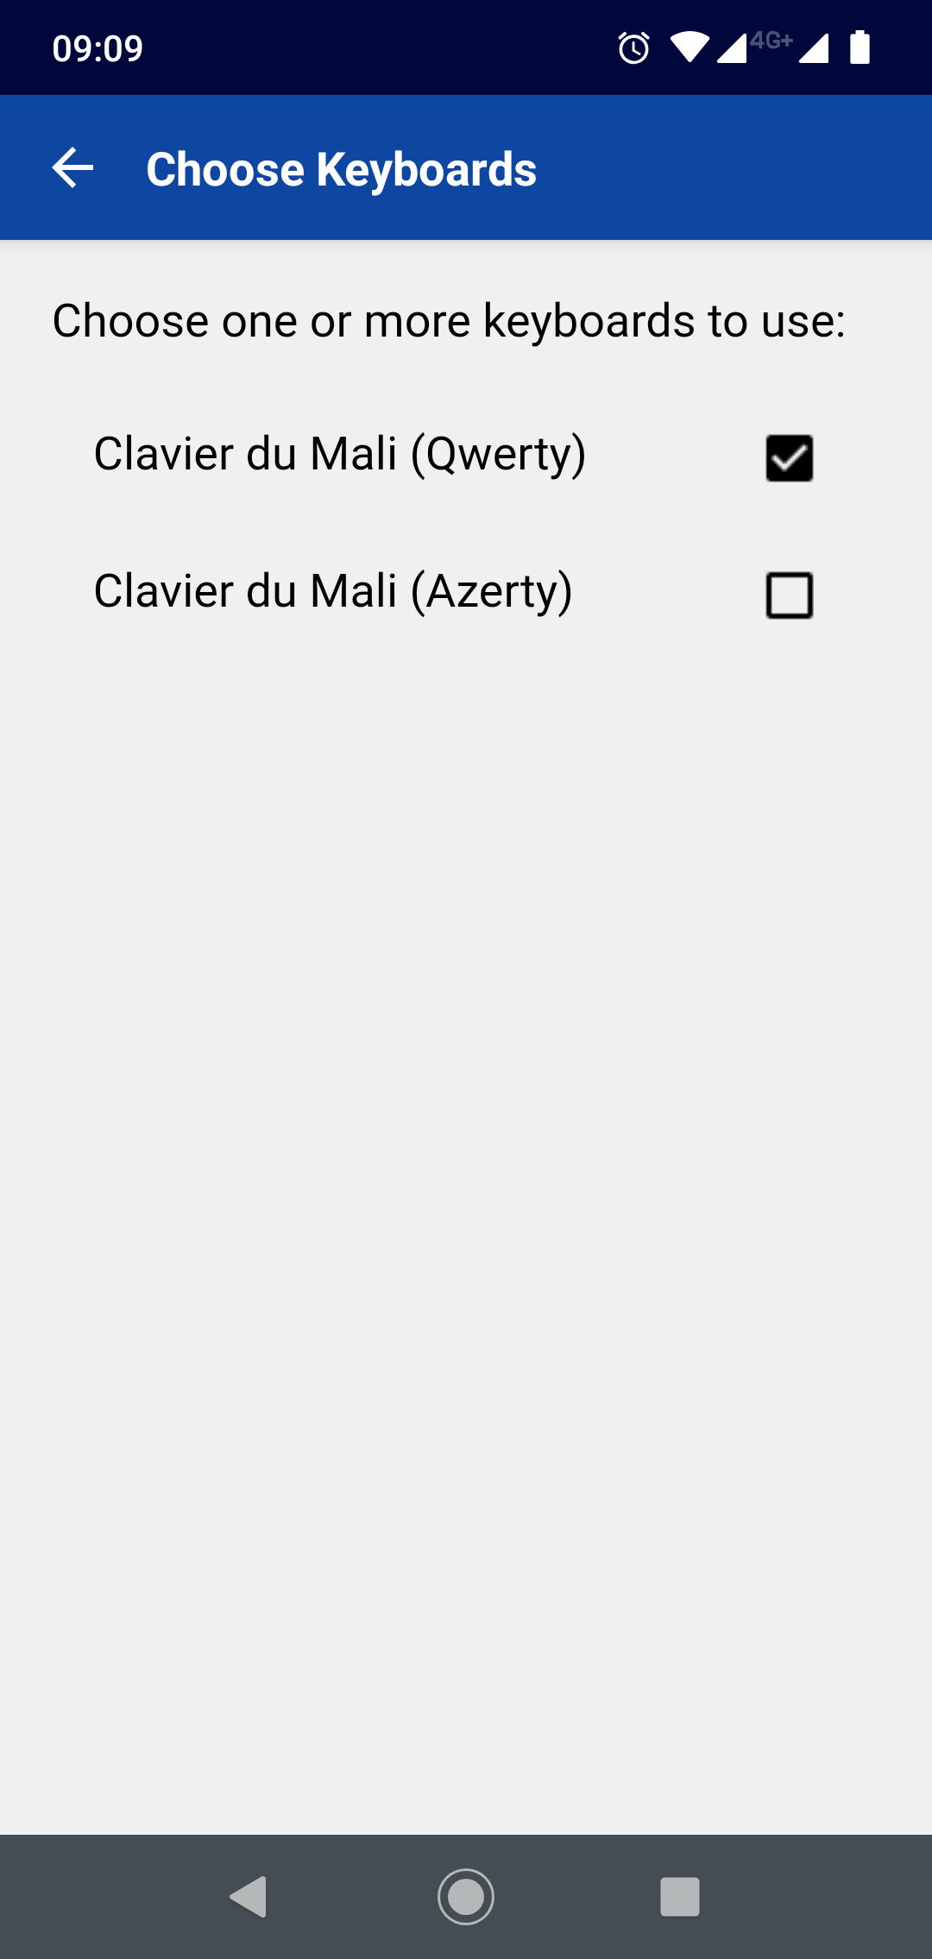

Enable Keyboard

When the user taps the **Enable Keyboard** button, the phone’s **Manage keyboards** screen will appear. They need to tap on the new keyboard to enable it.

When they do this, Android will warn them that this input method could be dangerous. They should not worry: a Keyman keyboard does not collect any personal data.

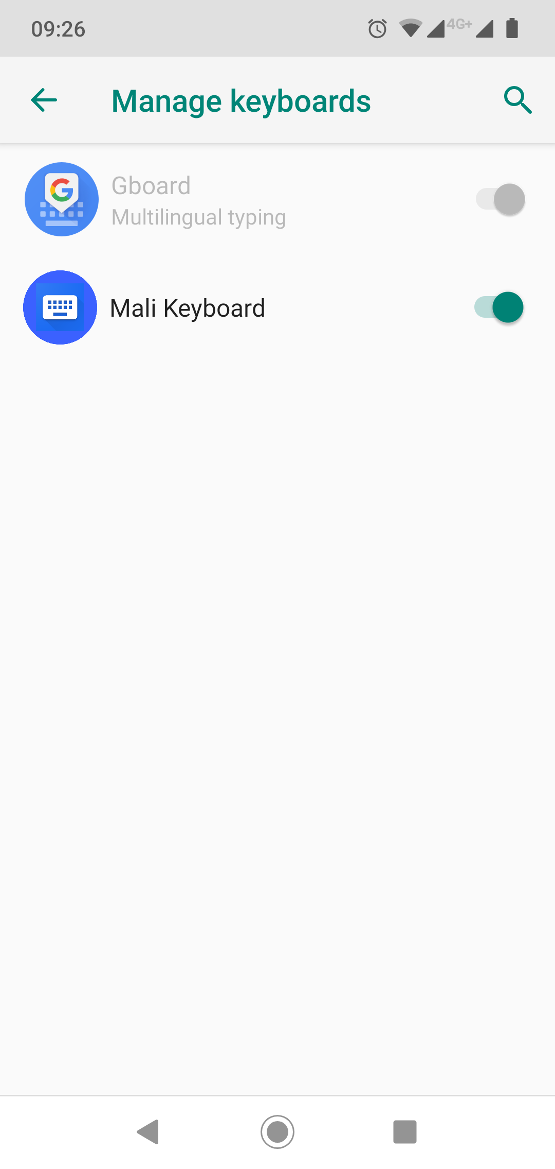

Change Keyboard

When the user taps the **Change Keyboard** button, the phone’s **Change Keyboard** dialog box will appear. They need to tap on the new keyboard to make it the current one.

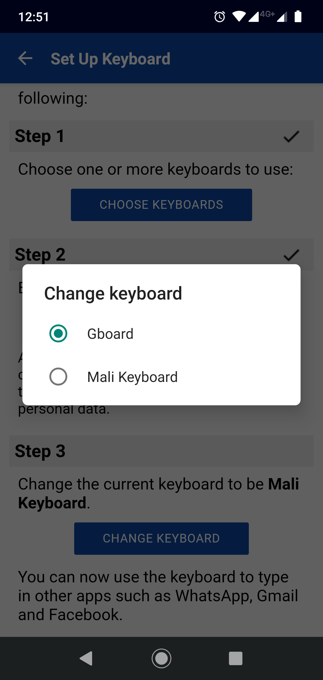

After completing each of the two or three steps, the keyboard is ready to be used in other apps such as WhatsApp, Gmail and Facebook.

# Navigation Drawer

You can customise the image that appears at the top of the navigation drawer. It can be a photo, your organisation’s logo or any relevant graphic design.

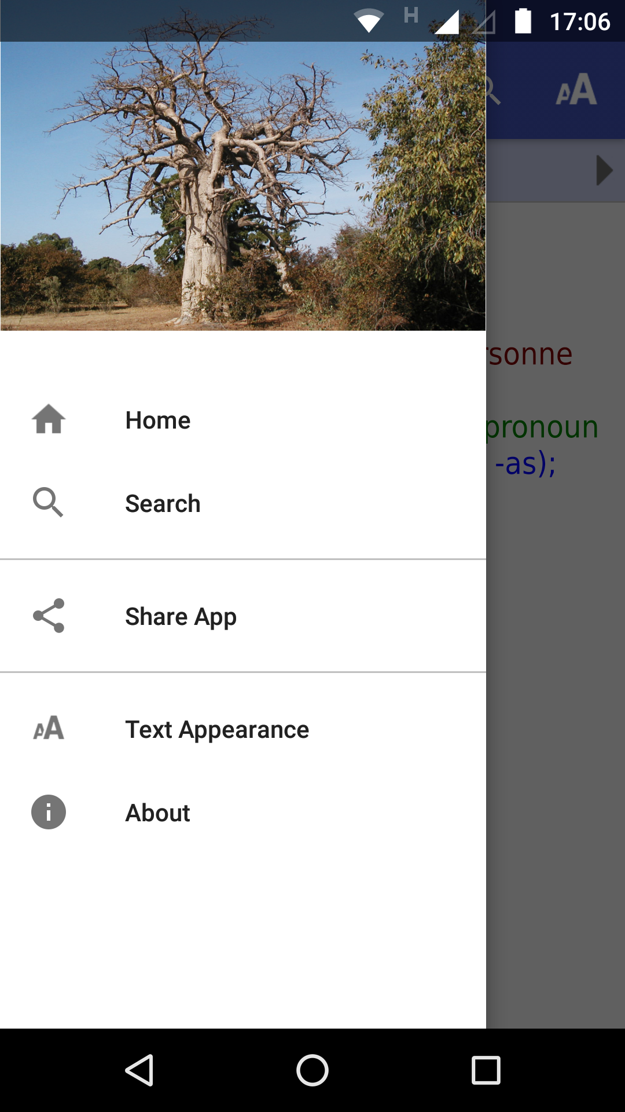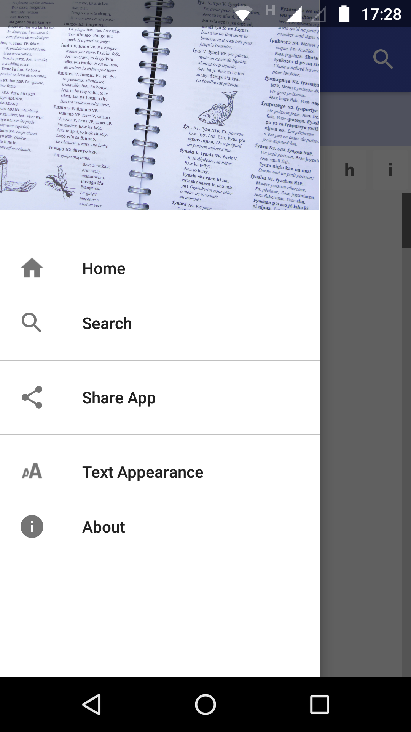

Specify a landscape image file on the **Appearance** ⮚ **Graphics** ⮚ **Navigation Drawer** page.

# Distribution

Android apps built with Keyboard App Builder can be published on the Google Play store, distributed on memory cards, shared by Bluetooth or Wi-Fi transfer, uploaded to websites, or sent out by email.

For more information, please see the user manual: *Distributing Apps*.