

Using HearThis   
for Audio Recording



Last updated: 15 August 2016

**Contents**

1. Introducing HearThis 3

2. Installing HearThis 3

3. Setting up your microphone and recording environment 5

3.1. Prepare your room to be a recording studio 5

3.2. Choose a good microphone 5

3.3. Set up the microphone to be the recording device on your computer 5

4. Recording audio with HearThis 6

4.1. The HearThis screen 6

4.2. Choose the Paratext project 6

4.3. Choose the book and chapter to record 7

4.4. Choose the parts of the text you want to record 8

4.5. Recording the selected chapter 9

5. Publishing audio for use in Scripture App Builder 11

6. Listen to your audio and make any edits if necessary 13

6.1. Listening for errors 13

6.2. Editing audio files using Audacity 13

7. Using HearThis generated files in Scripture App Builder 15

# Introducing HearThis

HearThis provides a do-it-yourself alternative for communities wanting to get translated Scripture text into audio form. It is designed to make Bible recording easy!



HearThis automatically finds your Paratext translations and walks you through recording it, one bit at a time. Not a great reader? Need to read it again? Just press on the record button and try again, until you get it right. Then click the arrow, and see the next thing you need to read.

HearThis can produce all the files needed for adding audio when using Scripture App Builder – including the timing files for audio-text synchronization.

# Installing HearThis

To install HearThis on your computer, do the following:

1. Go to the HearThis website, <http://software.sil.org/hearthis>, select the **Download** page, and download HearThis.

The filename is of the form: **HearThisInstaller-1.x.x.msi**

1. Double-click the installer after it has downloaded and follow the instructions in the Setup wizard.

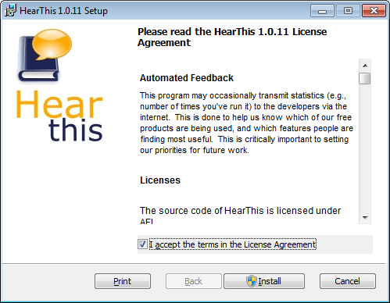

1. To enable HearThis to write its output as MP3 files, you need to install an additional plug-in called **Lame**. (If you use the sound editor Audacity, it is possible that you already have Lame installed.)

Download the latest Lame installation program from the Lame website:   
  
 [**http://lame.buanzo.org**](http://lame.buanzo.org)

Look for the file under the sub-heading **‘TO DOWNLOAD Lame and FFmpeg for Windows’**.

The filename to download will be called something like:

Lame_v3.99.3_for_Windows.exe

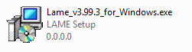

It might be that a newer version than 3.99.3 is available. If so, download this newer version instead. This should be a quick download since the file is small (around 500 KB).

Double-click this downloaded .exe file to start the installation and follow the instructions in the Setup Wizard.

# Setting up your microphone and recording environment

## Prepare your room to be a recording studio

Choose a place to record which is quiet and where you will receive few interruptions. To dampen the echo in a small office, you could place foam mattresses and blankets around the room.

Turn off any fans or any noisy air-conditioning units. Keep away from fridges or ticking clocks. Avoid tapping your feet or swaying from side to side on a squeaky chair!

## Choose a good microphone

HearThis will work with any microphone, whether it is the in-built microphone in your laptop computer, a headset microphone or a professional quality external microphone.

For a good quality recording, you will want to reduce background noise. For this reason, it is best not to use the internal microphone in your computer. It picks up too much computer noise. If you are going to do serious recording work, it is worth investing in a good microphone. In general, the more you spend on a microphone, the better the quality of the audio recording.

Do not hold the microphone in your hand. Instead put it on a stand or use a good quality headset microphone.

## Set up the microphone to be the recording device on your computer

Attach the microphone to your computer and ensure it is selected as the main recording device. If you don’t do this properly, you might find that your computer still uses the internal microphone rather than the external one.

To modify the recording device to use, right-click on the Speaker/Volume icon at the bottom right of your computer screen and select **Recording devices**. Here you can enable and disable devices.

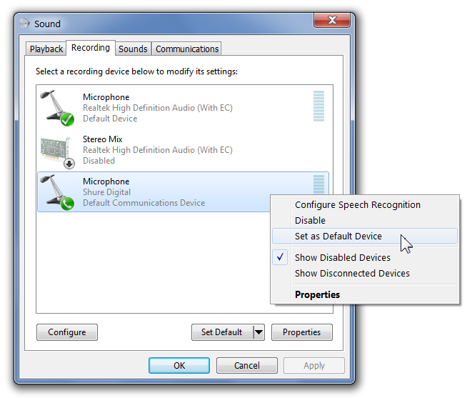

# Recording audio with HearThis

## The HearThis screen

The main HearThis screen presents you with all the controls you need to select books and chapters and to record phrases.

Publish Sound Files

Choose Paratext Project

Book selector

Chapter selector

Current phrase to record

Play, Record   
and Next buttons

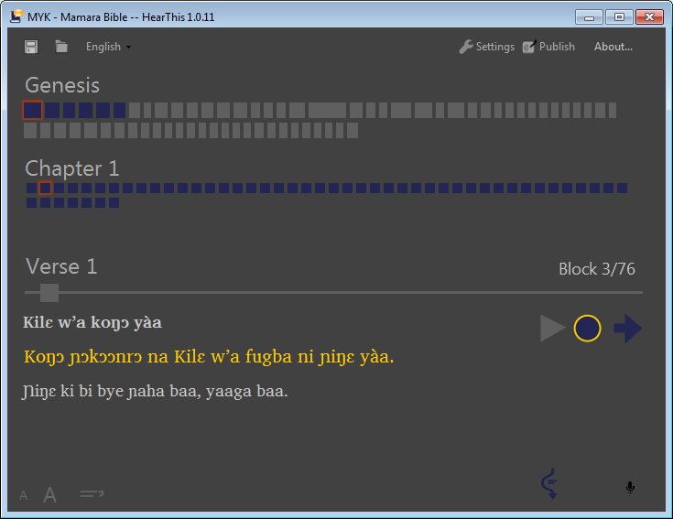

Input microphone level

Font size: make text smaller or larger

Use the font size buttons on the bottom left of the screen to adjust the text size so it will be easy to read.

The top left button is a **Save** button, but it does nothing. Your recordings are saved automatically. Clicking the Save button will remind you of this.

## Choose the Paratext project

When you start HearThis for the first time, you will be asked to select a Paratext project.



If you are already on the main HearThis screen, click the **Choose Paratext Project** button at the top left of the screen to select the project you want to record.

## Choose the book and chapter to record

You can select the book and chapter to record by clicking on the appropriate blue or gray boxes at the top of the screen.

Books



Chapters

The top set of boxes represents the books of the Bible, with Old Testament books on the first line of boxes and New Testament books on the second line of boxes. Genesis is the first box on the first line and Revelation is the final box on the second line.

The second set of boxes represents the chapters in the selected book. If the book has an introduction, it is the first box. Then comes chapter 1, 2, 3, etc.

## Choose the parts of the text you want to record

Before you start recording you need to decide which parts of the text you want to record. For example, some people like to record the section headings in a Scripture text but other people prefer to omit them and just read the verses.

Section headings are very useful in a printed text, but there are some cases in which they could be less useful in an audio recording. For example:

* where section headings are complete phrases that might sound like they are part of the Scripture text, yet out of order;
* where section headings give away the punch line of the story before the story is told, e.g. “Jesus calms the storm”. You might want new hearers to be drawn into the drama of the story without knowing already how it ends.

To choose the markers to include or omit:

1. Click the **Settings** button on the top right of the HearThis screen (the one with the spanner icon).
2. Check the styles that you want to omit from the recording.

For example, in the screen below, we have checked “s – Heading” which means not to record section headings.

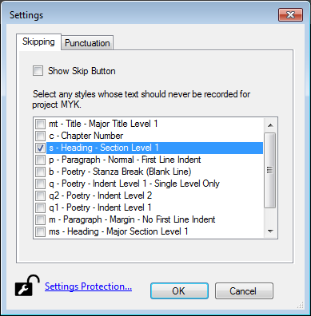

1. Click **OK** to save your selected settings.

## Recording the selected chapter

The phrases you need to record are displayed in the bottom half of the screen:

* The current phrase to record is displayed in YELLOW.
* The phrases displayed in WHITE show you the context of the current phrase, i.e. the phrases that come before and after it.

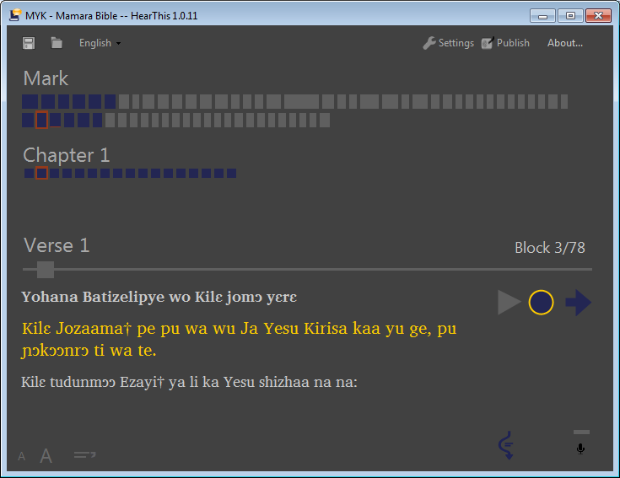

The text in yellow is the current phrase to be recorded.

To start recording the current yellow phrase, either:

* press and hold down the SPACE bar, or
* click the round record button and keep the mouse button pressed down.



The round button is the Record button. Press it and hold it down to record.

When recording starts, the round button will first turn RED and after a second it will turn GREEN. Do not speak until you see the GREEN, otherwise the first part of what you say will be cut off.



The Record button turns red when you first press it.



After a second of holding down the button, it turns green indicating that you can begin speaking.

When you have finished speaking, release the space bar or mouse button. Try to do this as quietly as possible so you don’t get a click in the recording.

To listen to the phrase you have just recorded, either:

* click on the PLAY button, or
* press the . (period) key.

Do you like what you have recorded?

* If yes, continue to the next phrase by clicking the Right arrow or using the right arrow key.
* If no, rerecord the same phrase by clicking on the record button again. Your previous recording of this phrase will be deleted.

Follow these steps for each phrase in the chapter.

You don’t need to listen to each phase after recording it unless you want to. Listening to a recorded phrase can be helpful if you are not sure whether or not you were fluent enough or whether you pronounced all the words with the right expression.

As you record each verse you will see a small horizontal blue line appear the Verse selector. To go back to a verse, click on one of these blue lines.

Verses already recorded



# Publishing audio for use in Scripture App Builder

HearThis records each phrase in a separate file. In order for your recording to be usable by Scripture App Builder, you need to “publish” the recording. In the publishing process, HearThis will do two things:

1. It will concatenate all the recorded phrases together in separate MP3 audio files for each chapter.
2. It will create timing files for each chapter, the files that Scripture App Builder needs for the audio-text synchronization.

To publish your recorded audio files for Scripture App Builder:

1. Click the **Publish** button at the top right of the HearThis screen.

The Publish Sound Files window will appear.

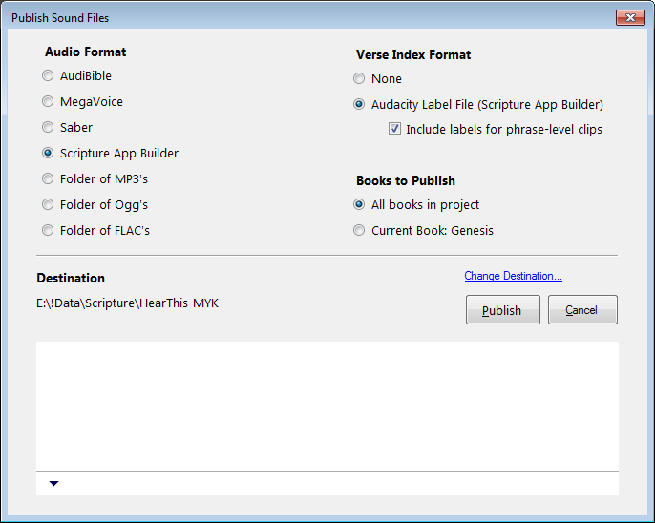

1. For Audio Format, choose **Scripture App Builder**.
2. For Verse Index Format, choose **Audacity Label File (Scripture App Builder)** and check the box **Include labels for phrase-level clips**.
3. Click the **Publish** button.

HearThis will work on joining the recorded audio clips together and producing the timing files for audio-text synchronization.

1. When the process is completed, you should see “Done” in the message box and a link to the output files in the Destination folder. Click on the Destination link to see the files.

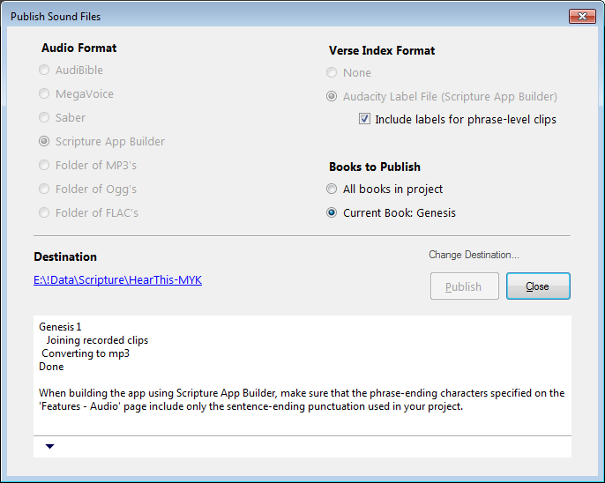

1. Use Windows Explorer to look in the output folders. You should see two files for each chapter:
   * the **audio MP3 file**, with a name such as XYZ-GEN-001.mp3, where XYZ is the Paratext project code and GEN is the code for the book of the Bible, in this case Genesis.
   * the corresponding **timing file**, with a name such as XYZ-GEN-001.txt.

These are the files you need to add to you app project within Scripture App Builder. See the next sections for more details.

# Listen to your audio and make any edits if necessary

## Listening for errors

After HearThis has generated the audio files for each chapter, it is a good idea to play them and listen carefully to check that there are no problems. The best way of doing this is to wear headphones so you can pick up any unwanted sounds that you might not be able to hear through your computer speakers.

To play an MP3 audio file on your computer:

1. Select the file you want to play in Windows Explorer.
2. Double-click it to play it with your default Media Player.

It is often the case that you will find some small edits you need to make before you can make the audio available to others.

* If the edits are **errors in reading to correct**, it is probably best to go back to HearThis, find the phrase which was read incorrectly and re-record it. After this, follow the process in section 5 (Publishing audio for use in Scripture App Builder) to produce the MP3 files again.
* If the edits are **short background noises** **to remove** or if you want to **make pauses between phrases longer or shorter** you might be able to make these changes in the Audacity audio editing program without re-recording anything. But if you hear short background noises at the same time as someone is speaking (such as dogs barking, doors slamming), it would be best to go back to HearThis and re-record the affected sections.

## Editing audio files using Audacity

To edit files generated by HearThis in Audacity:

1. Launch **Audacity**. If you don’t already have it installed on your computer you can download it here:

<http://www.audacityteam.org>



1. Select **File** ⮚ **Open…** on the main menu and find the audio MP3 file you want to edit. Click **Open** when you have selected the filename.

The audio file will be loaded into Audacity.

1. Select **File** ⮚ **Import Labels…** and select and import the corresponding timing text (.txt) file. For example, if you are editing XYZ-GEN-001.mp3, you want to import the labels file XYZ-GEN-001.txt.

It is important that you edit the MP3 file and its corresponding timing text file together. Otherwise the timing file will get out of synch with any changes you make to the audio.

1. Make sure **Tracks** ⮚ **Sync-Lock Tracks** is selected. This will ensure that the audio and label tracks are locked together and that when you delete a section from the audio track, a corresponding section is deleted from the label track. Or when you add a section to the audio track, a corresponding section is added to the label track.
2. Make the edits you need to, e.g. deleting clicks, adjusting the length of pauses, etc.

When you have finished editing remember to export both the audio and timings files:

1. Export the audio file, using **File** ⮚ **Export Audio…**, choosing to Save as type **MP3 Files**.
2. Export the timing labels file, using **File** ⮚ **Export Labels…**

If you are new to Audacity, a free manual for beginners can be found here:

How to do Recording on your Computer: A Beginner's Guide to Audacity

<http://www.scripture-engagement.org/content/how-do-recording-your-computer>

# Using HearThis generated files in Scripture App Builder

To use the audio MP3 and timing files from HearThis to build an app in Scripture App Builder, do the following:

1. Create a new app project in Scripture App Builder or open an existing app project.
2. Ensure the project contains the Scripture books you need.
3. Go to the **Audio Files** page of the book collection.
4. Click the **Add Audio…** button and select all of the audio and timing files from the HearThis output, i.e. the MP3 and the TXT files.

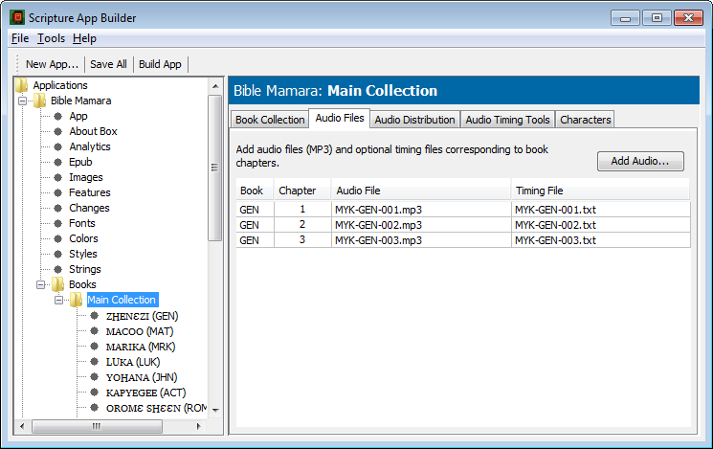

1. Go to the **Audio Distribution** page of the book collection and choose the method of distributing the audio. The default is “Package inside the APK file”.
2. Go to the **Features** ⮚ **Audio page** and specify the phrase-ending characters to correspond to the phrase-ending characters HearThis used.   
     
   Important: By default HearThis uses sentence-ending characters (full stop/period, question mark, exclamation mark), but it does not split phrases by commas in the middle of sentences. So you will need to delete the comma if it you see it on the SAB features page – otherwise your text and audio will not be synchronized correctly.

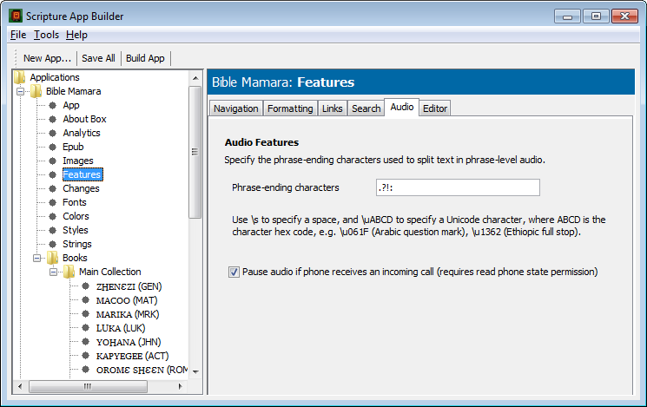

1. Build your app and try it out!