

Distributing Apps



Dictionary App Builder: Distributing Apps

© 2021, SIL International

Last updated: 04 August 2021

You are free to print this manual for personal use and for training workshops.

The latest version is available at

<http://software.sil.org/dictionaryappbuilder/resources/>

and on the Help menu of Dictionary App Builder.

**Contents**

1. Introduction 4

1.1. Distribution options for Android apps 4

1.2. Distribution options for iOS apps 5

1.3. Advantages and disadvantages of each distribution method 6

2. Publishing apps on Google Play 8

3. Distributing apps by memory card 12

4. Sharing apps by Bluetooth 13

5. Sharing apps by Wi-Fi transfer 13

# Introduction

## Distribution options for Android apps

There are several possible ways of transferring Android apps to a smartphone. These include both online and offline options:

Online distribution

|  |  |  |
| --- | --- | --- |
| Google Play Icon - Free vector graphic on Pixabay | Google Play | Publish the app on [Google Play](http://play.google.com/) for people to find and download. This is where most Android apps are distributed. |
|  | Web Sites | Post the app installation file (APK) on your website for people to find and download. Once people have downloaded the file, they tap on it to install it. |
|  | Dropbox, Google Drive, etc. | Upload the app installation file (APK) to a folder in a cloud storage service (such as Dropbox or Google Drive). Share the link with others. Once people have downloaded the file, they tap on it to install it. |
| Amazon.com: Amazon Appstore: Appstore for Android | Amazon Appstore | Publish the app on the [Amazon Appstore](https://www.amazon.com/appstore) for people to find and download. |

Offline distribution

|  |  |  |
| --- | --- | --- |
|  | Memory cards | Copy the app installation file (APK) onto microSD memory cards. People insert the card into their phone’s memory card slot, find the APK file using a file explorer app and tap on the file to install it. |
|  | Bluetooth | Use Bluetooth to transfer the app from your phone to another phone. Once people receive the app installation file (APK) they tap on it to install it. |
|  | Wi-Fi Transfer App | Transfer the app from phone to phone, like Bluetooth but much faster. Both sender and receiver phones need the same app installed, e.g. [Xender](https://play.google.com/store/apps/details?id=cn.xender&hl=en&gl=US), [SHAREit](http://shareit.lenovo.com/) or [SHAREit Lite](https://play.google.com/store/apps/details?id=shareit.lite&hl=en&gl=US). |
| LIGHTSTREAM WIFI HOTSPOT | Renew Outreach | **Wi-Fi Media Box** (LightStream, ConnectBox, MicroPi, etc.) | Copy the app installation file (APK) into the memory of a Wi-Fi media box, such as the [LightStream](https://renewoutreach.org/equipment/lightstream-wifi-hotspot/), [ConnectBox](https://connectbox.technology/wp/) or [MicroPi](https://sites.google.com/sil.org/micropi). Users connect to the Wi-Fi device and choose the file to transfer to their phone. Once the file arrives, they tap on it to install it. |

## Distribution options for iOS apps

For iOS apps, your main option for app distribution is the Apple App Store. You cannot distribute iOS apps from phone to phone offline.

|  |  |  |
| --- | --- | --- |
|  | Apple App Store | Publish the app on the Apple App Store for people to find and download. This is where all iOS apps are distributed. |

When you are testing your iOS app, it is possible to share it with a limited number of known devices. For more details on how to do this, please see the documentation on *Installing and Building on a Mac*.

## Advantages and disadvantages of each distribution method

The following table lists some of the advantages and disadvantages of each distribution method.

|  |  |  |
| --- | --- | --- |
|  | Advantages | Disadvantages |
| Google Play | Users can find the app by searching on the app store.  If you update the app, users will receive updates automatically next time they have an internet connection. | Requires an internet connection.  If you are uploading the app to Google Play yourself, you need to create a developer account ($25 one-time fee) and learn the publishing process.  The maximum Android App Bundle (AAB) size is 150 MB.  Audio files will often need to be hosted online and so it will cost the user for each chapter of audio they choose to download or stream.  When an app is installed from Google Play, it will be trimmed and repackaged for the user’s specific device. This means that if you want to share it offline with a friend it might not contain all that their device needs. |
| Memory cards  (microSD) | No internet connection needed.  No restriction on app file size: you can distribute hundreds of MB of audio files packaged inside the app. | Users have to remove their current memory card in order to insert the new one, then copy files from one memory card to the other.  When you update the app on Google Play, users who installed from a memory card will not get automatic updates.  You need a sales/distribution strategy to get the memory cards to people. |
| Bluetooth | No internet connection needed.  Allows friends to share the app with each other and encourages viral distribution. | When you update the app on Google Play, users who installed by Bluetooth will not get automatic updates.  A slow method if you have a lot of audio files to transfer. |
| Wi-Fi Transfer  (e.g. with the Xender or SHAREit apps) | No internet connection needed.  Up to 40 times faster than Bluetooth.  Allows friends to share the app with each other and encourages viral distribution.  No restriction on app file size: you can distribute hundreds of MB of audio files and images packaged inside the app. | Both phones need the Wi-Fi transfer app installed.  When you update the app on Google Play, users who installed by Wi-Fi transfer will not get automatic updates. |
| Website download | No restriction on app file size: you can distribute hundreds of MB of audio files and images packaged inside the app. You are not limited to a maximum app size of 150 MB like you would if you published it on Google Play. | Requires an internet connection.  When you update the app on Google Play, users who downloaded the app from a website will not get automatic updates. |
| Email | Allows you to share new apps with specific people. | Not recommended if your APK size is over 5 MB.  Requires an internet connection.  When you update the app on Google Play, users will not get automatic updates so you will need to email the latest version. |
| Cloud Storage  (Dropbox, Google Drive, etc.) | No restriction on app file size: you can distribute hundreds of MB of audio files and images packaged inside the app. You are not limited to a maximum app size of 150 MB like you would if you published it on Google Play. | Requires an internet connection.  When you update the app, users who receive the app via Dropbox will not get automatic updates. |
| **Wi-Fi Media Box** (LightStream, ConnectBox, MicroPi, etc.) | No internet connection needed. | Requires specialist equipment, not always available locally.  When you update the app on Google Play, users who downloaded the app from a Wi-Fi media box like Lightstream will not get automatic updates. |

# Publishing apps on Google Play

To publish an Android app on Google Play:

1. Select **Build** ⮚ **Build Android App Bundle** from the menu in Dictionary App Builder to build an **Android App Bundle** (an .aab file).

This is a different format from the APK file that you use for offline distribution.

To publish your app on Google Play, the AAB file size must be no more than 150 MB.

1. Go to the **Google Play Console**:

<https://play.google.com/apps/publish>

1. Create a new account or login with an existing Google account.

If this is the first time you do this, there is a one-time fee of USD $25 to create a Google Play developer account.

Note: If you are publishing an app on behalf of an organisation rather than you personally, we strongly recommend you create a new Google account for this purpose rather than using your personal Gmail account.

1. Click the **Create app** button at the top right of the screen.
2. Enter the **App name** and the **default language**. Specify **App** (rather than Game) and Free (rather than **Paid**).

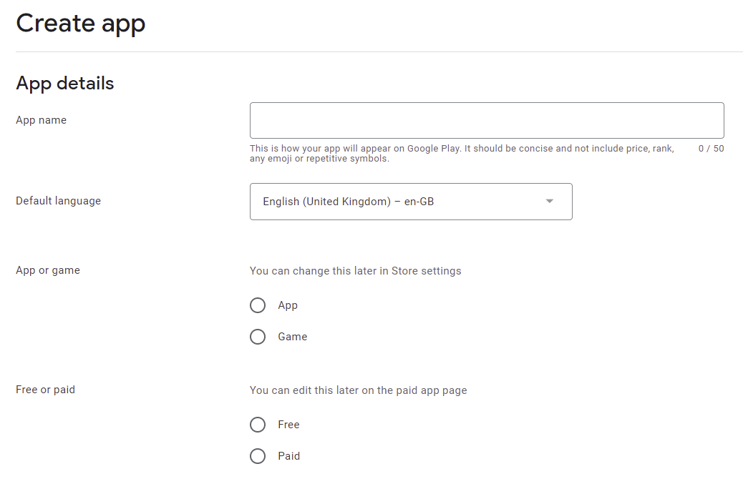

1. Read and check the declarations to confirm that the app meets the terms and conditions.
2. Click **Create app** at the bottom of the page.
3. Select **Grow** ⮚ **Store presence** ⮚ **Main store listing** from the menu on the left of the screen, and enter the following details:

App Details

* **Short description** of the app (up to 80 characters)
* **Full description** of the app (up to 4,000 characters)
  + These descriptions should describe the app clearly to the target audience in the most appropriate language(s). Mention the country and alternative language names to increase the chance of users finding the app when they search on Google Play.

Google encourages you to “highlight what's great about your app. Share interesting and exciting facts about your app to help users understand what makes your app special.”

You must not include user testimonials, excessive details or long lists of keywords. See <https://play.google.com/about/storelisting-promotional/metadata/> for more details.

Graphics

* **App icon** (512 by 512 pixels)
  + This should be the same as the app icon but a higher resolution 512 x 512 version. Ensure it is clear and not blurred, i.e. it might not work well to take a 144 x 144 icon and stretch it to 512 x 512.
* **Feature graphic** (1024 by 500 pixels)
  + The feature graphic is displayed at the top of your store listing page in the Play Store app. Do not include any copy or important visual information near the borders of the image - specifically near the bottom third of the frame. Try to center align any logo or information in the vertical and horizontal center of the frame.
* Phone Screenshots
  + Take screen captures from your phone when running the app. The way to do this differs from phone to phone: try pressing the **Power** and **Volume down** buttons simultaneously or the **Home** and **Volume down** buttons simultaneously. Find the screen capture images in your phone’s Pictures folder.

You need to specify at least 2 screenshots of the app running on a smartphone. You can add up to 8 screenshots for each device type: phone, 7-inch tablet and 10-inch tablet.

Click **Save** at the bottom of the screen when you have finished.

1. Select **Store presence** ⮚ **Store settings** from the menu on the left of the screen, and enter the following details:

* **App Category**:
  + Example: Books & reference.
* **Store Listing contact details**:
  + Email address (a contact email address, publicly displayed with your app)
    - Avoid using a personal email address, such as john.smith@gmail.com, or a work email account that is unrelated to the publishing of your apps. It might be best to create a new email address for this purpose.
  + Phone number (optional)
  + Website (optional)

Click **Save** at the bottom of the screen when you have finished.

1. Select **Policy** ⮚ **App content** from the menu on the left of the screen, and follow the instructions on the screen to specify the privacy policy, app access, content ratings, etc. Click **Save** after completing each page.
2. Select **Release** ⮚ **Production** from the menu on the left of the screen, and click the button **Create new release** at the top right of the screen.
3. In the **App Bundles** section of the screen, upload the Android App Bundle (.aab) file for your app and give release a **Release name** in the field below.

If there is a problem with the AAB file you upload, you will see a message in red. Possible error messages include:

* *“For new apps, Android App Bundles must be signed with an RSA key.”* – this means that the app has been signed with an old keystore which is now deprecated because it is insecure. You need to create a new keystore with the **Tools** ⮚ **Create New Keystore** wizard and change the keystore on the **App** ⮚ **App Signing** tab.
* *“Your Android App Bundle is signed with the wrong key. Ensure that your App Bundle is signed with the correct signing key and try again.” –* this means that you have previously used a different signing key to upload your app.
* *“You need to use a different package name because 'com.example' is restricted.”* – this means that you need to change the package name of your app on the **App** ⮚ **Package** tab.

1. Click the **Save** button and then **Review release** button at the bottom right of the screen.

If there are still steps to take before rolling out your app, you will see these listed under **Errors, warnings and messages**. Go to the **Dashboard** (at the top of the menu on the left of the screen) for links to take you to where you need to fill out any missing information.

1. After you have finished providing any missing information, click the **Start roll-out to Production** button at the bottom right of the screen. You will be given further information about the publication of your app.

**Tip**: To increase the visibility of your app on the app store, we recommend that you familiarize yourself with the principles of **App Store Optimization (ASO)**.

# Distributing apps by memory card

Copy the Android app’s APK file onto **microSD** memory cards. People insert the card into their phone’s memory card slot, browse for it in a file explorer app, and tap on the APK to install it.

Most phones come with a pre-installed file explorer app, but if not, search for “File Explorer” on Google Play. These types of app allow you to browse files and folders on the phone – both internal memory and external memory cards.

If you have audio files to distribute together with the app, these can be placed in a sub-folder on the memory card.

There are three main problems that you might encounter when installing an app from memory cards:

1. Install blocked

Most phones are configured only to install apps that are downloaded from the Google Play store – rather than those that are shared offline by memory card or Bluetooth. In that case you will get an “Install blocked” message. To fix this, go to **Settings** > **Security** (or Settings > Applications) and check the box next to **Unknown sources**.

1. Low on Space

If there is not much space left in the phone’s internal storage, you will get a message saying that the phone is low on space. Check the internal storage space by going to **Settings** > **SD card & phone storage** and looking at the **Available space** under **Internal phone storage**. It should be at least 27 MB. If it is less than that, clear up space by deleting unused apps (with the phone owner's permission of course). Similarly, the SD card will need to have sufficient space for installing the app and associated audio files. You can check the available space on the SD card in **Settings** > **SD card & phone storage**.

1. Problem with Parsing the Package

If you get an error about a problem parsing the package or if the application installation finishes and says that the application could not be installed, then the phone is unable to write the files to the memory card. When this happens, you need to remove the memory card from the phone and put it in a computer or other device and write the files directly to the memory card. Then put the memory card back in the phone and try the install again. It should work this time.

# Sharing apps by Bluetooth

Use Bluetooth to transfer the Android APK file from your phone to another phone. Once people receive the file, they tap on it to install it.

If you have audio files to distribute together with the app, these will need to be transferred as well.

Troubleshooting

Some Android devices block you from sending or receiving APK files. This is analogous to some email systems stopping you from sending .exe or .zip files because of security concerns. To get round this, you can rename the file extension to MP3, send it, and then change it back to APK before installing it.

# Sharing apps by Wi-Fi transfer

If you have large Android APK files to transfer from phone to phone or if you have a lot of audio files, Bluetooth can be a slow method of transfer. In such cases, using a Wi-Fi transfer app can give you phone to phone transfer speeds up to 40 times faster than Bluetooth.

Both devices (the sender and the receiver phone) need to have a Wi-Fi transfer app installed, and both need to have Wi-Fi turned on.

Popular apps for Wi-Fi transfer include:

* Xender
* SHAREit
* SHAREit Lite

If you are in doubt about which Wi-Fi transfer app to use, ask around in the community, especially among young people, to find out which app they use to share digital content between them.