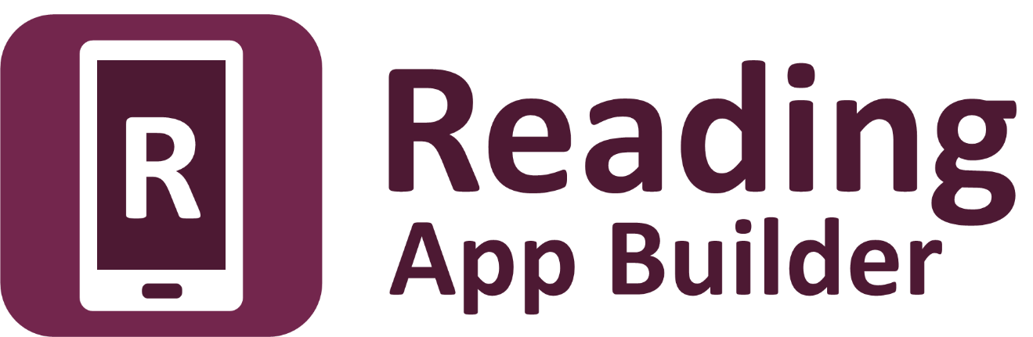

Creating Apps   
with Quizzes

Reading App Builder:

Creatings Apps with Quizzes

© 2021, SIL International

08 December 2021

You are free to print this manual for personal use and for training workshops.

The latest version is available at

<http://software.sil.org/readingappbuilder/resources/>

and on the Help menu of Reading App Builder.

Contents

1. Quiz files 5

2. Questions and answers in words 6

3. Question with picture, and answers in words 7

4. Question in words, and answers in pictures 8

5. Question and answer in words, with audio 9

6. Question and answer in words, with explanations 10

7. Question and answer in words, with explanations and audio 11

8. Sound effects for right and wrong answers 12

# Quiz files

Quizzes are developed using **text files** (.txt), created with a text editor such as **Notepad**. Do not use a word processor such as Word or LibreOffice.

A quiz file contains :

* Some information at the beginning: ID, name, short name;
* Questions: at least one question (there is no limit to the number of questions).

In Reading App Builder, you add quiz files as you do with other kinds of books on the **Books** page. Click **Add Book...** and select the file.

Codes to use

**\id** *abc* Quiz ID

**\quiz** Specify that this file is a quiz

**\qn** xyz Quiz Name

**\qs** *hjk* Short name or abbreviation

Example 1

**\id** QUIZ1

\quiz

**\qn** Quiz on Mali

**\qs** Mali

Example 2

**\id** Q123

\quiz

**\qn** The cities of the world

**\qs** Cities

# Questions and answers in words

The easiest questions to write have one question in words followed by a few answers in words. You need to provide one right answer and one or more wrong answers. The order of the answers will be mixed up in the app. You can have two answers, like "True" and "False", or three or four answers, or even more depending on the question.

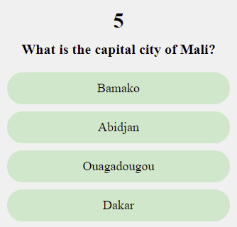

Codes to use

**\qu** *abc* Question

**\ar** xyz Right answer (a = “answer”, r = "right")

**\aw** xyz Wrong answer (a = “answer”, w = "wrong")

Example

**\qu** What is the capital city of Mali?

**\ar** Bamako

**\aw** Abidjan

**\aw** Ouagadougou

**\aw** Dakar

# Question with picture, and answers in words

Here we have a question with an image and text, and the answers are in words.

In Reading App Builder, you need to put the image (a JPG or PNG file) in the **Illustrations** tab for the quiz book.

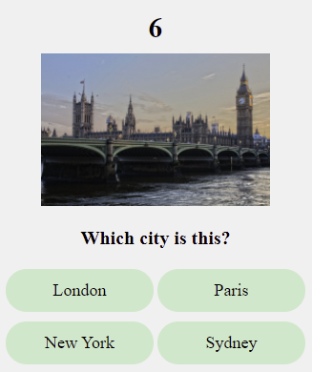

Codes to use

**\qu** *abc* Question in words

**\qu** qqq.jpg Image to be displayed in the question (a JPG or PNG filename)

**\ar** xyz Right answer

**\aw** xyz Wrong answer

Example

**\qu** Which city is this?

**\qu** city.jpg

**\ar** London

**\aw** Paris

**\aw** New York

**\aw** Sydney

# Question in words, and answers in pictures

Here we have a question in words, and the answers are pictures.

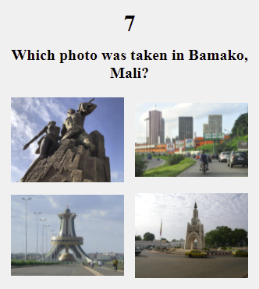

Codes to use

**\qu** *abc* Question in words

**\ar** *xyz.jpg* Right answer - image file (JPG or PNG)

**\aw** *xyz.jpg* Wrong answer - image file (JPG or PNG)

Example

**\qu** Which photo was taken in Bamako, Mali?

**\aw** dakar.jpg

**\aw** abidjan.jpg

**\aw** ouaga.jpg

**\ar** bamako.jpg

# Question and answer in words, with audio

You can provide an audio recording for the question and for each answer. The recording can be done in a program like Audacity (<https://www.audacityteam.org>). Use **File** > **Export** > **Export Selected Audio**.

In Reading App Builder, you need to put the audio clip (MP3 file) in the **Audio Clips** tab for the quiz book.



Codes to use

**\qu** *abc* Question

**\qu** *abc.mp3* Audio recording of the question (MP3 audio file)

**\ar** xyz Right answer

**\ar** *xyz.mp3* Audio recording of the right answer (MP3 audio file)

**\aw** xyz Wrong answer

**\aw** *xyz.mp3* Audio recording of the wrong answer (MP3 audio file)

Example

**\qu** What is the capital city of Mali?

**\qu** capital-question.mp3

**\ar** Bamako

**\ar** bamako.mp3

**\aw** Abidjan

**\aw** abidjan.mp3

**\aw** Ouagadougou

**\aw** ouagadougou.mp3

**\aw** Dakar

**\aw** dakar.mp3

# Question and answer in words, with explanations

You can give an explanation to the user after they select an answer, helping them to see why it is the right or the wrong answer.

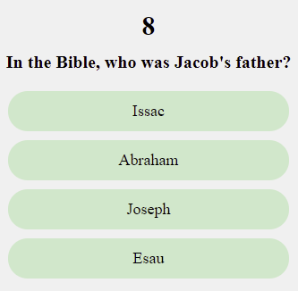

Codes to use

**\qu** *abc* Question

**\ar** xyz Right answer

**\ae** *hjk* Explanation - why the answer is right

**\aw** xyz Wrong answer

**\ae** *hjk* Explanation - why the answer is not right

Example

**\qu** In the Bible, who was Jacob's father?

**\ar** Issac

**\ae** Yes, Isaac was the father of Jacob and Esau.

**\aw** Abraham

**\ae** No, it was Isaac. Abraham was Jacob's grandfather.

**\aw** Joseph

**\ae** No, it was Isaac. Joseph was one of Jacob's sons.

**\aw** Esau

**\ae** No, it was Isaac. Esau was Jacob's brother.

# Question and answer in words, with explanations and audio

It is possible to give the explanations in audio.

Codes to use

**\qu** *abc* Question

**\qu** *abc.mp3* Audio recording of the question (mp3)

**\ar** xyz Right answer

**\ae** *xyz.mp3* Audio recording of the answer (mp3)

**\ae** *hjk* Explanation - why the answer is right

**\ae** *hjk.mp3* Explanation - audio file (mp3)

**\aw** xyz Wrong answer

**\aw** *xyz.mp3* Audio recording of the answer (mp3)

**\ae** *hjk* Explanation - why the answer is not right

**\ae** *hjk.mp3* Explanation - audio file (mp3)

Example

**\qu** In the Bible, who was Jacob's father?

**\qu** question-jacob-father.mp3

**\ar** Issac

**\ar** isaac.mp3

**\ae** Yes, Isaac was the father of Jacob and Esau.

**\ae** expl-isaac.mp3

**\aw** Abraham

**\aw** Abraham.mp3

**\ae** No, it was Isaac. Abraham was Jacob's grandfather.

**\ae** expl-abraham.mp3

**\aw** Joseph

**\aw** joseph.mp3

**\ae** No, it was Isaac. Joseph was one of Jacob's sons.

**\ae** expl-joseph.mp3

**\aw** Esau

**\aw** esau.mp3

**\ae** No, it was Isaac. Esau was Jacob's brother.

**\ae** expl-esau.mp3

# Sound effects for right and wrong answers

After a right or wrong answer, there is a sound effect to indicate to the user whether the answer is right or wrong. You can change these sound effects.

Codes to use

Put these codes at the end or beginning of the quiz file. They apply to all questions.

**\ra** abc.mp3 Sound effect for a right answer

**\wa** hjk.mp3 Sound effect for a wrong answer

Example 1

**\ra** good.mp3

**\wa** wrong.mp3

Example 2

You can give several files for the right and wrong answers. The application will choose among them for each answer.

**\ra** very-good.mp3

**\ra** excellent.mp3

**\ra** good-answer.mp3

**\wa** sorry.mp3

**\wa** incorrect.mp3

**\wa** not-good.mp3