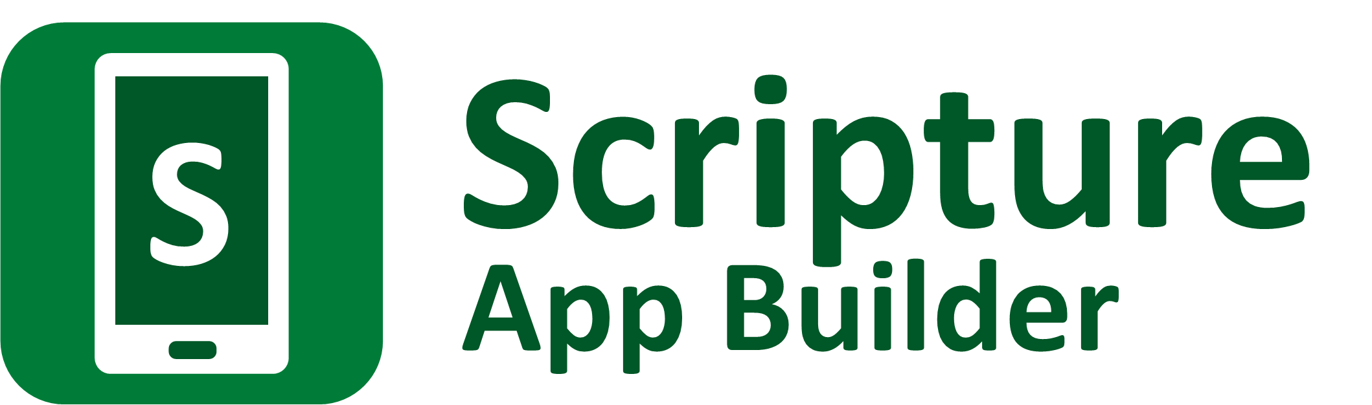

App Store Optimization



Scripture App Builder: App Store Optimization

© 2021, SIL International

Last updated: 23 July 2021

You are free to print this manual for personal use and for training workshops.

The latest version is available at

<http://software.sil.org/scriptureappbuilder/resources/>

and on the Help menu of Scripture App Builder.

**Contents**

1. Introduction 4

2. How do we improve discoverability? 4

2.1. Make the most of the app name/title 6

2.2. Include plenty of keywords in the description 8

2.3. Use the language (or languages) that people are most likely to search with 8

2.4. Translate your app store page into different languages 8

3. How do we improve the conversion rate? 8

3.1. How can we improve on-metadata factors to optimise the conversion rate? 9

3.1.1. App Icon 9

3.1.2. Description 9

3.1.3. Screenshots 10

3.2. How can we influence off-metadata factors to optimise the conversion rate? 12

3.2.1. Number of installs 12

3.2.2. Ratings 13

3.2.3. Reviews 13

# Introduction

You have built a great app, but can people find it, and do they want to install it?

When we talk about **App Store Optimization (ASO)**, we focus on two things: discoverability and conversion.

1. **Discoverability** - making it easier for users to find your app on the app store.
2. **Conversion** - increasing the likelihood of a user installing and trying out your app once they have found it.

In other words, we don't just want to create apps: we want people to find the apps, install them and use them.

We will begin by looking at the area of discoverability.

# How do we improve discoverability?

How will users find your app on Google Play or the Apple App Store? There can be several pathways:

* **Searching** in the app store, e.g. typing in keywords into the Google Play app search box, such as “Minyanka Bible”.
* Clicking on an **advert** from a marketing campaign that you have paid for, e.g. using Google Ads or Facebook Ads.
* Links from **other websites**, such as language community forums.
* Links for **related apps**, e.g. you are looking at the store page of a dictionary app and you see there is also a Bible app available for the same language, or an interesting app by the same developer.
* Recommendations from **friends**.

The first of these, searching using keywords in the app store is likely to be one of the major sources of new users. What can we do to increase the likelihood that someone in your target audience finds your app when searching in the store? First we need to think about the keywords they might type in the search bar, and secondly we need to make sure that as many of these keywords appear on the store page for our app.

If your app is in **Google Play**, the following elements on your app store page are indexed for keywords:

* the app name/title
* the short description (displayed on the front page for the app)
* the long description (displayed when the user taps on ‘About this app’)
* the app package name (not shown when viewing apps on a phone, but visible in the browser address bar when viewing on a computer)
* the developer name

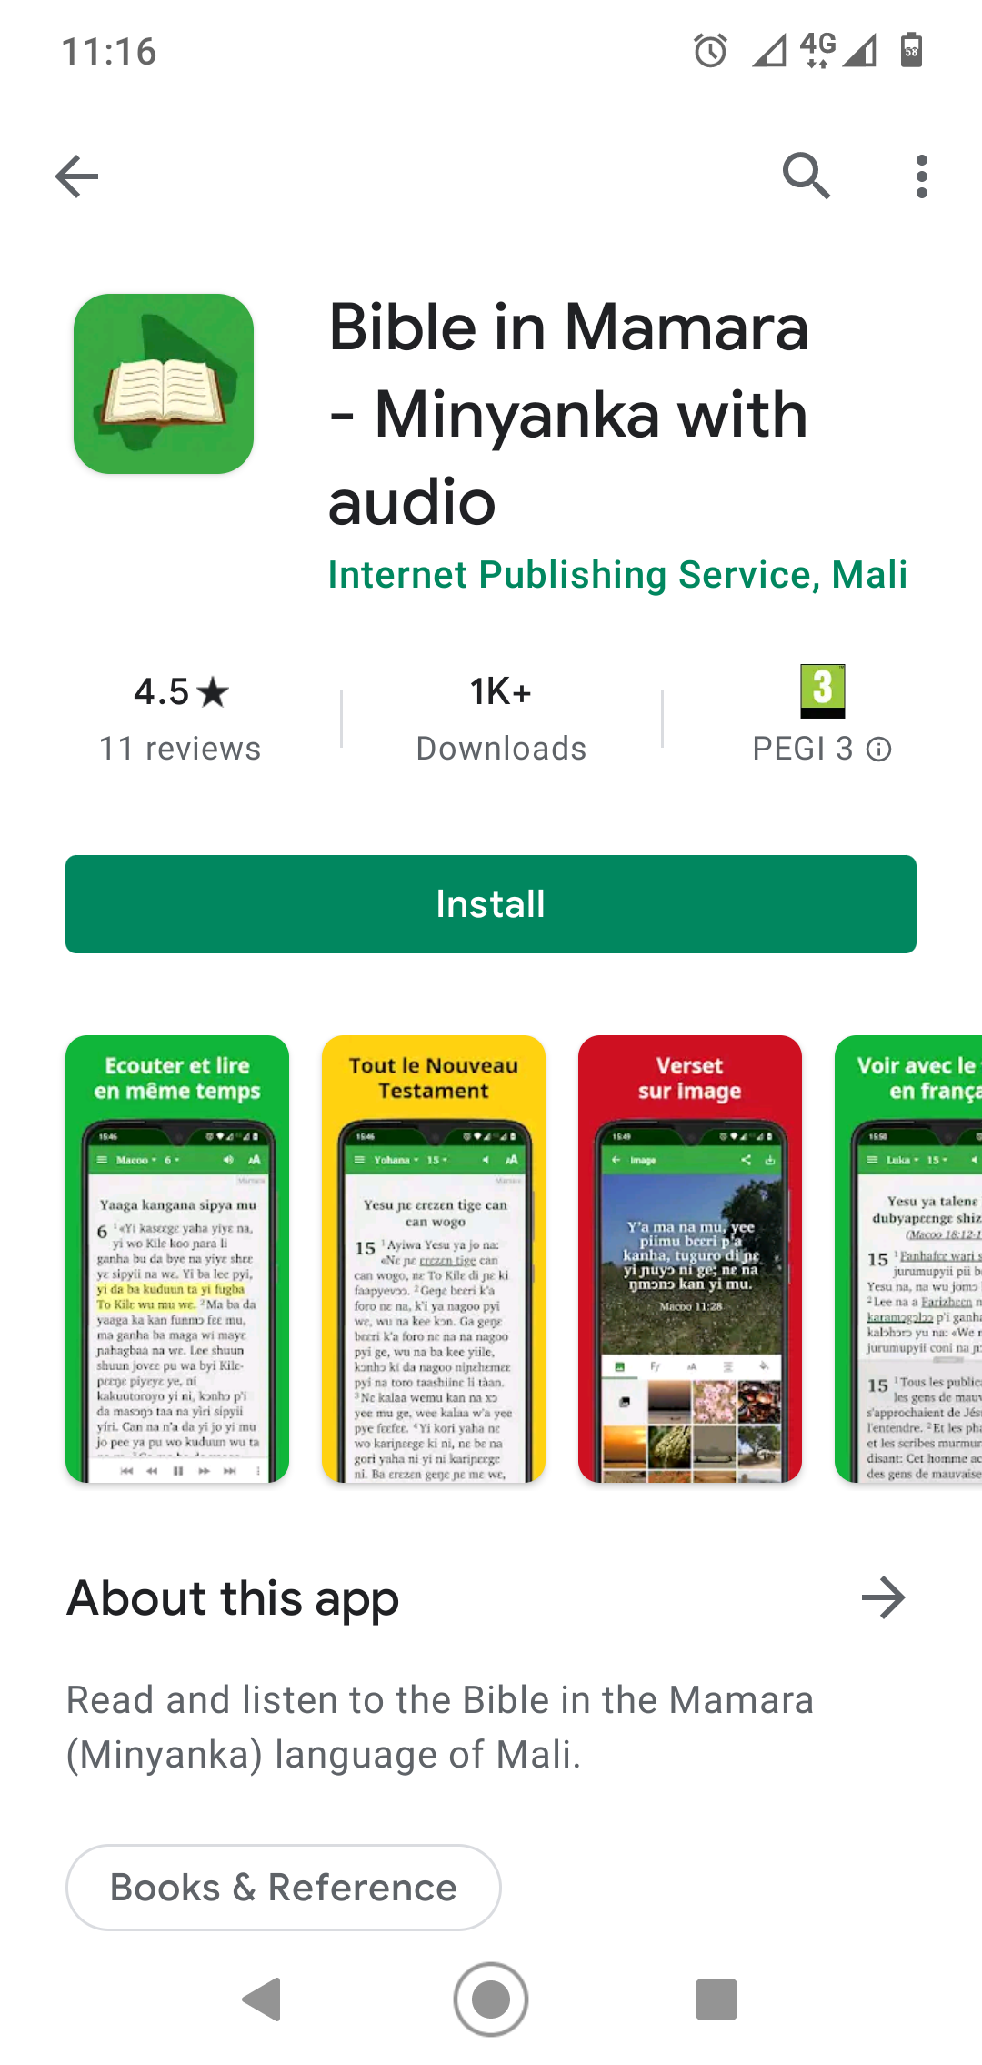

If your app is in the **Apple App Store**, the following elements are indexed for keywords:

* the app name/title
* the subtitle/promo text
* the keywords field
* the developer name

You need to think about the keywords someone in your target audience might be searching for and then include them in the above parts of the store page. You could imagine different scenarios, for example:

* ***Someone is looking for a Bible app for a specific language***, say Minyanka. In such a case, they might use search terms like “Minyanka Bible”, “Bible en langue minyanka”, “Minyanka New Testament”, “Minyanka Scriptures”. You will want to make sure the elements on your store page contain these keywords. Think about the different terms people use for God's Word in your context, e.g. “Scriptures”, “Holy Book”, “Bible”, “Gospel̠”, “Injil”, “New Testament”, etc.

* ***Someone is looking for any apps about a specific language***. In such a case, they might use search terms like “Minyanka”, “Minyanka apps”, “Minyanka language”, etc. They might use variations on the spelling of the language name, such as “Minianka” or “Mianka”. Make sure the elements on your store page contain the different ways people might spell the language.
* ***Someone is looking for apps for a specific country***. In such a case, they might want to be searching for “Mali”, “Nigeria”, “Burkina Faso”, etc. Make sure that your store page contains a reference to the country and region in which the language is spoken.

* ***Someone is looking for apps with a certain feature***. For example, they might be looking for an app in a certain language with audio. They might search for something like “French Bible audio” or “audio Bible Tanzania”. Make sure your app store description (and perhaps the app name too) highlights the fact that the app contains both text and audio.

There are some online keyword research tools to help you find good keywords, such as:

* App Radar - <https://appradar.com>
* Mobile Action - <https://www.mobileaction.co>
* Sensor Tower - <https://sensortower.com>
* Keyword Tool - <https://keywordtool.io>

You will need to pay to use most of these tools. With some brainstorming, however, you should be able to come up with a list of likely keywords and rank them in order of importance.

Here are some tips on placing keywords on your app page:

## Make the most of the app name/title

The app title on the store page does not need to be the same as the name of the app itself. It can be a longer name than the one that will appear under the icon on your smartphone. What app developers often do is add a keyword or two after the actual app name, especially if the app name itself does not include keywords that people would typically search for.

For example, here is the Cheapflights app title in Google Play:

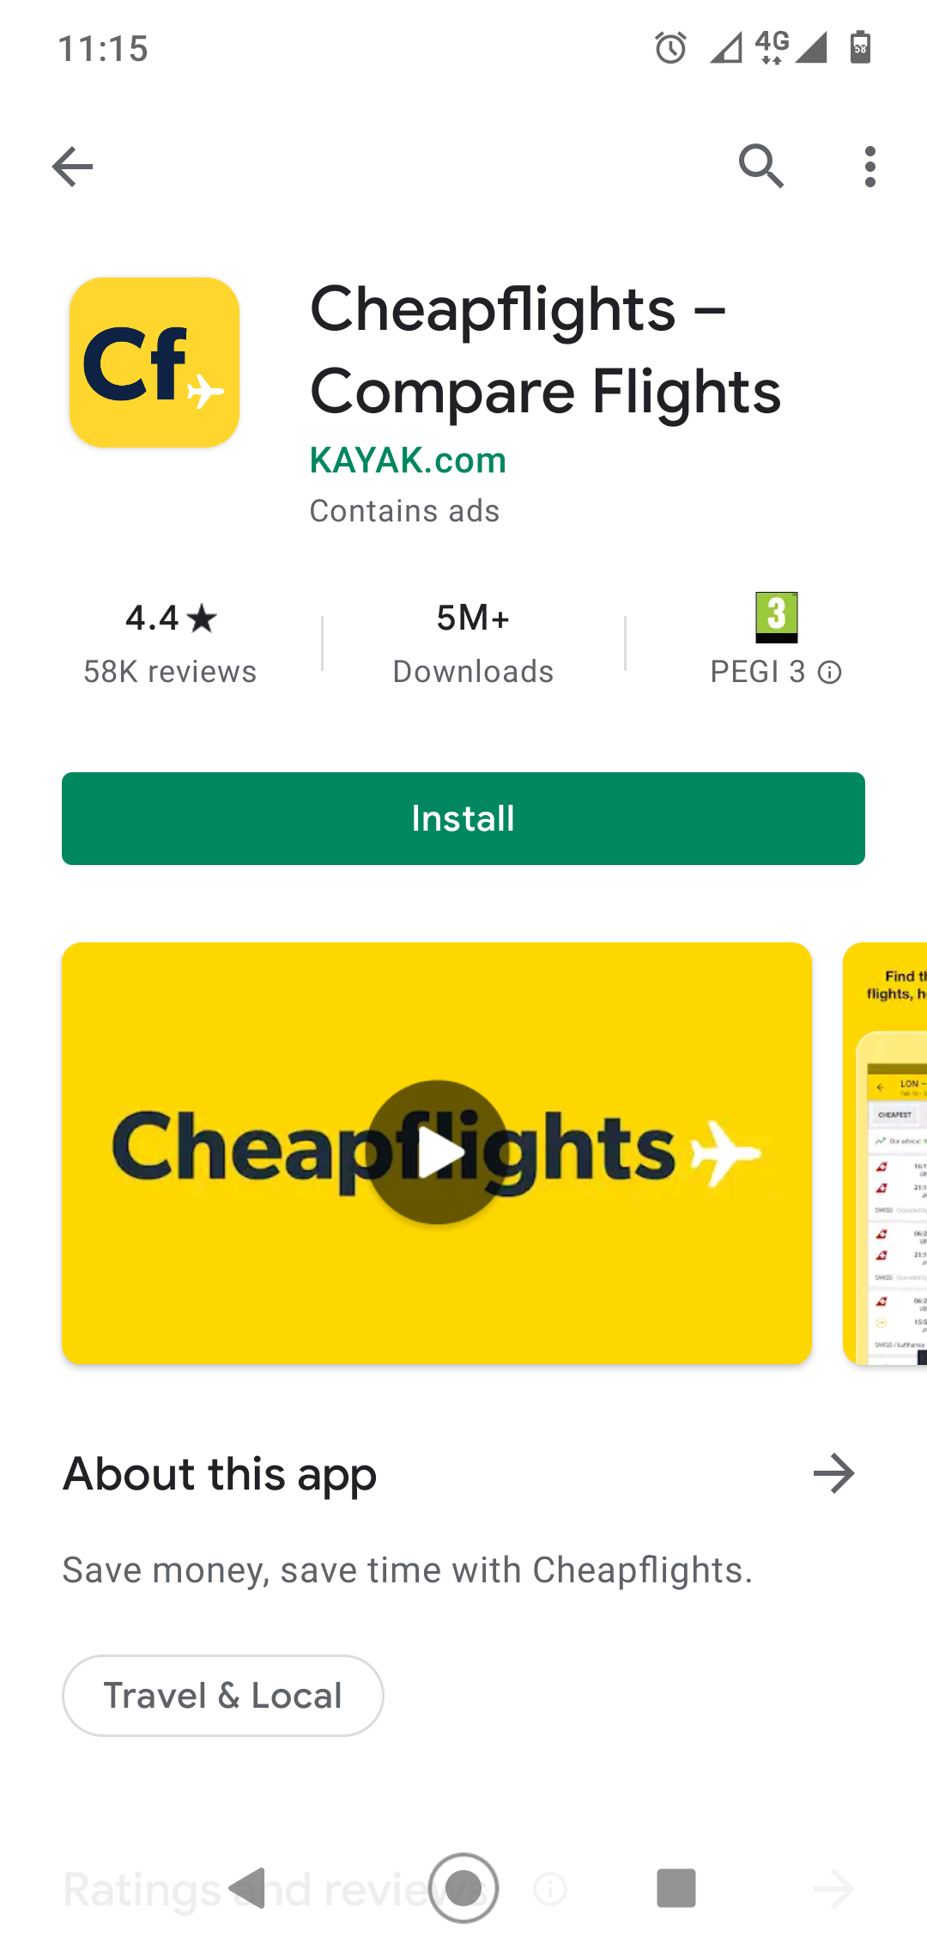

Notice how the developers have added the keywords “Compare Flights” after the app name itself, separated by a hyphen. This increases the chance of this app ranking high for the keywords “compare flights”.

Here are some more examples of popular apps where additional keywords have been added after the app name:

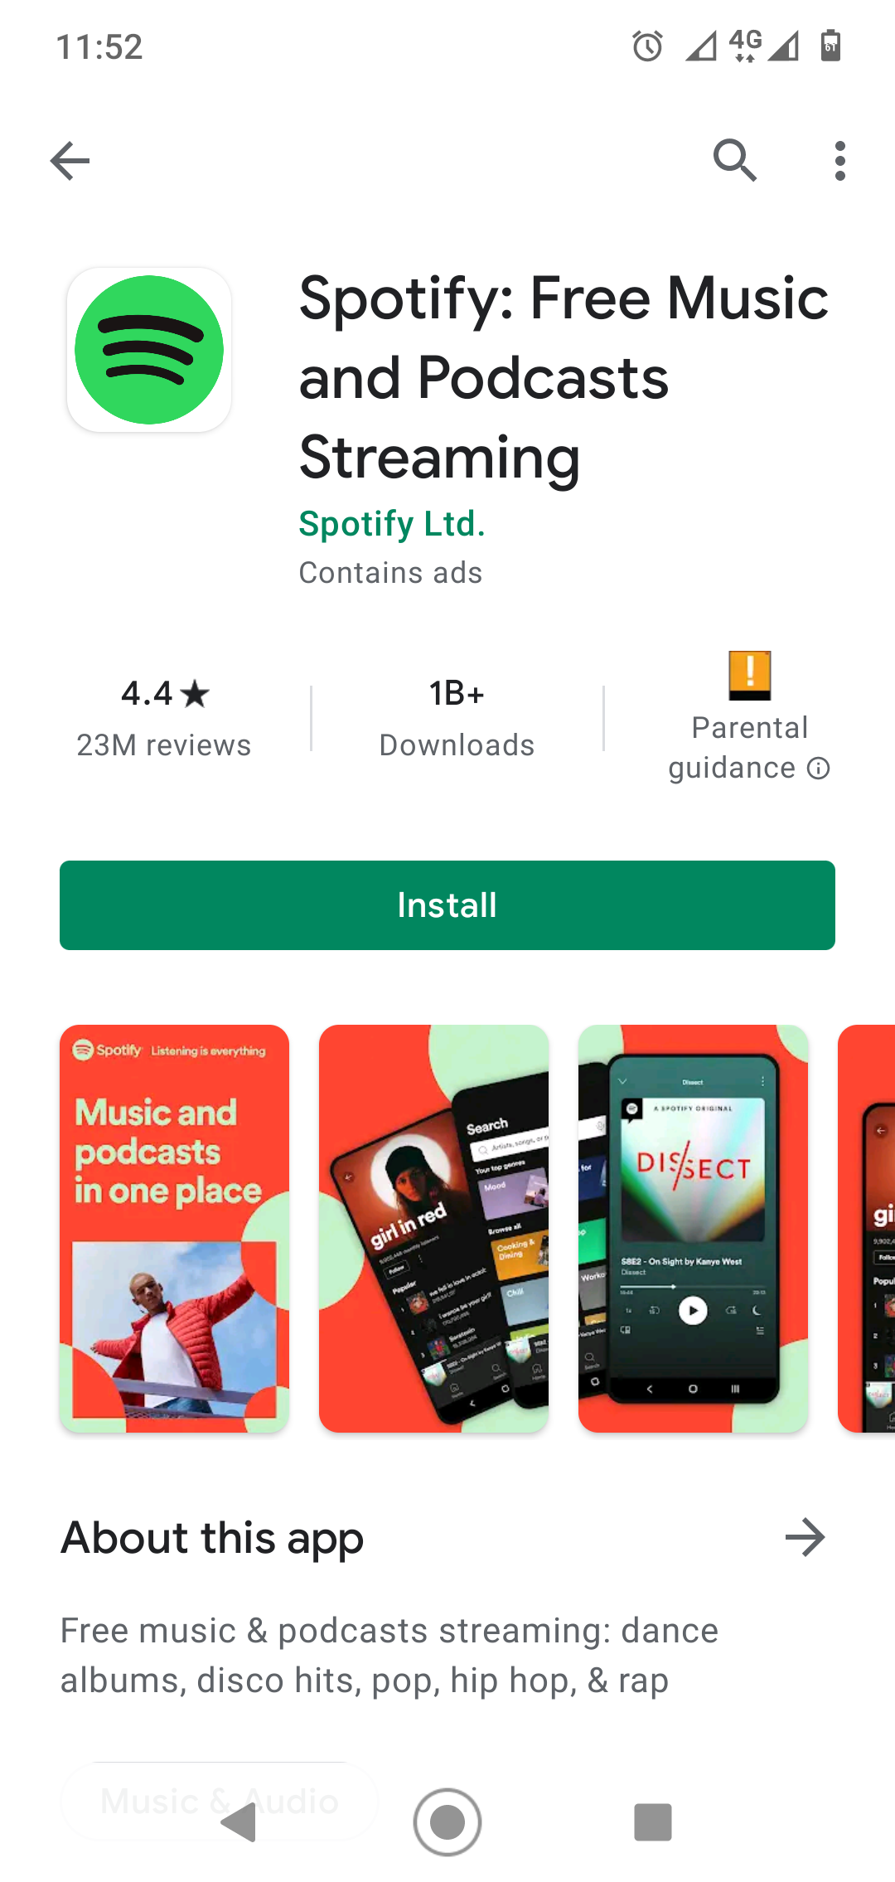

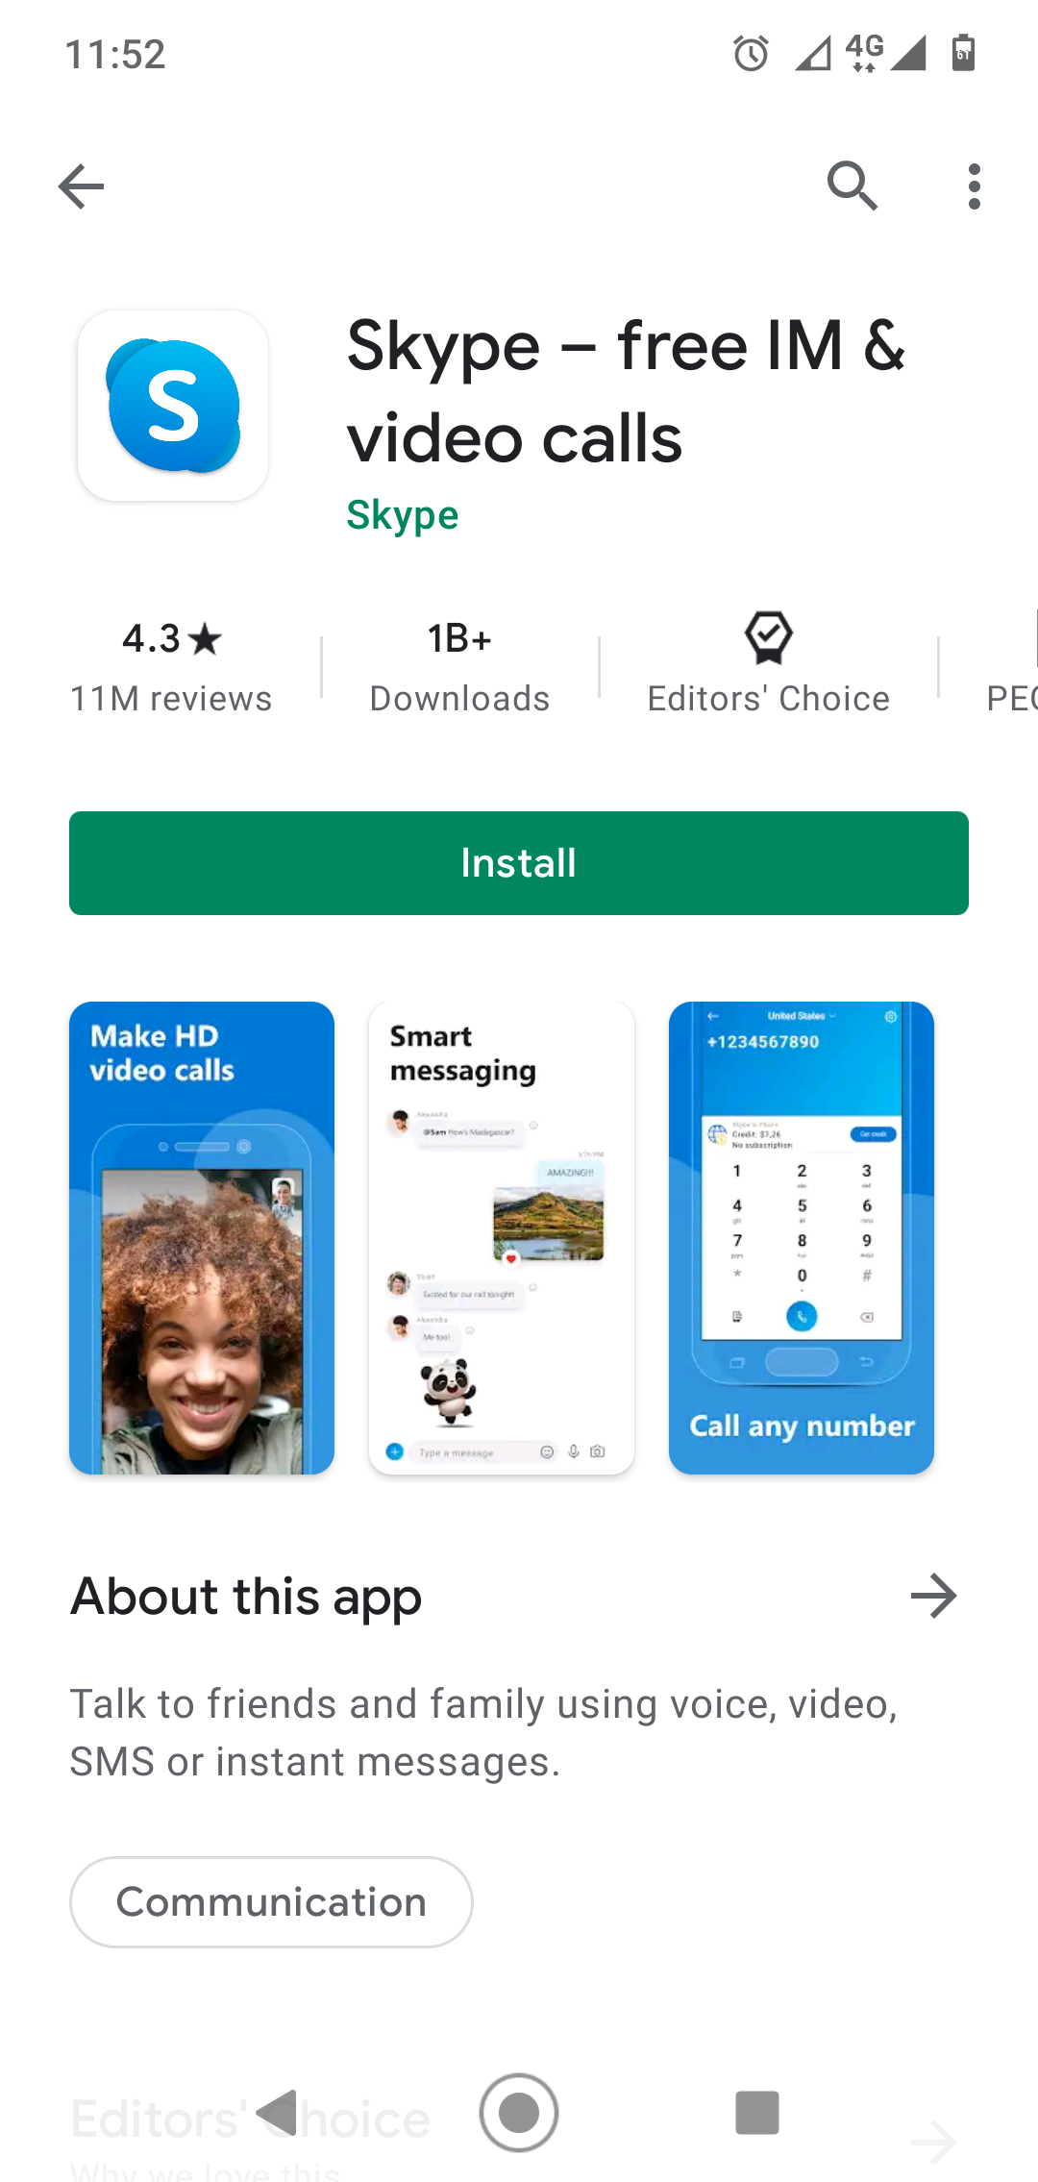

So, if your app name is “Kilɛ Kafila”, you might want to include it in the app store as “Kilɛ Kafila - Bible in Mamara”, including a couple of important keywords (“Bible” and “Mamara”) alongside the app name.

If several apps exist already for a language, such as a number of different Bible apps, you might want to highlight a unique feature of your app in the app title. For example, “Mamara Bible - text and audio”, or “Supyire Bible - with French”.

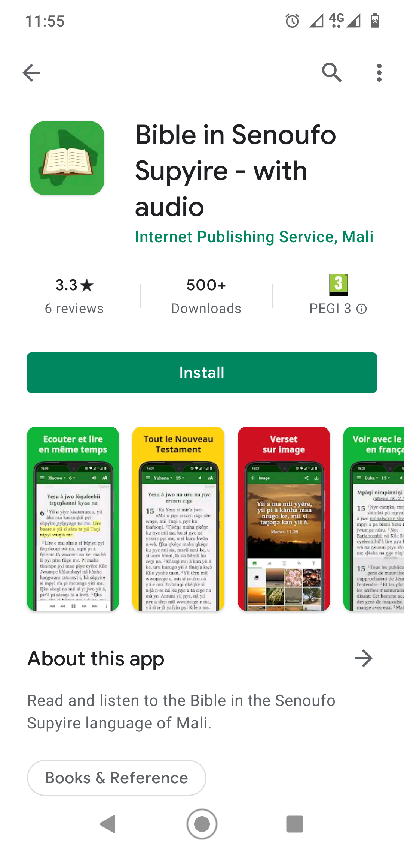

## Include plenty of keywords in the description

In Google Play, the short and long descriptions are indexed for keywords, so make sure your descriptions contain the kinds of words and phrases that people might be searching for. You will want to include the name of the language, including different possible spellings. Include the name of the country and region, and perhaps the names of some key towns. If it is a Bible app, include the different ways people might refer to Holy Scripture. If it is a dictionary app, include terms such as “lexicon” and “dictionary”.

Your keywords need to appear as part of ordinary sentences, as natural prose, and you should not present a list of keywords, such as “Keywords: Minyanka, Mianka, Bible, Mali, NT,” etc. This is known as **keyword stuffing** and is against the terms of Google Play.

## Use the language (or languages) that people are most likely to search with

There are app store pages where the app name and description are all in a local language, i.e. the language that the app contains. This might seem like good contextualization, but you need to think about whether this approach will make your app harder to find. If people are most likely to search using a word like “Bible”, rather than a local name like “Ala ka Kuma”, leaving out the major language name and description will result in your app being hidden away and less discoverable.

## Translate your app store page into different languages

If you know that some of your potential users will be searching the app store in English, others in French and others in Russian, you will boost the app’s discoverability if you translate the page into these three languages - both the app name and the descriptions. Do not include all three languages in the same description: use the page translation feature of the app store and supply a description for each language separately.

# ****How do we improve the conversion rate?****

In this section we will look at optimizing the conversion rate: Conversion Rate Optimisation (CRO).

Imagine that a user has searched for the name of his language, “Abidji”, in Google Play and has found a Scripture app in the Abidji language. They have the Abidji Bible store page listing in front of them on their smartphone screen and they scan up and down the page. As they look at it, they are going to make a quick decision, asking themselves, “Am I interested in this app, or shall I keep on searching for something more interesting?” What is it about the store page that could encourage them to install and try out the app? Or what it is about the page that could be off-putting, boring or could give them the impression that it is not worth installing the app?

There are two categories of content on the store page that the user will be looking at:

* + **On-metadata factors** - These are elements on the page that you have control over and can modify easily: the app name, the icon, the screenshots, the description, videos, and feature graphics.
  + **Off-metadata factors** - These are elements that you do not control but can influence, such as the number of installs, the app rating and user reviews.

We will look at each of these factors in turn.

## How can we improve on-metadata factors to optimise the conversion rate?

### App Icon

First impressions count. If your app icon is well designed and attractive, it can make a difference in users choosing to install your app. If users are faced with a list of several apps, it will often be the quality of the icon that makes them click on one app rather than another. We say, “Don't judge a book by its cover”, but that is what many people do, for books as well as apps.

Here are a few tips on creating an attractive app icon:

* Be honest with yourself. If you are not a graphic designer or do not really have amateur skills in design, ask someone gifted in design to help you produce a quality icon - rather than trying to hack together something which looks amateurish. If you do not know anyone experienced in this area, ask around for contacts.
* Test the icon design with potential users. Show them a selection of possibilities and see which one they prefer.
* Use colour well. Choose colours that are attractive and appropriate for the Scriptures in the context.
* Make sure that any symbols you use on the icon are appropriate and understood, e.g. fishes, crosses, books, loudspeaker symbols, country maps, etc.
* Avoid too many details on the icon, such as small text. An icon has to look good in 512x512 pixels as well as on someone's smartphone screen.
* Use a service such as 99designs if you are looking for an especially professional-looking icon.

### Description

Think about what kinds of app descriptions draw users in, and what kinds of descriptions are off-putting. Write the app description in a way that is clear and attractive. It should not sound like a technical manual or a legal document. It needs to explain the app's unique features in such a way that they see that it is an app they will enjoy and find useful.

Make sure the description is written in a language your potential users will understand.

### Screenshots

Screenshots capture our attention. Your potential users will glance at the screenshots to see whether the app looks good or not. Here are some tips on choosing good screenshots:

* Include at least five screenshots, rather than being satisfied with the minimum number.
* Choose screenshots that highlight the most interesting features of the app.
* Screenshots that have colour and images will usually be more interesting than those which just contain text.
* Arrange the screenshots in order of “interestingness”. Put the most attractive ones first.
* Be ruthless about deleting screenshots that are boring and do not really communicate much that is interesting to a potential user.

You may have noticed that some app store pages use **enhanced screenshots**. These are screenshots that are framed with captions and coloured backgrounds. For example, see the Skype app screenshots:



and the Kindle app screenshots:

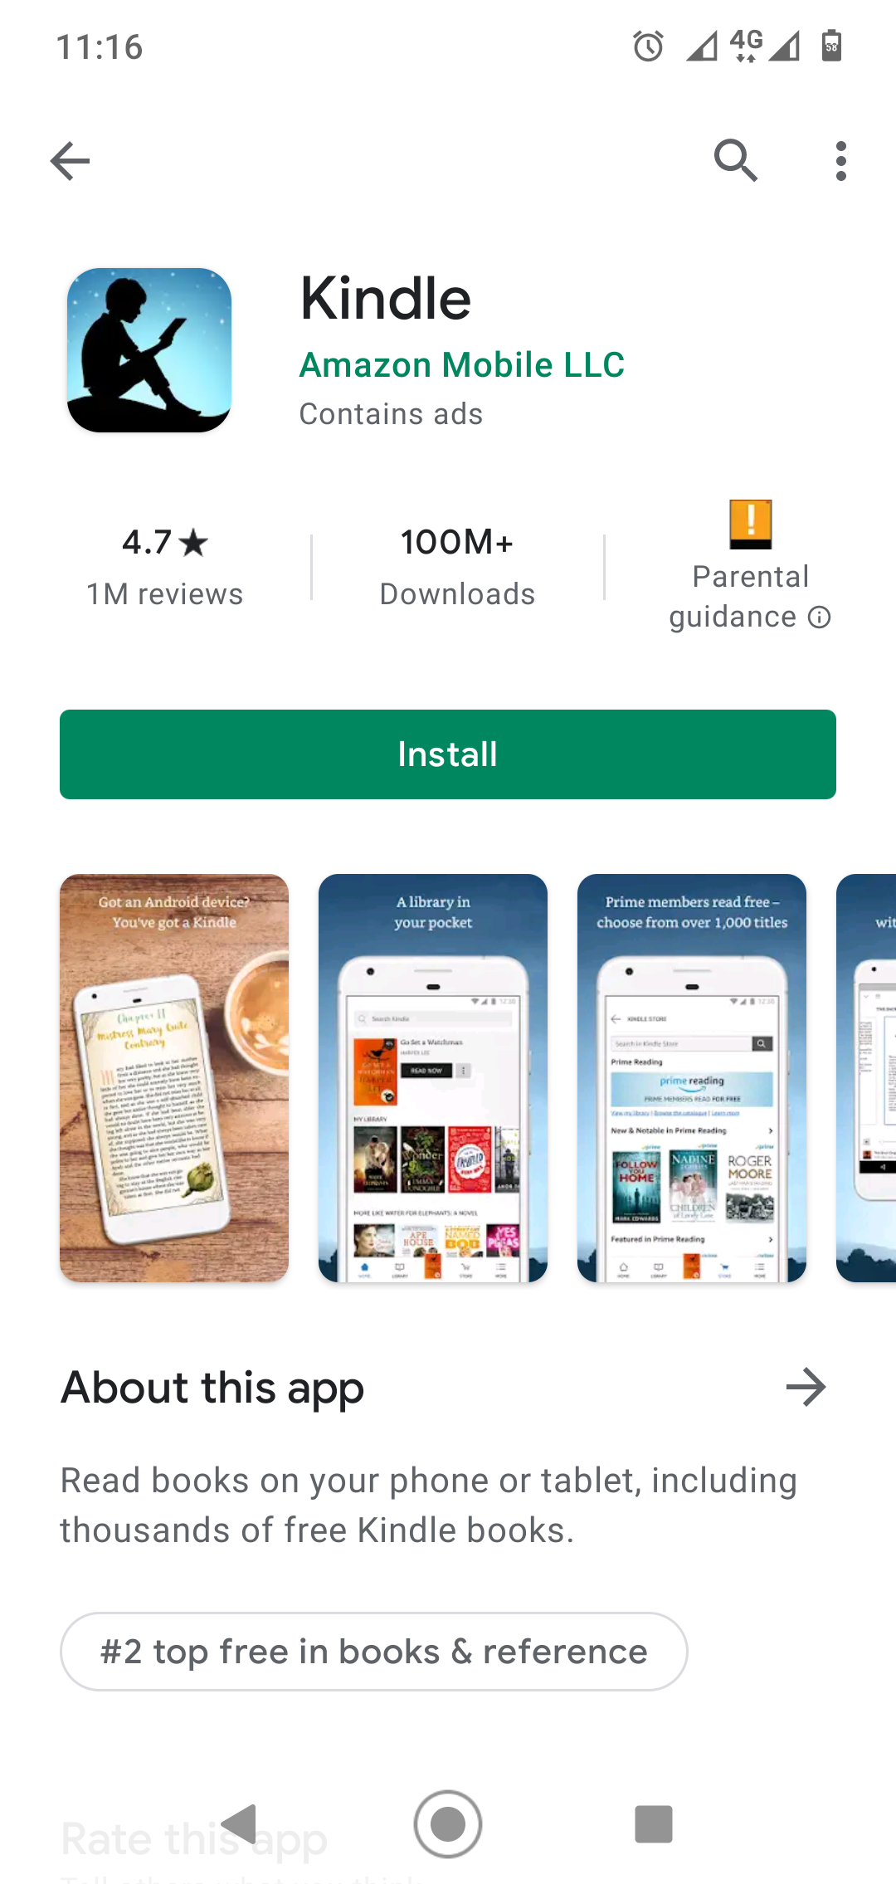

If you want to experiment with creating these types of enhanced screenshots, there are some screenshot generators online, such as:

* AppScreens - <https://appscreens.com>
* App Institute - <https://appinstitute.com/app-screenshot-maker/>
* AppLaunchPad - [https://theapplaunchpad.com](https://theapplaunchpad.com/)

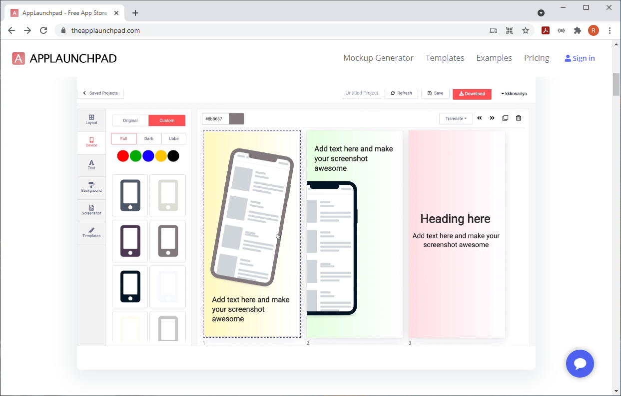

Some of these are free. Others require a subscription.

Here is an example of enhanced screenshots for a Scripture app:



## How can we influence off-metadata factors to optimise the conversion rate?

Off-meta data factors include the number of installs, ratings, and reviews.

### Number of installs

If someone sees an app that was released some ago but has only a few installs, they might think twice about installing it. Why isn’t it more popular? Why aren’t people interested in installing it? Getting more installs can increase the conversion rate.



How can you increase the number of app installs?

* Apply the ASO techniques described this document to optimize app discoverability and conversion.
* Promote your app well among potential users, using social media, email, and announcements in local gatherings.
* Use paid marketing campaigns, e.g. Google Ads or Facebook Ads. Just a small investment can make a big difference.

### Ratings

If an app has a rating less than 4.0, it will appear less attractive to potential users. We want to do what we can to ensure that the rating stays high.

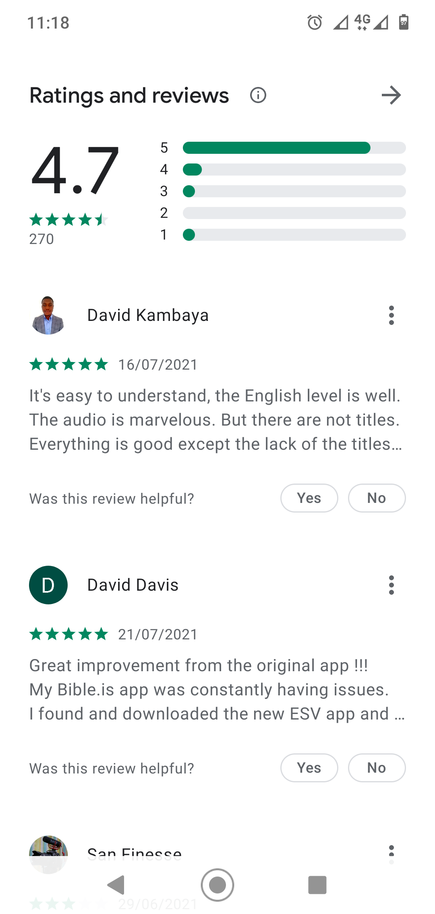

How can you keep the app rating high?

* Make sure that you have high quality and unique app content.
* Check that the spelling is correct and use Paratext checks for Scripture.
* Ensure that the app description describes accurately what the app does, so that users do not feel misled or disappointed after they install the app.
* Ask people you know to rate the app - as long as they can do so honestly, i.e. avoid asking a friend to rate an app for a language they don't understand.

### Reviews

It is always interesting to see what users are saying about the app. Lots of enthusiastic and positive reviews can increase the conversion rate. Bad reviews can turn people away.



Here are some tips about app reviews:

* Ask people you know to write a review of the app - as long as they can do so honestly, i.e. avoid asking a friend to rate an app for a language they don't understand. It is more convincing if the names and photos of those reviewing the app are obviously from the language community.
* If someone tells you that they like the app, encourage them to write a review on the store page.
* Respond to user reviews as much as possible, especially those that are longer (not necessarily the ones that say something like “Good app!”)
* If someone leaves a negative review, answer graciously, and do not get into an argument.
* Sometimes reviews can indicate that you have not explained the contents of the app clearly enough in the description. A common comment received on Scripture apps is, “It’s only the New Testament, where is the Old Testament?”. Such comments show you that you need to make it clearer that the app is the New Testament, and that you need to say something about if/when the Old Testament is coming.
* If people have good ideas about possible enhancements, please let the App Builder developers know.