Acids and Bases Quiz: Answer Key
Quick key
Q | Answer | Focus | Level
1 | C | Atom | Direct
2 | B | Atom | Two-factor
3 | A | Atom | Two-factor
4 | B | Atom | Direct
5 | D | Resonance | Direct
6 | C | Resonance | Two-factor
7 | A | Resonance | Direct
8 | B | Resonance | Two-factor
9 | A | Resonance | Two-factor
10 | C | Resonance | Two-factor
11 | D | Resonance | Two-factor
12 | B | Induction | Two-factor
13 | A | Induction | Two-factor
14 | D | Induction | Two-factor
15 | C | Orbitals | Direct
16 | C | Orbitals | Direct
17 | B | Orbitals | Direct
18 | D | Competing factors | Challenge
19 | A | Competing factors | Challenge
20 | C | Competing factors | Challenge
21 | D | Competing factors | Challenge
22 | B | Competing factors | Two-factor
23 | A | Equilibrium | Two-factor
24 | D | Equilibrium | Two-factor
25 | B | Equilibrium | Challenge
26 | C | Equilibrium | Two-factor
27 | D | Equilibrium | Challenge
28 | C | Equilibrium | Two-factor
29 | A | Equilibrium | Two-factor
30 | B | Equilibrium | Challenge

Answer distribution: A = 7, B = 8, C = 8, D = 7

ARIO reminder
Priority order for comparing conjugate-base stability: (1) Atom (same row: electronegativity; same column: size), (2) Resonance, (3) Induction, (4) Orbital (sp > sp² > sp³). For equilibrium, the position favors the more stable ion (weaker base, weaker acid).
1. Answer: C (Atom; Direct)
C) Hc (the O–H)
Why: Each conjugate base has its charge on a different atom: C, N or O. These are in the same row, so electronegativity decides. O is the most electronegative, so RO⁻ is the most stable base and the O–H is the most acidic.
2. Answer: B (Atom; Two-factor)
B) Hb (the S–H), because S is larger than O and spreads the charge over a larger volume
Why: Compare RS⁻ with RO⁻. O and S are in the same column, so size is the dominant effect, not electronegativity. The larger S⁻ is more stable, so the S–H is more acidic.
3. Answer: A (Atom; Two-factor)
A) Ha (the phenol O–H), because O is more electronegative than N
Why: Ha and Hb both give resonance-stabilized bases, so look at factor 1 first: the charge is on O in one and on N in the other. Same row, so the more electronegative O wins. Hc and Hd are C–H bonds, which is the weakest factor 1 outcome.
4. Answer: B (Atom; Direct)
B) II, because N is less electronegative than O, so the negative charge on N is less stable
Why: Both charges are in the same row of the periodic table, so electronegativity decides. N is less electronegative than O, so N⁻ is less stable (stronger base).
5. Answer: D (Resonance; Direct)
D) Ha (the carboxylic acid O–H), because its conjugate base is resonance stabilized
Why: Ha and Hb both put the charge on O, so atom does not decide. The carboxylate is delocalized over two oxygens by resonance; the alkoxide is localized. Hc is a C–H (atom favors O).
6. Answer: C (Resonance; Two-factor)
C) Hb (the amide N–H)
Why: Ha and Hb are both N–H, so factor 1 ties. Deprotonating the amide N–H gives a base whose charge is delocalized onto the carbonyl O by resonance; the amine N⁻ is localized. Hc and Hd are C–H bonds and lose on factor 1.
7. Answer: A (Resonance; Direct)
A) Ha (the phenol O–H), because the phenoxide charge is delocalized into the ring
Why: Ha and Hb both give O⁻, so factor 1 does not decide (Hc is a C–H, which loses). Only the phenoxide is resonance stabilized; the benzylic alkoxide is not.
8. Answer: B (Resonance; Two-factor)
B) Hb (the CH₂ between the two C=O groups)
Why: All four are C–H bonds, so factor 1 is a tie. Only removing Hb gives a base whose charge is delocalized onto two carbonyl oxygens. Ha gives a base delocalized onto only one.
9. Answer: A (Resonance; Two-factor)
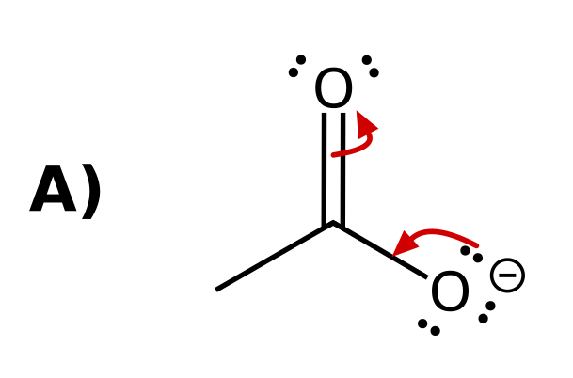
Why: Arrow 1 starts on a lone pair of O⁻ and ends between O and C (forming the C=O π bond). Arrow 2 starts on the C=O π bond and ends on the other O (becoming a lone pair). Every arrow goes from electrons to where the electrons end up.
10. Answer: C (Resonance; Two-factor)
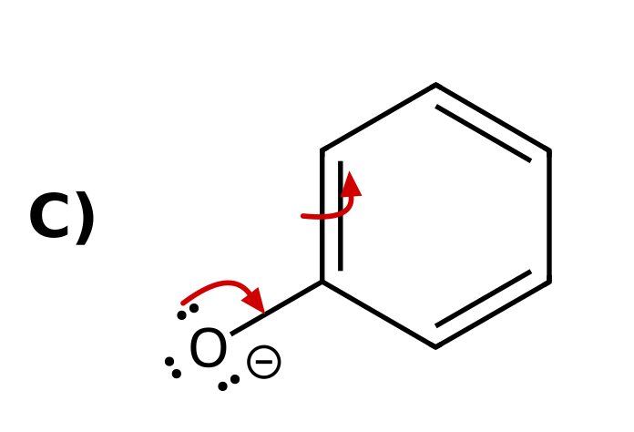
Why: Arrow 1: lone pair on O⁻ forms the C=O π bond. Arrow 2: the adjacent ring C=C π bond moves onto the ortho carbon as a lone pair. A single arrow leaves the ipso carbon with five bonds, and moving the electrons to a meta carbon is not a valid resonance shift. The delocalization of charge into the ring is why phenol is more acidic than an alcohol.
11. Answer: D (Resonance; Two-factor)
D) Ha (the CH₂ hydrogen)
Why: All are C–H bonds. Removing Ha gives the cyclopentadienyl anion, with the charge delocalized over five carbons by resonance. Removing a vinyl H (Hb or Hc) puts the charge in an sp² orbital that does not overlap with the π system, so there is no resonance.
12. Answer: B (Induction; Two-factor)
B) I < II < III
Why: All three have the same atom and resonance. Cl withdraws electron density by induction and stabilizes the carboxylate. The effect weakens with distance: III (Cl on the α carbon) > II (Cl on the γ carbon) > I (no Cl).
13. Answer: A (Induction; Two-factor)
A) Ha, because the CF₃ groups stabilize the nearby alkoxide by induction
Why: Both conjugate bases have the charge on O with no resonance. The three F atoms on each CF₃ pull electron density through the σ bonds and stabilize the nearby O⁻. The other alkoxide is too far away to feel it.
14. Answer: D (Induction; Two-factor)
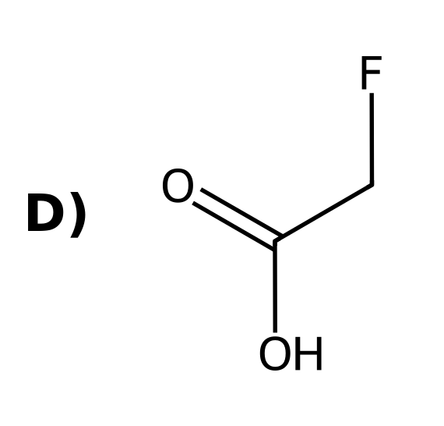
Why: Same atom, no change in resonance. The halogen on the α carbon withdraws electron density by induction. F is the most electronegative, so FCH₂CO₂⁻ is the most stabilized.
15. Answer: C (Orbitals; Direct)
C) Ha (the alkyne H)
Why: All are C–H bonds, with no resonance or induction available. Only the orbital differs: sp (alkyne) > sp² (vinyl) > sp³ (alkyl). The sp orbital has the most s character, holding the lone pair closest to the nucleus.
16. Answer: C (Orbitals; Direct)
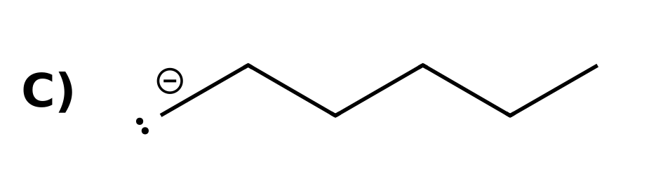
Why: The charge is on carbon in all three, with no resonance or induction. The orbital differs: the alkyl anion has the charge in an sp³ orbital (highest energy, least stable, strongest base). The alkynide is in an sp orbital (most stable, weakest base).
17. Answer: B (Orbitals; Direct)
B) The electron pair in the sp orbital is held closer to the nucleus, so the alkynide ion is more stable
Why: This is factor 4 (orbitals). An sp orbital is 50% s character, which is closer to the nucleus than the 33% s character of an sp² orbital, so the lone pair in an sp orbital is lower in energy.
18. Answer: D (Competing factors; Challenge)
D) Ha in I (ethanol), because the atom (O vs. C) outranks resonance
Why: Propene's CH₃ gives a resonance-stabilized allyl anion, but the charge is on carbon. Ethoxide has the charge on O. The atom (factor 1) takes priority over resonance (factor 2).
19. Answer: A (Competing factors; Challenge)
A) Ha, because resonance outranks induction
Why: Both put the charge on O, so factor 1 ties. The carboxylate is resonance stabilized (factor 2); the alkoxide only has the inductive effect of CF₃ (factor 3). Resonance beats induction.
20. Answer: C (Competing factors; Challenge)
C) Hb, because the atom (O vs. C) outranks the orbital
Why: Ha gives a carbanion on an sp carbon; Hb gives an alkoxide. Atom comes before orbital: O⁻ is more stable than C⁻ even in an sp orbital.
21. Answer: D (Competing factors; Challenge)
D) I < II < III
Why: All three have the charge on O. III is resonance stabilized (factor 2), the strongest effect here. II has the inductive effect of three F atoms (factor 3), and I has neither.
22. Answer: B (Competing factors; Two-factor)
B) Ha (the carboxylic acid O–H)
Why: Ha puts the charge on O (factor 1) and the carboxylate is resonance stabilized. Hb and Hc put the charge on carbon, which loses on factor 1.
23. Answer: A (Equilibrium; Two-factor)
A) The products, because acetate is resonance stabilized and is the more stable anion
Why: The equilibrium favors the more stable ion. Both anions have O⁻, so compare resonance: acetate is delocalized over two O atoms, ethoxide is not. Acetate is the weaker base, so the products are favored.
24. Answer: D (Equilibrium; Two-factor)
D) The products, because the larger S atom stabilizes the charge better
Why: Compare HO⁻ with RS⁻. O and S are in the same column, so size decides. The larger RS⁻ is more stable (weaker base), so the equilibrium favors the products.
25. Answer: B (Equilibrium; Challenge)
B) The reactants, because ethoxide (O⁻) is more stable than the sp carbanion (C⁻)
Why: Compare RO⁻ with the alkynide. Atom (factor 1) before orbital (factor 4): O is more electronegative than C, so ethoxide is more stable. The reactants are favored.
26. Answer: C (Equilibrium; Two-factor)
C) The reactants, because phenoxide is resonance stabilized
Why: Both anions have O⁻, so compare resonance. Phenoxide is delocalized into the ring; ethoxide is not. The more stable anion (phenoxide) is on the reactant side, so the reactants are favored.
27. Answer: D (Equilibrium; Challenge)
D) The reactants, because CF₃CO₂⁻ is stabilized by induction
Why: Both anions are carboxylates, so atom and resonance tie. The three F atoms stabilize CF₃CO₂⁻ by induction (factor 3), so CF₃CO₂⁻ is more stable and the reactant side is favored.
28. Answer: C (Equilibrium; Two-factor)
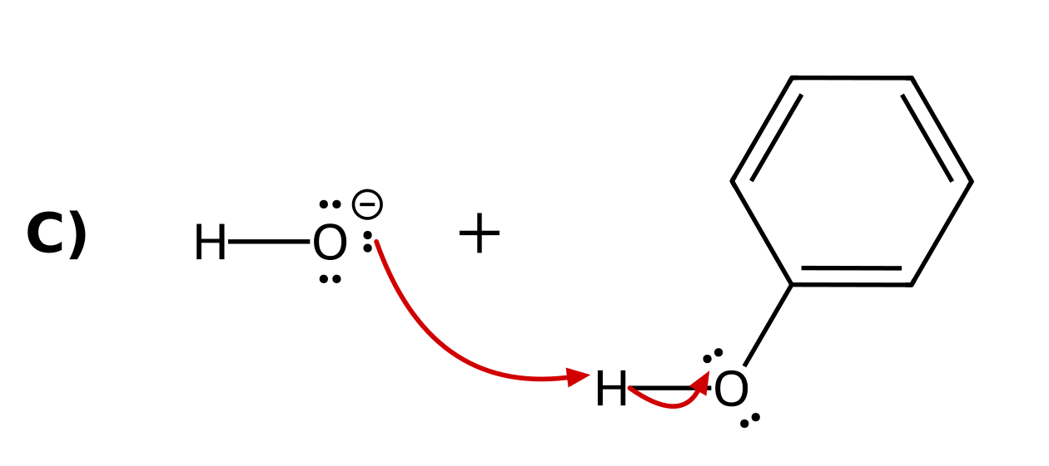
Why: A proton transfer always uses at least two arrows. Arrow 1 starts on a lone pair of the base (HO⁻) and ends on the H. Arrow 2 starts on the O–H bond and ends on the O of the acid, which becomes the conjugate base.
29. Answer: A (Equilibrium; Two-factor)
A) The reactants, because the alkynide (charge in an sp orbital) is more stable than the vinyl anion (charge in an sp² orbital)
Why: Both ions have the charge on carbon, with no resonance and no inductive effects, so only the orbital differs (factor 4). An sp orbital (50% s character) holds the lone pair closer to the nucleus than an sp² orbital (33% s), so the alkynide is more stable. The more stable ion is on the reactant side, so the reactants are favored.
30. Answer: B (Equilibrium; Challenge)
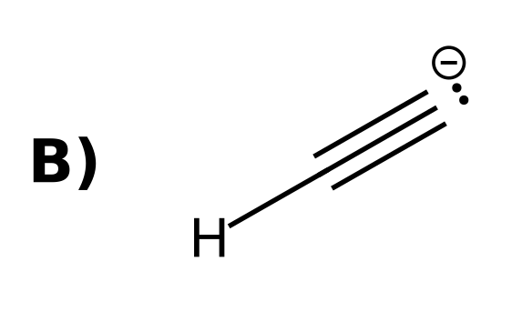
Why: Ethanol deprotonates to give ethoxide, so the base must be a less stable (stronger) base than ethoxide. Acetate (resonance), phenoxide (resonance), and CH₃S⁻ (larger atom) are all more stable than ethoxide. The alkynide ion has the charge on C and is less stable.

