Organic Chemistry Quiz: Acids, Bases and Nomenclature (Answer Key)
Quick key
Q | Answer | Focus | Level
1 | C | Atom | Direct
2 | B | Atom | Two-factor
3 | A | Atom | Two-factor
4 | B | Atom | Direct
5 | D | Resonance | Direct
6 | C | Resonance | Two-factor
7 | A | Resonance | Direct
8 | B | Resonance | Two-factor
9 | A | Resonance | Two-factor
10 | C | Resonance | Two-factor
11 | D | Resonance | Two-factor
12 | B | Induction | Two-factor
13 | A | Induction | Two-factor
14 | D | Induction | Two-factor
15 | C | Orbitals | Direct
16 | C | Orbitals | Direct
17 | B | Orbitals | Direct
18 | D | Competing factors | Challenge
19 | A | Competing factors | Challenge
20 | C | Competing factors | Challenge
21 | D | Competing factors | Challenge
22 | B | Competing factors | Two-factor
23 | A | Equilibrium | Two-factor
24 | D | Equilibrium | Two-factor
25 | B | Equilibrium | Challenge
26 | C | Equilibrium | Two-factor
27 | D | Equilibrium | Challenge
28 | C | Equilibrium | Two-factor
29 | A | Equilibrium | Two-factor
30 | B | Equilibrium | Challenge
31 | A | Nomenclature | Direct
32 | D | Nomenclature | Direct
33 | B | Nomenclature | Direct
34 | C | Nomenclature | Direct
35 | D | Nomenclature | Direct
36 | A | Nomenclature | Direct
37 | C | Nomenclature | Direct
38 | B | Nomenclature | Direct
39 | A | Nomenclature | Direct
40 | D | Nomenclature | Two-factor

Answer distribution: A = 10, B = 10, C = 10, D = 10

ARIO reminder
Priority order for comparing conjugate-base stability: (1) Atom (same row: electronegativity; same column: size), (2) Resonance, (3) Induction, (4) Orbital (sp > sp² > sp³). For equilibrium, the position favors the more stable ion (weaker base, weaker acid).
1. Answer: C (Atom; Direct)
C) H₃ (the O–H)
Why: Each conjugate base has its charge on a different atom: C, N or O. These are in the same row, so electronegativity decides. O is the most electronegative, so RO⁻ is the most stable base and the O–H is the most acidic.
2. Answer: B (Atom; Two-factor)
B) H₂ (the S–H), because S is larger than O and spreads the charge over a larger volume
Why: Compare RS⁻ with RO⁻. O and S are in the same column, so size is the dominant effect, not electronegativity. The larger S⁻ is more stable, so the S–H is more acidic.
3. Answer: A (Atom; Two-factor)
A) H₁ (the phenol O–H), because O is more electronegative than N
Why: H₁ and H₂ both give resonance-stabilized bases, so look at factor 1 first: the charge is on O in one and on N in the other. Same row, so the more electronegative O wins. H₃ and H₄ are C–H bonds, which is the weakest factor 1 outcome.
4. Answer: B (Atom; Direct)
B) II, because N is less electronegative than O, so the negative charge on N is less stable
Why: Both charges are in the same row of the periodic table, so electronegativity decides. N is less electronegative than O, so N⁻ is less stable (stronger base).
5. Answer: D (Resonance; Direct)
D) H₁ (the carboxylic acid O–H), because its conjugate base is resonance stabilized
Why: H₁ and H₂ both put the charge on O, so atom does not decide. The carboxylate is delocalized over two oxygens by resonance; the alkoxide is localized. H₃ is a C–H (atom favors O).
6. Answer: C (Resonance; Two-factor)
C) H₂ (the amide N–H)
Why: H₁ and H₂ are both N–H, so factor 1 ties. Deprotonating the amide N–H gives a base whose charge is delocalized onto the carbonyl O by resonance; the amine N⁻ is localized. H₃ and H₄ are C–H bonds and lose on factor 1.
7. Answer: A (Resonance; Direct)
A) H₁ (the phenol O–H), because the phenoxide charge is delocalized into the ring
Why: H₁ and H₂ both give O⁻, so factor 1 does not decide (H₃ is a C–H, which loses). Only the phenoxide is resonance stabilized; the benzylic alkoxide is not.
8. Answer: B (Resonance; Two-factor)
B) H₂ (the CH₂ between the two C=O groups)
Why: All four are C–H bonds, so factor 1 is a tie. Only removing H₂ gives a base whose charge is delocalized onto two carbonyl oxygens. H₁ gives a base delocalized onto only one.
9. Answer: A (Resonance; Two-factor)
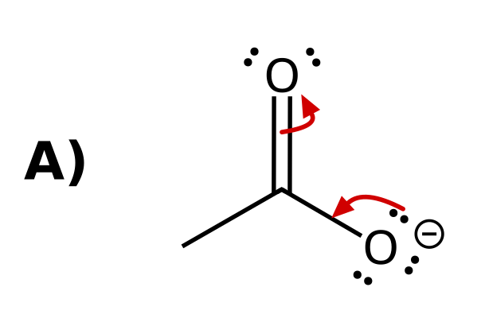
Why: Arrow 1 starts on a lone pair of O⁻ and ends between O and C (forming the C=O π bond). Arrow 2 starts on the C=O π bond and ends on the other O (becoming a lone pair). Every arrow goes from electrons to where the electrons end up.
10. Answer: C (Resonance; Two-factor)
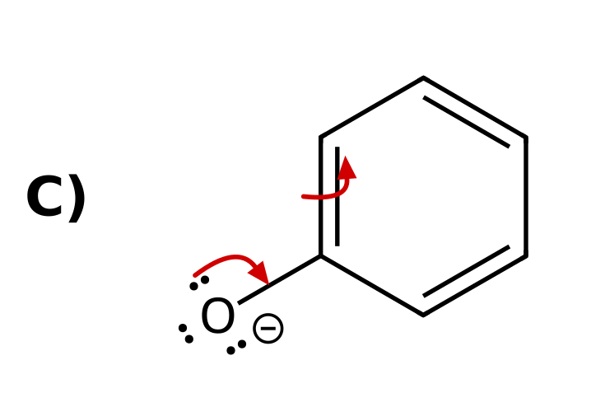
Why: Arrow 1: lone pair on O⁻ forms the C=O π bond. Arrow 2: the adjacent ring C=C π bond moves onto the ortho carbon as a lone pair. A single arrow leaves the ipso carbon with five bonds, and moving the electrons to a meta carbon is not a valid resonance shift. The delocalization of charge into the ring is why phenol is more acidic than an alcohol.
11. Answer: D (Resonance; Two-factor)
D) H₁ (the CH₂ hydrogen)
Why: All are C–H bonds. Removing H₁ gives the cyclopentadienyl anion, with the charge delocalized over five carbons by resonance. Removing a vinyl H (H₂ or H₃) puts the charge in an sp² orbital that does not overlap with the π system, so there is no resonance.
12. Answer: B (Induction; Two-factor)
B) I < II < III
Why: All three have the same atom and resonance. Cl withdraws electron density by induction and stabilizes the carboxylate. The effect weakens with distance: III (Cl on the α carbon) > II (Cl on the γ carbon) > I (no Cl).
13. Answer: A (Induction; Two-factor)
A) H₁, because the CF₃ groups stabilize the nearby alkoxide by induction
Why: Both conjugate bases have the charge on O with no resonance. The three F atoms on each CF₃ pull electron density through the σ bonds and stabilize the nearby O⁻. The other alkoxide is too far away to feel it.
14. Answer: D (Induction; Two-factor)
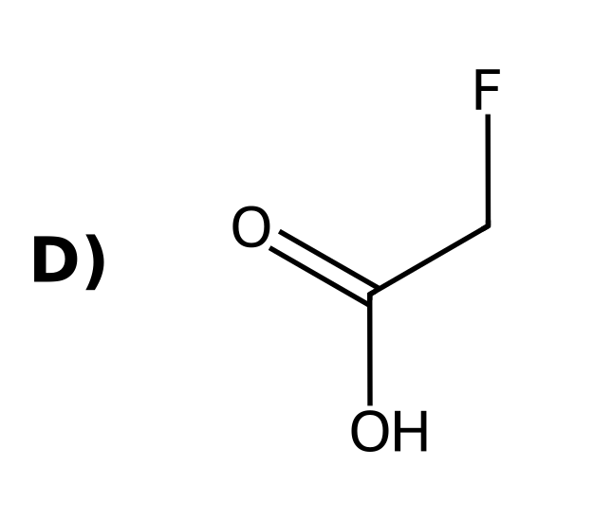
Why: Same atom, no change in resonance. The halogen on the α carbon withdraws electron density by induction. F is the most electronegative, so FCH₂CO₂⁻ is the most stabilized.
15. Answer: C (Orbitals; Direct)
C) H₁ (the alkyne H)
Why: All are C–H bonds, with no resonance or induction available. Only the orbital differs: sp (alkyne) > sp² (vinyl) > sp³ (alkyl). The sp orbital has the most s character, holding the lone pair closest to the nucleus.
16. Answer: C (Orbitals; Direct)
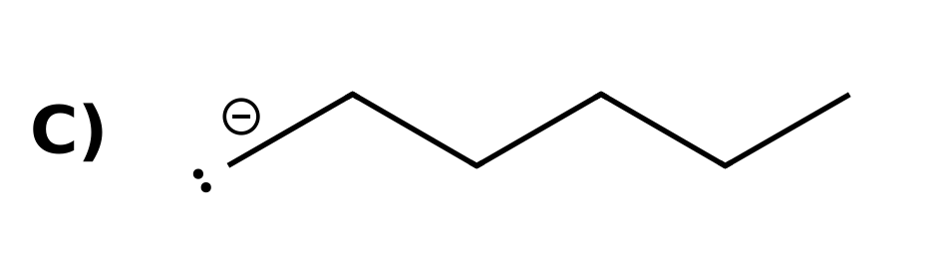
Why: The charge is on carbon in all three, with no resonance or induction. The orbital differs: the alkyl anion has the charge in an sp³ orbital (highest energy, least stable, strongest base). The alkynide is in an sp orbital (most stable, weakest base).
17. Answer: B (Orbitals; Direct)
B) The electron pair in the sp orbital is held closer to the nucleus, so the alkynide ion is more stable
Why: This is factor 4 (orbitals). An sp orbital is 50% s character, which is closer to the nucleus than the 33% s character of an sp² orbital, so the lone pair in an sp orbital is lower in energy.
18. Answer: D (Competing factors; Challenge)
D) H₁ in I (ethanol), because the atom (O vs. C) outranks resonance
Why: Propene's CH₃ gives a resonance-stabilized allyl anion, but the charge is on carbon. Ethoxide has the charge on O. The atom (factor 1) takes priority over resonance (factor 2).
19. Answer: A (Competing factors; Challenge)
A) H₁, because resonance outranks induction
Why: Both put the charge on O, so factor 1 ties. The carboxylate is resonance stabilized (factor 2); the alkoxide only has the inductive effect of CF₃ (factor 3). Resonance beats induction.
20. Answer: C (Competing factors; Challenge)
C) H₂, because the atom (O vs. C) outranks the orbital
Why: H₁ gives a carbanion on an sp carbon; H₂ gives an alkoxide. Atom comes before orbital: O⁻ is more stable than C⁻ even in an sp orbital.
21. Answer: D (Competing factors; Challenge)
D) I < II < III
Why: All three have the charge on O. III is resonance stabilized (factor 2), the strongest effect here. II has the inductive effect of three F atoms (factor 3), and I has neither.
22. Answer: B (Competing factors; Two-factor)
B) H₁ (the carboxylic acid O–H)
Why: H₁ puts the charge on O (factor 1) and the carboxylate is resonance stabilized. H₂ and H₃ put the charge on carbon, which loses on factor 1.
23. Answer: A (Equilibrium; Two-factor)
A) The products, because acetate is resonance stabilized and is the more stable anion
Why: The equilibrium favors the more stable ion. Both anions have O⁻, so compare resonance: acetate is delocalized over two O atoms, ethoxide is not. Acetate is the weaker base, so the products are favored.
24. Answer: D (Equilibrium; Two-factor)
D) The products, because the larger S atom stabilizes the charge better
Why: Compare HO⁻ with RS⁻. O and S are in the same column, so size decides. The larger RS⁻ is more stable (weaker base), so the equilibrium favors the products.
25. Answer: B (Equilibrium; Challenge)
B) The reactants, because ethoxide (O⁻) is more stable than the sp carbanion (C⁻)
Why: Compare RO⁻ with the alkynide. Atom (factor 1) before orbital (factor 4): O is more electronegative than C, so ethoxide is more stable. The reactants are favored.
26. Answer: C (Equilibrium; Two-factor)
C) The reactants, because phenoxide is resonance stabilized
Why: Both anions have O⁻, so compare resonance. Phenoxide is delocalized into the ring; ethoxide is not. The more stable anion (phenoxide) is on the reactant side, so the reactants are favored.
27. Answer: D (Equilibrium; Challenge)
D) The reactants, because CF₃CO₂⁻ is stabilized by induction
Why: Both anions are carboxylates, so atom and resonance tie. The three F atoms stabilize CF₃CO₂⁻ by induction (factor 3), so CF₃CO₂⁻ is more stable and the reactant side is favored.
28. Answer: C (Equilibrium; Two-factor)
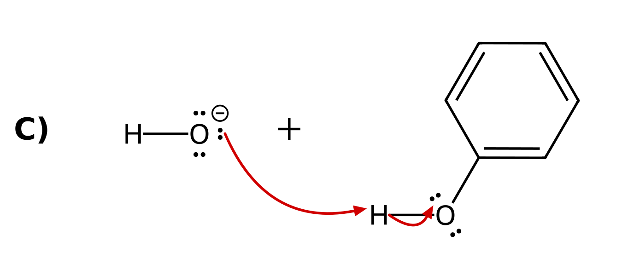
Why: A proton transfer always uses at least two arrows. Arrow 1 starts on a lone pair of the base (HO⁻) and ends on the H. Arrow 2 starts on the O–H bond and ends on the O of the acid, which becomes the conjugate base.
29. Answer: A (Equilibrium; Two-factor)
A) The reactants, because the alkynide (charge in an sp orbital) is more stable than the vinyl anion (charge in an sp² orbital)
Why: Both ions have the charge on carbon, with no resonance and no inductive effects, so only the orbital differs (factor 4). An sp orbital (50% s character) holds the lone pair closer to the nucleus than an sp² orbital (33% s), so the alkynide is more stable. The more stable ion is on the reactant side, so the reactants are favored.
30. Answer: B (Equilibrium; Challenge)
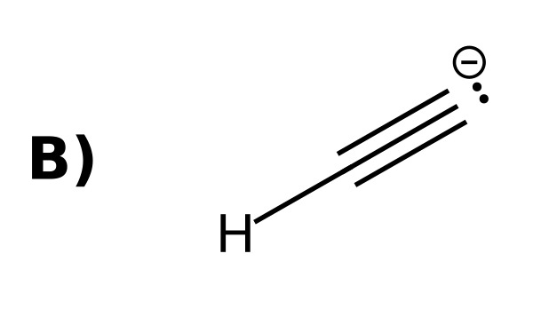
Why: Ethanol deprotonates to give ethoxide, so the base must be a less stable (stronger) base than ethoxide. Acetate (resonance), phenoxide (resonance), and CH₃S⁻ (larger atom) are all more stable than ethoxide. The alkynide ion has the charge on C and is less stable.
31. Answer: A (Nomenclature; Direct)
A) 2-methylpentane
Why: The longest chain has 5 carbons (pentane) with one methyl branch. Number from the end that gives the branch the lower number: 2-methylpentane, not 4-methylpentane.
32. Answer: D (Nomenclature; Direct)
D) 3-methylhexane
Why: The longest chain has 6 carbons (hexane). The methyl is on carbon 3 when numbered from the left and carbon 4 from the right, so use the lower number: 3-methylhexane.
33. Answer: B (Nomenclature; Direct)
B) 2,2-dimethylbutane
Why: The longest chain has 4 carbons (butane) with two methyl groups on the same carbon. Number from the end that gives them the lower number (2,2), and repeat the locant for each methyl.
34. Answer: C (Nomenclature; Direct)
C) 2,3-dimethylpentane
Why: The longest chain has 5 carbons (pentane) with two methyl branches. Numbering from the left gives locants 2,3; from the right it gives 3,4. Use 2,3 and combine the identical groups as dimethyl.
35. Answer: D (Nomenclature; Direct)
D) 3-ethylpentane
Why: The longest chain has 5 carbons: the central carbon can be reached by chains through any two of the three ethyl groups. The third ethyl is the branch on carbon 3: 3-ethylpentane. (Choosing a 6-carbon chain is not possible for this structure.)
36. Answer: A (Nomenclature; Direct)
A) 4-ethyl-2-methylhexane
Why: The longest chain has 6 carbons (hexane). Numbering from the left gives locants 2,4; from the right it gives 3,5, so use 2,4. List the substituents in alphabetical order: ethyl comes before methyl, so 4-ethyl-2-methylhexane.
37. Answer: C (Nomenclature; Direct)
C) 2,2,4-trimethylpentane
Why: The longest chain has 5 carbons (pentane) with three methyl groups. Numbering from the end that gives the lowest locants gives 2,2,4 (from the other end the set would be 2,4,4). Three identical groups use the prefix tri.
38. Answer: B (Nomenclature; Direct)
B) 3-ethyl-2-methylpentane
Why: The longest chain has 5 carbons (pentane). Numbering from the left gives the substituents locants 2 and 3; from the right they would be 3 and 4. Alphabetical order puts ethyl before methyl: 3-ethyl-2-methylpentane.
39. Answer: A (Nomenclature; Direct)
A) 2,5-dimethylhexane
Why: The longest chain has 6 carbons (hexane) with a methyl on each side. The molecule is symmetric, so both directions give 2,5. Combine the two identical groups as dimethyl: 2,5-dimethylhexane.
40. Answer: D (Nomenclature; Two-factor)
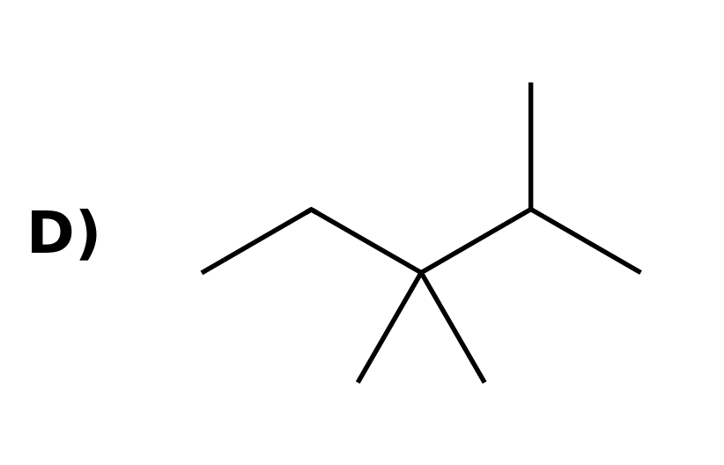
Why: Draw a 5-carbon chain and put one methyl on carbon 2 and two methyls on carbon 3. The other three choices are the isomers 2,2,3-trimethylpentane, 2,3,4-trimethylpentane and 2,2,4-trimethylpentane.

