Substitution and Elimination: Answer Key
Substitution reasoning follows the four-factor framework in Klein, Organic Chemistry, Ch. 7. Elimination items (E1/E2, Zaitsev/Hofmann, alcohol dehydration) use standard textbook conventions and were not checked against an elimination chapter; compare them with your text. Items are tagged in the source field of problems.json.
1. Choose the reagents (SN2; difficulty 1)
Q: What reagent(s) and solvent would convert iodomethane into ethanenitrile? Name the mechanism and justify your choice with the four factors (substrate, nucleophile, leaving group, solvent).
Answer: NaCN in DMSO (SN2).
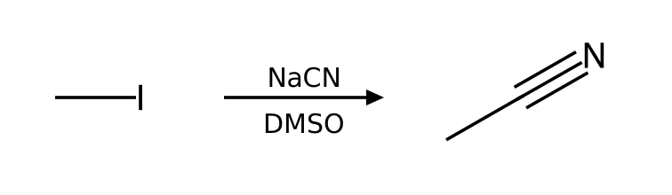
Why: Substrate: methyl alkyl halide; Leaving group: excellent leaving group (I); Nucleophile/base: cyanide is a strong nucleophile and a weak base; Solvent: DMSO is aprotic. These favor SN2.
2. Choose the reagents (SN2; difficulty 1)
Q: What reagent(s) and solvent would convert bromoethane into azidoethane? Name the mechanism and justify your choice with the four factors (substrate, nucleophile, leaving group, solvent).
Answer: NaN₃ in DMF (SN2).
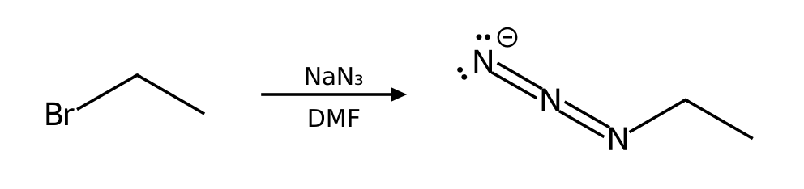
Why: Substrate: primary (1°) alkyl halide; Leaving group: good leaving group (Br); Nucleophile/base: azide is a strong nucleophile and a weak base; Solvent: DMF is aprotic. These favor SN2.
3. Choose the reagents (SN2; difficulty 1)
Q: What reagent(s) and solvent would convert 1-bromopropane into propane-1-thiol? Name the mechanism and justify your choice with the four factors (substrate, nucleophile, leaving group, solvent).
Answer: NaSH in DMSO (SN2).
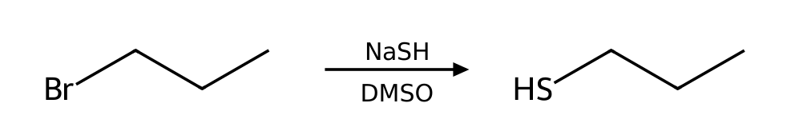
Why: Substrate: primary (1°) alkyl halide; Leaving group: good leaving group (Br); Nucleophile/base: hydrosulfide is a strong nucleophile and a weak base; Solvent: DMSO is aprotic. These favor SN2.
4. Choose the reagents (SN2; difficulty 1)
Q: What reagent(s) and solvent would convert 2-bromopropane into 2-methylpropanenitrile? Name the mechanism and justify your choice with the four factors (substrate, nucleophile, leaving group, solvent).
Answer: NaCN in DMSO (SN2).
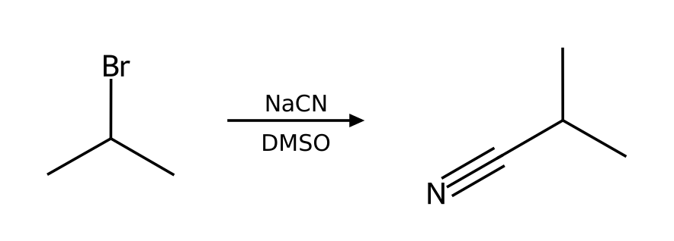
Why: Substrate: secondary (2°) alkyl halide; Leaving group: good leaving group (Br); Nucleophile/base: cyanide is a strong nucleophile and a weak base; Solvent: DMSO is aprotic. These favor SN2.
5. Choose the reagents (SN2; difficulty 1)
Q: What reagent(s) and solvent would convert 2-bromobutane into butane-2-thiol? Name the mechanism and justify your choice with the four factors (substrate, nucleophile, leaving group, solvent).
Answer: NaSH in DMSO (SN2).
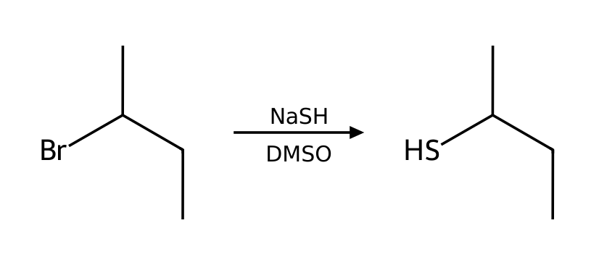
Why: Substrate: secondary (2°) alkyl halide; Leaving group: good leaving group (Br); Nucleophile/base: hydrosulfide is a strong nucleophile and a weak base; Solvent: DMSO is aprotic. These favor SN2.
6. Choose the reagents (SN1; difficulty 2)
Q: What reagent(s) and solvent would convert 2-bromo-2-methylpropane into 2-methylpropan-2-ol? Name the mechanism and justify your choice with the four factors (substrate, nucleophile, leaving group, solvent).
Answer: H₂o as the solvent (SN1).
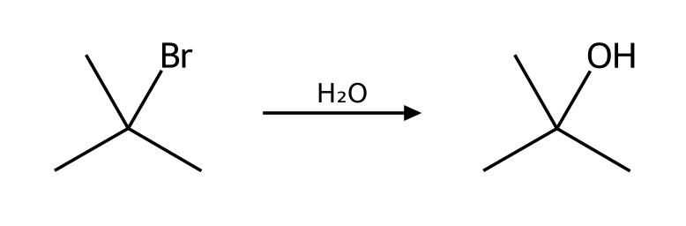
Why: Substrate: tertiary (3°) alkyl halide; Leaving group: good leaving group (Br); Nucleophile/base: water is a weak nucleophile and a weak base; Solvent: H2O is protic. These favor SN1. Competing pathway: E1 (minor; favored by heat).
7. Choose the reagents (E2; difficulty 2)
Q: What reagent(s) and solvent would convert 2-bromopropane into prop-1-ene? Name the mechanism and justify your choice with the four factors (substrate, nucleophile, leaving group, solvent).
Answer: NaOEt in EtOH with heat (E2).
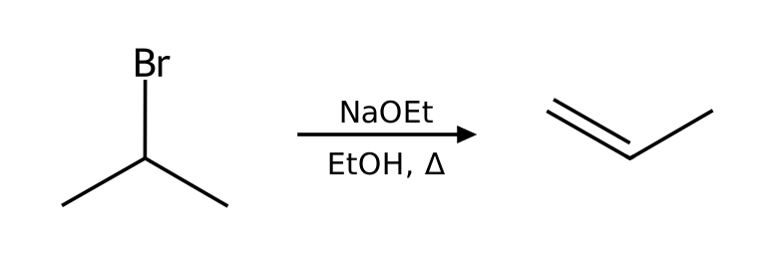
Why: Substrate: secondary (2°) alkyl halide; Leaving group: good leaving group (Br); Nucleophile/base: ethoxide is a strong nucleophile and a strong base; Solvent: EtOH is protic. These favor E2. Competing pathway: SN1/E1 do not compete under strongly basic conditions.
Source note: Standard elimination conventions (Zaitsev/Hofmann); not from the provided PDF
8. Choose the reagents (E2; difficulty 2)
Q: What reagent(s) and solvent would convert 2-bromobutane into (E)-but-2-ene? Name the mechanism and justify your choice with the four factors (substrate, nucleophile, leaving group, solvent).
Answer: NaOEt in EtOH with heat (E2).
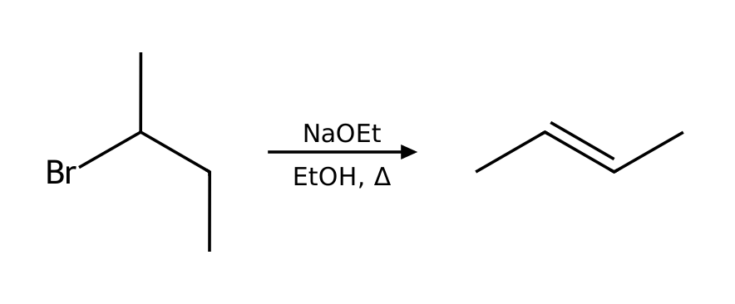
Why: Substrate: secondary (2°) alkyl halide; Leaving group: good leaving group (Br); Nucleophile/base: ethoxide is a strong nucleophile and a strong base; Solvent: EtOH is protic. These favor E2. Competing pathway: SN1/E1 do not compete under strongly basic conditions.
Source note: Standard elimination conventions (Zaitsev/Hofmann); not from the provided PDF
9. Choose the reagents (E2; difficulty 2)
Q: What reagent(s) and solvent would convert 2-bromo-2-methylbutane into 2-methylbut-1-ene? Name the mechanism and justify your choice with the four factors (substrate, nucleophile, leaving group, solvent).
Answer: KOtBu in tBuOH with heat (E2).
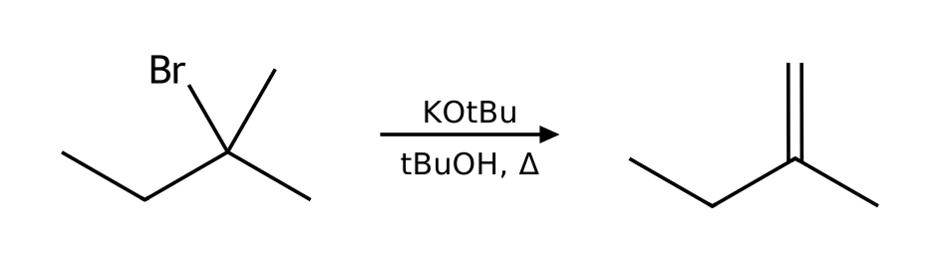
Why: Substrate: tertiary (3°) alkyl halide; Leaving group: good leaving group (Br); Nucleophile/base: tert-butoxide is a strong nucleophile and a strong base (bulky); Solvent: tBuOH is protic. These favor E2. Competing pathway: SN1/E1 do not compete under strongly basic conditions.
Source note: Standard elimination conventions (Zaitsev/Hofmann); not from the provided PDF
10. Choose the reagents (E2; difficulty 2)
Q: What reagent(s) and solvent would convert 2-iodobutane into but-1-ene? Name the mechanism and justify your choice with the four factors (substrate, nucleophile, leaving group, solvent).
Answer: KOtBu in tBuOH with heat (E2).
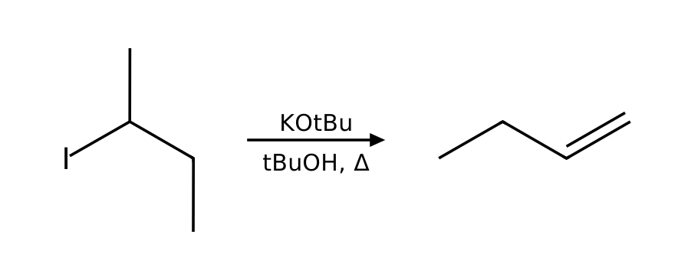
Why: Substrate: secondary (2°) alkyl halide; Leaving group: excellent leaving group (I); Nucleophile/base: tert-butoxide is a strong nucleophile and a strong base (bulky); Solvent: tBuOH is protic. These favor E2. Competing pathway: SN1/E1 do not compete under strongly basic conditions.
Source note: Standard elimination conventions (Zaitsev/Hofmann); not from the provided PDF
11. Predict the product (SN2; difficulty 2)
Q: Predict the major organic product of 1-iodobutane with NaCN in CH3CN. State the mechanism and any minor pathway.
Answer: pentanenitrile via SN2.
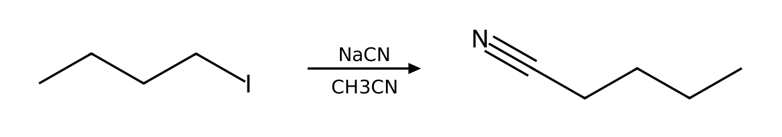
Why: Substrate: primary (1°) alkyl halide; Leaving group: excellent leaving group (I); Nucleophile/base: cyanide is a strong nucleophile and a weak base; Solvent: CH3CN is aprotic. These favor SN2.
12. Predict the product (SN2; difficulty 2)
Q: Predict the major organic product of 1-chlorobutane with NaI in acetone. State the mechanism and any minor pathway.
Answer: 1-iodobutane via SN2.
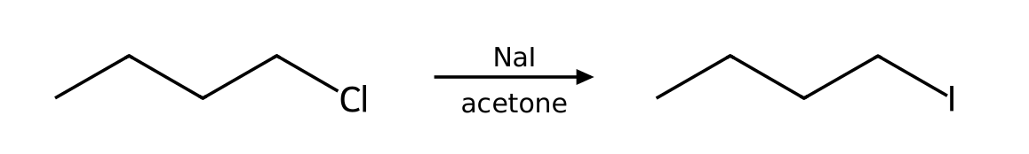
Why: Substrate: primary (1°) alkyl halide; Leaving group: good leaving group (Cl); Nucleophile/base: iodide is a strong nucleophile and a weak base; Solvent: acetone is aprotic. These favor SN2.
13. Predict the product (SN2; difficulty 2)
Q: Predict the major organic product of 1-bromopropane with NaOMe in MeOH. State the mechanism and any minor pathway.
Answer: 1-methoxypropane via SN2. Minor: E2 (minor).
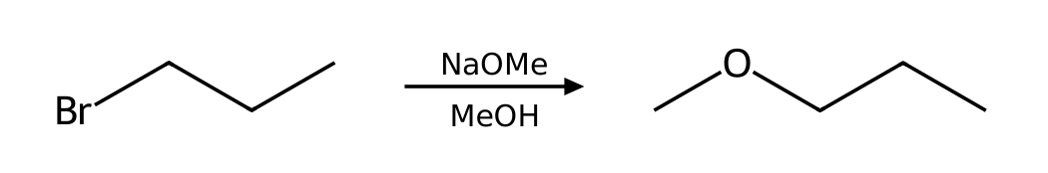
Why: Substrate: primary (1°) alkyl halide; Leaving group: good leaving group (Br); Nucleophile/base: methoxide is a strong nucleophile and a strong base; Solvent: MeOH is protic. These favor SN2. Competing pathway: E2 (minor).
14. Predict the product (SN2; difficulty 2)
Q: Predict the major organic product of 2-iodobutane with NaN₃ in DMF. State the mechanism and any minor pathway.
Answer: 2-azidobutane via SN2.
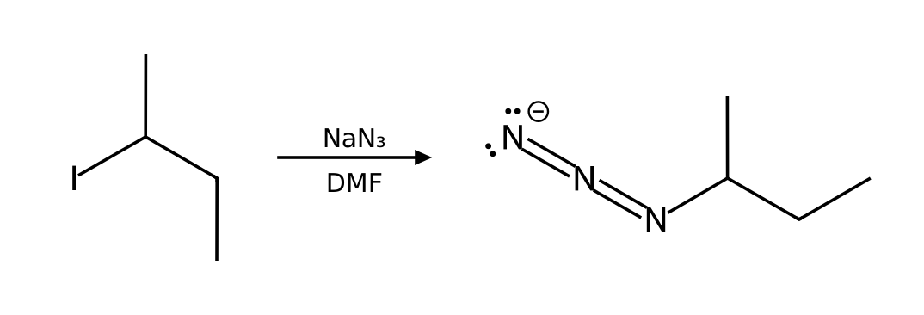
Why: Substrate: secondary (2°) alkyl halide; Leaving group: excellent leaving group (I); Nucleophile/base: azide is a strong nucleophile and a weak base; Solvent: DMF is aprotic. These favor SN2.
15. Predict the product (SN2; difficulty 2)
Q: Predict the major organic product of bromocyclohexane with NaN₃ in DMF. State the mechanism and any minor pathway.
Answer: azidocyclohexane via SN2.
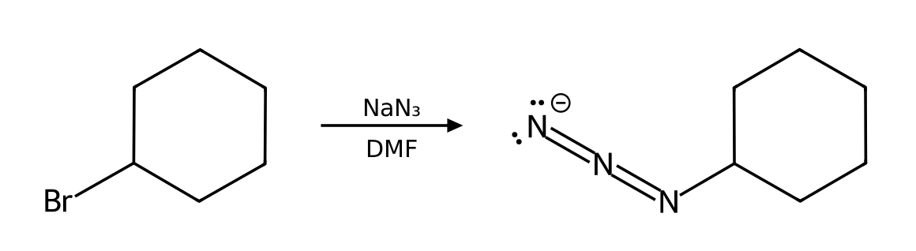
Why: Substrate: secondary (2°) alkyl halide; Leaving group: good leaving group (Br); Nucleophile/base: azide is a strong nucleophile and a weak base; Solvent: DMF is aprotic. These favor SN2.
16. Predict the product (SN1; difficulty 2)
Q: Predict the major organic product of 2-chloro-2-methylbutane with EtOH as the solvent. State the mechanism and any minor pathway.
Answer: 2-ethoxy-2-methylbutane via SN1. Minor: E1 (minor; favored by heat).
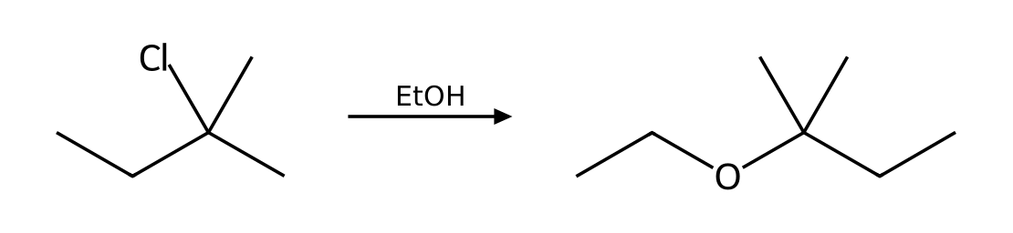
Why: Substrate: tertiary (3°) alkyl halide; Leaving group: good leaving group (Cl); Nucleophile/base: ethanol is a weak nucleophile and a weak base; Solvent: EtOH is protic. These favor SN1. Competing pathway: E1 (minor; favored by heat).
17. Predict the product (SN1; difficulty 2)
Q: Predict the major organic product of 1-bromo-1-methylcyclohexane with MeOH as the solvent. State the mechanism and any minor pathway.
Answer: 1-methoxy-1-methylcyclohexane via SN1. Minor: E1 (minor; favored by heat).
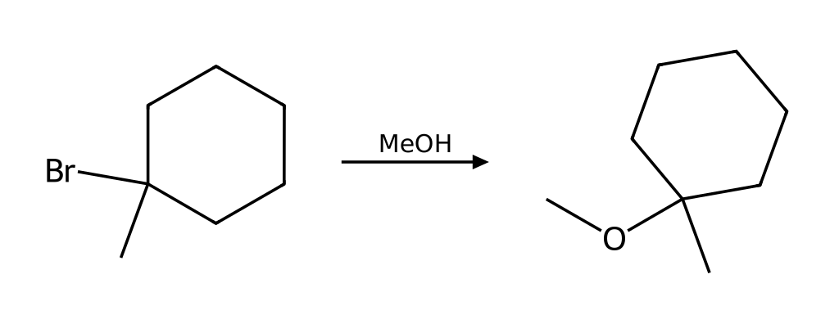
Why: Substrate: tertiary (3°) alkyl halide; Leaving group: good leaving group (Br); Nucleophile/base: methanol is a weak nucleophile and a weak base; Solvent: MeOH is protic. These favor SN1. Competing pathway: E1 (minor; favored by heat).
18. Predict the product (E2; difficulty 2)
Q: Predict the major organic product of 2-bromopentane with NaOH in EtOH. State the mechanism and any minor pathway.
Answer: (E)-pent-2-ene via E2. Minor: SN1/E1 do not compete under strongly basic conditions.
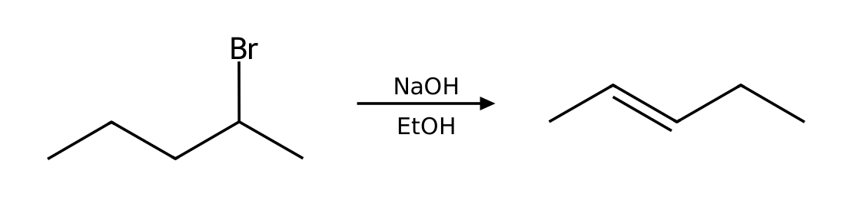
Why: Substrate: secondary (2°) alkyl halide; Leaving group: good leaving group (Br); Nucleophile/base: hydroxide is a strong nucleophile and a strong base; Solvent: EtOH is protic. These favor E2. Competing pathway: SN1/E1 do not compete under strongly basic conditions.
Source note: Standard elimination conventions (Zaitsev/Hofmann); not from the provided PDF
19. Predict the product (E2; difficulty 2)
Q: Predict the major organic product of bromocyclohexane with NaOEt in EtOH. State the mechanism and any minor pathway.
Answer: cyclohexene via E2. Minor: SN1/E1 do not compete under strongly basic conditions.
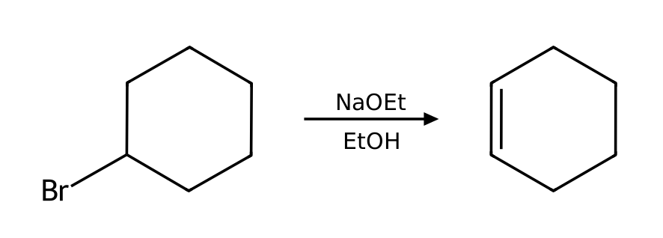
Why: Substrate: secondary (2°) alkyl halide; Leaving group: good leaving group (Br); Nucleophile/base: ethoxide is a strong nucleophile and a strong base; Solvent: EtOH is protic. These favor E2. Competing pathway: SN1/E1 do not compete under strongly basic conditions.
Source note: Standard elimination conventions (Zaitsev/Hofmann); not from the provided PDF
20. Predict the product (E2; difficulty 2)
Q: Predict the major organic product of 1-bromo-1-methylcyclohexane with KOtBu in tBuOH. State the mechanism and any minor pathway.
Answer: methylenecyclohexane via E2. Minor: SN1/E1 do not compete under strongly basic conditions.
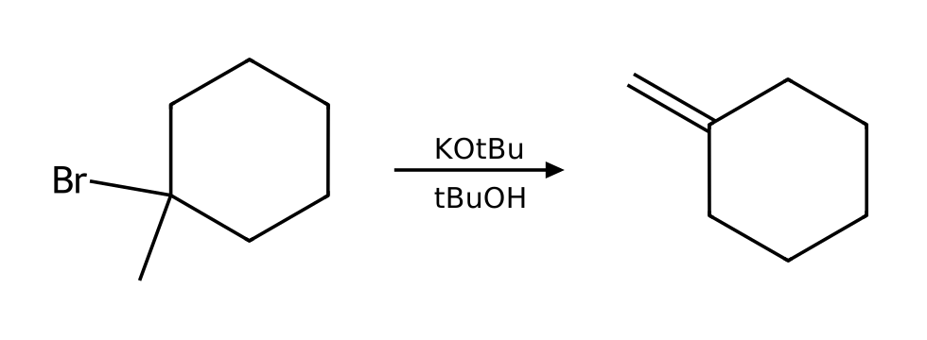
Why: Substrate: tertiary (3°) alkyl halide; Leaving group: good leaving group (Br); Nucleophile/base: tert-butoxide is a strong nucleophile and a strong base (bulky); Solvent: tBuOH is protic. These favor E2. Competing pathway: SN1/E1 do not compete under strongly basic conditions.
Source note: Standard elimination conventions (Zaitsev/Hofmann); not from the provided PDF
21. Identify the mechanism (SN2; difficulty 2)
Q: Which mechanism (SN1, SN2, E1 or E2) predominates when bromoethane reacts with NaN₃ in DMF? List the factors that support your answer and give the major product.
Answer: SN2. Major product: azidoethane.
Why: Substrate: primary (1°) alkyl halide; Leaving group: good leaving group (Br); Nucleophile/base: azide is a strong nucleophile and a weak base; Solvent: DMF is aprotic. These favor SN2.
22. Identify the mechanism (SN2; difficulty 2)
Q: Which mechanism (SN1, SN2, E1 or E2) predominates when 1-bromobutane reacts with NaOAc in DMF? List the factors that support your answer and give the major product.
Answer: SN2. Major product: butyl ethanoate.
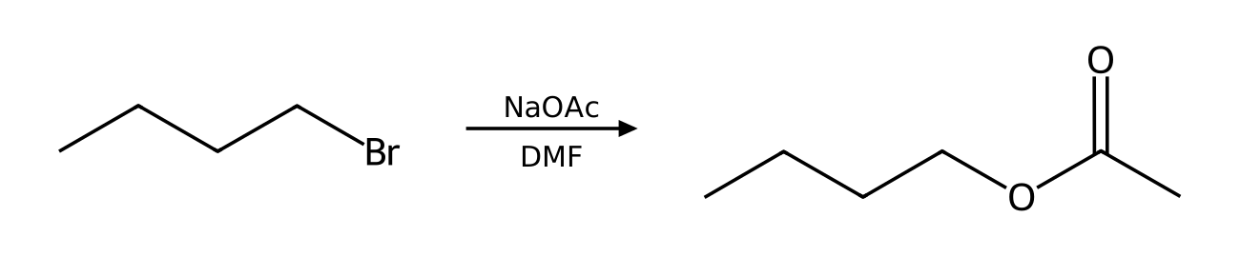
Why: Substrate: primary (1°) alkyl halide; Leaving group: good leaving group (Br); Nucleophile/base: acetate is a weak nucleophile and a weak base; Solvent: DMF is aprotic. These favor SN2.
23. Identify the mechanism (SN1; difficulty 2)
Q: Which mechanism (SN1, SN2, E1 or E2) predominates when 3-bromo-3-methylpentane reacts with EtOH as the solvent? List the factors that support your answer and give the major product.
Answer: SN1. Major product: 3-ethoxy-3-methylpentane.
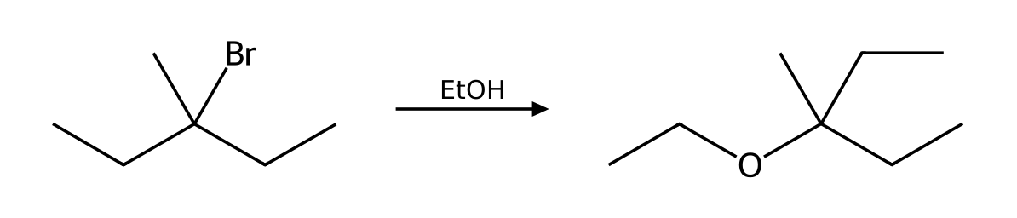
Why: Substrate: tertiary (3°) alkyl halide; Leaving group: good leaving group (Br); Nucleophile/base: ethanol is a weak nucleophile and a weak base; Solvent: EtOH is protic. These favor SN1. Competing pathway: E1 (minor; favored by heat).
24. Identify the mechanism (SN1; difficulty 2)
Q: Which mechanism (SN1, SN2, E1 or E2) predominates when 2-iodo-2-methylpropane reacts with CH₃CO₂H as the solvent? List the factors that support your answer and give the major product.
Answer: SN1. Major product: tert-butyl ethanoate.
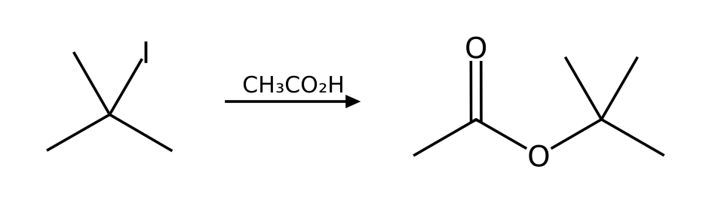
Why: Substrate: tertiary (3°) alkyl halide; Leaving group: excellent leaving group (I); Nucleophile/base: acetic acid is a weak nucleophile and a weak base; Solvent: AcOH is protic. These favor SN1. Competing pathway: E1 (minor; favored by heat).
25. Identify the mechanism (E2; difficulty 2)
Q: Which mechanism (SN1, SN2, E1 or E2) predominates when 2-bromopentane reacts with NaOH in EtOH? List the factors that support your answer and give the major product.
Answer: E2. Major product: (E)-pent-2-ene.
Why: Substrate: secondary (2°) alkyl halide; Leaving group: good leaving group (Br); Nucleophile/base: hydroxide is a strong nucleophile and a strong base; Solvent: EtOH is protic. These favor E2. Competing pathway: SN1/E1 do not compete under strongly basic conditions.
Source note: Standard elimination conventions (Zaitsev/Hofmann); not from the provided PDF
26. Identify the mechanism (E2; difficulty 2)
Q: Which mechanism (SN1, SN2, E1 or E2) predominates when 1-bromopropane reacts with KOtBu in tBuOH? List the factors that support your answer and give the major product.
Answer: E2. Major product: prop-1-ene.
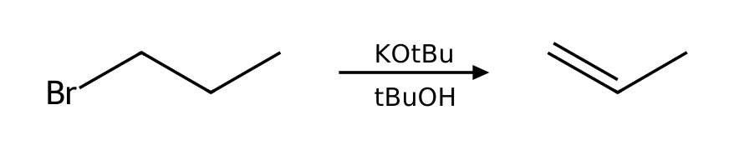
Why: Substrate: primary (1°) alkyl halide; Leaving group: good leaving group (Br); Nucleophile/base: tert-butoxide is a strong nucleophile and a strong base (bulky); Solvent: tBuOH is protic. These favor E2. Competing pathway: SN2 (minor).
Source note: Standard elimination conventions (Zaitsev/Hofmann); not from the provided PDF
27. Identify the mechanism (E2; difficulty 2)
Q: Which mechanism (SN1, SN2, E1 or E2) predominates when 3-bromo-3-methylpentane reacts with NaOMe in MeOH? List the factors that support your answer and give the major product.
Answer: E2. Major product: 3-methylpent-2-ene.
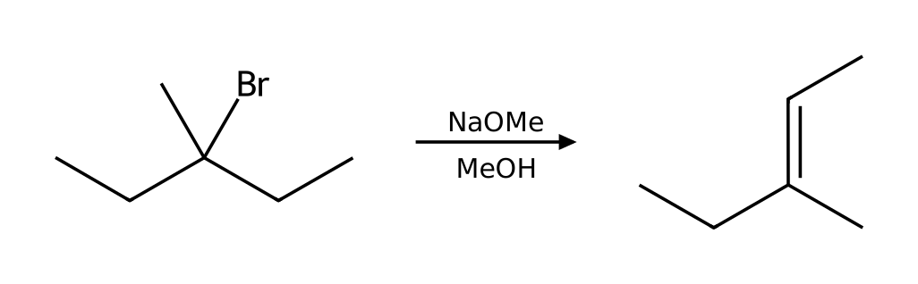
Why: Substrate: tertiary (3°) alkyl halide; Leaving group: good leaving group (Br); Nucleophile/base: methoxide is a strong nucleophile and a strong base; Solvent: MeOH is protic. These favor E2. Competing pathway: SN1/E1 do not compete under strongly basic conditions.
Source note: Standard elimination conventions (Zaitsev/Hofmann); not from the provided PDF
28. Identify the mechanism (SN2; difficulty 2)
Q: Which mechanism (SN1, SN2, E1 or E2) predominates when 1-chlorobutane reacts with NaI in acetone? List the factors that support your answer and give the major product.
Answer: SN2. Major product: 1-iodobutane.
Why: Substrate: primary (1°) alkyl halide; Leaving group: good leaving group (Cl); Nucleophile/base: iodide is a strong nucleophile and a weak base; Solvent: acetone is aprotic. These favor SN2.
29. Identify the mechanism (E2; difficulty 2)
Q: Which mechanism (SN1, SN2, E1 or E2) predominates when 2-bromo-2-methylbutane reacts with NaOEt in EtOH? List the factors that support your answer and give the major product.
Answer: E2. Major product: 2-methylbut-2-ene.
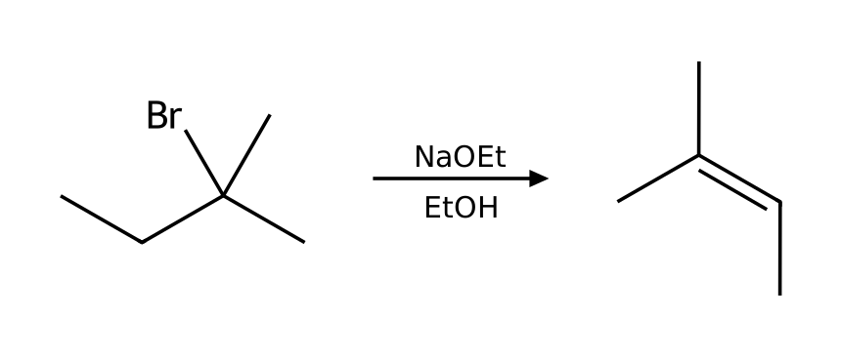
Why: Substrate: tertiary (3°) alkyl halide; Leaving group: good leaving group (Br); Nucleophile/base: ethoxide is a strong nucleophile and a strong base; Solvent: EtOH is protic. These favor E2. Competing pathway: SN1/E1 do not compete under strongly basic conditions.
Source note: Standard elimination conventions (Zaitsev/Hofmann); not from the provided PDF
30. Stereochemistry (SN2; difficulty 2)
Q: Draw the product of (S)-2-bromobutane with NaSH in DMSO. Give the configuration (R or S) of the substrate and the product and explain the stereochemical outcome.
Answer: (R)-butane-2-thiol: inversion of configuration (S → R).
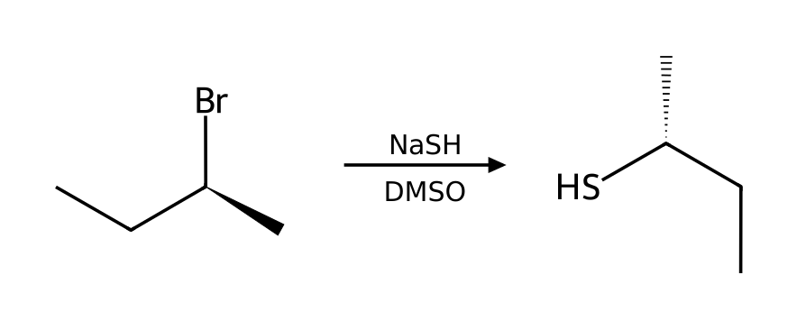
Why: SN2 proceeds by back-side attack, so the α carbon inverts like an umbrella in the wind. Note that the R/S label changes only if the CIP priorities keep the same order; the geometry always inverts. Substrate: secondary (2°) alkyl halide; Leaving group: good leaving group (Br); Nucleophile/base: hydrosulfide is a strong nucleophile and a weak base; Solvent: DMSO is aprotic. These favor SN2.
31. Stereochemistry (SN2; difficulty 2)
Q: Draw the product of (S)-2-chloropentane with NaCN in DMSO. Give the configuration (R or S) of the substrate and the product and explain the stereochemical outcome.
Answer: (R)-2-methylpentanenitrile: inversion of configuration (S → R).
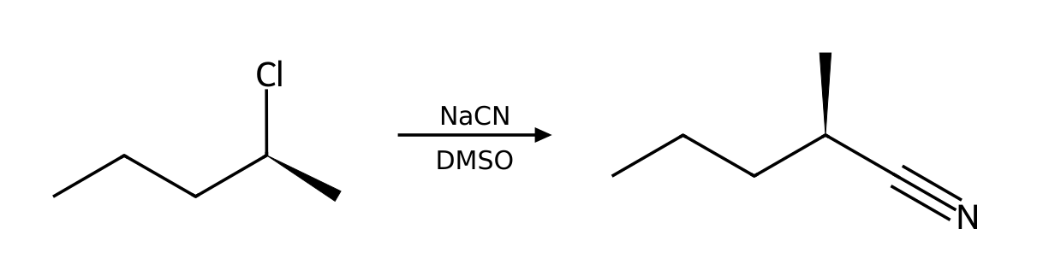
Why: SN2 proceeds by back-side attack, so the α carbon inverts like an umbrella in the wind. Note that the R/S label changes only if the CIP priorities keep the same order; the geometry always inverts. Substrate: secondary (2°) alkyl halide; Leaving group: good leaving group (Cl); Nucleophile/base: cyanide is a strong nucleophile and a weak base; Solvent: DMSO is aprotic. These favor SN2.
32. Stereochemistry (SN2; difficulty 2)
Q: Draw the product of (R)-3-iodohexane with NaN₃ in DMF. Give the configuration (R or S) of the substrate and the product and explain the stereochemical outcome.
Answer: (S)-3-azidohexane: inversion of configuration (R → S).
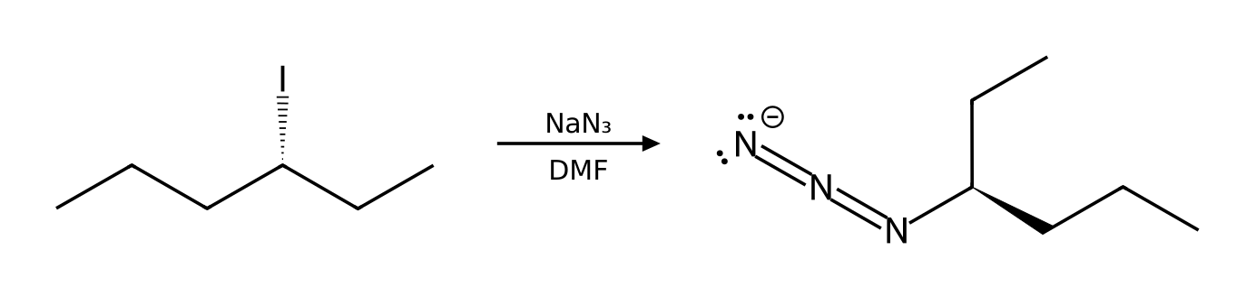
Why: SN2 proceeds by back-side attack, so the α carbon inverts like an umbrella in the wind. Note that the R/S label changes only if the CIP priorities keep the same order; the geometry always inverts. Substrate: secondary (2°) alkyl halide; Leaving group: excellent leaving group (I); Nucleophile/base: azide is a strong nucleophile and a weak base; Solvent: DMF is aprotic. These favor SN2.
33. Stereochemistry (SN2; difficulty 2)
Q: Draw the product of (R)-2-bromohexane with NaI in acetone. Give the configuration (R or S) of the substrate and the product and explain the stereochemical outcome.
Answer: (S)-2-iodohexane: inversion of configuration (R → S).
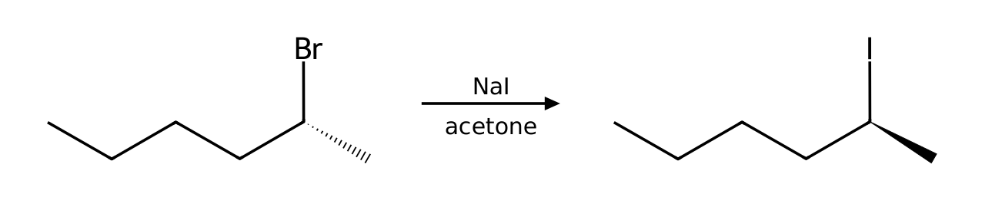
Why: SN2 proceeds by back-side attack, so the α carbon inverts like an umbrella in the wind. Note that the R/S label changes only if the CIP priorities keep the same order; the geometry always inverts. Substrate: secondary (2°) alkyl halide; Leaving group: good leaving group (Br); Nucleophile/base: iodide is a strong nucleophile and a weak base; Solvent: acetone is aprotic. These favor SN2.
34. Stereochemistry (SN1; difficulty 3)
Q: (R)-3-bromo-3-methylhexane reacts with MeOH as the solvent. Draw the product(s), including stereochemistry, and explain why the result differs from an SN2 reaction.
Answer: Both enantiomers form: (S)-3-methoxy-3-methylhexane (inversion, slightly in excess because of ion pairing) and (R)-3-methoxy-3-methylhexane (retention).
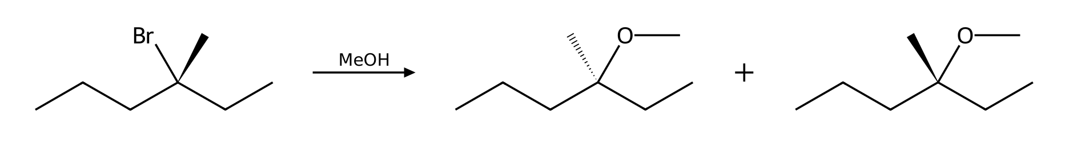
Why: The leaving group departs first to give a planar carbocation, which the solvent attacks from either face, so the stereocenter racemizes. Substrate: tertiary (3°) alkyl halide; Leaving group: good leaving group (Br); Nucleophile/base: methanol is a weak nucleophile and a weak base; Solvent: MeOH is protic. These favor SN1. Competing pathway: E1 (minor; favored by heat).
35. Stereochemistry (SN1; difficulty 3)
Q: (S)-3-chloro-3-methylhexane reacts with EtOH as the solvent. Draw the product(s), including stereochemistry, and explain why the result differs from an SN2 reaction.
Answer: Both enantiomers form: (R)-3-ethoxy-3-methylhexane (inversion, slightly in excess because of ion pairing) and (S)-3-ethoxy-3-methylhexane (retention).
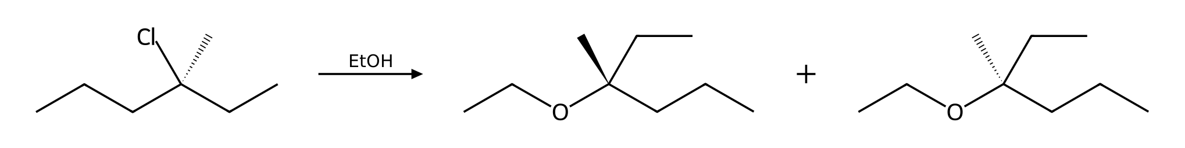
Why: The leaving group departs first to give a planar carbocation, which the solvent attacks from either face, so the stereocenter racemizes. Substrate: tertiary (3°) alkyl halide; Leaving group: good leaving group (Cl); Nucleophile/base: ethanol is a weak nucleophile and a weak base; Solvent: EtOH is protic. These favor SN1. Competing pathway: E1 (minor; favored by heat).
36. Stereochemistry (SN1; difficulty 3)
Q: (S)-3-bromo-3-methylhexane reacts with H₂O as the solvent. Draw the product(s), including stereochemistry, and explain why the result differs from an SN2 reaction.
Answer: Both enantiomers form: (R)-3-methylhexan-3-ol (inversion, slightly in excess because of ion pairing) and (S)-3-methylhexan-3-ol (retention).
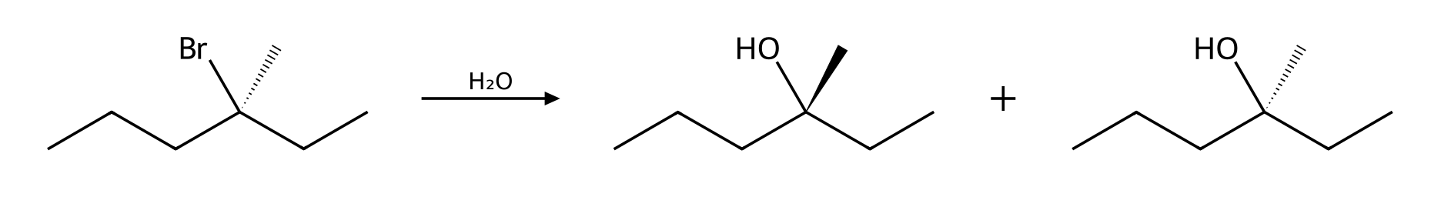
Why: The leaving group departs first to give a planar carbocation, which the solvent attacks from either face, so the stereocenter racemizes. Substrate: tertiary (3°) alkyl halide; Leaving group: good leaving group (Br); Nucleophile/base: water is a weak nucleophile and a weak base; Solvent: H2O is protic. These favor SN1. Competing pathway: E1 (minor; favored by heat).
37. Stereochemistry (E2; difficulty 3)
Q: (S)-2-bromobutane is treated with NaOEt in EtOH. What is the major product? Does the stereocenter of the starting material appear in the product?
Answer: (E)-but-2-ene (Zaitsev, trans); the product has no stereocenter, so the configuration of the substrate is lost.
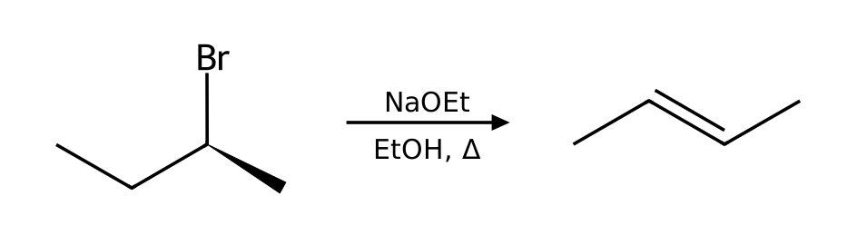
Why: Substrate: secondary (2°) alkyl halide; Leaving group: good leaving group (Br); Nucleophile/base: ethoxide is a strong nucleophile and a strong base; Solvent: EtOH is protic. These favor E2. Competing pathway: SN1/E1 do not compete under strongly basic conditions. Anti-periplanar elimination; the more stable trans (E) alkene predominates.
Source note: Standard elimination conventions (Zaitsev/Hofmann); not from the provided PDF
38. Draw the mechanism (SN2; difficulty 3)
Q: Describe the complete mechanism (list each step and the curved arrows) for the reaction of bromoethane with NaN₃ in DMF. How many steps are there?
Answer: (1) One concerted step: the nucleophile attacks the α carbon from the back side while the leaving group departs (inversion).
Why: Each ionic mechanism is built from nucleophilic attack, loss of a leaving group, proton transfer and rearrangement. Substrate: primary (1°) alkyl halide; Leaving group: good leaving group (Br); Nucleophile/base: azide is a strong nucleophile and a weak base; Solvent: DMF is aprotic. These favor SN2.
39. Draw the mechanism (SN2; difficulty 3)
Q: Describe the complete mechanism (list each step and the curved arrows) for the reaction of 1-bromopropane with NaOMe in MeOH. How many steps are there?
Answer: (1) One concerted step: the nucleophile attacks the α carbon from the back side while the leaving group departs (inversion).
Why: Each ionic mechanism is built from nucleophilic attack, loss of a leaving group, proton transfer and rearrangement. Substrate: primary (1°) alkyl halide; Leaving group: good leaving group (Br); Nucleophile/base: methoxide is a strong nucleophile and a strong base; Solvent: MeOH is protic. These favor SN2. Competing pathway: E2 (minor).
40. Draw the mechanism (SN1; difficulty 3)
Q: Describe the complete mechanism (list each step and the curved arrows) for the reaction of 2-bromo-2-methylpropane with H₂O as the solvent. How many steps are there?
Answer: (1) Loss of the leaving group gives a planar carbocation (rate-determining step). (2) Nucleophilic attack on the carbocation (either face). (3) Proton transfer removes the positive charge from the oxonium ion.
Why: Each ionic mechanism is built from nucleophilic attack, loss of a leaving group, proton transfer and rearrangement. Substrate: tertiary (3°) alkyl halide; Leaving group: good leaving group (Br); Nucleophile/base: water is a weak nucleophile and a weak base; Solvent: H2O is protic. These favor SN1. Competing pathway: E1 (minor; favored by heat).
41. Draw the mechanism (SN1; difficulty 3)
Q: Describe the complete mechanism (list each step and the curved arrows) for the reaction of 2-chloro-2-methylbutane with EtOH as the solvent. How many steps are there?
Answer: (1) Loss of the leaving group gives a planar carbocation (rate-determining step). (2) Nucleophilic attack on the carbocation (either face). (3) Proton transfer removes the positive charge from the oxonium ion.
Why: Each ionic mechanism is built from nucleophilic attack, loss of a leaving group, proton transfer and rearrangement. Substrate: tertiary (3°) alkyl halide; Leaving group: good leaving group (Cl); Nucleophile/base: ethanol is a weak nucleophile and a weak base; Solvent: EtOH is protic. These favor SN1. Competing pathway: E1 (minor; favored by heat).
42. Draw the mechanism (E2; difficulty 3)
Q: Describe the complete mechanism (list each step and the curved arrows) for the reaction of 2-bromobutane with NaOEt in EtOH. How many steps are there?
Answer: (1) One concerted step: the base removes a β hydrogen (anti to the leaving group) as the π bond forms and the leaving group departs.
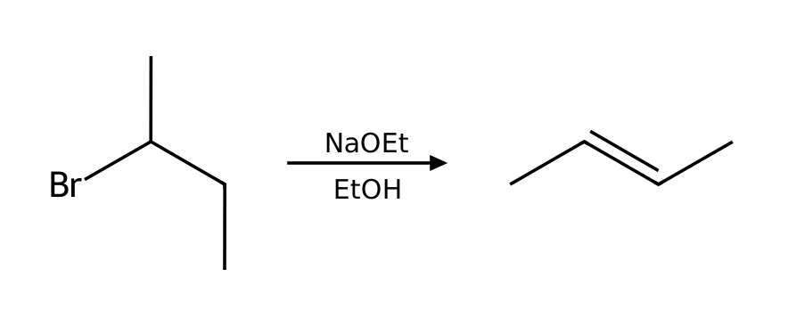
Why: Each ionic mechanism is built from nucleophilic attack, loss of a leaving group, proton transfer and rearrangement. Substrate: secondary (2°) alkyl halide; Leaving group: good leaving group (Br); Nucleophile/base: ethoxide is a strong nucleophile and a strong base; Solvent: EtOH is protic. These favor E2. Competing pathway: SN1/E1 do not compete under strongly basic conditions.
Source note: Standard elimination conventions (Zaitsev/Hofmann); not from the provided PDF
43. Draw the mechanism (SN2; difficulty 3)
Q: Describe the complete mechanism (list each step and the curved arrows) for the reaction of 2-bromobutane with NaSH in DMSO. How many steps are there?
Answer: (1) One concerted step: the nucleophile attacks the α carbon from the back side while the leaving group departs (inversion).
Why: Each ionic mechanism is built from nucleophilic attack, loss of a leaving group, proton transfer and rearrangement. Substrate: secondary (2°) alkyl halide; Leaving group: good leaving group (Br); Nucleophile/base: hydrosulfide is a strong nucleophile and a weak base; Solvent: DMSO is aprotic. These favor SN2.
44. Draw the mechanism (SN2; difficulty 3)
Q: Describe the complete mechanism (list each step and the curved arrows) for the reaction of 1-bromo-2,2-dimethylpropane with EtOH as the solvent. How many steps are there?
Answer: (1) One concerted step: the nucleophile attacks the α carbon from the back side while the leaving group departs (inversion). (2) Proton transfer: a base removes the proton from the positively charged nucleophile atom.
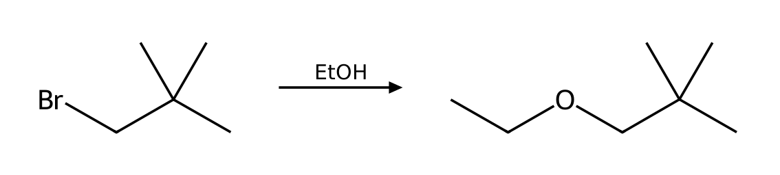
Why: Each ionic mechanism is built from nucleophilic attack, loss of a leaving group, proton transfer and rearrangement. Substrate: primary (1°) alkyl halide; Leaving group: good leaving group (Br); Nucleophile/base: ethanol is a weak nucleophile and a weak base; Solvent: EtOH is protic. These favor SN2. Competing pathway: none significant (slow solvolysis).
45. Draw the mechanism (SN1; difficulty 3)
Q: Describe the complete mechanism (list each step and the curved arrows) for the reaction of 2-bromo-2-methylbutane with MeOH as the solvent. How many steps are there?
Answer: (1) Loss of the leaving group gives a planar carbocation (rate-determining step). (2) Nucleophilic attack on the carbocation (either face). (3) Proton transfer removes the positive charge from the oxonium ion.
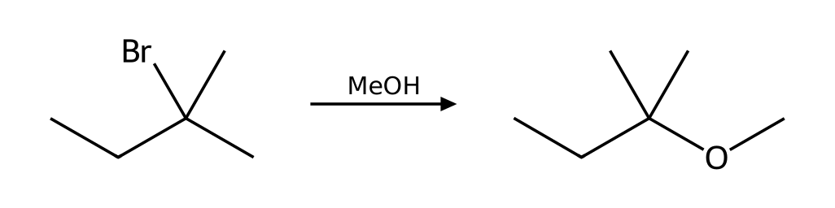
Why: Each ionic mechanism is built from nucleophilic attack, loss of a leaving group, proton transfer and rearrangement. Substrate: tertiary (3°) alkyl halide; Leaving group: good leaving group (Br); Nucleophile/base: methanol is a weak nucleophile and a weak base; Solvent: MeOH is protic. These favor SN1. Competing pathway: E1 (minor; favored by heat).
46. What went wrong (SN2/E2; difficulty 2)
Q: A student predicts an SN2 reaction to give a nitrile. Reaction: 2-bromo-2-methylpropane + NaCN in DMSO. Explain what is wrong and give the correct outcome.
Answer: No SN2: a tertiary carbon is too hindered for back-side attack. Cyanide is a weak base but the only feasible path is E2, giving 2-methylpropene (isobutylene).
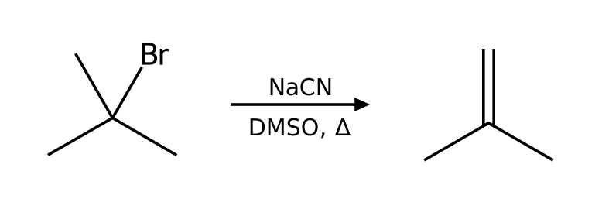
Why: Apply the four factors in order: substrate, nucleophile/base, leaving group, solvent.
47. What went wrong (SN2/E2; difficulty 2)
Q: A student says a primary halide always reacts quickly by SN2. Reaction: 1-bromo-2,2-dimethylpropane + NaOH in DMSO. Explain what is wrong and give the correct outcome.
Answer: Neopentyl bromide is primary but the three β methyl groups block back-side attack; SN2 is extremely slow (like a tertiary substrate). The primary carbocation is also too unstable for SN1.
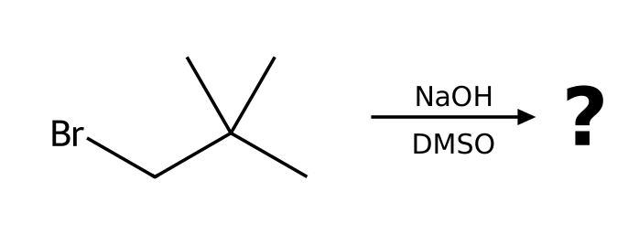
Why: Apply the four factors in order: substrate, nucleophile/base, leaving group, solvent.
48. What went wrong (SN2/E2; difficulty 2)
Q: A student predicts substitution to give vinyl alcohol. Reaction: bromoethene (vinyl bromide) + NaOH in DMSO. Explain what is wrong and give the correct outcome.
Answer: Vinyl halides do not react by SN2 (sp² carbon, back side blocked) or SN1 (unstable vinyl cation). No substitution occurs.
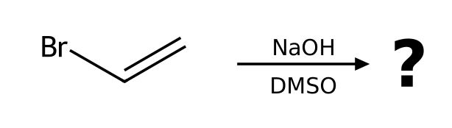
Why: Apply the four factors in order: substrate, nucleophile/base, leaving group, solvent.
49. What went wrong (SN2/E2; difficulty 2)
Q: A student predicts benzonitrile. Reaction: bromobenzene + NaCN in DMSO. Explain what is wrong and give the correct outcome.
Answer: Aryl halides do not undergo SN2 or SN1: back-side attack is impossible and the phenyl cation is unstable. No reaction under these conditions.
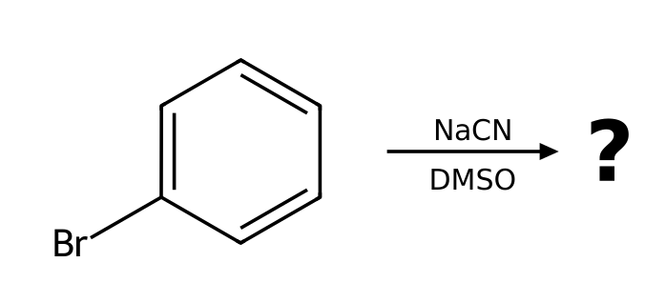
Why: Apply the four factors in order: substrate, nucleophile/base, leaving group, solvent.
50. What went wrong (SN2/E2; difficulty 2)
Q: A student predicts 1-bromobutane. Reaction: butan-1-ol + NaBr in DMF. Explain what is wrong and give the correct outcome.
Answer: Hydroxide is a poor leaving group (strong base), so bromide cannot displace it. The OH must first be protonated (HBr) or converted to a tosylate or bromide with PBr₃.
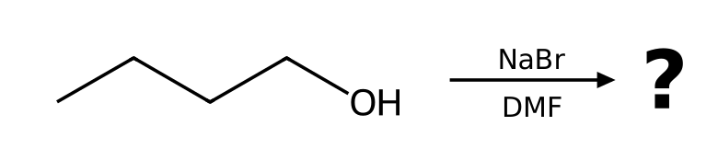
Why: Apply the four factors in order: substrate, nucleophile/base, leaving group, solvent.
51. What went wrong (SN2/E2; difficulty 2)
Q: A student predicts the ether 2-ethoxybutane by SN2. Reaction: 2-bromobutane + NaOEt in EtOH. Explain what is wrong and give the correct outcome.
Answer: Ethoxide is a strong base and the substrate is secondary, so E2 predominates: (E)-but-2-ene is the major product with some but-1-ene.
Why: Apply the four factors in order: substrate, nucleophile/base, leaving group, solvent.
52. What went wrong (SN2/E2; difficulty 2)
Q: A student predicts butanenitrile. Reaction: 1-fluoropropane + NaCN in DMSO. Explain what is wrong and give the correct outcome.
Answer: Fluoride is a poor leaving group (conjugate base of a weak acid, HF), so no SN2 reaction occurs at a useful rate.
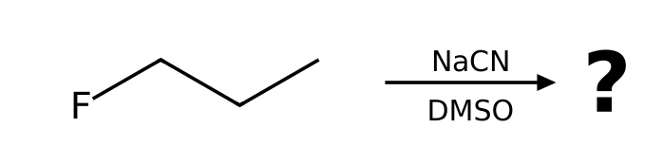
Why: Apply the four factors in order: substrate, nucleophile/base, leaving group, solvent.
53. Compare two conditions (SN2 vs E2; difficulty 3)
Q: 2-bromopropane is treated under two different conditions: (a) NaCN in DMSO; (b) NaOEt in EtOH with heat. For each, name the mechanism and the major product.
Answer: (a) SN2: 2-methylpropanenitrile. (b) E2: prop-1-ene.
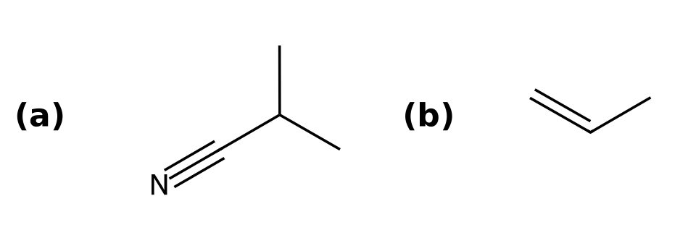
Why: (a) Substrate: secondary (2°) alkyl halide; Leaving group: good leaving group (Br); Nucleophile/base: cyanide is a strong nucleophile and a weak base; Solvent: DMSO is aprotic. These favor SN2. (b) Substrate: secondary (2°) alkyl halide; Leaving group: good leaving group (Br); Nucleophile/base: ethoxide is a strong nucleophile and a strong base; Solvent: EtOH is protic. These favor E2.
Source note: Standard elimination conventions (Zaitsev/Hofmann); not from the provided PDF
54. Compare two conditions (SN1 vs E2; difficulty 3)
Q: 2-bromo-2-methylbutane is treated under two different conditions: (a) EtOH in EtOH; (b) NaOEt in EtOH with heat. For each, name the mechanism and the major product.
Answer: (a) SN1: 2-ethoxy-2-methylbutane. (b) E2: 2-methylbut-2-ene.
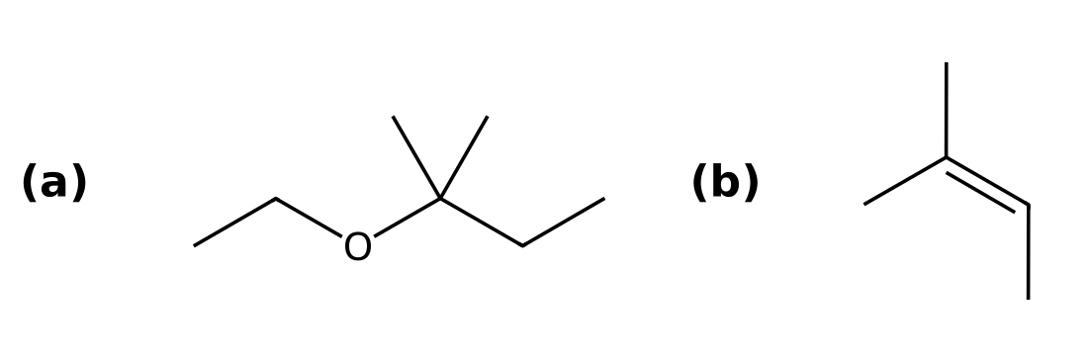
Why: (a) Substrate: tertiary (3°) alkyl halide; Leaving group: good leaving group (Br); Nucleophile/base: ethanol is a weak nucleophile and a weak base; Solvent: EtOH is protic. These favor SN1. (b) Substrate: tertiary (3°) alkyl halide; Leaving group: good leaving group (Br); Nucleophile/base: ethoxide is a strong nucleophile and a strong base; Solvent: EtOH is protic. These favor E2.
Source note: Standard elimination conventions (Zaitsev/Hofmann); not from the provided PDF
55. Compare two conditions (SN2 vs E2; difficulty 3)
Q: 1-bromopropane is treated under two different conditions: (a) NaOEt in EtOH; (b) KOtBu in tBuOH. For each, name the mechanism and the major product.
Answer: (a) SN2: 1-ethoxypropane. (b) E2: prop-1-ene.
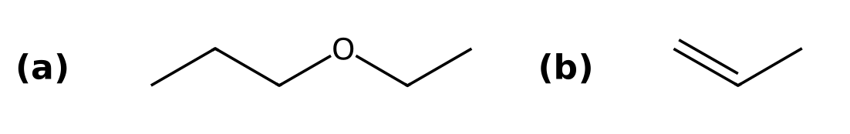
Why: (a) Substrate: primary (1°) alkyl halide; Leaving group: good leaving group (Br); Nucleophile/base: ethoxide is a strong nucleophile and a strong base; Solvent: EtOH is protic. These favor SN2. (b) Substrate: primary (1°) alkyl halide; Leaving group: good leaving group (Br); Nucleophile/base: tert-butoxide is a strong nucleophile and a strong base (bulky); Solvent: tBuOH is protic. These favor E2.
Source note: Standard elimination conventions (Zaitsev/Hofmann); not from the provided PDF
56. Compare two conditions (SN2 vs E2; difficulty 3)
Q: 2-bromobutane is treated under two different conditions: (a) NaN₃ in DMF; (b) KOtBu in tBuOH. For each, name the mechanism and the major product.
Answer: (a) SN2: 2-azidobutane. (b) E2: but-1-ene.
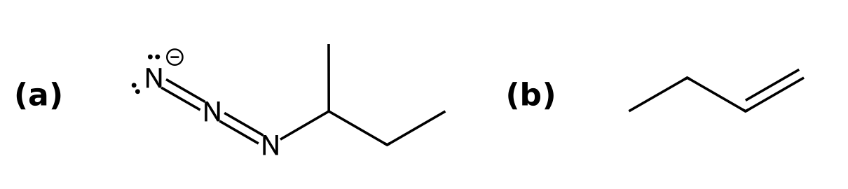
Why: (a) Substrate: secondary (2°) alkyl halide; Leaving group: good leaving group (Br); Nucleophile/base: azide is a strong nucleophile and a weak base; Solvent: DMF is aprotic. These favor SN2. (b) Substrate: secondary (2°) alkyl halide; Leaving group: good leaving group (Br); Nucleophile/base: tert-butoxide is a strong nucleophile and a strong base (bulky); Solvent: tBuOH is protic. These favor E2.
Source note: Standard elimination conventions (Zaitsev/Hofmann); not from the provided PDF
57. Compare two conditions (SN1 vs E2; difficulty 3)
Q: 2-bromo-2-methylpropane is treated under two different conditions: (a) H₂O in H2O; (b) NaOH in EtOH with heat. For each, name the mechanism and the major product.
Answer: (a) SN1: 2-methylpropan-2-ol. (b) E2: 2-methylprop-1-ene.
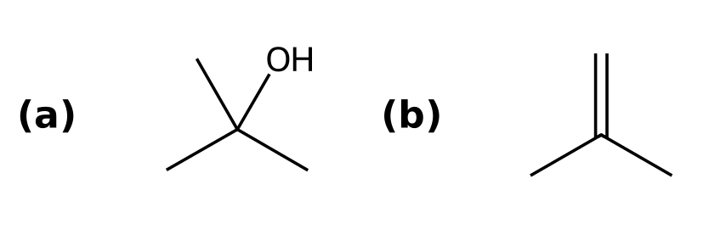
Why: (a) Substrate: tertiary (3°) alkyl halide; Leaving group: good leaving group (Br); Nucleophile/base: water is a weak nucleophile and a weak base; Solvent: H2O is protic. These favor SN1. (b) Substrate: tertiary (3°) alkyl halide; Leaving group: good leaving group (Br); Nucleophile/base: hydroxide is a strong nucleophile and a strong base; Solvent: EtOH is protic. These favor E2.
Source note: Standard elimination conventions (Zaitsev/Hofmann); not from the provided PDF
58. Compare two conditions (SN2 vs E2; difficulty 3)
Q: bromocyclohexane is treated under two different conditions: (a) NaSH in DMSO; (b) NaOMe in MeOH with heat. For each, name the mechanism and the major product.
Answer: (a) SN2: SC1CCCCC1. (b) E2: cyclohexene.
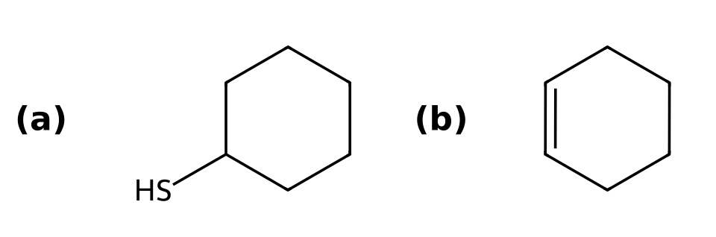
Why: (a) Substrate: secondary (2°) alkyl halide; Leaving group: good leaving group (Br); Nucleophile/base: hydrosulfide is a strong nucleophile and a weak base; Solvent: DMSO is aprotic. These favor SN2. (b) Substrate: secondary (2°) alkyl halide; Leaving group: good leaving group (Br); Nucleophile/base: methoxide is a strong nucleophile and a strong base; Solvent: MeOH is protic. These favor E2.
Source note: Standard elimination conventions (Zaitsev/Hofmann); not from the provided PDF
59. Functional group conversion (SN2; difficulty 2)
Q: Propose reagents to convert (S)-butan-2-ol into (R)-2-bromobutane. Explain why the OH group cannot simply be displaced, and state the stereochemical outcome if there is a stereocenter.
Answer: PBr3 (SN2). Inversion at the stereocenter.
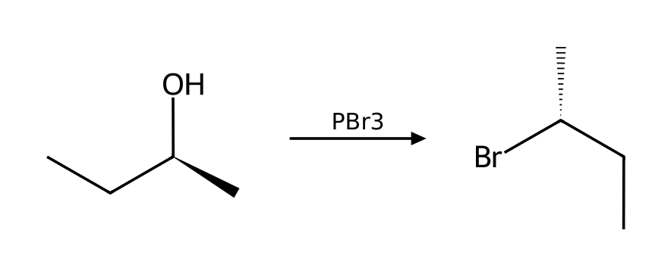
Why: Hydroxide is a bad leaving group, so the OH must be activated first: protonated by HX (SN1 for tertiary, SN2 for primary), or converted to a tosylate (TsCl/pyridine) or halide (PBr₃, SOCl₂) for SN2. Tosylate formation does not touch the stereocenter, so one inversion occurs in the substitution step.
60. Functional group conversion (SN1; difficulty 2)
Q: Propose reagents to convert 2-methylpropan-2-ol into 2-bromo-2-methylpropane. Explain why the OH group cannot simply be displaced, and state the stereochemical outcome if there is a stereocenter.
Answer: HBr (SN1).
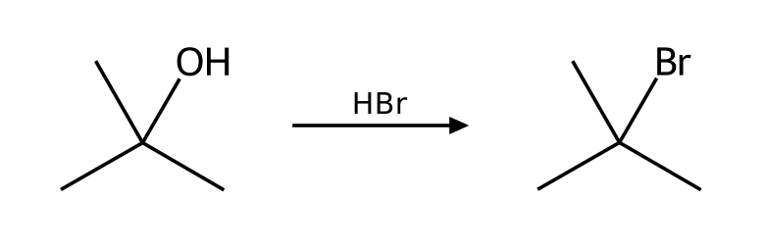
Why: Hydroxide is a bad leaving group, so the OH must be activated first: protonated by HX (SN1 for tertiary, SN2 for primary), or converted to a tosylate (TsCl/pyridine) or halide (PBr₃, SOCl₂) for SN2. Tosylate formation does not touch the stereocenter, so one inversion occurs in the substitution step.
61. Functional group conversion (SN2; difficulty 2)
Q: Propose reagents to convert butan-1-ol into 1-bromobutane. Explain why the OH group cannot simply be displaced, and state the stereochemical outcome if there is a stereocenter.
Answer: HBr (SN2).
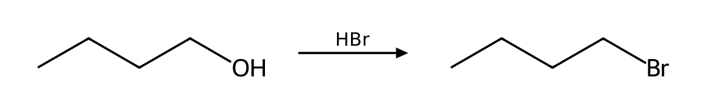
Why: Hydroxide is a bad leaving group, so the OH must be activated first: protonated by HX (SN1 for tertiary, SN2 for primary), or converted to a tosylate (TsCl/pyridine) or halide (PBr₃, SOCl₂) for SN2. Tosylate formation does not touch the stereocenter, so one inversion occurs in the substitution step.
62. Functional group conversion (SN2; difficulty 2)
Q: Propose reagents to convert propan-2-ol into 2-chloropropane. Explain why the OH group cannot simply be displaced, and state the stereochemical outcome if there is a stereocenter.
Answer: SOCl2, pyridine (SN2).
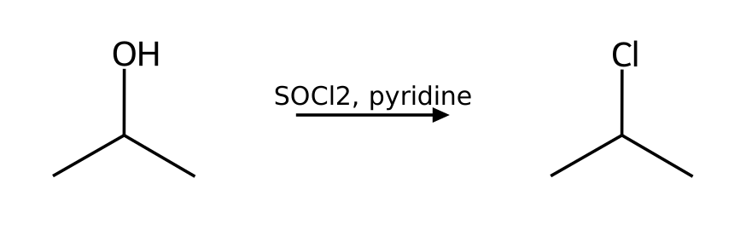
Why: Hydroxide is a bad leaving group, so the OH must be activated first: protonated by HX (SN1 for tertiary, SN2 for primary), or converted to a tosylate (TsCl/pyridine) or halide (PBr₃, SOCl₂) for SN2. Tosylate formation does not touch the stereocenter, so one inversion occurs in the substitution step.
63. Functional group conversion (SN2; difficulty 2)
Q: Propose reagents to convert (R)-pentan-2-ol into (S)-2-methylpentanenitrile. Explain why the OH group cannot simply be displaced, and state the stereochemical outcome if there is a stereocenter.
Answer: TsCl, pyridine; then NaCN, DMSO (SN2). Inversion at the stereocenter.
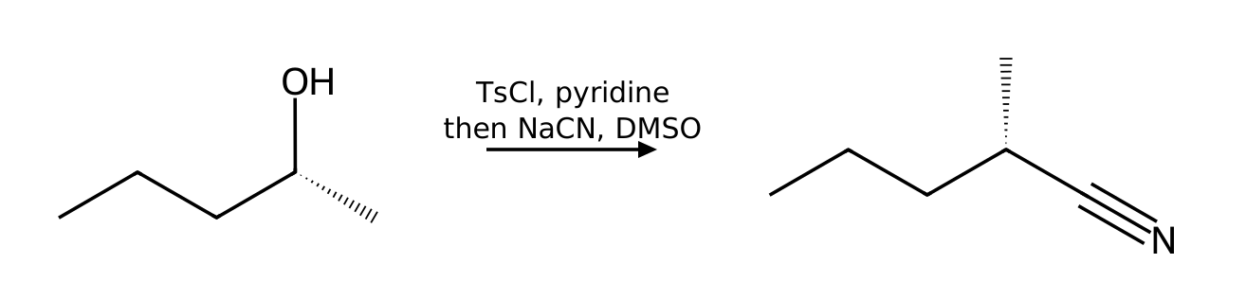
Why: Hydroxide is a bad leaving group, so the OH must be activated first: protonated by HX (SN1 for tertiary, SN2 for primary), or converted to a tosylate (TsCl/pyridine) or halide (PBr₃, SOCl₂) for SN2. Tosylate formation does not touch the stereocenter, so one inversion occurs in the substitution step.
64. Functional group conversion (SN2; difficulty 2)
Q: Propose reagents to convert butan-1-ol into 1-azidobutane. Explain why the OH group cannot simply be displaced, and state the stereochemical outcome if there is a stereocenter.
Answer: TsCl, pyridine; then NaN3, DMF (SN2).
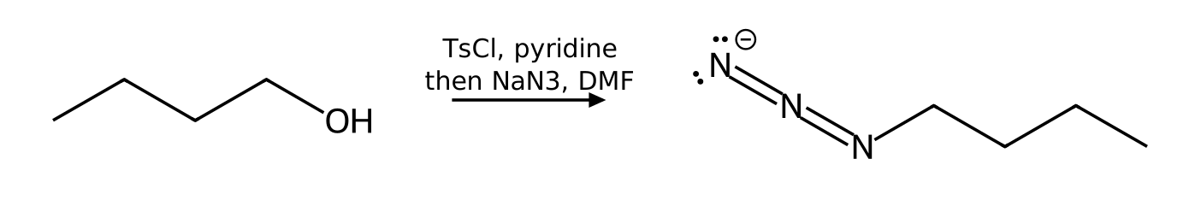
Why: Hydroxide is a bad leaving group, so the OH must be activated first: protonated by HX (SN1 for tertiary, SN2 for primary), or converted to a tosylate (TsCl/pyridine) or halide (PBr₃, SOCl₂) for SN2. Tosylate formation does not touch the stereocenter, so one inversion occurs in the substitution step.
65. Carbocation rearrangement (SN1; difficulty 3)
Q: Will 2-bromo-3-methylbutane rearrange when heated in EtOH? Show the carbocation that forms, the shift involved, and the major substitution product.
Answer: Yes: hydride shift converts the initial cation into a more stable tertiary cation; major product 2-ethoxy-2-methylbutane.
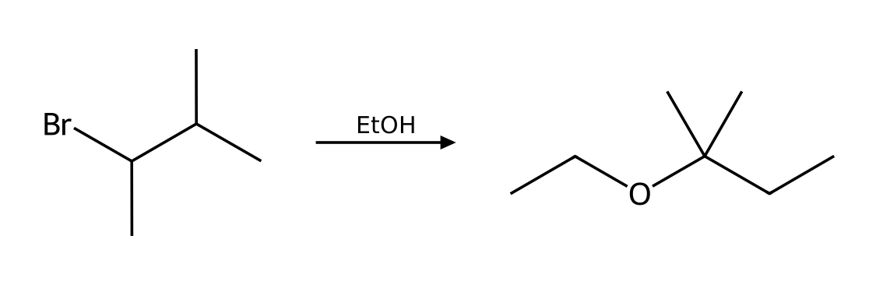
Why: (1) Loss of the leaving group gives a planar carbocation (rate-determining step). (2) Carbocation rearrangement (hydride shift) gives a more stable carbocation. (3) Nucleophilic attack on the carbocation (either face). (4) Proton transfer removes the positive charge from the oxonium ion. Substrate: secondary (2°) alkyl halide; Leaving group: good leaving group (Br); Nucleophile/base: ethanol is a weak nucleophile and a weak base; Solvent: EtOH is protic. These favor SN1.
66. Carbocation rearrangement (SN2; difficulty 3)
Q: Will 1-bromo-2,2-dimethylpropane rearrange when heated in EtOH? Show the carbocation that forms, the shift involved, and the major substitution product.
Answer: Yes: methyl shift converts the initial cation into a more stable tertiary cation; major product 1-ethoxy-2,2-dimethylpropane.
Why: (1) One concerted step: the nucleophile attacks the α carbon from the back side while the leaving group departs (inversion). (2) Proton transfer: a base removes the proton from the positively charged nucleophile atom. Substrate: primary (1°) alkyl halide; Leaving group: good leaving group (Br); Nucleophile/base: ethanol is a weak nucleophile and a weak base; Solvent: EtOH is protic. These favor SN2.
67. Carbocation rearrangement (SN1; difficulty 3)
Q: Will 3-bromo-2,2-dimethylbutane rearrange when heated in MeOH? Show the carbocation that forms, the shift involved, and the major substitution product.
Answer: Yes: methyl shift converts the initial cation into a more stable tertiary cation; major product 2-methoxy-2,3-dimethylbutane.
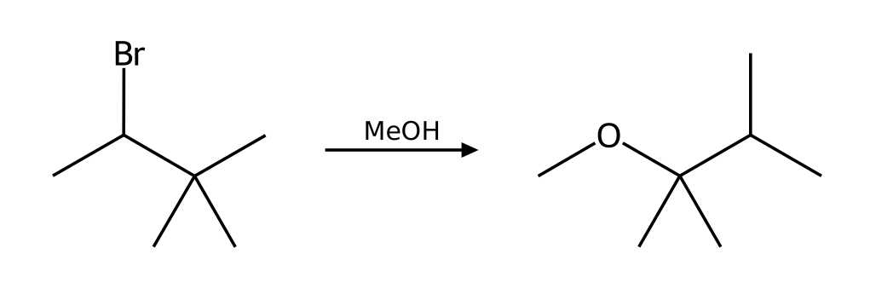
Why: (1) Loss of the leaving group gives a planar carbocation (rate-determining step). (2) Carbocation rearrangement (methyl shift) gives a more stable carbocation. (3) Nucleophilic attack on the carbocation (either face). (4) Proton transfer removes the positive charge from the oxonium ion. Substrate: secondary (2°) alkyl halide; Leaving group: good leaving group (Br); Nucleophile/base: methanol is a weak nucleophile and a weak base; Solvent: MeOH is protic. These favor SN1.
68. Carbocation rearrangement (SN1; difficulty 3)
Q: Will 2-bromo-3-methylpentane rearrange when heated in MeOH? Show the carbocation that forms, the shift involved, and the major substitution product.
Answer: Yes: hydride shift converts the initial cation into a more stable tertiary cation; major product 3-methoxy-3-methylpentane.
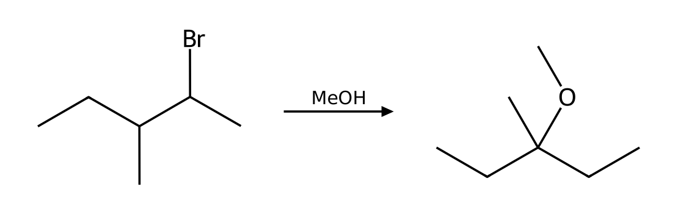
Why: (1) Loss of the leaving group gives a planar carbocation (rate-determining step). (2) Carbocation rearrangement (hydride shift) gives a more stable carbocation. (3) Nucleophilic attack on the carbocation (either face). (4) Proton transfer removes the positive charge from the oxonium ion. Substrate: secondary (2°) alkyl halide; Leaving group: good leaving group (Br); Nucleophile/base: methanol is a weak nucleophile and a weak base; Solvent: MeOH is protic. These favor SN1.
69. Carbocation rearrangement (E1; difficulty 3)
Q: Predict the major alkene from heating 3-methylbutan-2-ol with H₂SO₄. Explain the rearrangement.
Answer: 2-methylbut-2-ene via E1 after a hydride shift.
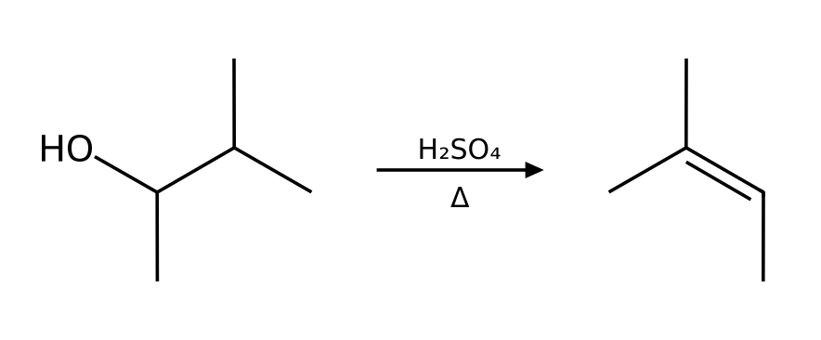
Why: (1) Proton transfer: the acid protonates the OH group. (2) Loss of water gives a carbocation (rate-determining step). (3) Carbocation rearrangement (hydride shift) gives a more stable carbocation. (4) A base (water or HSO₄⁻) removes a β hydrogen next to the cation, forming the alkene. Zaitsev elimination from the rearranged tertiary cation.
Source note: Standard elimination conventions (Zaitsev/Hofmann); not from the provided PDF
70. Elimination (E1) (E1; difficulty 2)
Q: What happens when 2-methylpropan-2-ol is heated with concentrated H₂SO₄? Give the major product, name the mechanism and explain why the OH must be protonated first.
Answer: 2-methylprop-1-ene via E1.
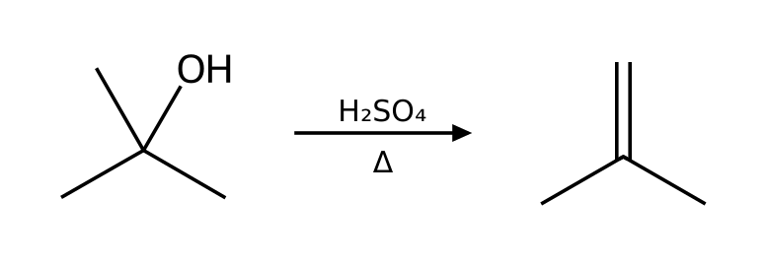
Why: (1) Proton transfer: the acid protonates the OH group. (2) Loss of water gives a carbocation (rate-determining step). (3) A base (water or HSO₄⁻) removes a β hydrogen next to the cation, forming the alkene.
Source note: Standard elimination conventions (Zaitsev/Hofmann); not from the provided PDF
71. Elimination (E1) (E1; difficulty 2)
Q: What happens when 2-methylbutan-2-ol is heated with concentrated H₂SO₄? Give the major product, name the mechanism and explain why the OH must be protonated first.
Answer: 2-methylbut-2-ene via E1 (Zaitsev).
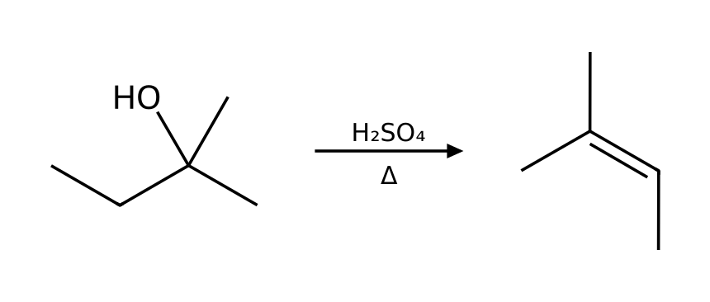
Why: (1) Proton transfer: the acid protonates the OH group. (2) Loss of water gives a carbocation (rate-determining step). (3) A base (water or HSO₄⁻) removes a β hydrogen next to the cation, forming the alkene.
Source note: Standard elimination conventions (Zaitsev/Hofmann); not from the provided PDF
72. Elimination (E1) (E1; difficulty 2)
Q: What happens when 1-methylcyclohexan-1-ol is heated with concentrated H₂SO₄? Give the major product, name the mechanism and explain why the OH must be protonated first.
Answer: 1-methylcyclohexene via E1 (Zaitsev).
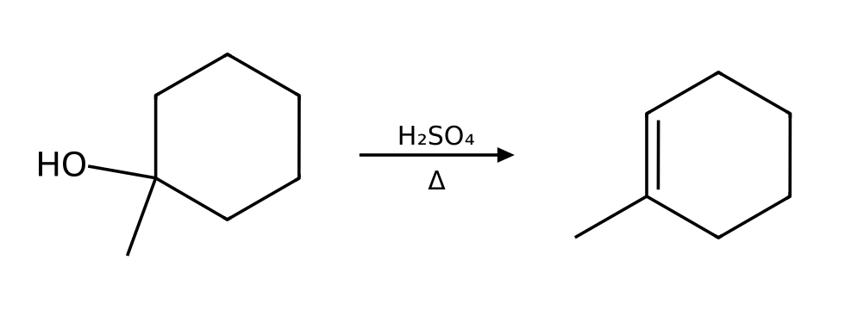
Why: (1) Proton transfer: the acid protonates the OH group. (2) Loss of water gives a carbocation (rate-determining step). (3) A base (water or HSO₄⁻) removes a β hydrogen next to the cation, forming the alkene.
Source note: Standard elimination conventions (Zaitsev/Hofmann); not from the provided PDF
73. Elimination (E1) (E1; difficulty 2)
Q: What happens when butan-2-ol is heated with concentrated H₂SO₄? Give the major product, name the mechanism and explain why the OH must be protonated first.
Answer: (E)-but-2-ene via E1 (Zaitsev).
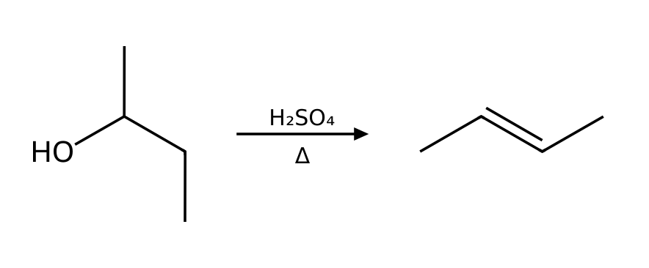
Why: (1) Proton transfer: the acid protonates the OH group. (2) Loss of water gives a carbocation (rate-determining step). (3) A base (water or HSO₄⁻) removes a β hydrogen next to the cation, forming the alkene.
Source note: Standard elimination conventions (Zaitsev/Hofmann); not from the provided PDF
74. Regiochemistry of elimination (E2; difficulty 3)
Q: Starting from 2-bromo-2-methylbutane, choose reagents to make (a) the more substituted alkene and (b) the less substituted alkene. Give both products.
Answer: (a) NaOEt/EtOH (small base, Zaitsev): 2-methylbut-2-ene. (b) KOtBu/tBuOH (bulky base, Hofmann): 2-methylbut-1-ene.
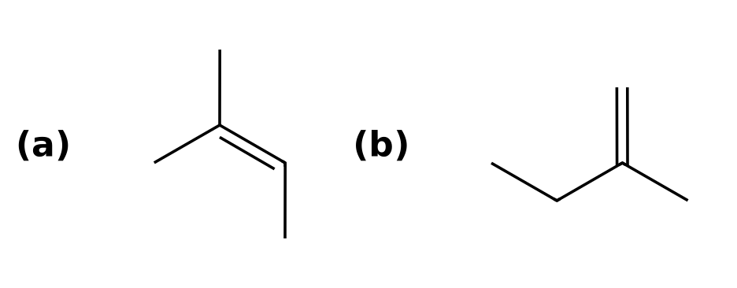
Why: A small base removes the β hydrogen that leads to the more stable, more substituted alkene (Zaitsev). A bulky base removes the more accessible, less hindered hydrogen (Hofmann).
Source note: Standard elimination conventions (Zaitsev/Hofmann); not from the provided PDF
75. Regiochemistry of elimination (E2; difficulty 3)
Q: Starting from 2-bromobutane, choose reagents to make (a) the more substituted alkene and (b) the less substituted alkene. Give both products.
Answer: (a) NaOEt/EtOH (small base, Zaitsev): (E)-but-2-ene. (b) KOtBu/tBuOH (bulky base, Hofmann): but-1-ene.
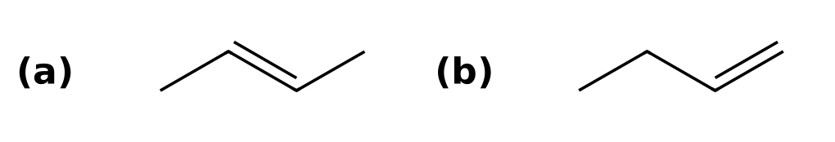
Why: A small base removes the β hydrogen that leads to the more stable, more substituted alkene (Zaitsev). A bulky base removes the more accessible, less hindered hydrogen (Hofmann).
Source note: Standard elimination conventions (Zaitsev/Hofmann); not from the provided PDF
76. Regiochemistry of elimination (E2; difficulty 3)
Q: Starting from 2-bromopentane, choose reagents to make (a) the more substituted alkene and (b) the less substituted alkene. Give both products.
Answer: (a) NaOEt/EtOH (small base, Zaitsev): (E)-pent-2-ene. (b) KOtBu/tBuOH (bulky base, Hofmann): pent-1-ene.
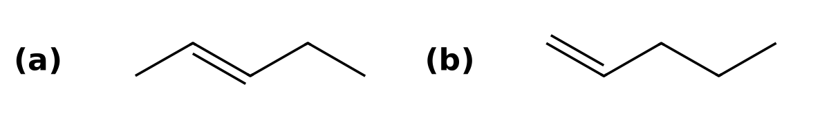
Why: A small base removes the β hydrogen that leads to the more stable, more substituted alkene (Zaitsev). A bulky base removes the more accessible, less hindered hydrogen (Hofmann).
Source note: Standard elimination conventions (Zaitsev/Hofmann); not from the provided PDF
77. Regiochemistry of elimination (E2; difficulty 3)
Q: Starting from 1-bromo-1-methylcyclohexane, choose reagents to make (a) the more substituted alkene and (b) the less substituted alkene. Give both products.
Answer: (a) NaOEt/EtOH (small base, Zaitsev): 1-methylcyclohexene. (b) KOtBu/tBuOH (bulky base, Hofmann): methylenecyclohexane.
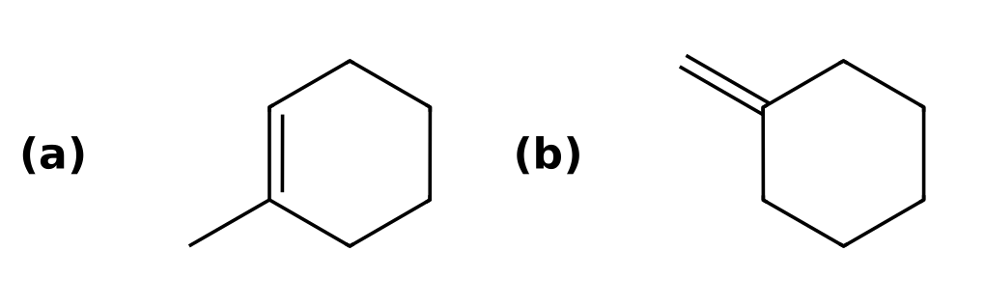
Why: A small base removes the β hydrogen that leads to the more stable, more substituted alkene (Zaitsev). A bulky base removes the more accessible, less hindered hydrogen (Hofmann).
Source note: Standard elimination conventions (Zaitsev/Hofmann); not from the provided PDF
78. Regiochemistry of elimination (E2; difficulty 3)
Q: Starting from 3-bromo-3-methylpentane, choose reagents to make (a) the more substituted alkene and (b) the less substituted alkene. Give both products.
Answer: (a) NaOEt/EtOH (small base, Zaitsev): 3-methylpent-2-ene. (b) KOtBu/tBuOH (bulky base, Hofmann): 2-ethylbut-1-ene.
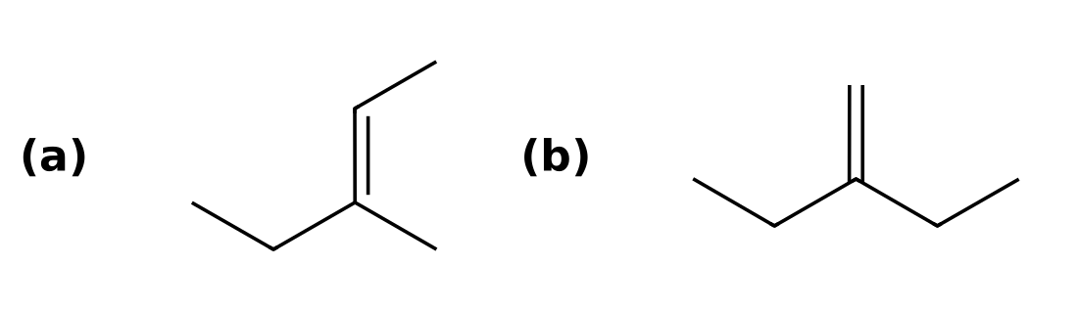
Why: A small base removes the β hydrogen that leads to the more stable, more substituted alkene (Zaitsev). A bulky base removes the more accessible, less hindered hydrogen (Hofmann).
Source note: Standard elimination conventions (Zaitsev/Hofmann); not from the provided PDF
79. Synthesis design (SN2; difficulty 3)
Q: Design a synthesis of 2-methoxy-2-methylpropane from an alkyl halide and an alkoxide. Which combination works, and why does the other combination fail?
Answer: Use iodomethane with sodium tert-butoxide. The alternative, tert-butyl bromide with sodium methoxide, fails because it gives E2 elimination instead of substitution.
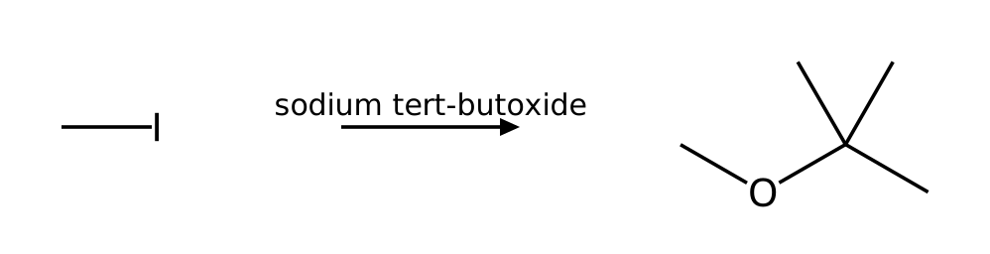
Why: The Williamson ether synthesis is an SN2 reaction, so the halide must be methyl or primary. A secondary or tertiary halide with a strongly basic alkoxide gives E2 elimination.
80. Synthesis design (SN2; difficulty 3)
Q: Design a synthesis of 2-ethoxypropane from an alkyl halide and an alkoxide. Which combination works, and why does the other combination fail?
Answer: Use bromoethane with sodium isopropoxide. The alternative, 2-bromopropane with sodium ethoxide, fails because it gives E2 elimination instead of substitution.
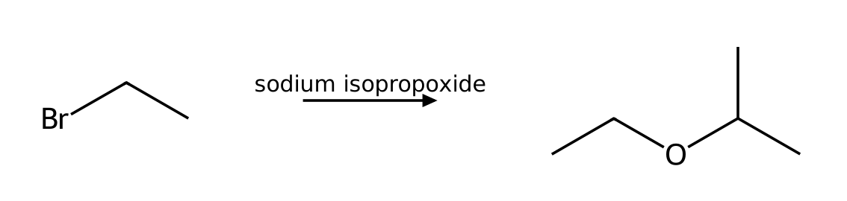
Why: The Williamson ether synthesis is an SN2 reaction, so the halide must be methyl or primary. A secondary or tertiary halide with a strongly basic alkoxide gives E2 elimination.
81. Synthesis design (SN2; difficulty 3)
Q: Design a synthesis of 2-ethoxy-2-methylpropane from an alkyl halide and an alkoxide. Which combination works, and why does the other combination fail?
Answer: Use iodoethane with sodium tert-butoxide. The alternative, tert-butyl bromide with sodium ethoxide, fails because it gives E2 elimination instead of substitution.
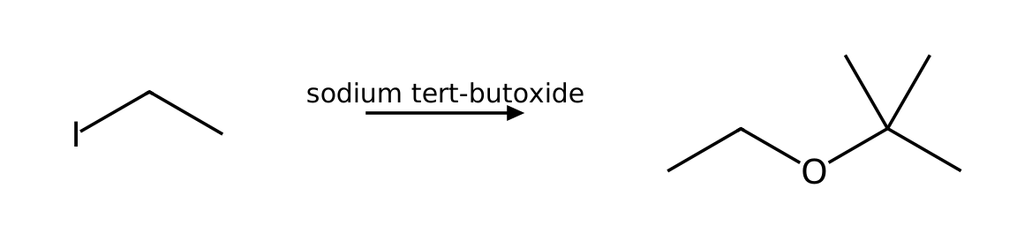
Why: The Williamson ether synthesis is an SN2 reaction, so the halide must be methyl or primary. A secondary or tertiary halide with a strongly basic alkoxide gives E2 elimination.
82. Intramolecular substitution (SN2; difficulty 3)
Q: Treatment of 4-bromobutan-1-ol with NaOH gives a cyclic ether, tetrahydrofuran (oxolane). Explain the mechanism and why a ring forms.
Answer: NaOH deprotonates the OH to give an alkoxide, which attacks the carbon bearing bromine intramolecularly (SN2, 5- or 6-membered ring) displacing bromide.
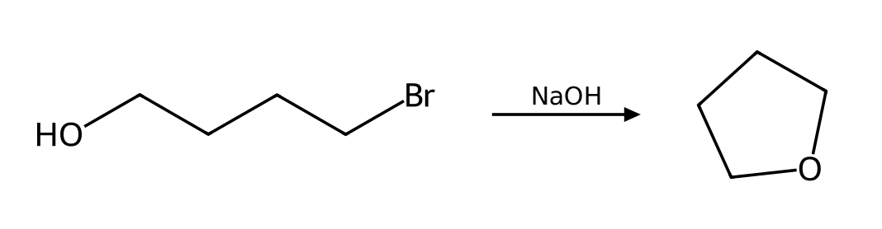
Why: Intramolecular SN2 is favored because the nucleophile and electrophile are tethered together; 5- and 6-membered rings form fastest.
83. Intramolecular substitution (SN2; difficulty 3)
Q: Treatment of 5-bromopentan-1-ol with NaOH gives a cyclic ether, tetrahydropyran (oxane). Explain the mechanism and why a ring forms.
Answer: NaOH deprotonates the OH to give an alkoxide, which attacks the carbon bearing bromine intramolecularly (SN2, 5- or 6-membered ring) displacing bromide.
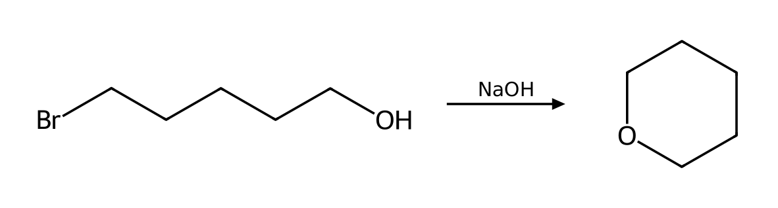
Why: Intramolecular SN2 is favored because the nucleophile and electrophile are tethered together; 5- and 6-membered rings form fastest.
84. Nucleophile strength (SN2; difficulty 2)
Q: Rank the halide ions F⁻, Cl⁻, Br⁻, I⁻ by nucleophilicity (a) in methanol (a protic solvent) and (b) in DMSO (a polar aprotic solvent). Explain the reversal.
Answer: (a) in methanol: I⁻ > Br⁻ > Cl⁻ > F⁻; (b) in DMSO: F⁻ > Cl⁻ > Br⁻ > I⁻.
Why: In protic solvents the small anions are strongly solvated by hydrogen bonding and are tied up; in polar aprotic solvents anions are not solvated, so basicity (F⁻ most basic) tracks nucleophilicity.
85. Nucleophile strength (SN2; difficulty 2)
Q: Classify each as a strong or weak nucleophile and state whether it favors SN2 or SN1: (a) HS⁻ (b) H₂O (c) CH₃CH₂O⁻ (d) CH₃CH₂OH (e) I⁻ (f) CN⁻.
Answer: Strong (favor SN2): HS⁻, CH₃CH₂O⁻, I⁻, CN⁻. Weak (allow SN1 to compete): H₂O, CH₃CH₂OH.
Why: Strong nucleophiles speed up SN2; the rate of SN1 does not depend on the nucleophile, so weak nucleophiles disfavor SN2 and let SN1 compete.
86. Substrate reactivity (SN2; difficulty 2)
Q: Rank bromomethane, 1-bromopropane, 2-bromopropane and 2-bromo-2-methylpropane from fastest to slowest toward SN2. Then give the order for SN1.
Answer: SN2: bromomethane > 1-bromopropane > 2-bromopropane >> 2-bromo-2-methylpropane (essentially unreactive). SN1 is the reverse: 2-bromo-2-methylpropane > 2-bromopropane > 1-bromopropane > bromomethane.
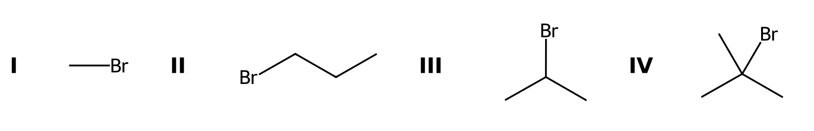
Why: SN2 is limited by steric hindrance in the transition state; SN1 is limited by carbocation stability.
87. Substrate reactivity (SN2; difficulty 3)
Q: Neopentyl bromide, (CH₃)₃CCH₂Br, is a primary alkyl halide. Predict whether it reacts well by SN2 or by SN1 and explain.
Answer: It reacts very poorly by SN2 because of the bulky β substituents, and a primary carbocation is too unstable for SN1 (a rearrangement concerted with ionization can occur in ionizing solvents).
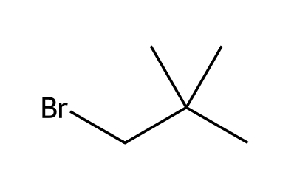
Why: Steric hindrance at the β position slows SN2 almost as much as α branching.
88. Leaving groups (SN1/SN2; difficulty 2)
Q: Which is the better leaving group in each pair, and why? (a) Cl⁻ or I⁻ (b) HO⁻ or H₂O (c) CH₃O⁻ or TsO⁻.
Answer: (a) I⁻. (b) H₂O. (c) TsO⁻.
Why: Good leaving groups are weak bases, the conjugate bases of strong acids. Iodide is the conjugate base of HI; water is the conjugate base of H₃O⁺; tosylate is the conjugate base of a strong sulfonic acid.
89. Leaving groups (SN2; difficulty 2)
Q: Rank 1-chlorobutane, 1-bromobutane and 1-iodobutane by their rate of reaction with NaCN in DMSO, and explain.
Answer: 1-iodobutane > 1-bromobutane > 1-chlorobutane.
Why: The rate of SN2 depends on the leaving group: iodide is the weakest base and the best leaving group.
90. Solvent effects (SN2/SN1; difficulty 2)
Q: Classify each solvent as protic or polar aprotic and say which substitution mechanism it favors: DMSO, methanol, acetonitrile, water, DMF, acetic acid.
Answer: Polar aprotic (favor SN2): DMSO, acetonitrile, DMF. Protic (favor SN1): methanol, water, acetic acid.
Why: Protic solvents have an H on an electronegative atom; they stabilize ions and intermediates (SN1) but solvate and weaken anionic nucleophiles. Polar aprotic solvents leave the nucleophile unsolvated.
91. Solvent effects (SN2; difficulty 2)
Q: The SN2 reaction of 1-bromobutane with azide is about 1300 times faster in DMSO than in methanol. Explain.
Answer: In methanol the azide ion is hydrogen-bonded to the solvent, which lowers its energy and raises the barrier. DMSO solvates the cation but not the anion, so the nucleophile is higher in energy and reacts faster.
Why: See the effect of polar aprotic solvents on nucleophile energy in the SN2 energy diagram.
92. Kinetics (SN2; difficulty 2)
Q: The reaction of 2-bromobutane with NaSH in DMSO follows the mechanism predicted for these conditions. Write the rate law. What happens to the rate if (a) [substrate] is doubled and [hydrosulfide] is unchanged, and (b) [hydrosulfide] is tripled and [substrate] is unchanged?
Answer: SN2: rate = k[substrate][nucleophile]. (a) Rate doubles. (b) Rate triples.
Why: The rate law reflects the species in the rate-determining step.
93. Kinetics (SN1; difficulty 2)
Q: The reaction of 2-chloro-2-methylbutane with EtOH as the solvent follows the mechanism predicted for these conditions. Write the rate law. What happens to the rate if (a) [substrate] is doubled and [ethanol] is unchanged, and (b) [ethanol] is tripled and [substrate] is unchanged?
Answer: SN1: rate = k[substrate]. (a) Rate doubles. (b) No change.
Why: The rate law reflects the species in the rate-determining step.
94. Kinetics (E2; difficulty 2)
Q: The reaction of 2-bromobutane with NaOEt in EtOH follows the mechanism predicted for these conditions. Write the rate law. What happens to the rate if (a) [substrate] is doubled and [ethoxide] is unchanged, and (b) [ethoxide] is tripled and [substrate] is unchanged?
Answer: E2: rate = k[substrate][base]. (a) Rate doubles. (b) Rate triples.
Why: The rate law reflects the species in the rate-determining step.
Source note: Standard elimination conventions (Zaitsev/Hofmann); not from the provided PDF
95. Kinetics (SN2; difficulty 2)
Q: The reaction of 1-chlorobutane with NaI in acetone follows the mechanism predicted for these conditions. Write the rate law. What happens to the rate if (a) [substrate] is doubled and [iodide] is unchanged, and (b) [iodide] is tripled and [substrate] is unchanged?
Answer: SN2: rate = k[substrate][nucleophile]. (a) Rate doubles. (b) Rate triples.
Why: The rate law reflects the species in the rate-determining step.
96. Classify the substrate (SN1/SN2; difficulty 2)
Q: For each substrate, classify the α carbon (methyl, 1°, 2° or 3°), identify the leaving group, and state whether SN2, SN1, both or neither is feasible: (I) iodoethane (II) 2-bromo-2-methylbutane (III) 2-chlorobutane (IV) bromobenzene.
Answer: I: 1°, I⁻, SN2 only. II: 3°, Br⁻, SN1 (SN2 impossible). III: 2°, Cl⁻, either (conditions decide). IV: aryl halide, Br⁻, neither.
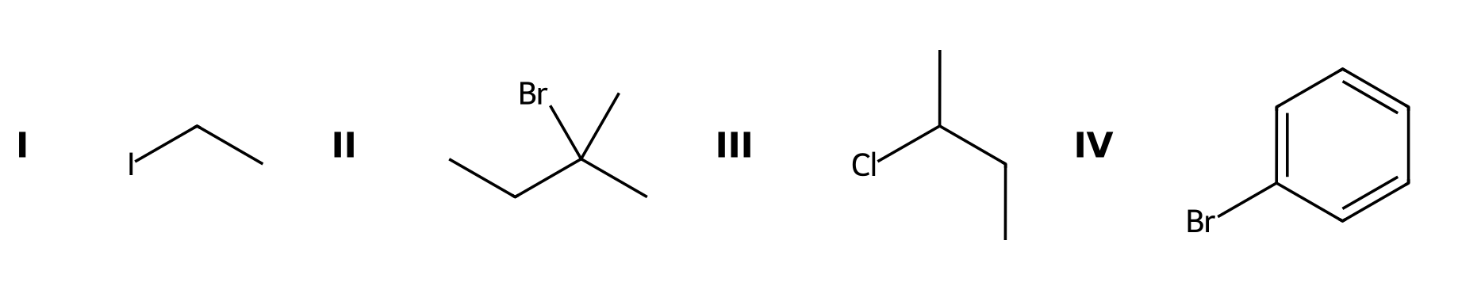
Why: Methyl/primary favor SN2, tertiary favors SN1, secondary can go either way, and aryl/vinyl halides do not react.
97. Classify the substrate (SN1/SN2; difficulty 2)
Q: Label each carbon bearing a leaving group as 1°, 2° or 3° and say which substitution mechanism is favored by the substrate alone: (I) 1-bromobutane (II) 3-bromo-3-methylpentane (III) iodocyclohexane.
Answer: I: 1°, SN2. II: 3°, SN1. III: 2°, either.
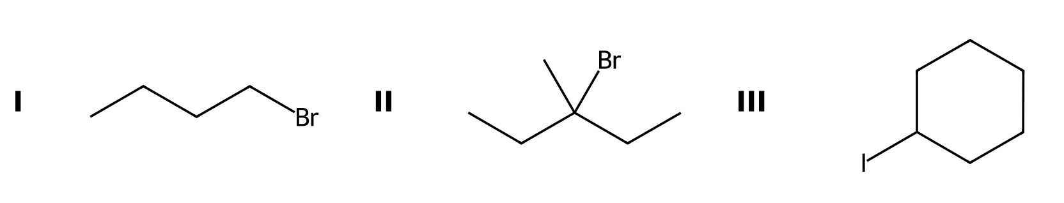
Why: This is the first of the four factors; secondary substrates need the nucleophile and solvent to decide.
98. Which reacts faster? (SN2; difficulty 2)
Q: Which compound reacts faster with NaN₃ in DMF, 1-bromobutane or 2-bromobutane? Which reacts faster with ethanol (solvolysis), 2-bromo-2-methylpropane or 2-bromopropane?
Answer: 1-bromobutane (less hindered SN2). 2-bromo-2-methylpropane (more stable tertiary carbocation, SN1).
Why: SN2 rate falls as steric hindrance increases; SN1 rate rises with carbocation stability.
99. Energy diagrams (SN1; difficulty 3)
Q: Sketch the reaction energy diagram for the SN1 solvolysis of 2-bromo-2-methylpropane in water. How many transition states and intermediates are there, and which step is rate-determining?
Answer: Two steps give two transition states and one carbocation intermediate (plus a proton transfer at the end because water is neutral, so three steps). The first step, loss of bromide, is rate-determining.
Why: The number of humps equals the number of steps; the highest hump is the rate-determining step.
100. Energy diagrams (SN2; difficulty 2)
Q: How does the energy diagram of an SN2 reaction differ from that of an SN1 reaction? Include the number of steps, transition states and intermediates.
Answer: SN2: one step, one transition state, no intermediate. SN1: two core steps, two transition states and a carbocation intermediate.
Why: SN2 is concerted; SN1 is stepwise.

