Organic Chemistry Quiz: Acids and Bases and Nomenclature
Name: ______________________________ Date: _______________ Section: ________
Directions: Choose the single best answer for each question. Do not use pKa values. Use the stability of the conjugate base and the ARIO factors (Atom, Resonance, Induction, Orbital) to reason through each problem. In structures, the red numbered H atoms are the hydrogens being compared (for example, H₁ is the hydrogen labeled 1), curved arrows show the movement of electron pairs, and a circled minus sign is a formal negative charge. Questions 31–40 ask for the IUPAC names of branched alkanes.
1. Ethanolamine has three different kinds of hydrogen, labeled below. Which labeled H is the most acidic?
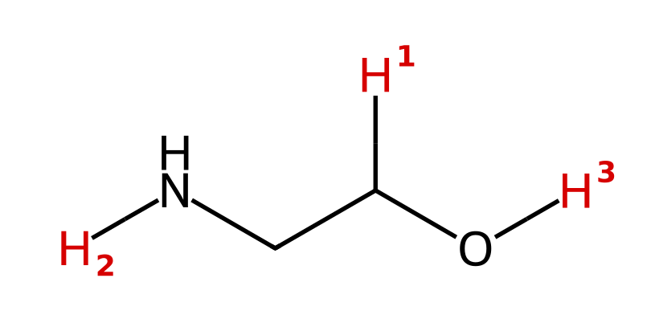
A) H₁ (the C–H on the carbon bearing O)
B) H₂ (the N–H)
C) H₃ (the O–H)
D) All three are about equally acidic
2. Which labeled hydrogen in 3-mercaptopropan-1-ol is the most acidic?
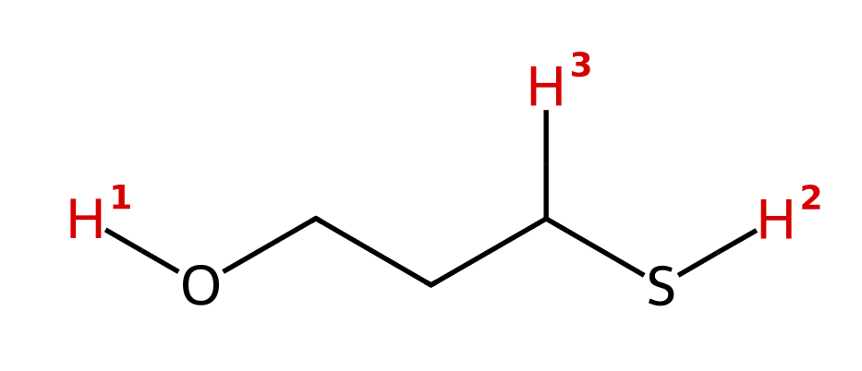
A) H₁ (the O–H), because O is more electronegative than S
B) H₂ (the S–H), because S is larger than O and spreads the charge over a larger volume
C) H₃ (the C–H next to S), because it is closest to the large S atom
D) H₁ and H₂ are equally acidic because O and S are in the same column
3. Acetaminophen (Tylenol) is shown below. Which labeled H is the most acidic?
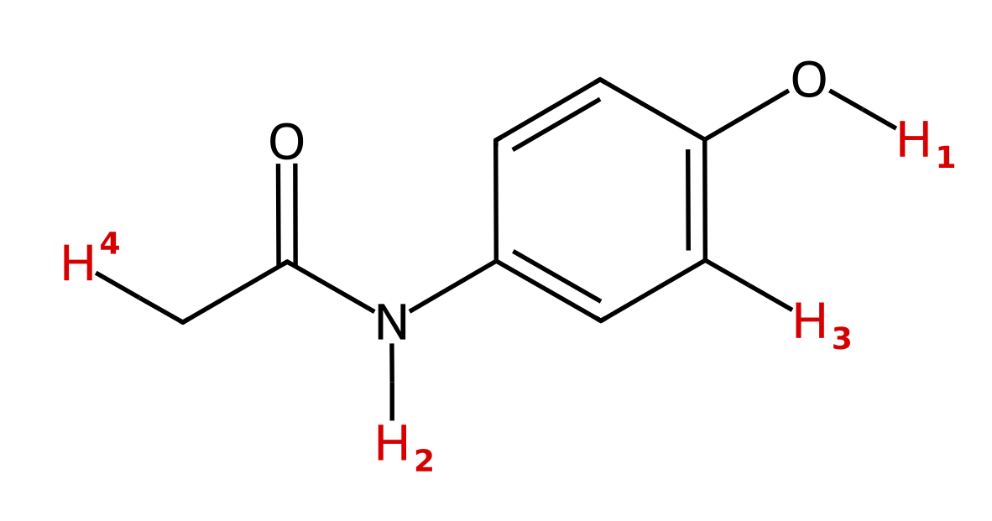
A) H₁ (the phenol O–H), because O is more electronegative than N
B) H₂ (the amide N–H), because the N⁻ charge is delocalized onto the carbonyl O
C) H₃ (the aromatic C–H), because it is on an sp²-hybridized carbon
D) H₄ (the CH₃ hydrogen), because it is next to a C=O
4. Two anions are shown. Which is the stronger base, and why?
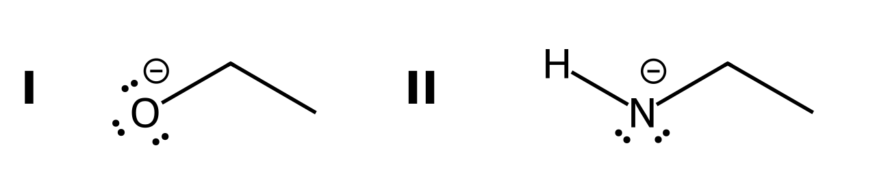
A) I, because O is more electronegative, so its charge is held more tightly
B) II, because N is less electronegative than O, so the negative charge on N is less stable
C) I, because O is larger than N
D) They are equally basic because both anions have a lone pair
5. 4-Hydroxybutanoic acid has the labeled hydrogens shown. Which is the most acidic?
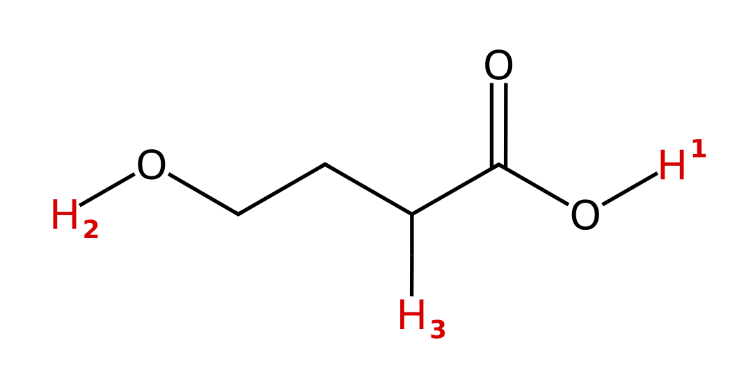
A) H₂ (the alcohol O–H), because alcohols are more acidic than carboxylic acids
B) H₃ (the C–H next to C=O), because it is next to a carbonyl
C) H₁ and H₂ are equally acidic because both are on oxygen
D) H₁ (the carboxylic acid O–H), because its conjugate base is resonance stabilized
6. Which labeled hydrogen in the following compound is the most acidic?
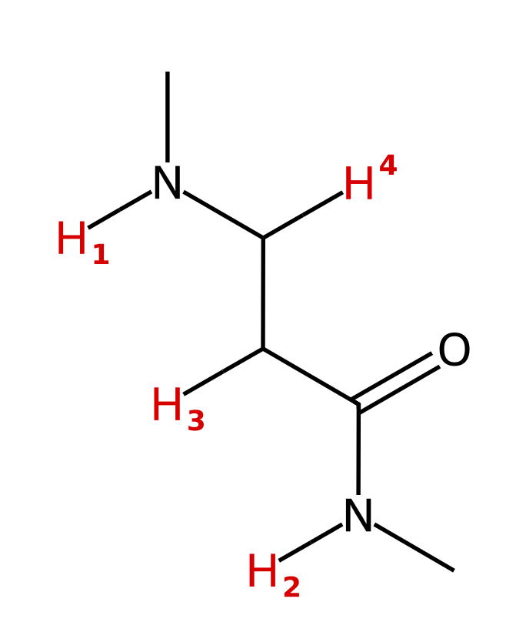
A) H₁ (the amine N–H)
B) H₃ (the C–H next to C=O)
C) H₂ (the amide N–H)
D) H₄ (the C–H next to the amine N)
7. Which labeled hydrogen is the most acidic?
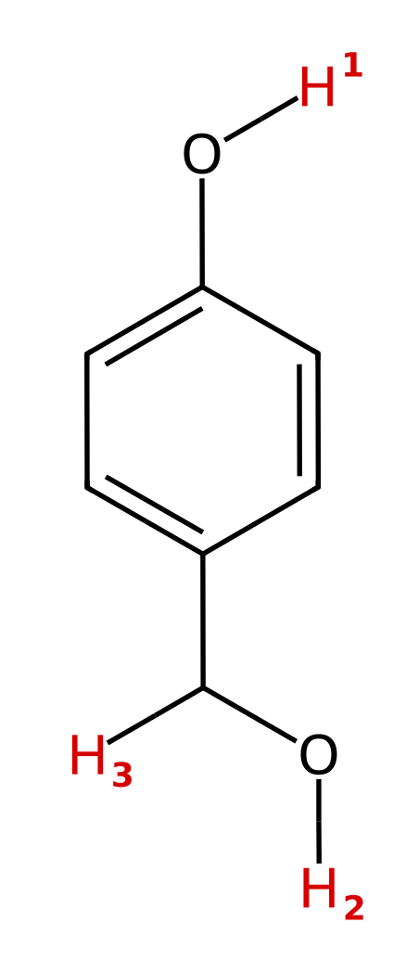
A) H₁ (the phenol O–H), because the phenoxide charge is delocalized into the ring
B) H₂ (the benzylic alcohol O–H), because the alkoxide is more electronegative
C) H₃ (the benzylic C–H), because the carbanion is next to a ring
D) All three are equally acidic
8. Ethyl acetoacetate has the labeled hydrogens shown. Which one is the most acidic?
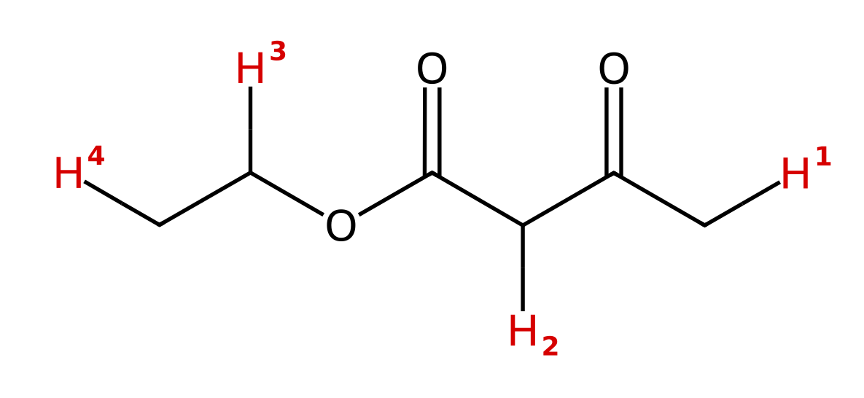
A) H₁ (the CH₃ next to the ketone)
B) H₂ (the CH₂ between the two C=O groups)
C) H₃ (the OCH₂ hydrogen)
D) H₄ (the CH₃ of the ethyl group)
9. Acetate is shown. Which set of curved arrows correctly converts this resonance structure into the other one?
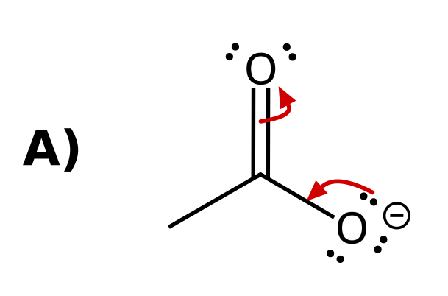 | 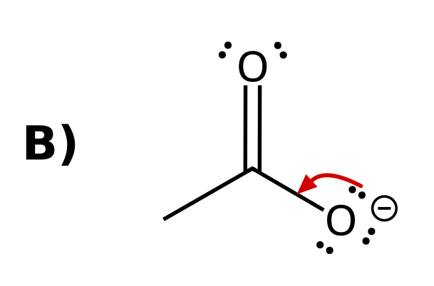
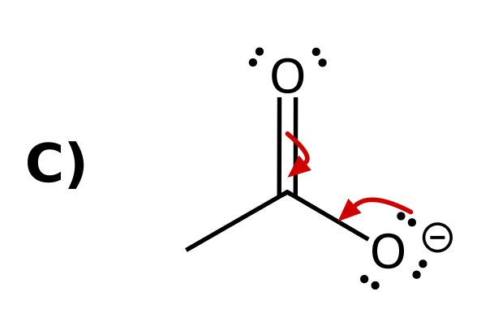 | 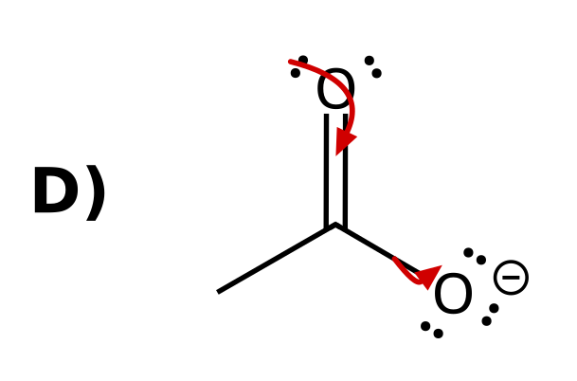

10. Which set of curved arrows correctly shows the charge of phenoxide moving onto an ortho carbon?
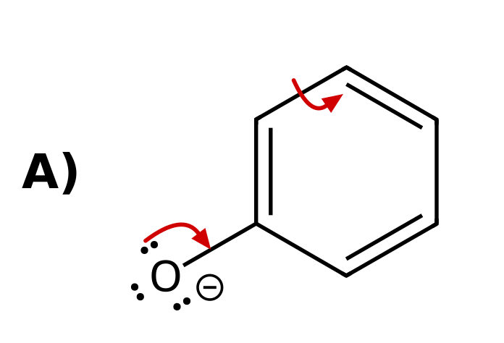 | 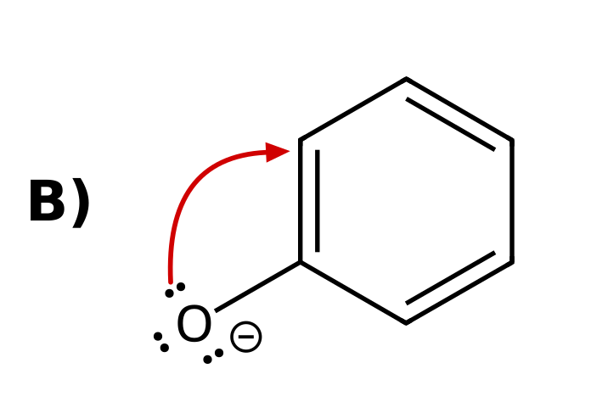
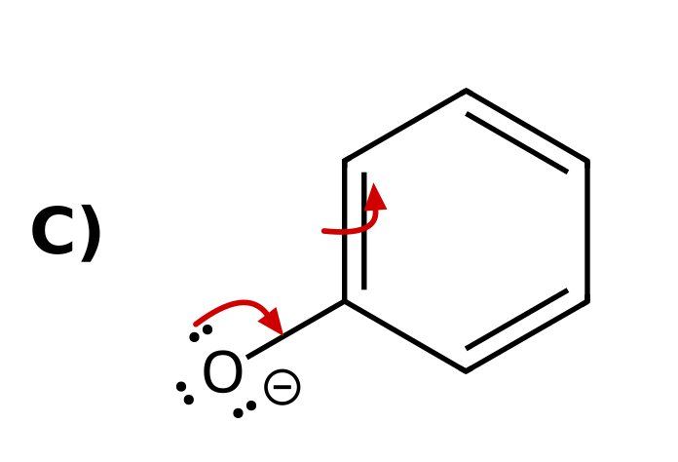 | 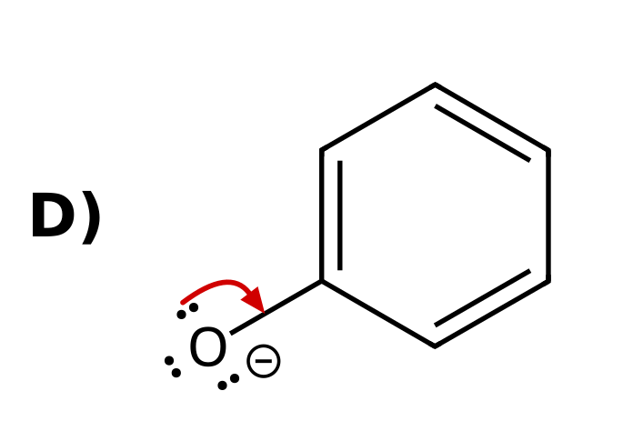

11. Cyclopentadiene is shown. Which labeled hydrogen is the most acidic?
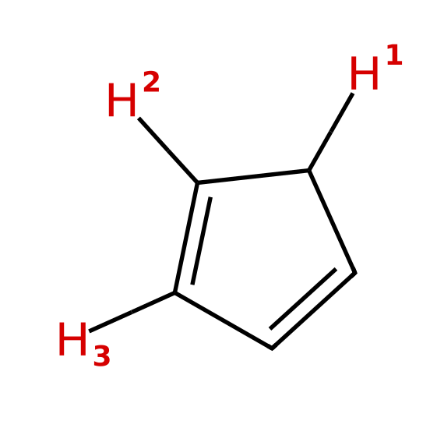
A) H₂ (the vinyl H next to the CH₂)
B) H₃ (the other vinyl H)
C) All three are equally acidic
D) H₁ (the CH₂ hydrogen)
12. Rank the carboxylic acids from LEAST acidic to MOST acidic.
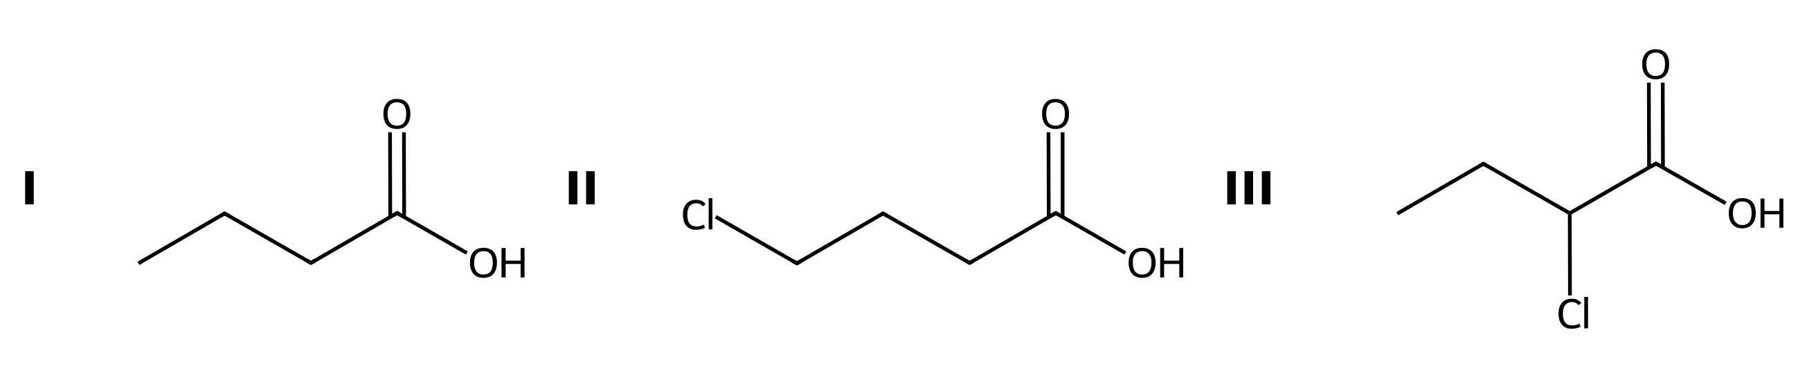
A) III < II < I
B) I < II < III
C) II < I < III
D) I < III < II
13. Which labeled hydrogen is the most acidic?
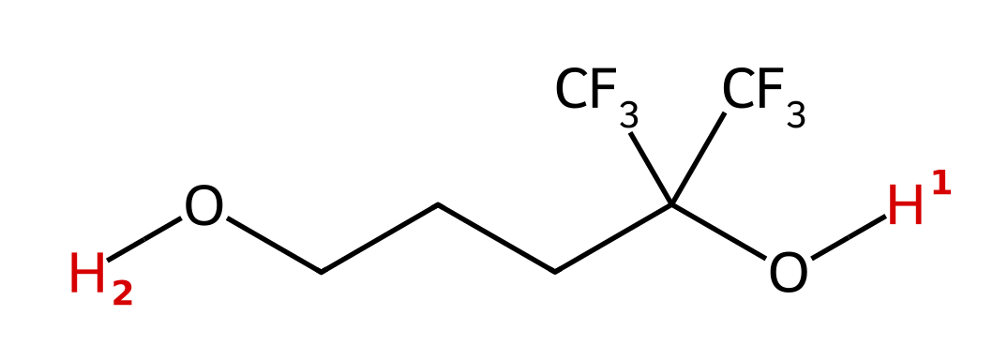
A) H₁, because the CF₃ groups stabilize the nearby alkoxide by induction
B) H₂, because primary alcohols are less hindered
C) H₂, because it is far from the electron-withdrawing groups
D) H₁ and H₂ are equally acidic
14. Which acid is the strongest?
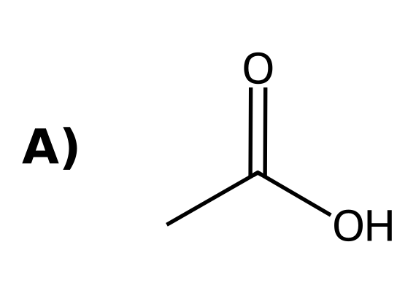 | 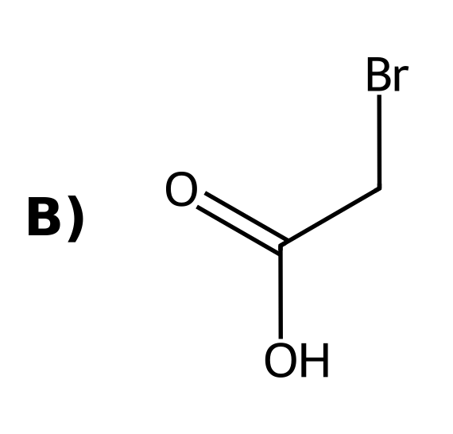
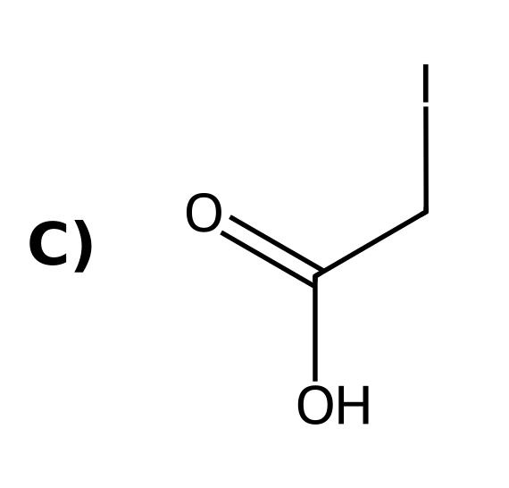 | 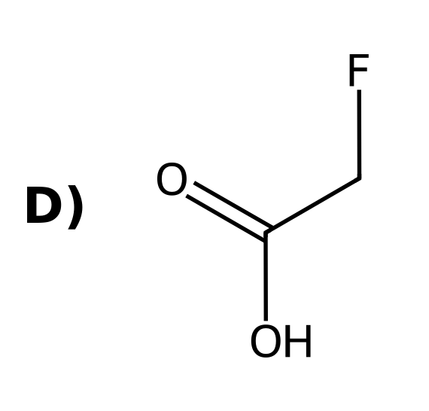

15. Which labeled hydrogen in the following compound is the most acidic?
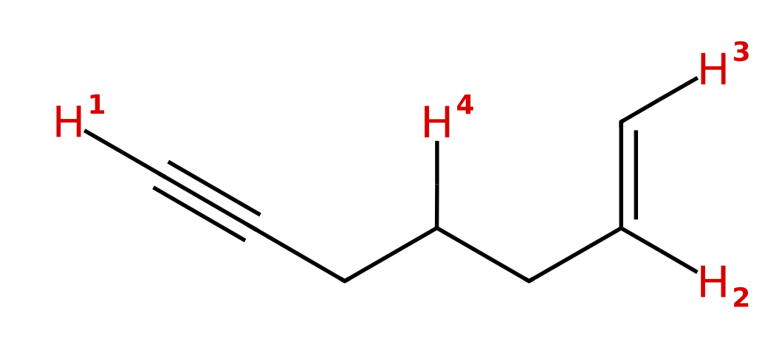
A) H₂ (the internal vinyl H)
B) H₃ (the terminal vinyl H)
C) H₁ (the alkyne H)
D) H₄ (the CH₂)
16. Which of these anions is the strongest base?
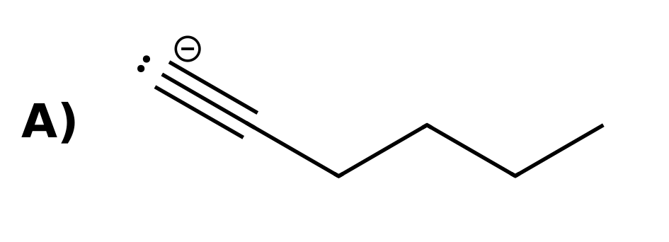 | 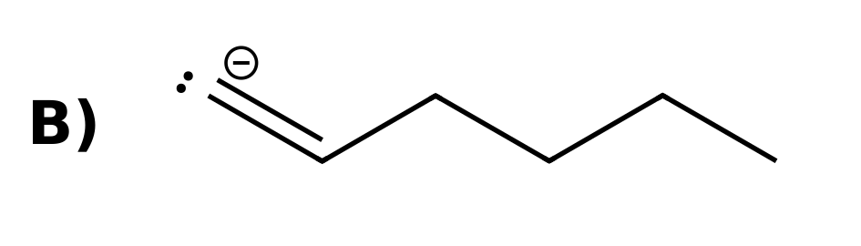
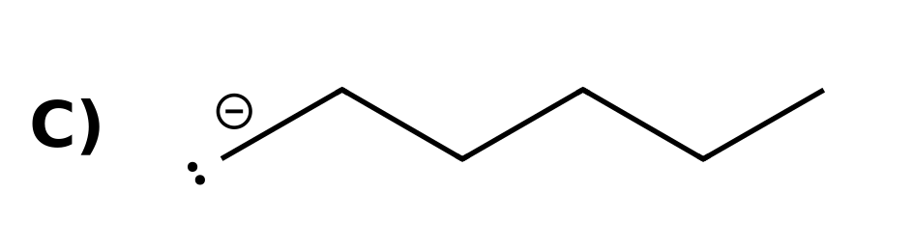 | D) All three are equally basic because the charge is on carbon in each

17. A terminal alkyne C–H is more acidic than an alkene C–H. Which statement best explains why?
A) The sp carbon has more p character, so it is more electronegative
B) The electron pair in the sp orbital is held closer to the nucleus, so the alkynide ion is more stable
C) The alkynide ion has resonance structures that spread out the charge
D) The triple bond withdraws electron density from the C–H bond by induction
18. Which of the labeled hydrogens is more acidic?
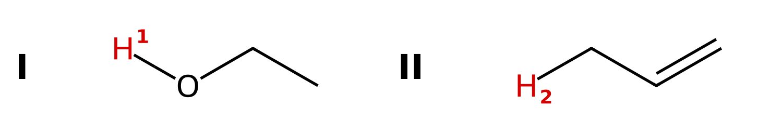
A) H₂ in II (propene), because the allyl anion is resonance stabilized
B) H₂ in II (propene), because the carbon is sp² hybridized
C) They are about equal
D) H₁ in I (ethanol), because the atom (O vs. C) outranks resonance
19. Which labeled hydrogen is the most acidic?
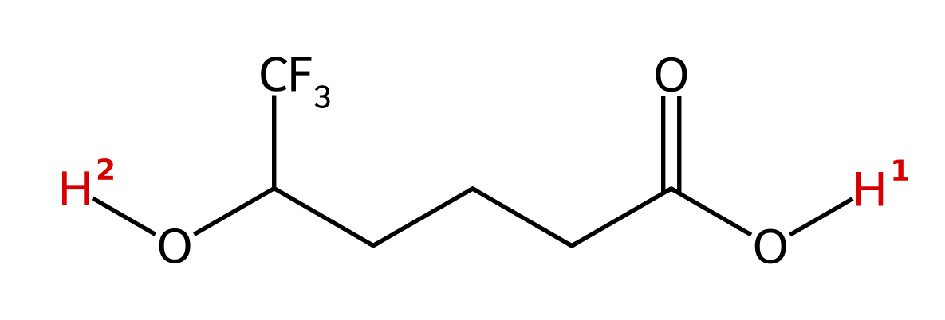
A) H₁, because resonance outranks induction
B) H₂, because the CF₃ group stabilizes the alkoxide by induction
C) H₂, because alcohols are more acidic than carboxylic acids
D) They are equally acidic
20. Which labeled hydrogen is more acidic?
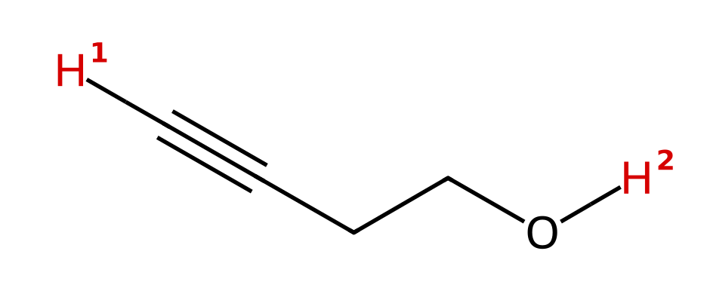
A) H₁, because an sp carbanion is the most stable
B) H₁, because the alkynide ion is resonance stabilized
C) H₂, because the atom (O vs. C) outranks the orbital
D) They are about equal
21. Rank these from LEAST acidic to MOST acidic.
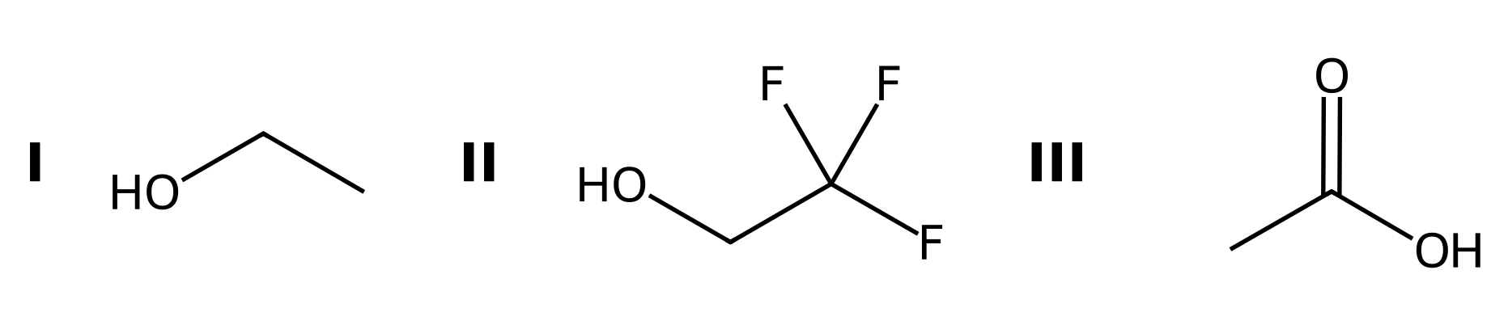
A) III < II < I
B) II < I < III
C) I < III < II
D) I < II < III
22. Aspirin is shown. Which labeled hydrogen is the most acidic?
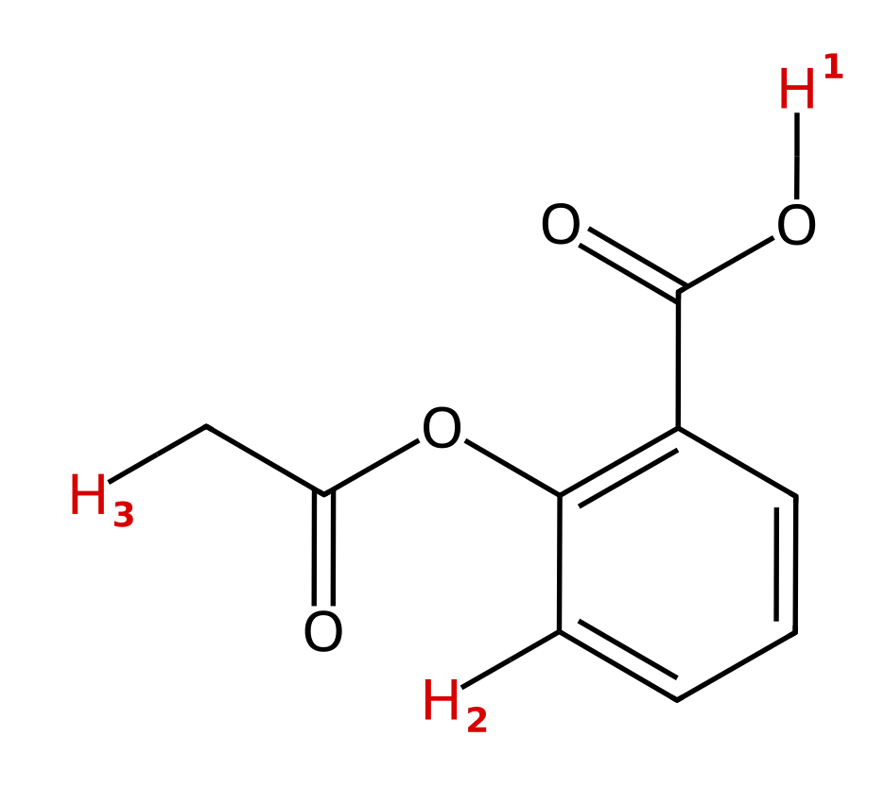
A) H₂ (the aromatic C–H)
B) H₁ (the carboxylic acid O–H)
C) H₃ (the CH₃ on the acetyl group)
D) All three are about equally acidic
23. Which side of the equilibrium is favored?
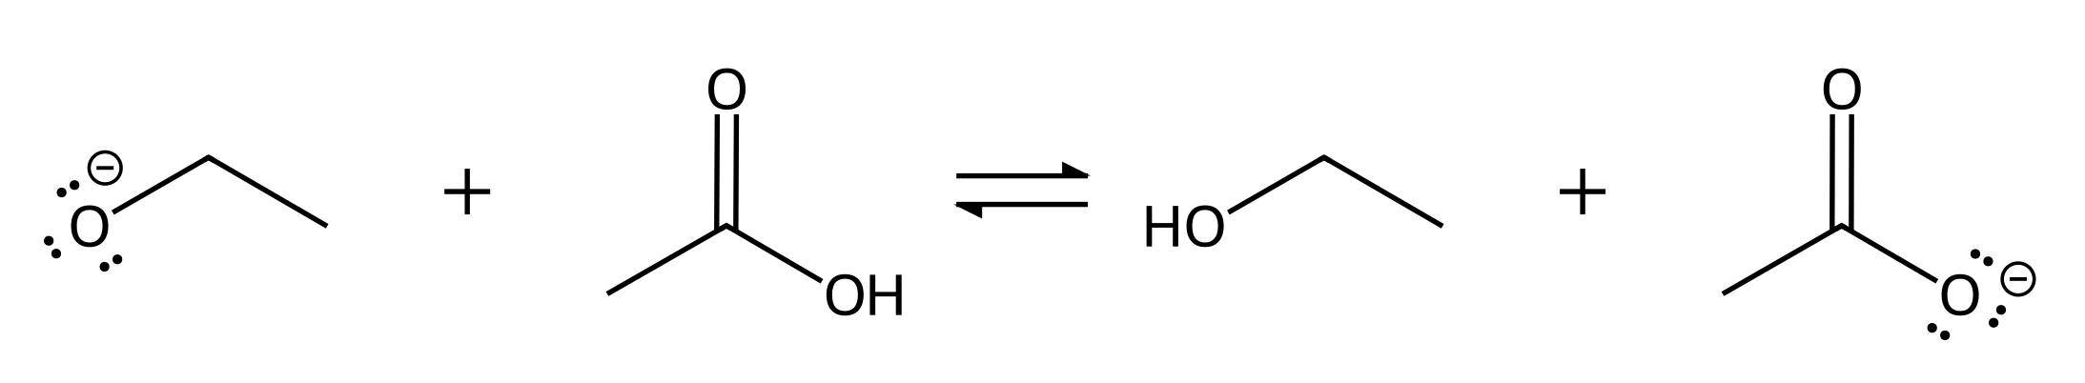
A) The products, because acetate is resonance stabilized and is the more stable anion
B) The reactants, because ethoxide is more stable
C) Neither side, because both anions have the charge on O
D) The products, because ethanol is a stronger acid than acetic acid
24. Which side of the equilibrium is favored?
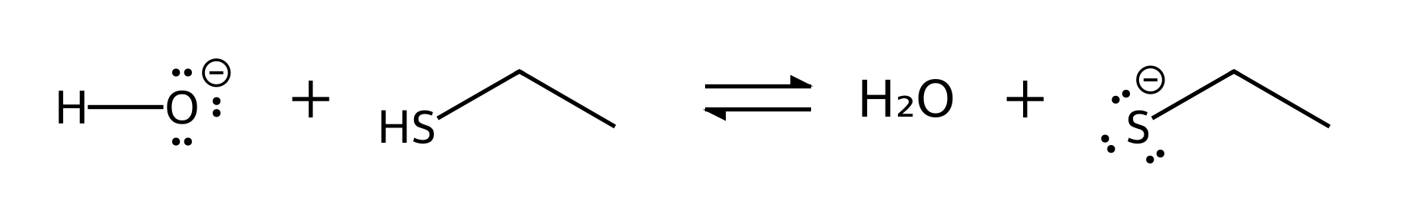
A) The reactants, because O is more electronegative than S
B) Neither side, because O and S are both in group 16
C) The reactants, because hydroxide is the smaller anion
D) The products, because the larger S atom stabilizes the charge better
25. Which side of the equilibrium is favored?
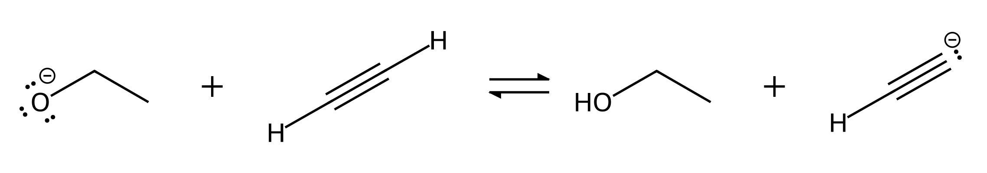
A) The products, because the sp carbanion is the most stable carbanion
B) The reactants, because ethoxide (O⁻) is more stable than the sp carbanion (C⁻)
C) The products, because the alkynide ion has resonance structures
D) Neither side, because both anions have lone pairs
26. Which side of the equilibrium is favored?
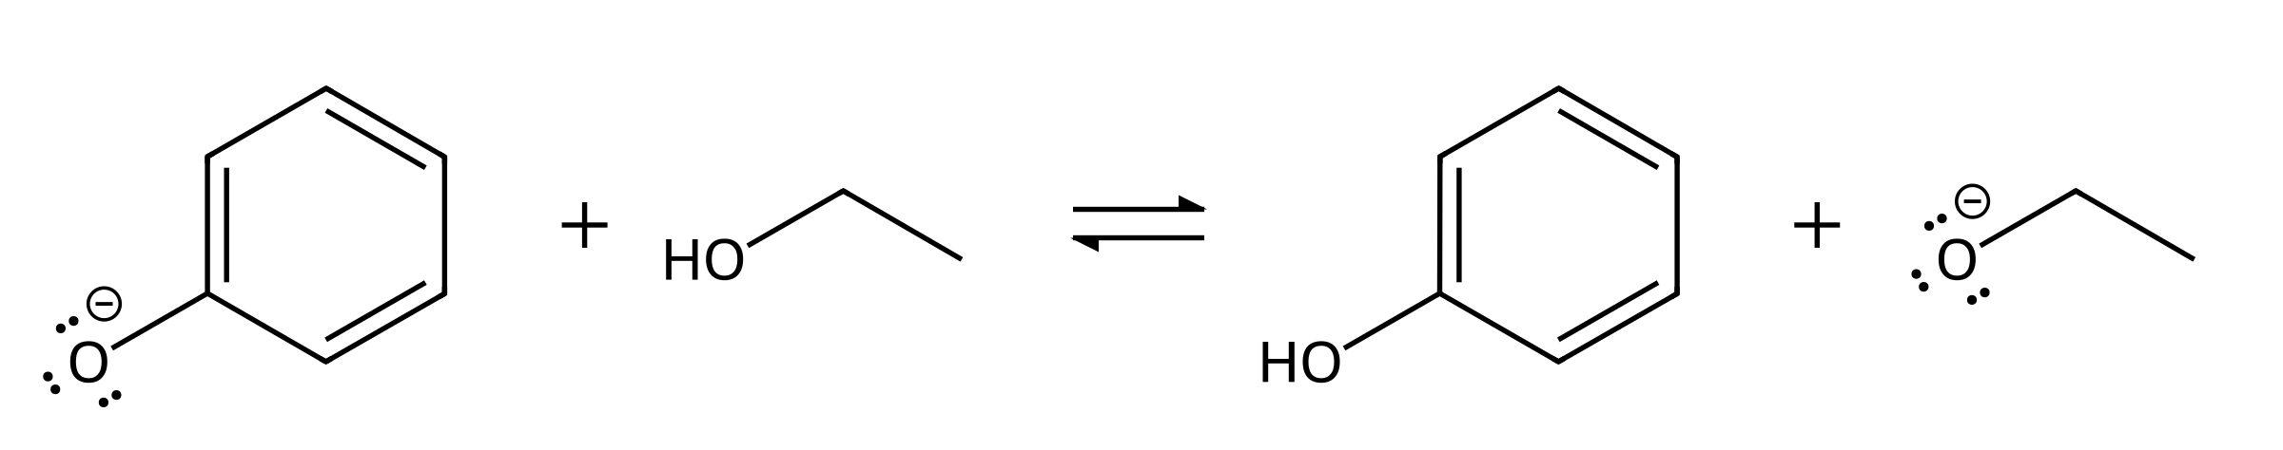
A) The products, because ethanol is the more acidic reactant
B) The products, because ethoxide is more stable
C) The reactants, because phenoxide is resonance stabilized
D) Neither side, because both anions have the charge on O
27. Which side of the equilibrium is favored?
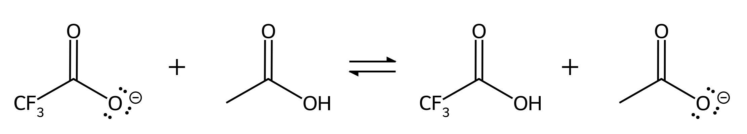
A) The products, because acetate is resonance stabilized
B) The products, because CH₃ donates electron density to the carboxylate
C) Neither side, because both anions are resonance stabilized
D) The reactants, because CF₃CO₂⁻ is stabilized by induction
28. Hydroxide deprotonates phenol. Which set of curved arrows correctly shows the proton transfer?
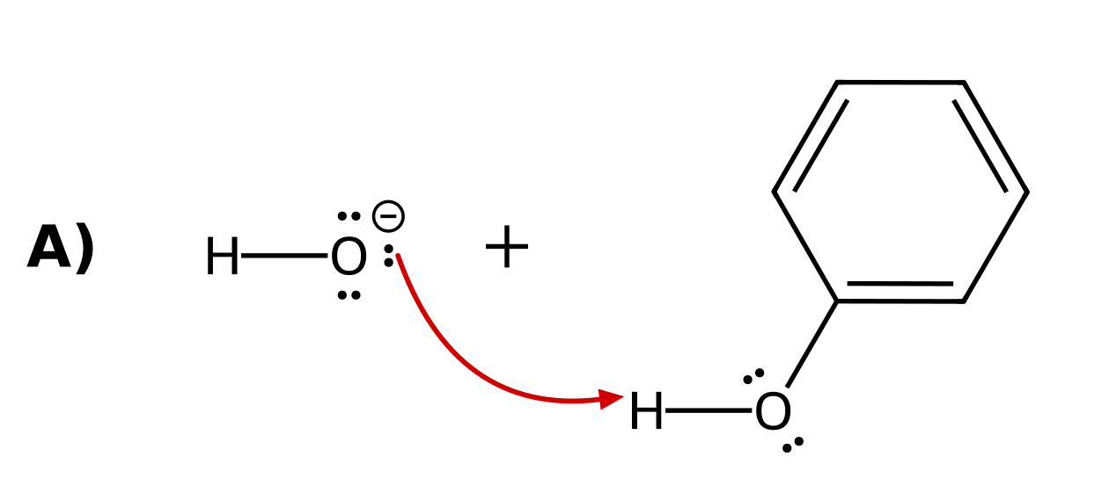 | 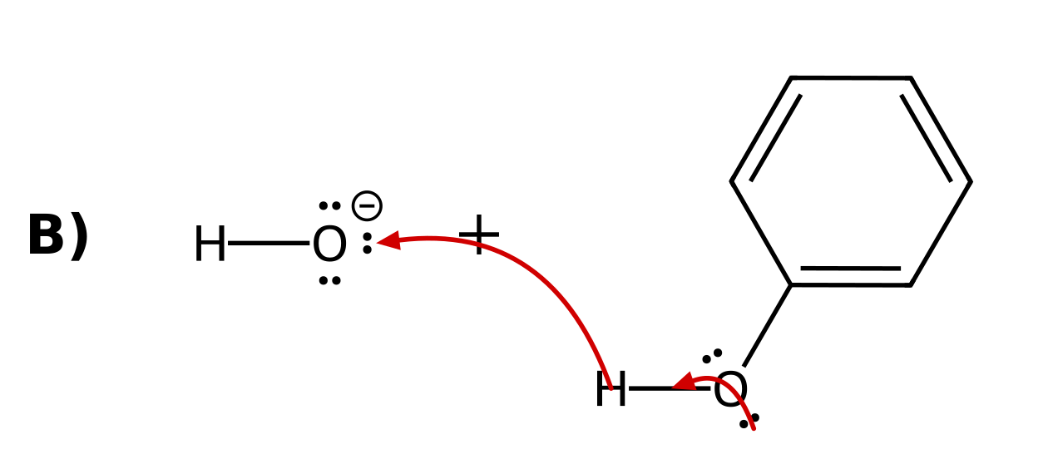
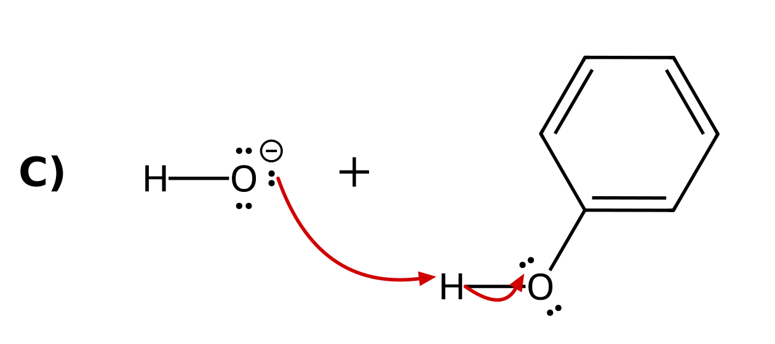 | 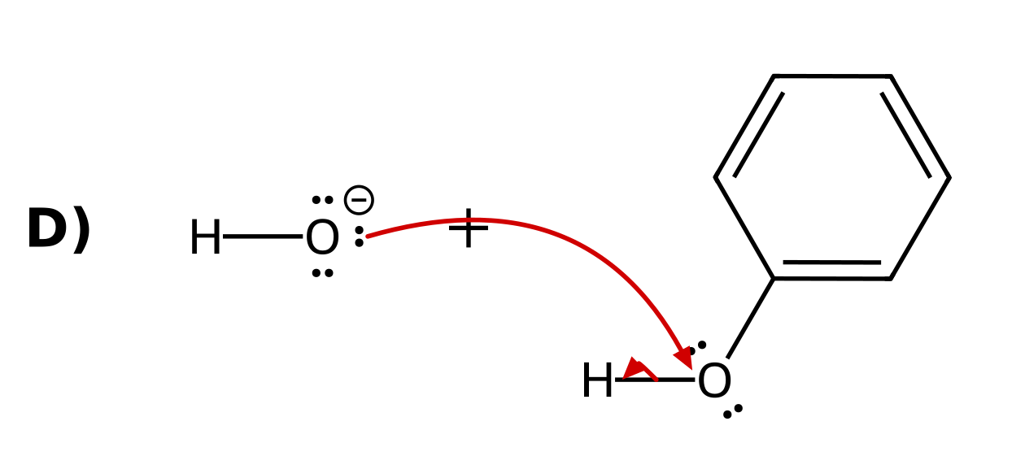

29. Which side of the equilibrium is favored?
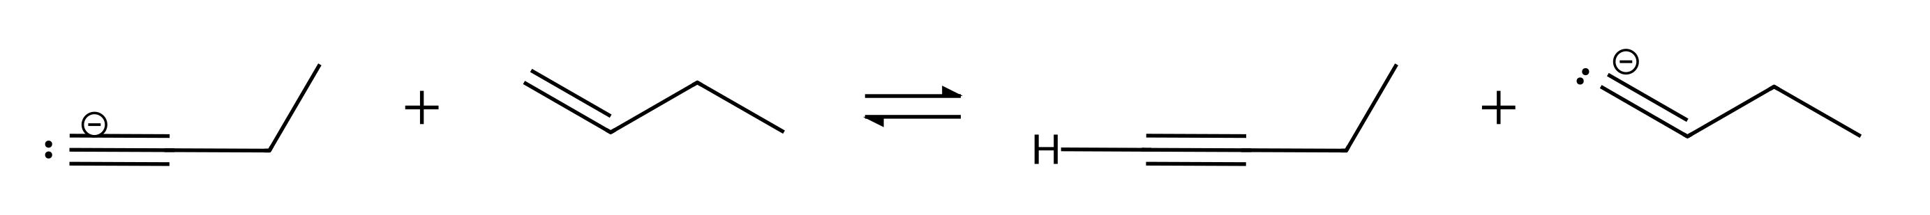
A) The reactants, because the alkynide (charge in an sp orbital) is more stable than the vinyl anion (charge in an sp² orbital)
B) The products, because the vinyl anion is resonance stabilized
C) The products, because an sp² orbital is closer to the nucleus than an sp orbital
D) Neither side, because both anions have the charge on carbon
30. Which anion is a strong enough base to deprotonate ethanol so that the equilibrium favors the products?
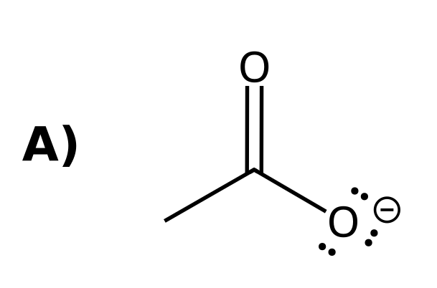 | 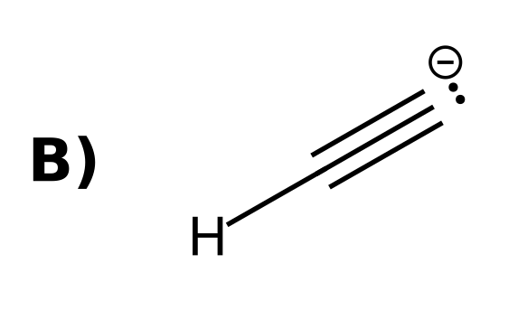
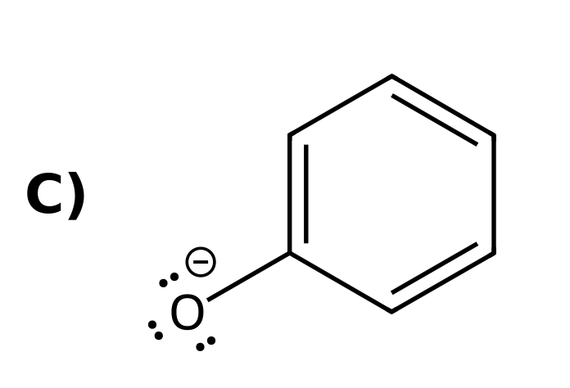 | 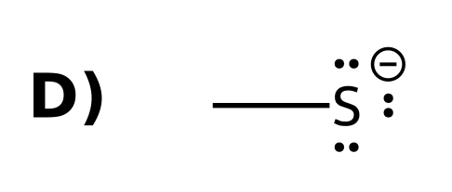

31. Which is the correct IUPAC name for this alkane?
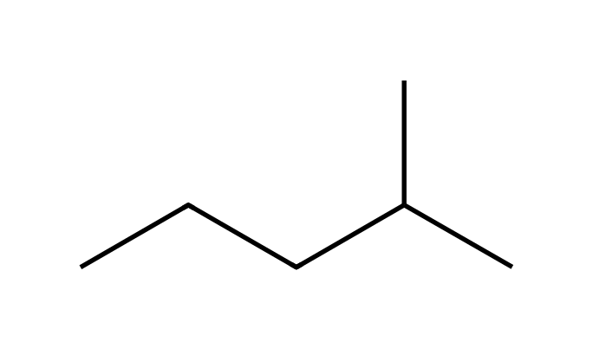
A) 2-methylpentane
B) 4-methylpentane
C) 3-methylpentane
D) 2-ethylbutane
32. Which is the correct IUPAC name for this alkane?
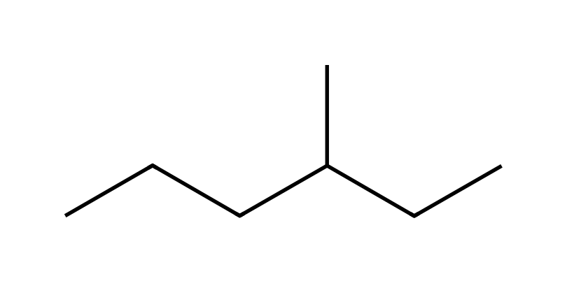
A) 4-methylhexane
B) 2-ethylpentane
C) 3-methylpentane
D) 3-methylhexane
33. Which is the correct IUPAC name for this alkane?
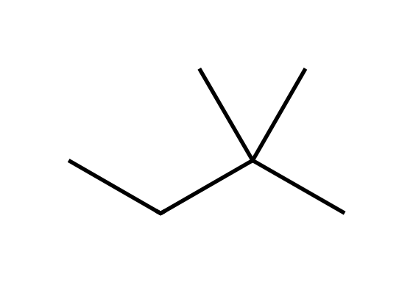
A) 3,3-dimethylbutane
B) 2,2-dimethylbutane
C) 2-ethyl-2-methylpropane
D) 2,2-dimethylpropane
34. Which is the correct IUPAC name for this alkane?
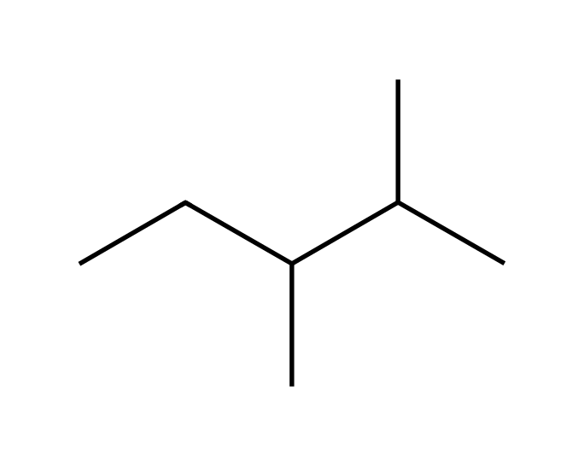
A) 3,4-dimethylpentane
B) 2-methyl-3-methylpentane
C) 2,3-dimethylpentane
D) 2,3-dimethylhexane
35. Which is the correct IUPAC name for this alkane?
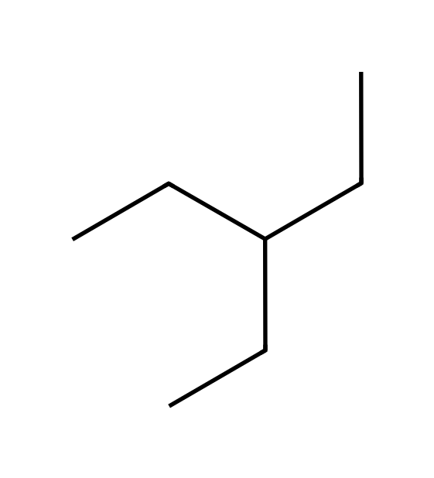
A) 3-methylhexane
B) 3-propylbutane
C) heptane
D) 3-ethylpentane
36. Which is the correct IUPAC name for this alkane?
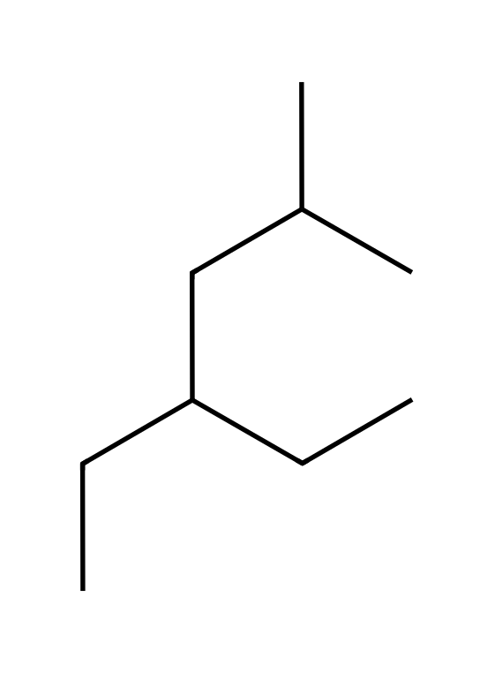
A) 4-ethyl-2-methylhexane
B) 3-ethyl-5-methylhexane
C) 2-methyl-4-ethylhexane
D) 2-ethyl-4-methylhexane
37. Which is the correct IUPAC name for this alkane?
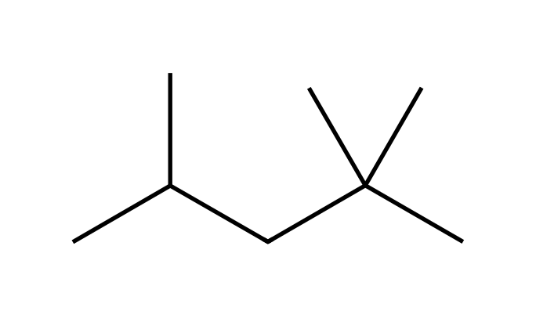
A) 2,4,4-trimethylpentane
B) 2,2,3-trimethylpentane
C) 2,2,4-trimethylpentane
D) 2,2,4-trimethylhexane
38. Which is the correct IUPAC name for this alkane?
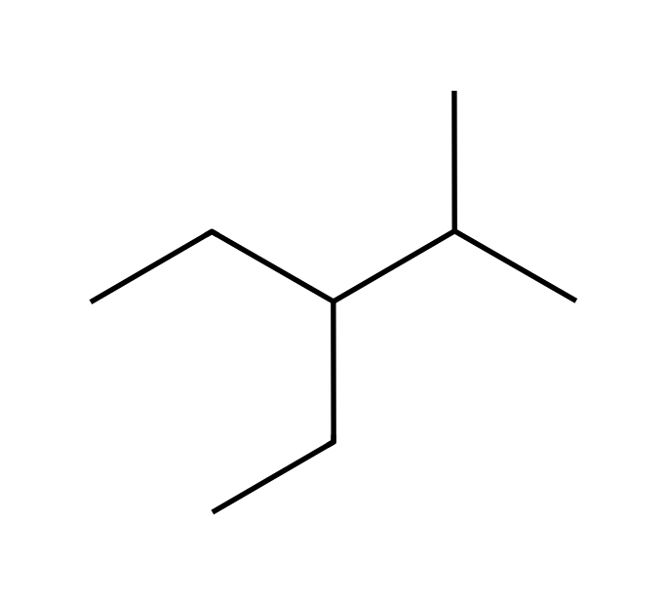
A) 2-methyl-3-ethylpentane
B) 3-ethyl-2-methylpentane
C) 3-ethyl-4-methylpentane
D) 2,3-diethylbutane
39. Which is the correct IUPAC name for this alkane?
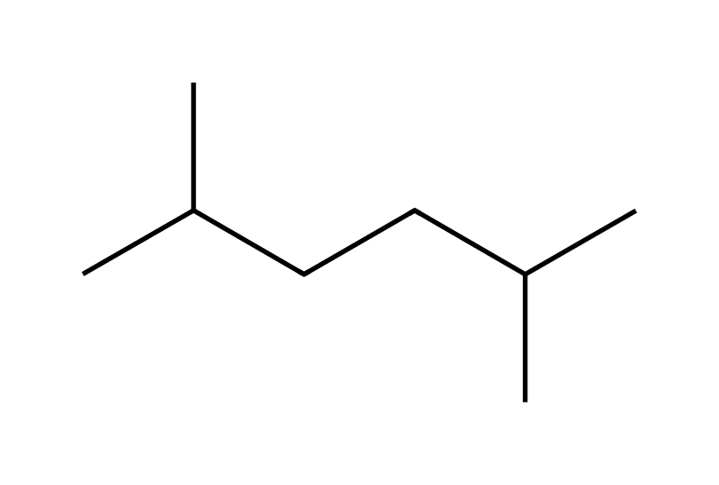
A) 2,5-dimethylhexane
B) 2,4-dimethylhexane
C) 1,1,4-trimethylpentane
D) 2-methyl-5-methylhexane
40. Which structure is 2,3,3-trimethylpentane?
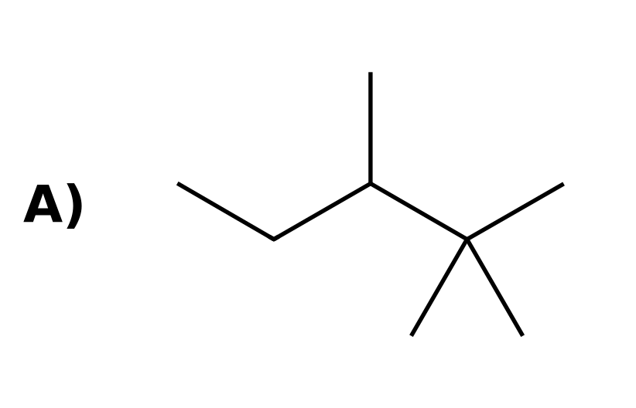 | 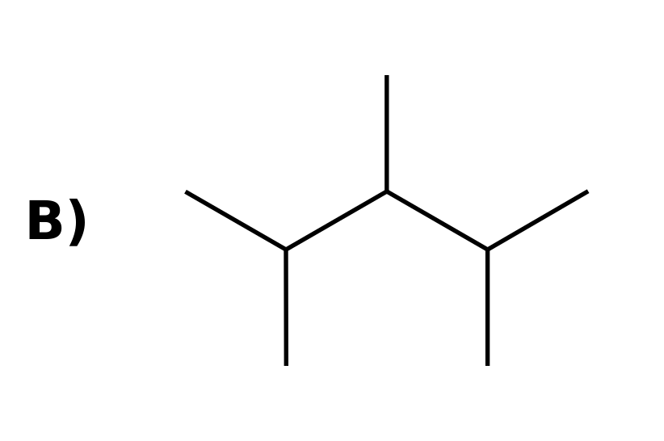
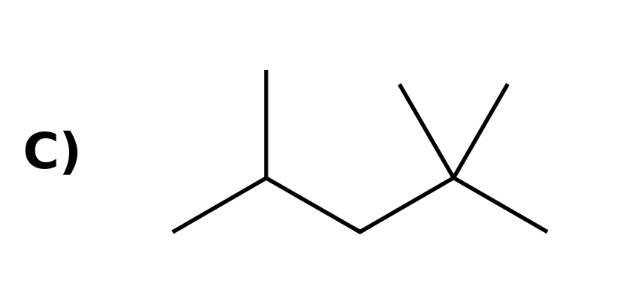 | 