🤖
Intelligent Cloud Document Analyst
n8n AI Engineering Project — Powered by Google Gemini API

What makes this project different?
This upgraded project replaces local Ollama models with the Google Gemini API — a production-grade, cloud-based LLM. Students will work with real API authentication, multi-modal AI (text + images), streaming responses, and build a full-stack intelligent document pipeline used in real enterprise workflows.

1. Project Summary

Students will design and build a complete cloud-connected automation pipeline that intelligently processes documents using n8n and the Google Gemini API. The system watches a local or cloud-synced folder for incoming files, extracts their content, and routes them through a multi-stage Gemini AI pipeline for summarization, classification, sentiment analysis, and entity extraction.

Unlike purely local setups, this project requires students to understand real-world API usage patterns: authentication via API keys, handling rate limits, parsing structured JSON responses, and connecting AI output to Google Sheets as a cloud results database and Gmail for real-time email notifications.

🎯 Real-World Simulation
This project mirrors actual enterprise Document Intelligence systems used in legal firms, finance, HR automation, and cybersecurity operations — where cloud AI APIs process thousands of documents daily.

2. Core Objectives

By the end of this project, students will be able to:

- Design and build multi-node automation workflows in n8n
- Authenticate and call the Google Gemini API (gemini-3-flash)
- Engineer effective prompts for structured AI extraction
- Handle multi-modal inputs: PDF text and embedded images via Gemini Vision
- Build and integrate a Python microservice (Flask/FastAPI)
- Route AI output to Google Sheets (cloud results database)
- Implement error handling, retries, and logging inside n8n
- Send real-time email notifications via Gmail when a document is processed

3. System Architecture

3.1 Components

Component | Description
n8n Workflow Engine | Local install or Docker — orchestrates all automation steps
Google Gemini API | Cloud LLM — gemini-3-flash model for text analysis & vision
Student Metadata API | Python Flask/FastAPI microservice for enrichment logic
Cloud Storage Layer | Google Sheets — used as the results database
Filesystem Trigger | Watched folder (incoming_docs/) for file drop detection
Email Notification | Gmail node sends a real-time email summary on completion
Output Folder | Processed JSON + summary reports written to output_docs/

3.2 Technology Stack

Area | Technology
AI Model | Google Gemini 3 Flash (via REST API)
Automation | n8n (self-hosted, v1.x)
Microservice Language | Python 3.10+ (Flask or FastAPI)
Cloud Storage | Google Sheets API (via the n8n Google Sheets node)
Notifications | Gmail (via the n8n Gmail node — OAuth2 authentication)
File Parsing | PyMuPDF (PDF), python-docx (DOCX), plain text
Authentication | Gemini API Key (Google AI Studio)

3.3 Architecture Diagram

The complete pipeline visualized end-to-end. Each colored layer represents a stage: input detection, file routing, text extraction, AI analysis with Gemini 3, metadata enrichment, and the three output channels (Google Sheets, output file, email).

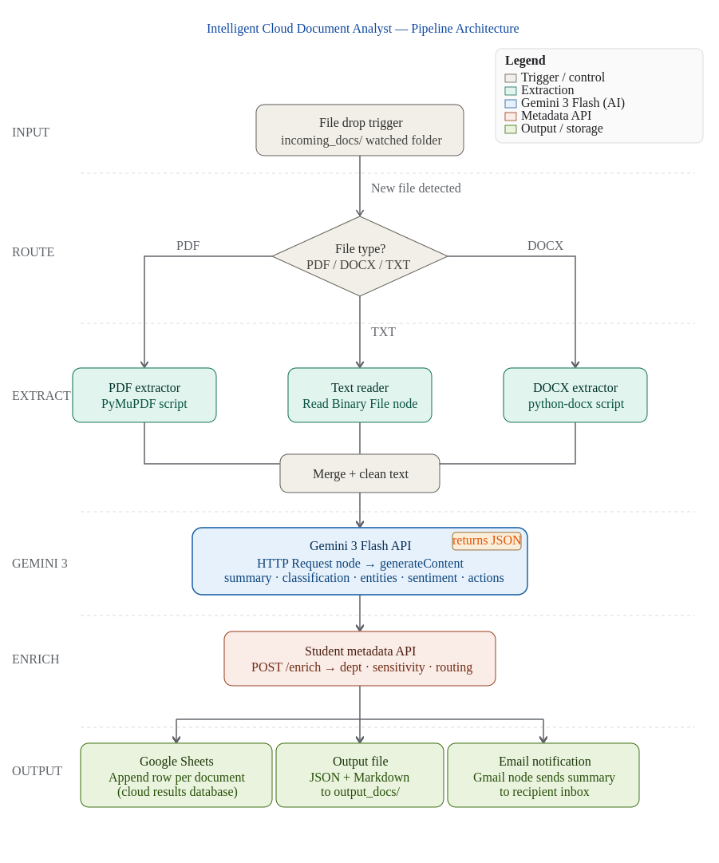
Figure 1 — End-to-end pipeline architecture

4. Functional Pipeline

The complete workflow runs in the following sequence:

- Step 1: File Detection — A user drops a document into the local incoming_docs/ folder.
- Step 2: Text + Image Extraction — n8n reads and extracts text content using an Execute Command or Code node. PDF files are parsed using pdfplumber or PyMuPDF via a Python script. Images embedded in PDFs are optionally passed to Gemini Vision.
- Step 3: Gemini AI Analysis — n8n sends the extracted text to the Gemini API using an HTTP Request node. The prompt requests a structured JSON response with: summary, classification, entities, sentiment, and action items.
- Step 4: Metadata Enrichment — n8n sends the same content to the student-built Metadata API. The API adds enriched metadata: sensitivity level, keyword tags, department routing, and a confidence score.
- Step 5: Google Sheets Write — n8n parses the JSON output from Gemini and appends a row per document into the Google Sheets results database.
- Step 6: Output Generation + Email Notification — n8n compiles a final human-readable summary (JSON + Markdown) and writes it to output_docs/, then sends an email via the Gmail node with the summary and routing tag.

🔑 Key Upgrade: Gemini Vision
If a document contains images (charts, scanned pages, diagrams), students can optionally pass the image bytes to Gemini's vision capability to extract visual information — something not possible with text-only Ollama models.

5. Gemini API Integration

5.1 Getting an API Key

- Visit Google AI Studio: https://aistudio.google.com/app/apikey
- Sign in with a Google account and click 'Create API Key'
- Store the key as an n8n Credential (HTTP Header Auth: x-goog-api-key)
- Never hardcode API keys — always use n8n's credential manager

5.2 Recommended Model

Model | Use Case
gemini-3-flash | Fast, cost-efficient, excellent for document analysis (RECOMMENDED)
gemini-3-pro | Higher accuracy for complex extraction, larger context window
gemini-3-flash (vision) | Use for image/PDF visual extraction tasks

5.3 n8n HTTP Request Node Setup

Configure the n8n HTTP Request node as follows:

Method: POST
URL: https://generativelanguage.googleapis.com/v1beta/models/gemini-3-flash:generateContent

Headers:
Content-Type: application/json
x-goog-api-key: {{ $credentials.geminiApiKey }}

Body (JSON):
{
"contents": [{
"parts": [{ "text": "{{ $json.prompt }}" }]
}],
"generationConfig": {
"temperature": 0.2,
"responseMimeType": "application/json"
}
}

5.4 Structured Output Prompt Template

Students must write a prompt that instructs Gemini to return valid JSON only. Example prompt:

You are a document intelligence assistant. Analyze the following document text
and return ONLY a valid JSON object with these exact fields:

{
"summary": "2-3 sentence summary of the document",
"classification": "one of: [invoice, report, contract, ticket, article, other]",
"sentiment": "one of: [positive, neutral, negative]",
"entities": {
"people": ["list of person names"],
"organizations": ["list of org names"],
"dates": ["list of dates mentioned"],
"amounts": ["list of monetary amounts"]
},
"action_items": ["list of recommended actions"],
"confidence_score": 0.0 to 1.0
}

Document text:
{{ $json.extracted_text }}

6. Student Metadata API

Students must build a lightweight Python microservice that enriches the Gemini output with business-specific metadata. This simulates real-world API integration patterns where an internal company service adds domain knowledge to AI results.

6.1 Required Endpoints

Endpoint | Description
POST /enrich | Accepts Gemini JSON output, returns enriched metadata
GET /health | Health check endpoint — must return {"status": "ok"}
GET /categories | Returns the list of available document categories
POST /sensitivity | Classifies document sensitivity: public / internal / confidential

6.2 Enrichment Logic Requirements

- Map Gemini classification to an internal department (e.g., 'invoice' → Finance)
- Assign a sensitivity level based on keywords found in entities
- Generate routing tags (e.g., 'needs-review', 'auto-approved', 'escalate')
- Add a timestamp and a unique document ID (UUID)
- Return a confidence score adjustment based on entity completeness

# Minimal FastAPI example
from fastapi import FastAPI
from pydantic import BaseModel
import uuid, datetime

app = FastAPI()

class GeminiResult(BaseModel):
classification: str
sentiment: str
confidence_score: float
entities: dict

@app.post('/enrich')
def enrich(data: GeminiResult):
dept_map = {'invoice': 'Finance', 'contract': 'Legal', 'report': 'Management'}
return {
'document_id': str(uuid.uuid4()),
'department': dept_map.get(data.classification, 'General'),
'sensitivity': 'confidential' if 'amount' in str(data.entities) else 'internal',
'routing_tag': 'needs-review' if data.confidence_score < 0.7 else 'auto-approved',
'processed_at': datetime.datetime.utcnow().isoformat()
}

7. Google Sheets Integration

Instead of writing to a local CSV or SQLite database, students must integrate Google Sheets as the cloud results database. Each processed document appends one row to a shared spreadsheet. This teaches OAuth2 authentication and real cloud API patterns.

7.1 Setup Steps

- Create a new Google Sheet and add the required column headers in row 1
- In n8n: Credentials → New → Google Sheets OAuth2 API
- Follow the n8n OAuth flow to authorize access to your Google account
- Add a Google Sheets node to your workflow with operation 'Append'
- Map fields from the previous nodes to the spreadsheet columns

7.2 Required Columns in Google Sheets

- document_id (UUID)
- filename and file type
- processed_at (ISO timestamp)
- classification and department
- sentiment and confidence_score
- summary (truncated to 500 chars)
- routing_tag and sensitivity
- action_items (as comma-separated text)

📊 Why Google Sheets?
Google Sheets is free, requires no extra setup, and lets students see their results update in real time. It also makes it trivial to build dashboards using built-in charts or to share results with the instructor for grading.

8. Email Notification (Gmail)

After every successful run, n8n must send a real-time email to a configured recipient. The email contains the document summary, classification, sensitivity, and a link to the row in Google Sheets.

8.1 Gmail Node Setup

- In n8n: Credentials → New → Gmail OAuth2 API
- Authorize access to your Gmail account through the OAuth flow
- Add a Gmail node to your workflow (operation: 'Send')
- Set the 'To' field to a configurable recipient address
- Build the email body using expressions from previous nodes

8.2 Recommended Email Template

Subject: [{{$json.classification}}] New document processed: {{$json.filename}}

Body (HTML):
<h2>Document Processed</h2>
<p><b>File:</b> {{$json.filename}}</p>
<p><b>Classification:</b> {{$json.classification}}</p>
<p><b>Sentiment:</b> {{$json.sentiment}}</p>
<p><b>Department:</b> {{$json.department}}</p>
<p><b>Sensitivity:</b> {{$json.sensitivity}}</p>
<p><b>Routing tag:</b> {{$json.routing_tag}}</p>
<h3>Summary</h3>
<p>{{$json.summary}}</p>
<h3>Action items</h3>
<p>{{$json.action_items}}</p>
<hr>
<p><i>Sent automatically by n8n + Gemini 3 Document Analyst</i></p>

9. Bonus Challenges

Students who complete the core project can tackle one or more of these bonus challenges for extra credit:

Challenge | Description
🌐 Gemini Vision | Pass embedded PDF images to Gemini 3 Flash Vision for visual analysis (charts, scanned pages)
📧 Daily Email Digest | Add a scheduled n8n workflow that sends a daily summary email of all documents processed in the past 24 hours
📊 Live Dashboard | Build a simple HTML/JS dashboard that reads from Google Sheets and shows live stats and charts
🔁 Retry Logic | Implement n8n error handling with automatic retry on Gemini API rate limit errors
🔍 Semantic Search | Store Gemini embeddings in a vector DB (Supabase / Pinecone) for document search
🧩 Multi-model Compare | Call both Gemini 3 Flash and Gemini 3 Pro and compare their extraction quality side by side
📎 Multi-file Batch | Extend the workflow to process a ZIP file of multiple documents in parallel
🛡️ Sensitivity Alerting | Send a high-priority email immediately when a 'confidential' document is detected

10. Scenarios Students Can Choose

Each student selects ONE domain scenario for their documents. All prompts and enrichment logic must be tailored to the chosen scenario.

- Business documents — contracts, invoices, purchase orders, vendor agreements
- Cybersecurity incident logs — alert reports, SIEM exports, vulnerability scans
- Financial reports — earnings summaries, budget proposals, expense reports
- HR and ticket summaries — employee complaints, support tickets, onboarding docs
- Product descriptions — e-commerce listings, spec sheets, marketing copy
- Academic articles — research abstracts, literature reviews, thesis summaries
- Legal documents — court filings, NDAs, compliance reports (ADVANCED)
- Medical summaries — clinical notes, discharge summaries, lab results (ADVANCED)

11. Student Deliverables

Students must submit ALL of the following:

Deliverable | Description
n8n Workflow JSON | Exported .json file of the complete working n8n workflow
Python Microservice | Flask/FastAPI app code with all required endpoints (50-100 lines)
Google Sheets Evidence | Screenshot or shareable link to the Google Sheets results table
Email Sample | Screenshot of one notification email actually received
Architecture Diagram | Full system diagram showing all components and data flows
README.md | Step-by-step setup guide including Gemini API key, n8n config, and API
Sample Documents | 3-5 sample input documents and their processed output JSON files
Prompt Log | The exact Gemini prompts used, with before/after examples showing iterations

12. Grading Rubric

Criteria | Description
Gemini API Integration (25%) | Correct auth, prompt quality, structured JSON response parsing
n8n Workflow Logic (20%) | Node connections, data mapping, error handling, conditional routing
Metadata API Quality (15%) | Correct endpoints, enrichment logic, code quality
Google Sheets + Email (15%) | Working append to Sheets and successful email notification
Documentation & README (10%) | Clarity, completeness, reproducibility of setup instructions
Prompt Engineering Quality (10%) | Evidence of prompt iteration and optimization
Creativity & Bonus Challenges (5%) | Extra features, bonus challenges completed

13. Setup Quick Start

13.1 Gemini API Setup

- Go to https://aistudio.google.com/app/apikey
- Sign in and create a new API key
- In n8n, go to Credentials → New → HTTP Header Auth
- Set Name: x-goog-api-key, Value: your API key
- Use this credential in your HTTP Request nodes

13.2 n8n Installation

# Option A: npx (fastest for development)
npx n8n

# Option B: Docker
docker run -it --rm \
-p 5678:5678 \
-v ~/.n8n:/home/node/.n8n \
n8nio/n8n

# Access at: http://localhost:5678

13.3 Python Microservice

pip install fastapi uvicorn pydantic
uvicorn main:app --reload --port 8000

# Test with:
curl http://localhost:8000/health

📌 Important Notes on API Usage
The Google Gemini API free tier allows up to 15 requests per minute and 1,500 requests per day on the free plan — sufficient for this project. Students should implement a 2-second delay between requests in n8n using a Wait node to avoid rate limit errors. For production use, the paid tier should be used.

💡 Teaching Tip
Encourage students to compare their Gemini prompt outputs across different document types and iterate on prompt wording. Prompt engineering quality significantly affects JSON accuracy — this is a core real-world skill for AI engineers.

Intelligent Cloud Document Analyst — n8n AI Engineering Project
Powered by Google Gemini API | Built with n8n

