

Table of Contents
1. Website analysis – avis.com 3
2.Video summary 4
3.Designing 5

1. Website analysis – avis.es
1- Is this website clear enough?
-At first, it doesn’t, because it shows you the image of a road, which could mean cars (the main purpose of the website) but it could also mean travel, or road service. As you scroll down, you can see the page is about cars, but not instantly.
Also, the purpose of the website is written almost at the end of it. Should be written at the first screen.
2- Does it follow conventions?
-It does follow, having menus, icons, a logo (not iconic one, just letters)… Except the footer, it’s way too bigger. And the page doesn’t re-escalate as you zoom out.
-Everything clear enough, doesn’t have social network but else it is good.
3- Is any law of the gestalt present on the page?
Rules that follows:
-Continuity law.
-Similarity law.
-Simplicity law.
-Almost symmetric law (the search car “box” gives the sensation it’s pushed to the right because there is a blank space at the bottom left corner.)
Rules that fails to follows or doesn’t use:
-Proximity law (Elements are touching each other without white spaces)
-Closure law
-Figure and ground law.
-Law of Synchrony
4-Is the menu visible?
-Only at the start, as you scroll down, it is lost, doesn’t follow the user.
5-Can you distinguish links and buttons, false accordance?
-It does underlain when you hover over them with the mouse, but they use the same color as normal text, white.
6-Is there any content that distracts the user?
-No.
7-Balanced or unbalanced page?
-Is balanced except the search car “box” gives the sensation it’s pushed to the right because there is a blank space at the bottom left corner.
8-Are there any search options? Are they clear enough?
-The search button could be better, right now it creates a new bar that pushes the page down further. It should be a search bar that push the other menu options to the left, and then change the search button to “continue” to do the search.

2.Video summary
1 of 3:
This video talks about the different ways to make a prototype for your protect, things to keep in mind when you do it
and some tricks. Sketching & paper prototyping can help you to see a preview of your idea and modify it easily. In a
paper you can draw and paint all the things that you want to see in your app, and you can use object to protect shadows and to try the position of the elements easily and see if it works. You can also simulate interactions in your app prototype easily using some handmade papers buttons and screens. You can use this to see how the application colors work.

2 of 3:
This video explains how to explain the idea to your users, using programs that let you test your website capabilities without need of coding called digital prototyping.
Perfect to find how a user can get to somewhere in the website more easily.

3 out 3:
The video explains the factors you have to think about when you create an application for a certain device. Each device has their own components and utilities, which the developer can take advantage from.
Also shows each device has different hardware and the application must be adapted between them, for example, computer applications wont work on mobile, they have different hardware and functionality.

3.Designing
Sketch home:

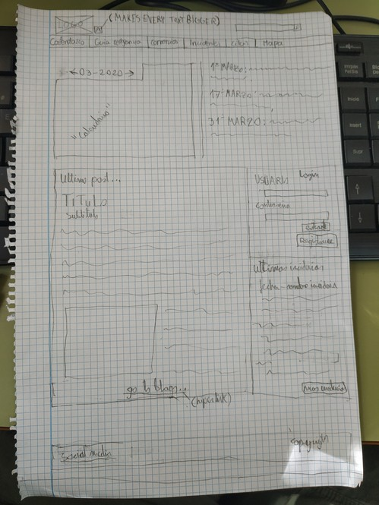

Design home:

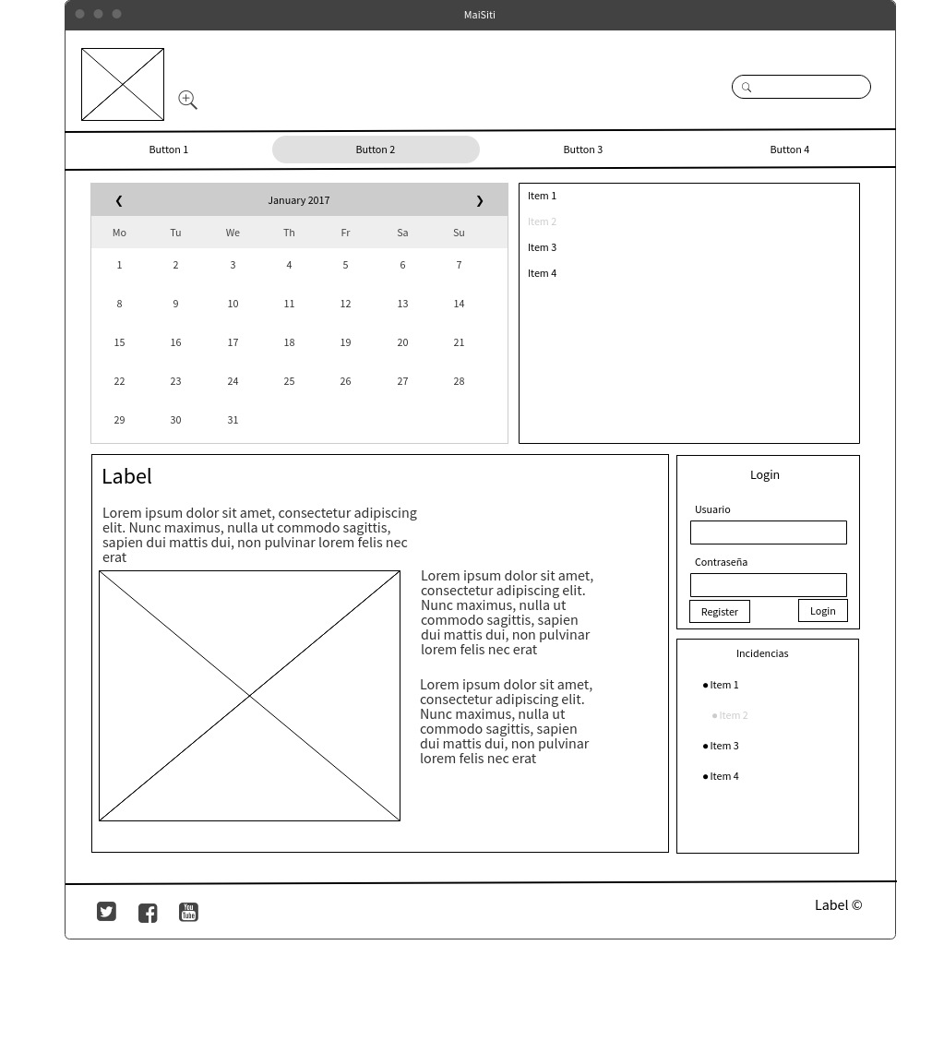

Design reports:

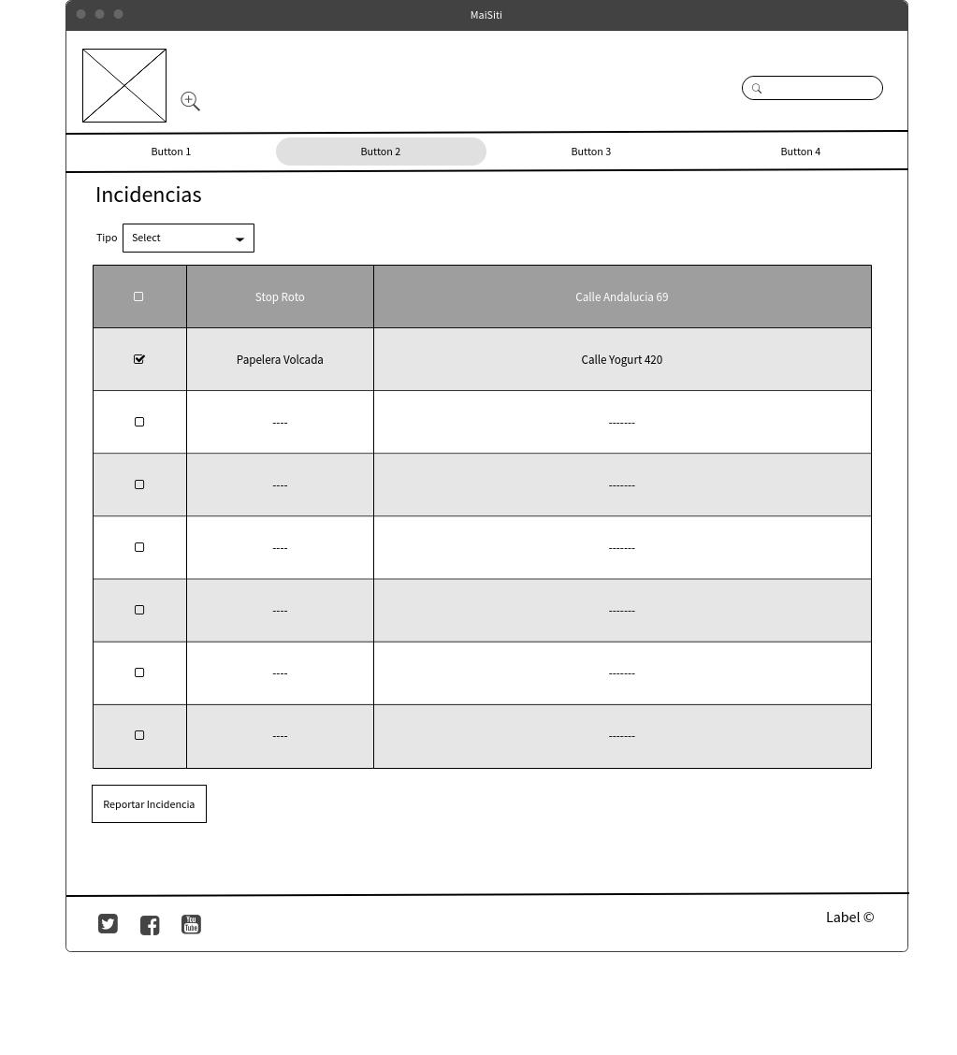

Sketch reports:
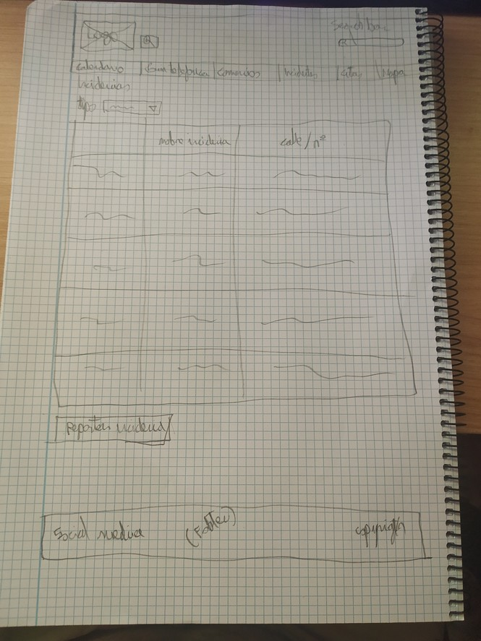

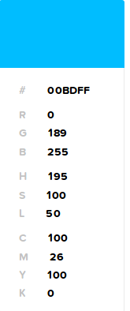
Colors
navigation bar background and footer - Navigation bar buttons (text white)
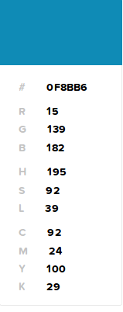

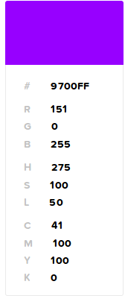
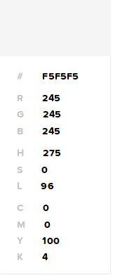
Hyperlink color Text field background

Font
Titles: Roboto mono.
Subtitles: Roboto slab.
Text: Roboto Condensed
Footer and navigation var: Oswald
Navigation map
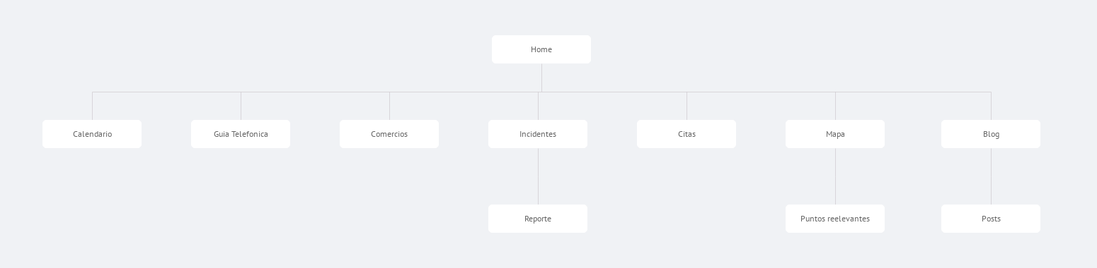
Icons
Corresponding Social Media icons on the footer.
The icon of a magnifier with a plus insde on the navigation bar for increasing the font size all over the page.
The logo is an icon that takes you to the home page on click.
The magnifier on the search bar that tells you it’s for searching text.
Navigation and interactions
The home page is a resume of the latest events on the page, the last blog post, the last calendar events, the last reports… When the user uses the navigation bar, it takes him to a detailed version of whatever he clicked, like the full details of the calendar, or the full details of the reports. There is a button next to the logo that increases the font size for those who can’t read well or doesn’t know how to zoom. Each image and button has an informative text that tells what is it, the colors of the page have been thought so diatonic people can see the text, for example, the navigation bar buttons are blue, but the text is white, so that color is never confusing. The logo takes you to the home page on click. And the navigation bar follows you if you scroll down.

