Hi, and thanks for purchasing my OLED replacement kit for the Pure Evoke Flow series of radios.
Please note that the display is not supported or endorsed by Pure Ltd. D&H Pye Ltd cannot be liable for any damage that occurs to the radio from incorrect use or installation of the kit.

Introduction

The reason the kit is needed is because the original OLED display the radio used is no longer available. While similar displays (with the same connectors) are available, they tend to give a mirror-effect display when fitted, making them unusable. The circuit board supplied as part of this kit sits in the middle of the data stream between the radio and the display, and makes the necessary adjustments to the data to make the display appear the correct way round.

Fitting instructions
It is worth reading through the set of instructions first so you know the outline of the procedure before you start.
Place the radio on its front, either on a cloth/towel or a surface that won’t scratch it.
Remove the six black screws shown in the picture below (circled in purple).
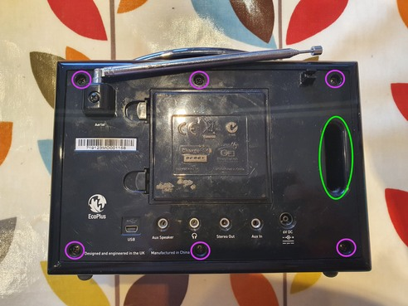

Once you’ve done this, separate the back of the radio carefully and lift it slightly to the right as you do to clear the edge of the case. It’s often useful to insert your fingers in the ‘bass channel’ circled in green on the above image to help. You’ll find the two halves of the radio are connected by a number of wires and cables, so don’t separate them too far.

With care you should be able to position the two halves of the radio as shown below: If the cables are a bit short, you can rest the ‘upright’ section of the radio on a suitable object to avoid the cables being too stretched. On the image below, you can also see (circled in purple) the four screws that hold the display holder panel in place, as well as the ribbon connector that joins it to the board (circled in green).
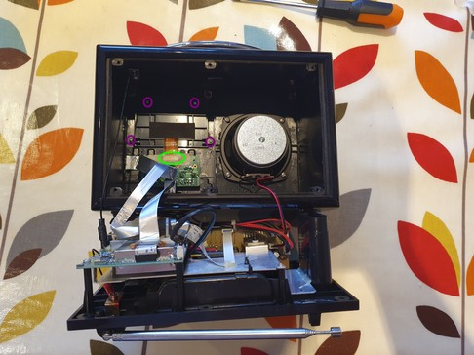

Some models have masking tape and/or hot glue over the connector -if so, gently peel it back enough to be able to see where the orange cable enters the connector, as well as the two black retaining lugs (arrowed in pink).
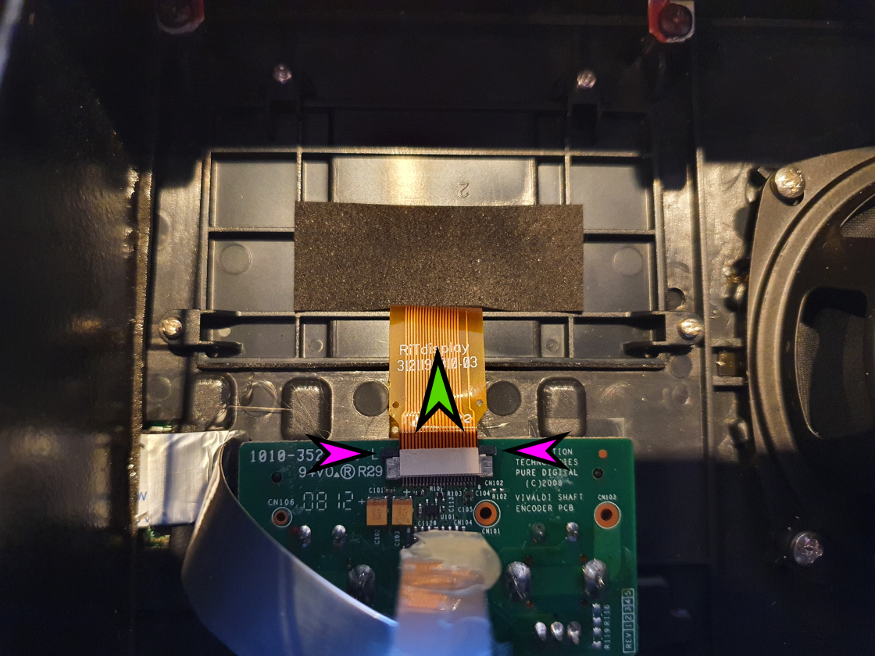
You only need to be able to peel back enough to be able to access the black retaining clips on the top of the connector where the orange cable enters it (highlighted by the purple arrows) – use a fingernail (or a small screwdriver type tool) to move each clip in the direction shown by the green arrow. They move probably around 1-2mm or so. Once they’re both released, the orange-coloured cable should slide easily out of the connector.

Next undo the four display panel retaining screws (circled in purple on the image below), and lift the panel and display out of the radio.

Also, there is a silver coloured ribbon cable directly below the orange one you have disconnected – this also needs to be unplugged from the circuit board, as we will need to connect it to our new board. It is circled in blue (below). Sometimes it has been stuck down/folded with some hot glue – this should come off with gentle finger pressure. The cable just pulls up and out from the connector – there are no retaining lugs holding it in.

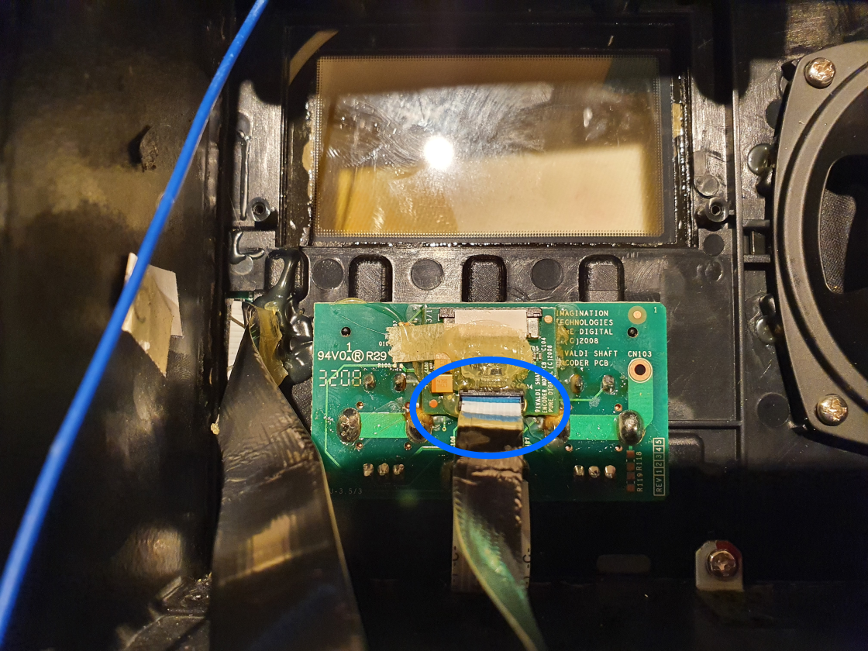

Preparing to install the new display

Gently separate the old faulty display from the plastic mounting bracket using your fingers (it’s stuck on with double sided tape), and dispose of the display only. There is some copper screening foil which should also come off with it, leaving the plastic bracket.

If need be, you might want to clean the clear plastic window the display sits behind, to make sure there is no dust or fluff. A cotton bud or similar dipped in meths (and another to dry it) is ideal for this. Try not to disturb the adhesive round the edge of the window, as this will help hold your new screen in place.

Peel off the foam-backed sticky tape from the back of the display, and gently offer it up to the mounting bracket, threading the orange ribbon cable out of the slot on the back of the bracket (as per the original display). Use the word TOP written on the back of the display to make sure you stick it the right way up. Centre the display on the bracket (the corners of the display align with the little plastic lugs in each corner of the bracket, and press it gently into place so the foam adhesive tape holds it firmly in place. Don’t press too hard, or the screen will crack. It will not be completely flush with the bracket – it just needs to be securely held in place by the foam tape.

You should be left with an assembly that looks like this:

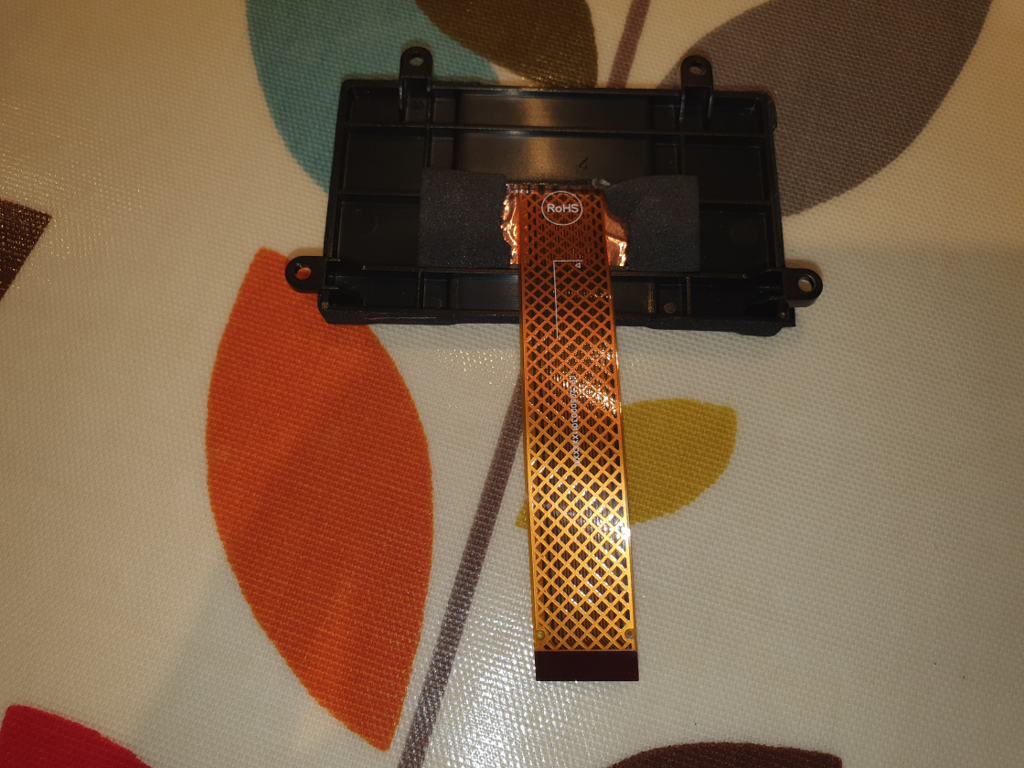

Now, gently remove the protective film from the front of the new display, and lower the display and bracket into place in the recess behind the front panel of the radio.

Secure it in place using the LOWER two screws only for now.

Now, it is time to connect the screen to the supplied circuit board. The long connector on this board (labelled LCD_CONN1) and has a retaining clip which hinges up to open it.

To open it, insert a fingernail (ideally) into the end of the connector where the cable would go in, and ensure the black clip is hinged up 90 degrees into its open position, like this:

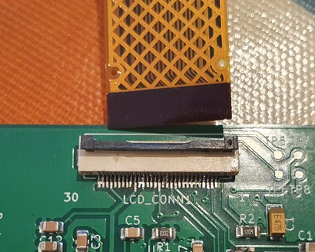

Now carefully insert the cable from the display into it (copper contacts face DOWN – towards the circuit board). Ensure the cable is central in the connector, and it will slide a small distance into place. Once it is correctly sited, hinge the clip shut to hold the cable firmly in place, as below:

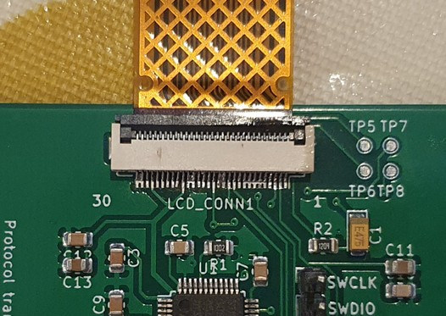
You will be left with the board and cable in this position:

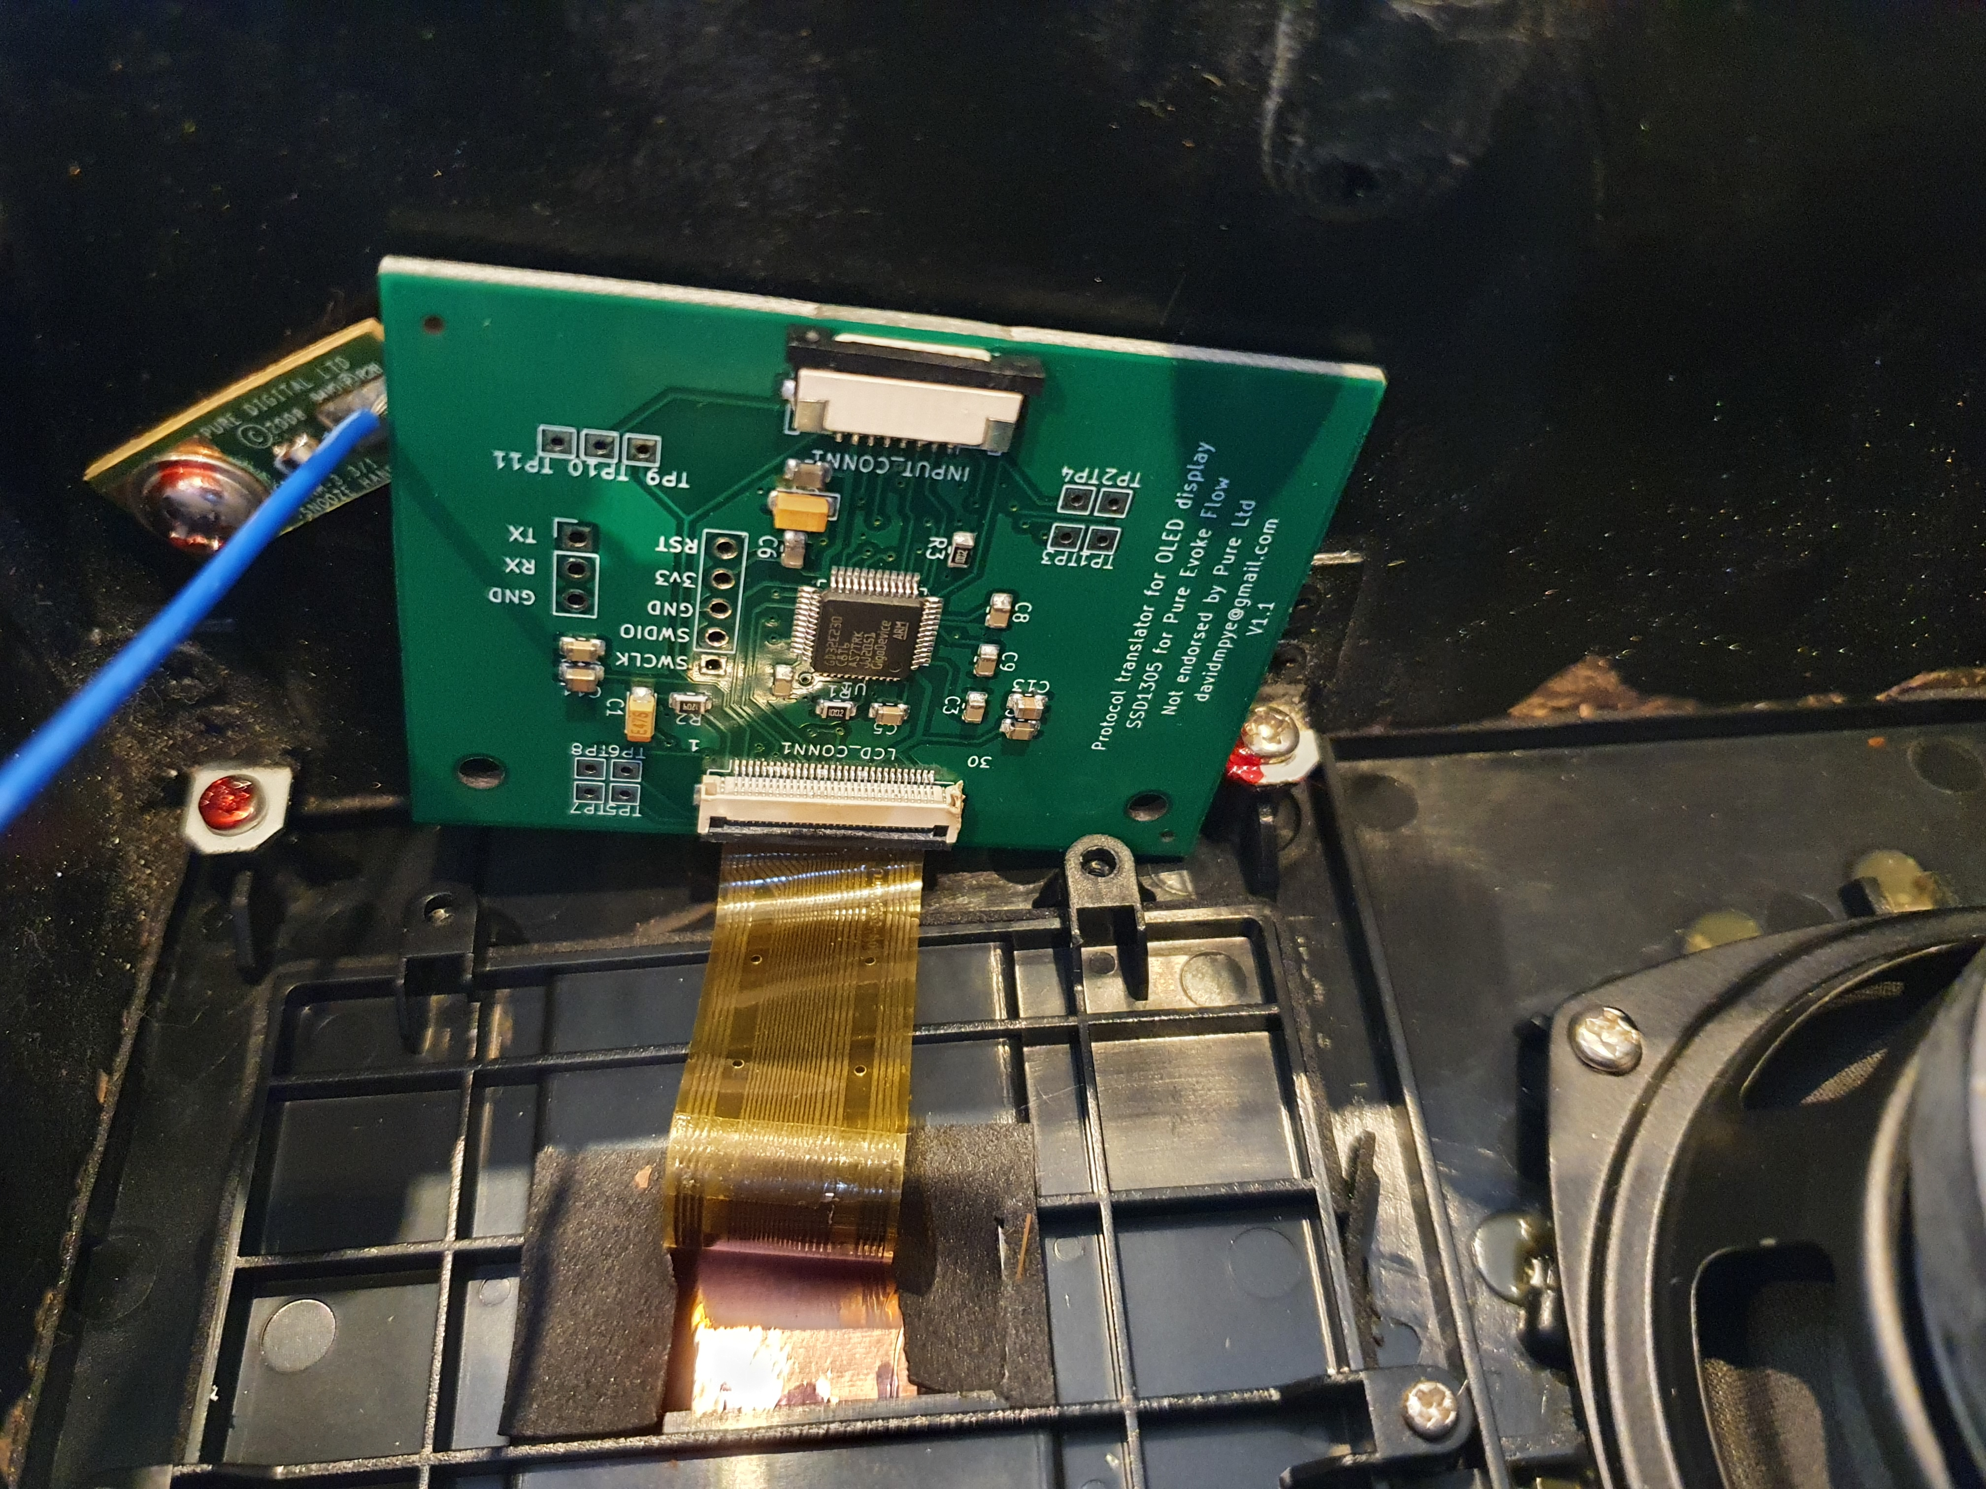

Now, it is time to connect the silver cable from the radio to the other connector on the supplied circuit board (labelled INPUT_CONN1). This connector has a small retaining clip, with two black lugs at each end. To ‘open’ the connector ready to receive the cable, slide each lug gently with a fingernail horizontally outwards, away from the white part of the connector.

Insert the silver cable with the metal contacts facing down (blue plastic side ‘up’ - away from the circuit board shown in the picture below:
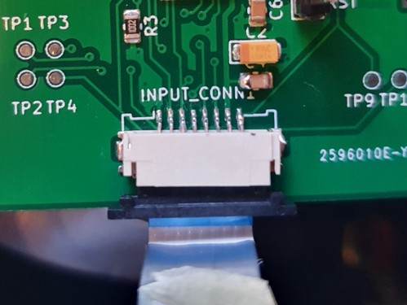

Once the cable is firmly inserted, push the retaining bar back in so it is flush with the connector body, gripping the cable firmly in place.

Now, lower the circuit board down so it is ‘blank side up’ – there should be no twists in the orange display cable. Use the supplied two screws to secure the board into place through the top two holes in the bracket as shown below.
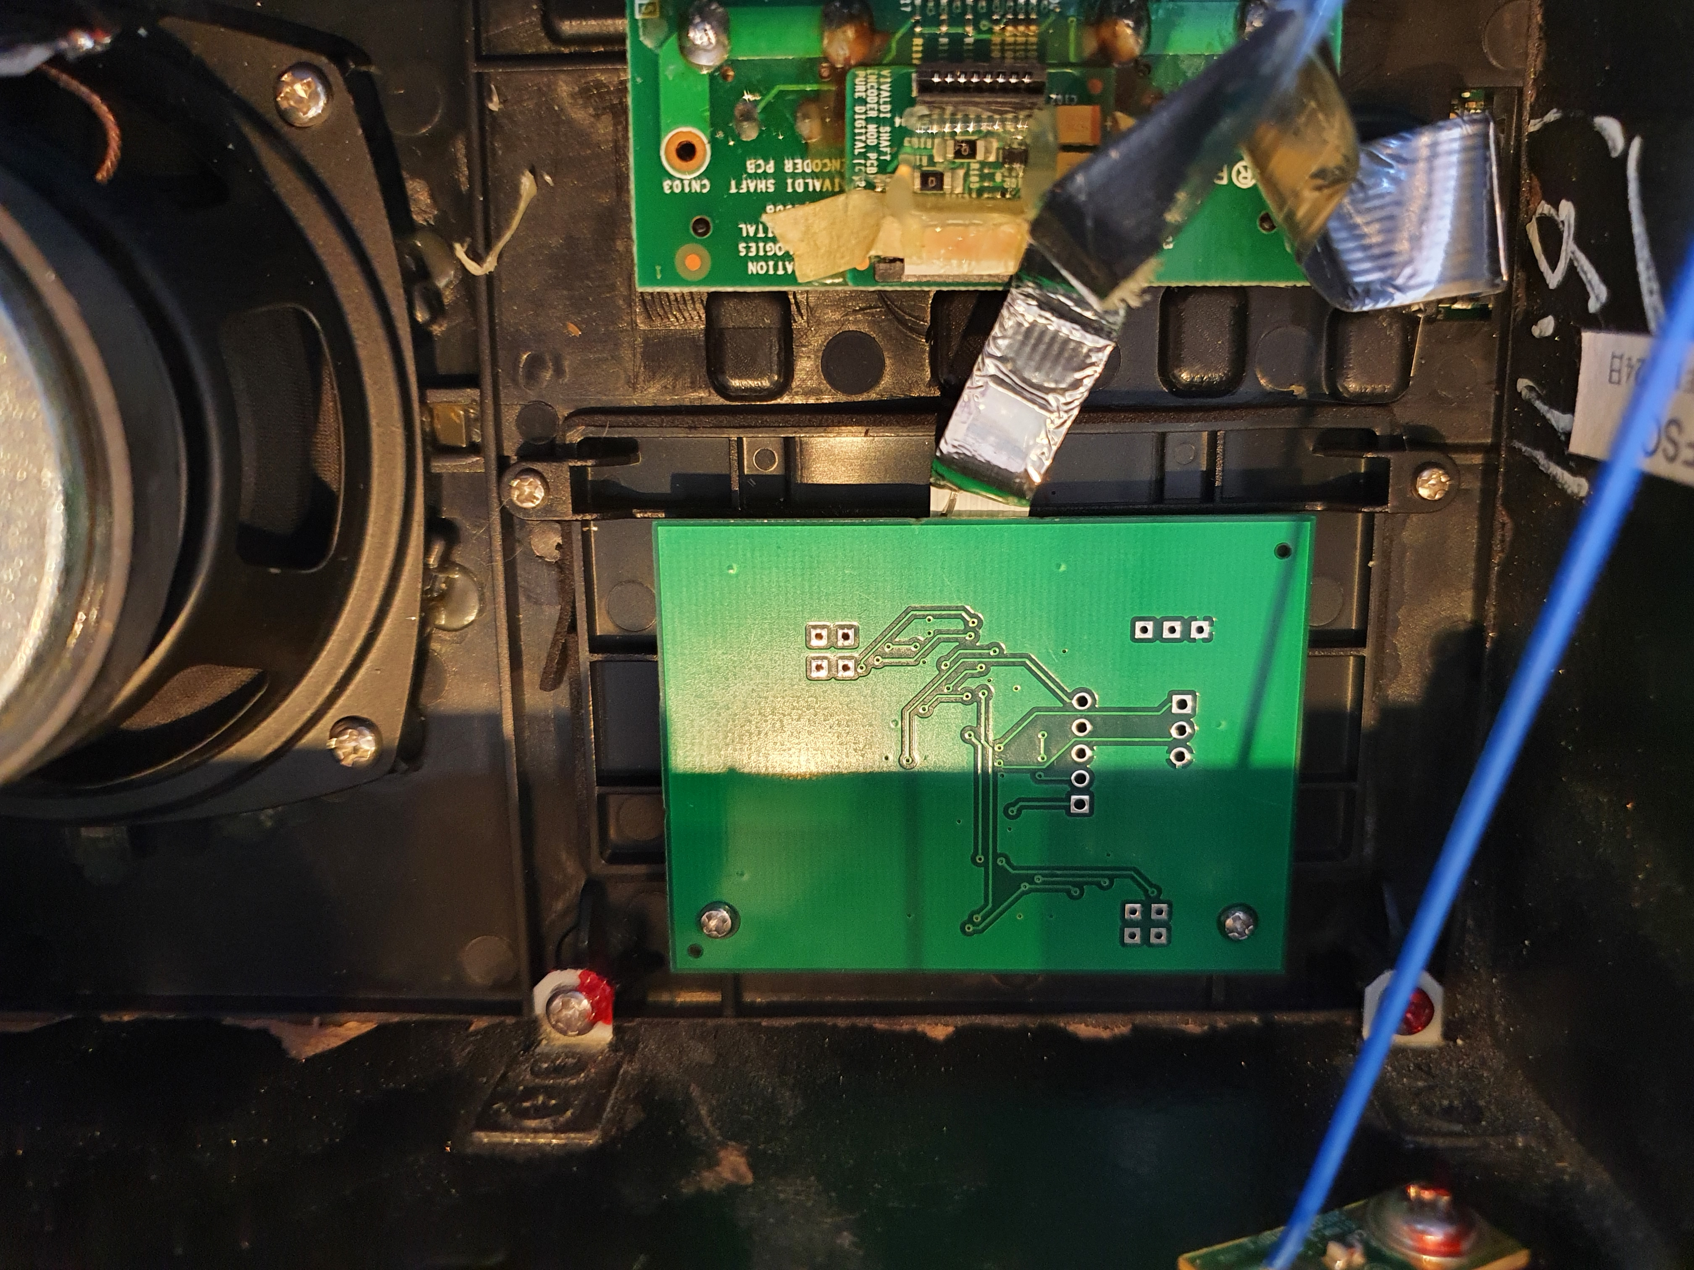

You can now reassemble the two halves of the radio. Check both the ribbon cables between the two halves of the radio are still snuggly inserted.

The left side slides in first to clear the little brackets on the edge of the case, and then it drops in to place. It’s now safe to power on the radio and check that the display works as expected.

Now, install the six retaining screws to hold the back panel on.

Well done – enjoy your newly repaired radio!

Any problems, please get in touch!

David Pye
davidmpye@gmail.com

