Hi, and thanks for purchasing my OLED replacement kit for the Pure Evoke Flow series of radios.
Please note that the display is not supported or endorsed by Pure Ltd.

Introduction

The reason the kit is needed is because the original OLED display the radio used is no longer available. While similar displays (with the same connectors) are available, they tend to give a mirror-effect display when fitted, making them unusable. The circuit board supplied as part of this kit sits in the middle of the data stream between the radio and the display, and makes the necessary adjustments to the data to make the display appear the correct way round.

Fitting instructions
Place the radio on it’s front, either on a cloth/towel or a surface that won’t scratch it.
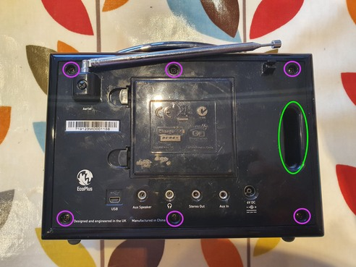
Remove the six black screws shown in the picture below (circled in purple).

Once you’ve done this, separate the back of the radio carefully and lift it slightly to the right as you do to clear the edge of the case. It’s often useful to insert your fingers in the ‘bass channel’ circled in green on the above image to help. You’ll find the two halves of the radio are connected by a number of wires and cables, so don’t separate them too far.

With care you should be able to position the two halves of the radio as shown below:

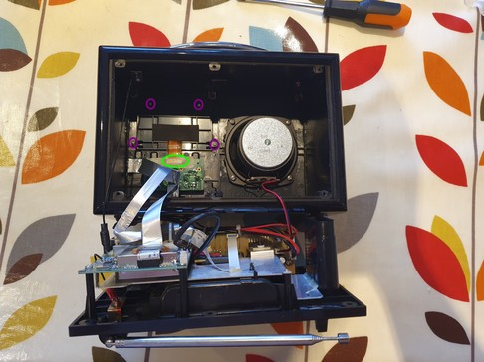

On the image above, you can see (circled in purple) the four screws that hold the display holder panel in place, as well as the ribbon connector that joins it to the board (circled in green). On the model above, you can see Pure have put a piece of masking tape over it to help keep it secure.

If yours has this, peel it off to reveal the connector as shown below.
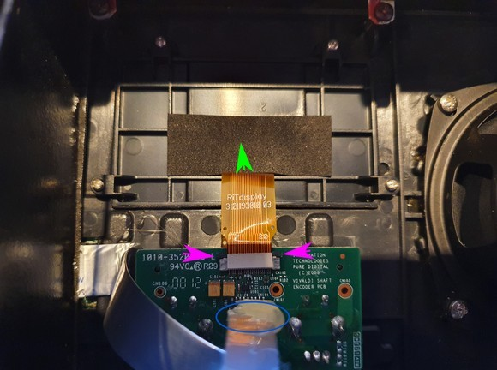

There are two retaining lugs (arrowed in purple) – using a fingernail (or a small screwdriver type tool) click each one in the direction shown by the green arrow. They move probably around 1mm or so. Once they’re both released, you can slide the orange-coloured ribbon cable out of the connector.

Next undo the four display panel retaining screws (circled in purple on the image before), and lift the panel and display out of the radio.

Also, there is a silver coloured ribbon cable directly below the orange one you have disconnected – this also needs to be unplugged from the circuit board, as we will need to connect it to our new board. It is circled in blue. Sometimes it has been stuck down/folded with some hot glue – this should come off with gentle finger pressure. The cable just pulls out from the connector – there are no retaining lugs holding it in.

Preparing to install the new display

Separate the old faulty display from the plastic mounting bracket, and dispose of it. There is some copper screening foil which should also come off with it, leaving the bracket as shown below.

In each corner of the plastic mounting bracket where the screen sits, is a moulded plastic lug like below (shown in close up). Each corner piece looks like this, in close up:


You need to remove the piece shown in RED in the diagram from each corner. - you can use a small pair of nippers (or a craft knife, or even a pair of fingernail clippers). Do not remove the whole corner lug, just the projecting bit as shown.

Now, prepare to stick the new screen to the mounting bracket. Thread the flexible cable through the slow in the screen bracket, then peel the backing pieces of the double-sided tape off, and gently affix it to the bracket. Press gently but firmly to get the screen to stick securely in place, but don’t apply so much pressure that you risk cracking the screen. Note the word ‘top’ is written on the copper foil on the back of the screen to make sure you get the screen the correct way up.

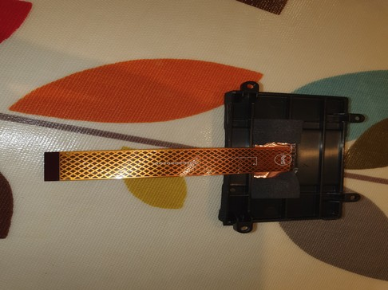
The screen/bracket assembly shouuld now look like this:

#

Now, it is time to connect the screen to the supplied circuit board. The connector on this board is a slightly different type to the previous one, and has a retaining clip which hinges up.

Insert a fingernail (ideally) into the end of the connector where the cable would go in, and ensure the brownish clip is hinged up, into its open position, like this:

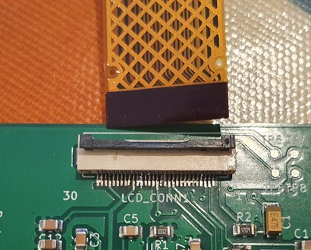

Now carefully insert the cable from the display into it (copper contacts face DOWN – towards the circuit board). Ensure it is central in the connector, and it will slide a small distance into place. Once it is correctly sited, hinge the clip shut to hold the cable firmly in place, as below:

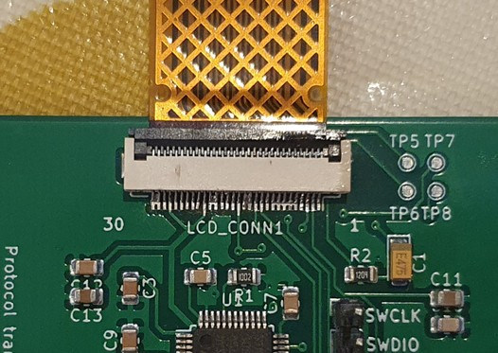
Now, it is tine to connect the silver cable from the radio to the other connector on the supplied circuit board. This connector has a small retaining clip, with two grey lugs at each end. To ‘open’ the connector ready to receive the cable, slide each lug gently with a fingernail horizontally outwards, away from the white part of the connector.

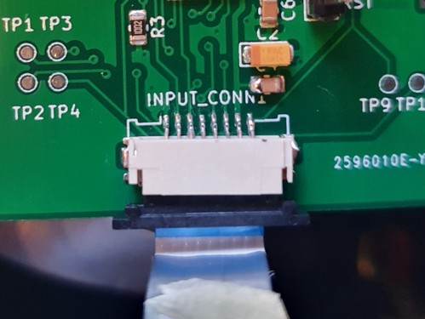
Then the silver cable can be inserted with the metal contacts facing down (blue plastic side ‘up’ as shown in the picture below:

Once ithe cable is firmly inserted, push the retaining bar back in so it is flush with the connector body, gripping the cable firmly in place.

Now it’s time to install the display back into the radio.

If need be, you might want to clean the clear plastic window the display sits behind, to make sure there is no dust or fluff. A cotton bud or similar dipped in meths (and another to dry it) is ideal for this. Once you’re happy it is clean, remove the protective film from the front of the new display, and holding the assembly by the bracket, gently push it into place.

Then, secure it into place by reinserting the LOWER TWO mounting screws.

Gently concertina the orange ribbon cable behind the circuit board, and lower it over the bracket so that the two mounting holes on the PCB line up with the TOP two mounting holes. Now use those screws to secure the circuit board into place by screwing them gently into the bracket holes.
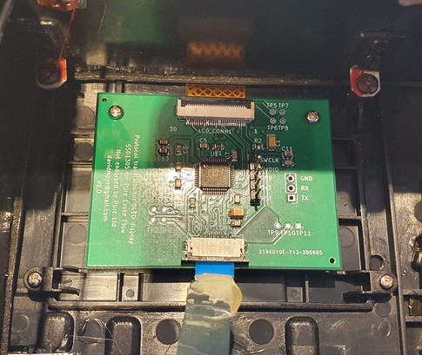

You can now reassemble the two halves of the radio. Check all the ribbon cables between the two halves of the radio are still snuggly inserted.

The left side slides in first to clear the little brackets on the edge of the case, and then it drops in vertically. It’s now safe to power on the radio and check that the display works as expected.

Now, install the six retaining screws.

Well done – enjoy your newly repaired radio!

