**THE RELATIONSHIP BETWEEN GDP, GOVERNMENT EXPENDITURE AND HOW THEY RELATE WITH THE HEALTH AND EDUCATION SECTORS.**

**BY**

**TEAM_3**

[**GitHub Repository Link**](https://github.com/davidmuna/Government-Expenditure-Project)

## **INTRODUCTION**

Governance is the international term associated with greater corporate responsibility and business conduct within acceptable ethical standards. Transparency, accountability, and openness in reporting and disclosure of information, both operational and financial, are internationally accepted to be vital to the practice of good corporate governance. The object of good governance is attained when institutions demonstrate their public accountability and conduct their business within acceptable ethical standards. This demonstration will take effective financial reporting, both internally and externally, and the unqualified encouragement of public debate regarding such financial reports.

**PROBLEM DEFINITION**

The rapid growth in government expenditure in Kenya has caused concern among policymakers. Most third-world countries face heavy debt burden, budget deficit, high inflation rate, and balance of payment deficit caused by poor domestic policies. The government's role in economic growth has been an issue since way back with the perception that, for sustainable development and efficient output, the government's role in economic policies should be reduced. Given this fiscal scenario, there is a need to identify the relationship between GDP, Government Expenditure, and how they relate to Kenya's economy.

**i) Government Expenditure on Health**

Kenya's budget allocation to the two health ministries-Ministry of Medical Services and Public Health and Sanitation for 2010 accumulated to a total of Ksh 39.9 billion of government resources, representing 7% of the total estimated government budget and 1.7% of GDP (KNBS, 2010). In Kenya, actual health expenditure grew by 41% in 2006 and 12% in 2008 (NBS, 2009). According to a World Bank report, published in 2010, Public Health expenditure (% of total health expenditure) in Kenya was at 17.41 in 2008 and 18.95 in 2009.

**ii) Government Expenditure on Education**

The percentage of government spending on education to Kenya's total government expenditure was 18.85 in 2008 and 15.04 in 2009 (UBOS, 2010). Kenya spent about 6.5 percent of GDP or 20 percent of total central government spending on the education sector, which sums to Kshs. 136.89 billion in 2009 (KNBS, 2010). Hansson and Henrekson (1994) concluded that government consumption expenditure is growth retarding, but increased education expenditure positively affects economic growth. The trend shows an increasing pattern of government expenditure and GDP growth. The results of impulse response functions and variance decomposition revealed that government expenditure on health and education affects economic growth.

**OBJECTIVES AND GOALS**

This research aimed to identify the relationship between GDP, government expenditure, and how they relate to the health and education sectors of the economy. The objectives of the study were to determine:

-Which year did Kenya experience a high GDP growth

-How Govt. Revenue correlates with Govt. Expenditure

-How Education and Health Correlate with GDP growth

-Which year had the highest expenditure on Health

-Which year had the highest expenditure on Education

-How Govt. Spending on Education & Health affect GDP growth

**PROJECT PLAN**

The overview plan for the study is as follows**:**

|  |  |  |  |
| --- | --- | --- | --- |
| **Phase** | **Time** | **Resources** | **Risks** |
| Problem definition, Objectives and goals | 6 hours | Research and report writing team | Economic change |
| Data sourcing and understanding | 6 hours | Data cleaning team | Data problems, technology problems |
| Data preparation and cleaning | 6 hours | Data cleaning team | Data problems, technology problems |
| Analysis | 12 hours | Analytics team | Data integrity loss |
| Recommendation | 12 hours | Analytics team | Economic change, inability to implement results |
| Next steps | 1 week | All teams | Economic change, inability to implement results |

**DATA SOURCING**

Data sourcing involves accessing the data and exploring it using tables and graphics that can be organized to determine the quality of the data and easily describe these steps' results. This study used secondary data, which was obtained from World-bank data sources on the following link. [Data Source: World Bank](http://api.worldbank.org/v2/en/country/KEN?downloadformat=csv)

The data used were government expenditure components that included expenditure on education, health care, and government consumption. Sources of data were Kenyan government documents and the World Bank. The study was done using the annual time series of data from 2003-2019 to evaluate government expenditure on economic growth.

Data for economic growth was obtained from the World Bank. It ranges from 2003 to 2019 as it indicates the era of a new government with new policies on government expenditure; furthermore, apart from being a more recent year, it was a year during which many changes were experienced in the Kenyan economy (Kosimbei, 2009). All the data obtained were cleaned, and all the nominal data converted to real data for easy analysis using collabs. The time-series data for average GDP was converted from nominal values to its real values by dividing nominal values with the GDP deflator using 2003 as the base year.

**DATA PREPARATION AND QUALITY**

The research identifies the procedures and techniques used in the collection, processing, and analysis of data and picking the most efficient and effective libraries for computations.

**Research Design**

Descriptive studies are usually the best methods for collecting information that will demonstrate relationships and describe the world. These studies are often done before an experiment to know what specific things to manipulate and include in an experiment. Descriptive studies can answer questions such as "what is" or "what was." Experiments can typically answer "why" or "how." This study's focus was to establish the relationships between variables of interest and not the causal effects. It is important to note that just because variables are related, does not necessarily mean that one directly causes the other. This study was descriptive and involved a quantitative analysis of data.

**DATA CLEANING**

Import the libraries to be used, i.e., pandas, NumPy, seaborn, and matplotlib.pyplot. Then load our dataset file into the environment.

Change the column names for the ease in writing code.

Checking for null values and cleaning the missing values by backfilling and interpolation.

Dropping the GDP in US$ because it already exists in local currency.

Rounding off the data to four decimal places.

Then later loaded the cleaned dataset to a new CSV file to be used for analysis. Create a description table below for the column names.

**gdp_dataset description**

|  |  |
| --- | --- |
| Year | Indicates the year of study |
| expe_education_%expe | expenditure on secondary education as a percentage of government expenditure |
| health_expe_/capita | current health expenditure per capita in current us dollar rate |
| Total_education_expe | government expenditure on education, total as a percentage of government expenditure |
| health_expe_%gdp | current health expenditure as a percentage of GDP |
| tax_revenue_%gdp | tax revenue as a percentage of GDP |
| revenue_excl_grants_%gdp | revenue excluding grants as a percentage of GDP |
| ibrd_and_ida | IBRD loans and IDA credits as DOD, current US$ |
| population_growth_annual% | population growth as annual percentage |
| gdp_growth_/capita_%gdp | GDP per capita growth as annual percentage |
| gdp deflator | GDP deflator, base year varies by country |
| domestic _health_expenditure_%gdp | domestic general government health expenditure as a percentage of the GDP |
| gdp_growth_annual% | GDP growth as an annual percentage |
| gdp_current_us$ | GDP in current US$ |
| gross _nat_expe_%gdp | gross national expenditure as a percentage of the GDP |
| Gdp_current_lcu | GDP in local currency unit |

**ANALYSIS**

Data is analyzed using Python with the help of analysis libraries like pandas and NumPy. The notebook containing the analysis for this project as well as the datasets are accessible through this link: [Drive Folder Containing Analysis Notebook](https://drive.google.com/drive/folders/1xkSDuSIBzVIDPN3R26ztOEnpstp4obfh?usp=sharing)

Assumptions made are;

* There was good governance during Mwai Kibaki's presidency.
* The Economy had just started to stabilize after hitting an all time low during and directly after the 2008 post election violence.
* Increase in Doctors and Nurses Salaries

Here are the findings;

**WHICH YEAR DID KENYA EXPERIENCE THE HIGHEST GDP? 2010**

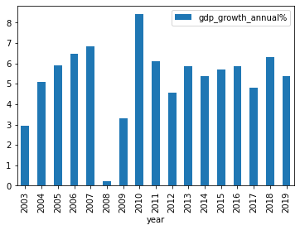

Assumptions made are;

* Good governance during Mwai Kibaki's presidency.
* The economy had just started to stabilize after hitting an all time low during and directly after the 2008 post election violence

**HOW DOES GOVERNMENT REVENUE CORRELATE WITH GOVERNMENT EXPENDITURE?**

Using Pearson's method to calculate the correlation between variables and displaying the correlation using the Seaborn heatmap, we derive the following from the correlation matrix's coefficients:

###### **Revenue From Taxes.**

Health Expenditure (health_expe_%gdp) has a strong correlation with Government Tax Revenue (tax_revenue_%gdp). The correlation coefficient is +0.78, which indicates they are directly proportional.

Education Expenditure (total_education_expe) has a good correlation with Tax Revenue (tax_revenue_%gdp). The correlation coefficient is +0.47, which indicates they are directly proportional but not in the same manner as the Health sector.

###### 

###### **Revenue From IBRD loans & IDA credits.**

Health Expenditure (health_expe_%gdp) strongly correlates with IBRD loans & IDA credits (ibrd_and_ida). The correlation coefficient is +0.74, which indicates they are directly proportional.

Education Expenditure (total_education_expe) has a significantly strong correlation with IBRD loans & IDA credits (ibrd_and_ida). The correlation coefficient is +0.75, which indicates they are directly proportional. It also indicates that Education is mostly funded through IBRD loans & IDA credits as opposed to Government Tax Revenue.

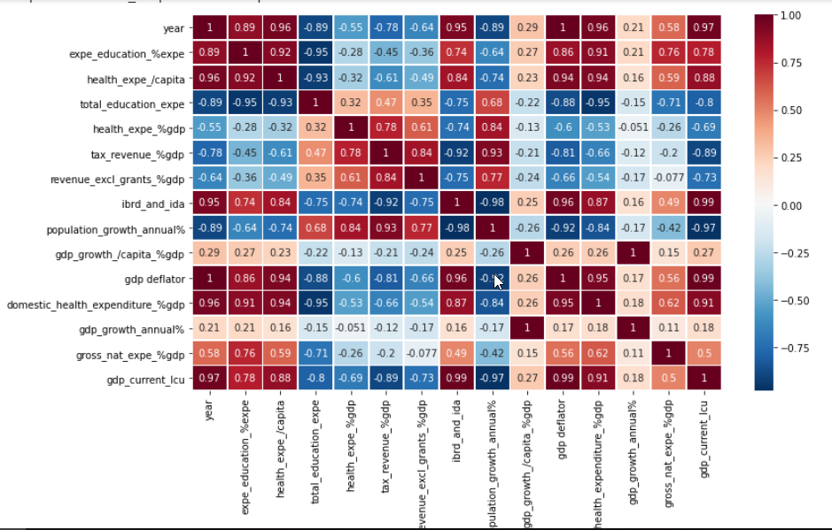

**EDUCATION AND HEALTH CORRELATION WITH GDP GROWTH**

Education Expenditure (total_education_expe) negatively correlates with GDP growth (gdp_growth_/capita_%gdp) over the years with a coefficient of -0.22. This can be majorly attributed to free education in Kenya, leading to lower spending on education by citizens.

Health Expenditure(health_expe_%gdp) also negatively correlates with GDP growth (gdp_growth_/capita_%gdp) by -0.05, which concludes that they are indirectly proportional. This is due to the lower overall healthcare spending in Kenya due mainly to lower prices—including lower drug prices and lower salaries for doctors and nurses.

**WHICH YEAR HAD THE HIGHEST EXPENDITURE ON HEALTH?**

From the df.plot(x="year", y=["health_exp"], kind="bar") below we find that 2019 was the year with highest expenditure.

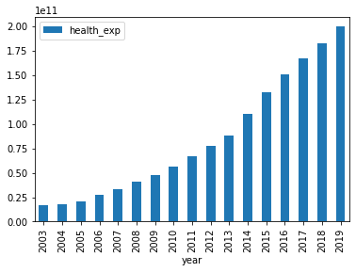

**WHICH YEAR HAD THE HIGHEST EXPENDITURE ON EDUCATION?**

From the figure, Government expenditure on education rose high in 2019. The Expenditure on education varied between 0.26 and 2.00 as the percentage the government spent on education contributed to economic development over the years.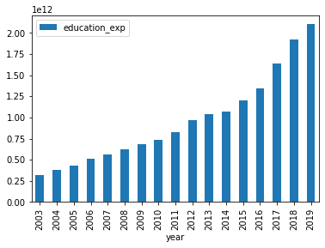

**HOW DOES GOVERNMENT SPENDING ON EDUCATION AND HEALTH AFFECT GDP GROWTH?**

The results suggest that government expenditure on education and health affects GDP growth positively. A unit increase in government expenditure leads to a 5.2754e-13 unit increase in GDP growth. <function matplotlib.pyplot.show>

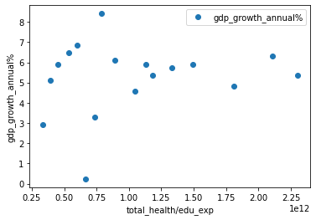

**CONCLUSION, RECOMMENDATION AND NEXT STEPS**

**Conclusion**

Based on the findings presented above, we can conclude that GDP value is affected by many factors, such as prices, disasters, economic crises, etc. Therefore, a simple time series model is not always enough to accurately predict GDP per capita. However, for short-term forecasting, our analysis results could be used as preliminary predictions, which can be used for the regional government to draw up economic plans and policies. However, our study’s results were that expenditure on the Health and Education sectors showed a significant contribution to GDP growth, where a unit increase in Government Expenditure led to a 5.2754e-13 unit increase in GDP growth.

**Recommendations**

The study makes policy contributions through recommendations it composes from the findings and conclusions made in this chapter. These include;

The Kenyan government should invest more in the improvement of the country’s health sector. This can be attained by making more capital investments in the health sector, like buying modern health equipment and building more hospitals, especially in remote places, to ensure that health services are accessible. As a form of human capital investment, the government should train more individuals in health matters, e.g., doctors, nurses, and channel more funds to research and development in health to counter tropical health epidemics. The latter will also assist in ensuring the provision of quality health care to everyone in the country. Incorporation of these policy recommendations should see to it that the Kenyan economy grows positively and significantly for a healthy nation is a wealthy nation.

The government should increase its expenditure on education. Education can help the country achieve sustainable economic growth because it improves the quality of life of people as it raises their productivity and creativity and promotes entrepreneurship and technological advances. For this reason, education plays a crucial role in securing the economic progress of the nation. The Kenyan government can ensure human capital development by; building more schools, training, reevaluating the system of education, and employing more teachers. This will ensure good quality education, make education accessible for all by all, and reduce the cost of education, making it affordable and inclusive for everyone.