climada – a tool to support Economics of Climate Adaptation (ECA) studies

The present document describes the core modules of and the Excel-interface to climada, the open-source software to support economics of climate adaptation studies.

Preamble

Climate adaptation is an urgent priority for the custodians of national and local economies, such as finance ministers and mayors.

Such decision-makers ask:
- What is the potential climate-related damage to our economies and societies over the coming decades?
- How much of that damage can we avert, with what measures?
- What investment will be required to fund those measures – and will the benefits of that investment outweigh the costs?

The economics of climate adaptation (ECA) methodology provides decision-makers with a fact base to answering these questions in a systematic way. It enables them to understand the impact of climate on their economies – and identify actions to minimize that impact at the lowest cost to society. Hence it allows decision-makers to integrate adaptation with economic development and sustainable growth. In essence, we provide a methodology to pro-actively manage total climate risk. Using state-of-the-art probabilistic modeling, we estimate the expected economic damage as a measure of risk today, the incremental increase from economic growth and the further incremental increase due to climate change. We then build a portfolio of adaptation measures, assessing the damage aversion potential and cost-benefit ratio for each measure. The adaptation cost curve illustrates that a balanced portfolio of prevention, intervention and insurance measures allows to pro-actively manage total climate risk. Insurance does put a price tag on risk, hence incentivizes prevention.

Introduction

The objective is to provide decision makers with the facts and methods necessary to design and execute a climate adaptation strategy. It supplies financial institutions, potential funders and insurers with the information required to unlock and deepen global adaptation finance, including risk transfer.

The methodology follows a rigorous risk management approach to assess local total climate risk, the sum of
- today’s climate risk
- the economic development paths that might put greater population and value at risk (a projection)
- the additional risks presented by climate change (based on impact scenarios)
It proposes and prioritizes a basket of adaptation measures to address total climate risk on an economic basis.

One way to summarize the facts is provided by the adaptation cost curve, showing the damage reduction potential as well as the cost-benefit ratio of each adaptation measure.

For a deeper introduction to economics of climate adaptation please refer to the publication “Shaping climate-resilient development, a framework for decision-making”, which inlcudes eight case studies (http://media.swissre.com/documents/rethinking_shaping_climate_resilent_development_en.pdf)

For an introduction to the climada software, please refer to the lecture course “Climate Change Uncertainty and Risk: from Probabilistic Forecasts to Economics of Climate Adaptation” by Dr. David Bresch and Prof. Dr. Reto Knutti at the Swiss Federal Institute of Technology, ETH (www.iac.ethz.ch/education/master/climate_risk).

In essence, climada is a probabilistic damage model with the capability to calculate a climate adaptation cost curve. climada is implemented in MATLAB. The climada package is open-source and can be redistributed and used in source and binary forms, with or without modification, as long as it retains the copyright notice (see climada license, www.iac.ethz.ch/education/master/climate_risk...LICENCE). MATLAB is a commercial software that needs to be installed in order to run climada.

Probabilistic damage model

...For a given portfolio of assets, damage due to a hazard is calculated.
[copy from Zimmerli publication and from ECA] also copy from ETH lecture.

Adaptation cost curve

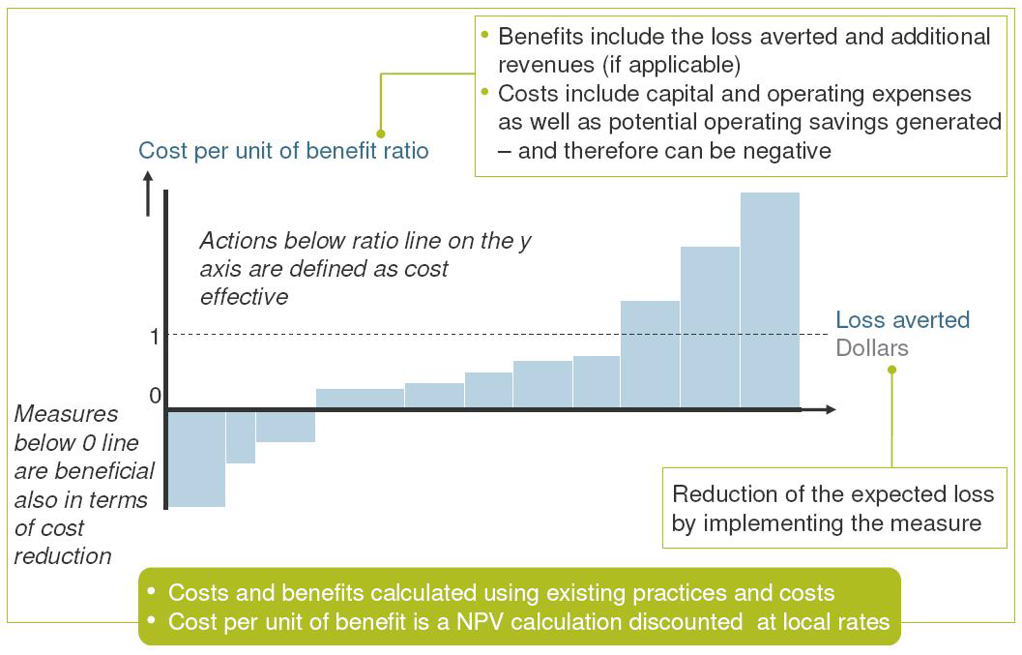

The width of each bar in a cost curve represents the cumulative potential of that measure to reduce total expected loss up to 2030 for a given scenario. The height of each bar represents the ratio between costs and benefits for that measure. Whether or not this ratio is attractive to a decision maker depends on many factors, including risk appetite. After considering the other – including non-economic – impacts and benefits related to implementing a measure, a risk-neutral decision maker would select measures based on a sense of how much protection they offer and at what cost. The advantage of calculating cost-benefit ratios for all measures is that doing so allows decision-makers to compare measures using a single simple metric.

Assessing the cost and damage aversion potential of each measure can be quite difficult. The potential loss aversion is particularly uncertain, even for measures for which extensive research exists – for example, for building codes to fix roofs against hurricane winds.

The assembled cost curve shows – from left to right – the range of measures from least cost-efficient to most cost-efficient. The results should thus be used to start discussions on the different measures and the opportunity to avert expected losses, rather than be read as recommendations to implement certain measures.

In a recipe form, the adaptation cost curve is constructed as follows (repeat for each measure)
1. Calculate present value (PV) of costs of measure [outside of climada]
2. Risk today: import today's assets and damage functions (input via Excel) and expose them to present hazard (part of climada)
2.1 climada calculates annual expected damage with no measures
2.2 climada calculates annual expected damage with measure applied
--> difference 2.1) minus 2.2) shows benefit of measure today
3. Future risk (e.g. year 2030): import future assets and damage functions (input via Excel, damage functions likely to be unchanged) and expose them to future hazard (part of climada)
3.1 climada calculates annual expected damage with no measures
3.2. climada calculates annual expected damage with measure applied
--> difference 3.1) minus 3.2) shows future benefit of measure
4. climada discounts benefits --> horizontal axis of adaptation cost curve
5. climada calculates the cost benefit ratio --> vertical axis of adaptation cost curve

Interface

The hazard module is provided by climada developers. It forms an integral part of climada and can be developed for almost any hazard (wind, flood, surge, landslides...). The assets, the damage functions as well as the list (and costs) of adaptation measures are defined in an Excel sheet which is imported into climada. climada provides several outputs, among them the adaptation cost curve (as a graphic in almost any format). Obviously, any number calculated by climada can be exported, too.

The key interface to climada is an Excel file, with three main tabs:

The tab 'assets' lists all exposed assets by location (latitude/longitude) and value. Please note that values do not necessarily need to be monetary values. In the case the number of exposed people is stated in the value column, climada might calculate the number of affected people.

The tab 'damage function' contains the relationship between the hazard intensity (e.g. storm surge height in meters) and the percentage of affected assets (PAA) as well as the mean damage degree (MDD). What's called a damage function in climada is often also referred to as 'vulnerability curve'. If for say a storm surge height of 1 meter, 50% of all assets are affected, and the damage to these affected assets is 5% of their total value, the PAA is 0.5 and MDD 0.05. In the case of value signifying exposed population, PAA is used to reflect affected individuals, while MDD could be used to parametrize some sort of impact to the affected individuals (e.g. using disability or quality adjusted life years, DALY/QALY).

The tab 'measures' contains the list of climate adaptation measures. It contains the costs of the measures, i.e. the net present value of CAPEX and OPEX for each measure. It also contains the parametrized impact of the measures on the hazard and damage function. Imagine a coastal study region and say a mangrove forest. Outside of climada, is has been calculated that the net present cost of this measure amounts to 1'234'567 million dollars. Let's assume this mangrove forest slows down the wind of a tropical cyclone by a certain amount, say 5 percent reduction in wind speed. Both the cost as well as this 'parametrized' impact is hence entered in the 'measures' tab for this particular measure. Note that climada can handle parametrized impacts of higher complexity, too.

Note on skills required

Required skills to prepare inputs into and to operate climada are a basic understanding of economics, in order to run net present value calculations to cost the assets, a (very) basic understanding of damage modeling and (obviously) familiarity with the topics of climate adaption and disaster risk management. In essence, the lecture course mentioned above does provide this basis. Hence a degree in e.g. civil engineering with some economics training is a good start, but there is no curriculum to provide the adaptation specialist (yet, except for mentioned lecture course).

Please be aware that the skill set required to run an economics of climate adaptation study is wider, as (very) strong communication and moderation skills are needed. Stakeholders need not only be informed about the methodology, real buy-in is required, first to agree on detailed scope, second to identify and agree on set of adaptation measures, third on cost of these measures and last but not least to convey the results (e.g. the adaptation cost curve).

