climada module **CAM**  7 Mar 2015

<https://github.com/davidnbresch/climada_module_CAM>

[david.bresch@gmail.com](mailto:david.bresch@gmail.com)

This module supports the CAM project

It allows to analyze other TC track data than UNISYS (e.g. from NCAR), to calculate country risk results[1] and all other analyses as provided by climada.

Further, the module calculates the property damage associated with the hazard event sets.

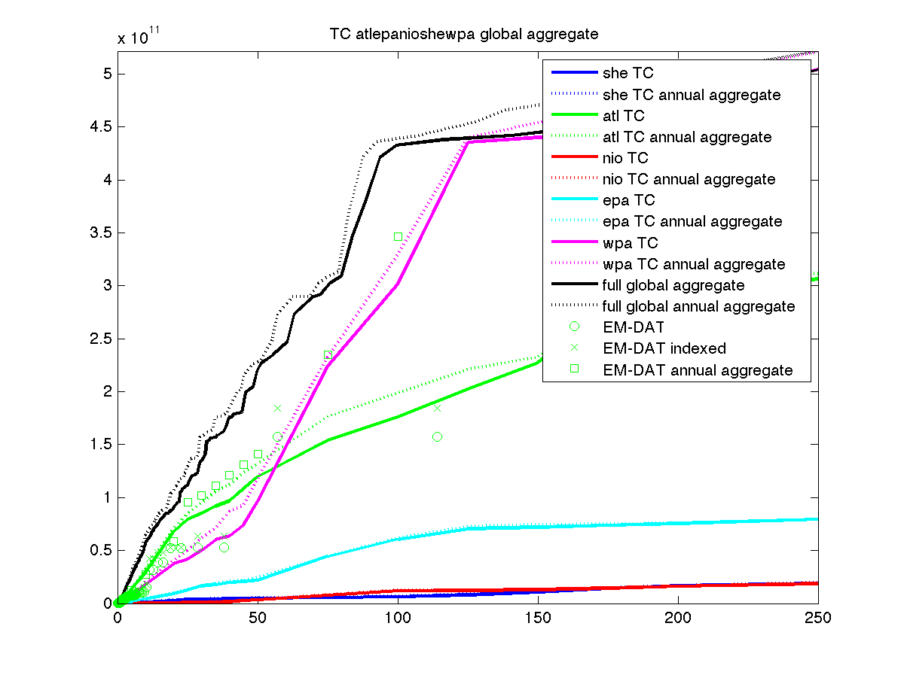

Fig 1: Results based on probabilistic tropical cyclone (TC) tracks (UNISYS, as used in core climada). The abbreviations atl/nio/wpa/epa/she stand for the ocean basins, e.g. Atlantic/North Indian/West Pacific/East Pacific and Southern Hemisphere. The solid lines show the per single event occurrence results (i.e. the damage of single events), the dotted lines the annual aggregate results (i.e. the sum of damages during years). The EM-DAT points show the available historic damage information from the EM-DAT database[2], indexed means inflated to todays’ values and annual aggregate means aggregated over each calendar year. Damage functions have been adjusted on a country-basis for those countries where enough EM-DAT data points existed (see code country_risk_calibrate in the country_risk module). Note the surprisingly good match with EM-DAT data, i.e. the good ‘reproduction’ of historic tropical cyclone damages over all (the biggest single EM-DAT damage represents hurricane Katrina in the US, order of USD 150 bn, which comes as about the 120 year event, not too bad…possibly a bit on the optimistic side). Since an absolute (actual USD) vertical scale is shown, the results are dominated by the large economies, i.e. US for atl and China for wpa…

Much remains to be done - but above figure shall illustrate that we get the order of magnitude of property damages right.

Content

Table of Contents

CAM module – basics 2

Function reference 2

Top level functions 2

Plotting functions 2

Support-level functions 2

Also useful 2

Notes on assets 2

Notes on damage functions 3

# CAM module – basics

The module mainly supports tropical cyclone (TC) tracks from other sources than UNISYS. Please first have a look at the code selected_countries_CAM, which runs all required steps as a batch code.

# Function reference

Use help {function name} to get a detailed description and input/output specification

## Top level functions

selected_countries_CAM: batch code to run all in one

cam_entity_value_GDP_SSP_one: Scale one entities assets to values corresponding to either present or future GDP projections

cam_entity_value_GDP_SSP: caller for cam_entity_value_GDP_SSP_one to process multiple entities (e.g. all country entities of the CAM project).

cam_calibrate: calibrate damage functions (currently all set to calibrated US)

## Plotting functions

..

## Support-level functions

climada_tc_read_cam_ibtrac_v02: read netCDF file with TC tracks, called by e.g. centroids_generate_hazard_sets from climada module country_risk.

## Also useful

..

# Notes on assets

The assets districutions are obtained from satellite night light intensity, which is available on a global 1x1 km resolution. For practical reasons, nightlight intensity is aggregated into 10x10 km cells (as we cover essentially thw whole globe and 1x1 km resolutions has heavy calculation implications, but is technically possible with climada). Nightlight distribution is then non-lineary scaled to obtain the relative asset distribution, all described in detail in documentation of climada module GDP_entity[3] (and some further comments in module country_risk[4]). Finally, assets are then scaled (see code cam_entity_value_GDP_SSP_one) based on a country's estimated total asset value, based on an SSP scenario and for a target year. First, asset values are normalized to one for any given country, then multiplied by GDP*PPP*SCL, where

* GDP comes from the SSP data file for any given (furture) year, available are 2000:5:20100 (i.e. 200, 2005, 2010 .. 2095,2100), either for the the Ssp3Db or Ssp5Db scenarios (see SSP_data_file in the CAM module’s data folder: SSP_country_data_2013-06-12_OECDonly.xls). Values are order of (many) billions of USD.
* PPP, the purchase power parity conversion comes from tab "conversion rate" in SSP_data_file. Values are order of 1.
* SCL, the scale_up_factor based on income group comes from the core climada economic_data_file (see economic_indicators_mastertable.xls in core climada’s data/system folder). Value is in the range 2 to 5, 2 for low(est) income countries, factor 5 for top income economies (based on World Bank figures).

# Notes on damage functions

The default damage function as provided by climada is nothing more than a starting point. Please consider at least the rough first-order calibration as offered by country_risk_calibrate in the country_risk module[5].

The code cam_calibrate does update all CAM entities with the calibrated (based on EM-DAT, see climada function emdat_read in the country_risk module and directly [www.emdat.be](http://www.emdat.be)) TC damage function for USA.

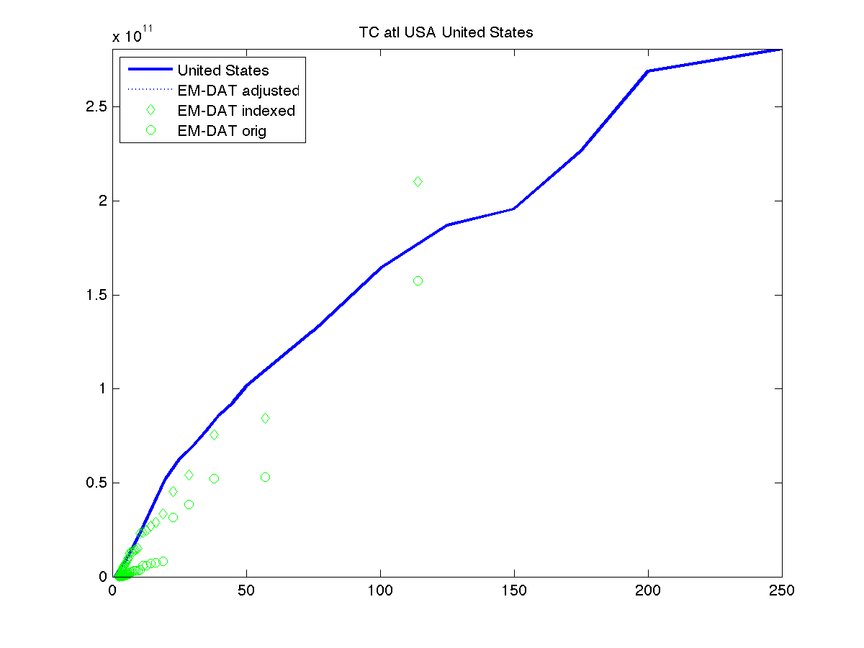

Fig 2: the calibrated damage frequency curve (DFC) for USA (since we adjusted to EM-DAT, the dotted line matches the solid one) Note that the adjustment to EM-DAT is based on a weighted average of the correction factors based on EM-DAT damages with return periods > 20 years (i.e. the biggest two data points in this case, see code cr_EDS_emdat_adjust).

1. Therefore, the present module relies heavily on <https://github.com/davidnbresch/climada_module_country_risk>
2. See climada function emdat_read in module country_risk.
3. <https://github.com/davidnbresch/climada_module_GDP_entity>
4. <https://github.com/davidnbresch/climada_module_country_risk>
5. <https://github.com/davidnbresch/climada_module_country_risk>