climada module drought fire 24 June 2017

<https://github.com/davidnbresch/climada_module_drought_fire>

[beuschl@student.ethz.ch](mailto:beuschl@student.ethz.ch), [horatc@student.ethz.ch](mailto:horatc@student.ethz.ch) (2016) &

[doerger@student.ethz.ch](mailto:doerger@student.ethz.ch), [dinah@student.ethz.ch](mailto:dinah@student.ethz.ch), [tschumie@student.ethz.ch](mailto:tschumie@student.ethz.ch) (2017) & [david.bresch@gmail.com](mailto:david.bresch@gmail.com)

This module implements a method to generate a local bushfire model any place on the globe, using a cellular automat for the small-scale fires and based on satellite information for the large(r) scale events.

This module is planned to also provide a global drought model (not implemented yet).

In essence, this module currently implements two approaches for bushfire

* Firms-data based historic fires 🡪 see bf_generator_large
* Cellular-automata generated fires 🡪 see bf_TEST
* Combined approach 🡪 see bf_TEST_jumpy

All details to be documented in the headers of the respective routines (for the time being).

This module is in TEST (very much beta) state. There are two relevant (higher level) codes, **bf_TEST** and **bf_generator_large(‘TEST’)**.

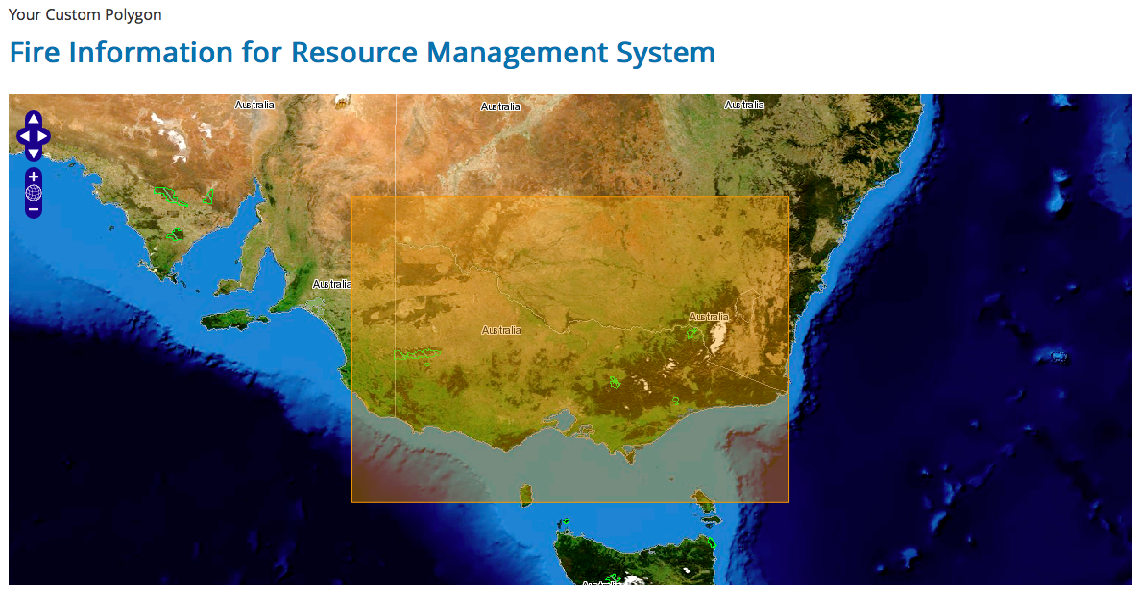

Figure: the region for which TEST data in Australia is available[1]. Obtained from <https://firms.modaps.eosdis.nasa.gov/download> . See bottom of this document for larger dataset(s).

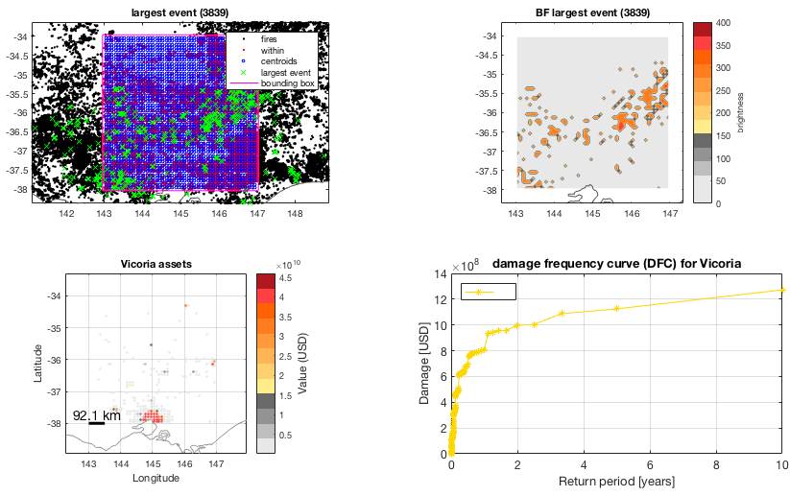

Figure: The result screen for TEST mode. Bushfire database on the top left and rendering of largest single event on the top right panel. Melbourne at the bottom center of the plots. Asset distribution in the lower left and resulting damage frequency curve (DFC) in the lower right panel. Generated by hazard=bf_generator_large('TEST')

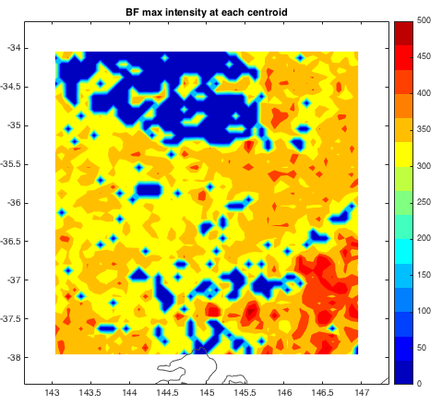

Figure: Maximum bushfire intensity at each centroid, based on the TEST data for Victoria (2006-2015). Melbourne at the bottom center of the plot. Plot generated by plotting climada_hazard_plot(hazard,0) after calling hazard=bf_generator_large('TEST').

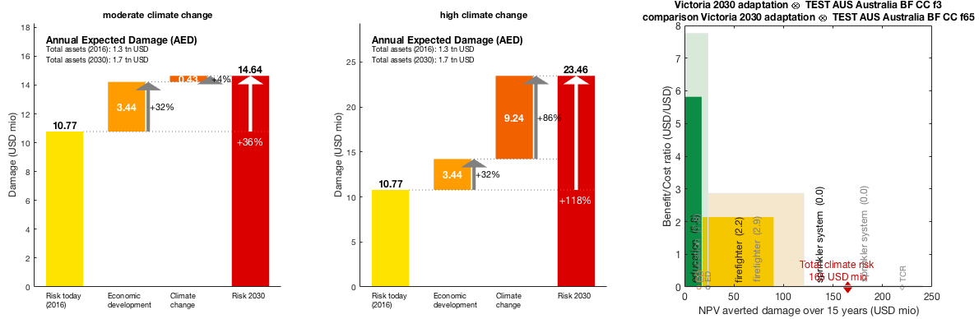

Figure: The results for the cellular automata approach (see climada_bushfire_cellular.pdf). Left and centre panels the waterfall charts for moderate and high climate change, right panel the adaptation cost curves for both moderate and high change (semi-transparent). Generated by bf_TEST.

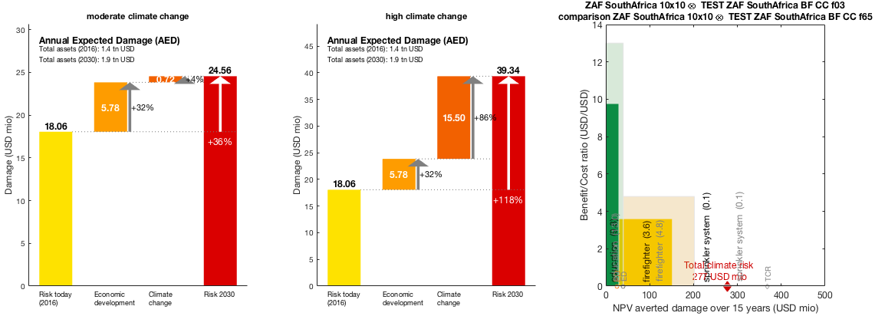

Figure: The result of bf_TEST_jumpy (South Africa, but only a few fires, hence numbers just dummy).

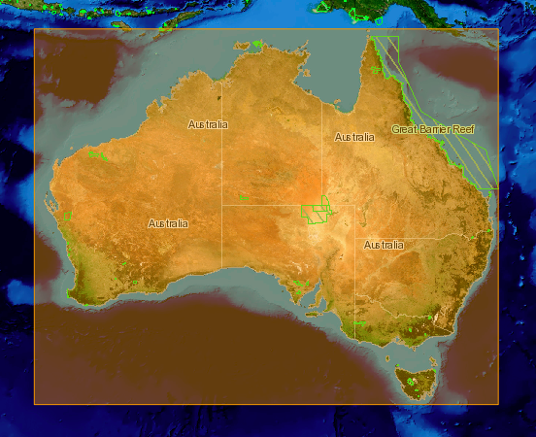

Figure: The boundary rectangle for the whole of Australia, resulting in a database of about 400MB of bushfire locations. Obtained from <https://firms.modaps.eosdis.nasa.gov/download>

1. file firms.csv in the module’s data/hazards/external_model_output folder.