**climada module eq_global** 23 Feb 2014

[https://github.com/davidnbresch/climada_module_eq_global](https://github.com/davidnbresch/climada_module_eq_global%20)

[david.bresch@gmail.com](mailto:david.bresch@gmail.com)

[melanie.bieli@bluewin.ch](mailto:melanie.bieli@bluewin.ch)

The climada module eq_global allows to generate earthquake hazard event sets and to conduct a probabilistic seismic hazard analysis which quantifies the rate (or probability) of exceeding various ground-motion levels at a site given all possible earthquakes. In particular, the module eq_global can be used to derive estimates of the earthquake threat in specific countries. Consider climada module country_risk[1] and/or GDP_entity[2] to generate the centroids for the earthquake model.

All-in-one, you can run the module as:

**hazard=eq_global_hazard_set(eq_global_probabilistic(eq_isc_gem_read,99,0))**

The module does also contain a simple volcano model … see vq_volcano_list_read (more to come soon)

## Earthquakes: Hazard profile

An earthquake is the result of a sudden release of energy in the Earth's crust that creates seismic waves. Most earthquakes originate from faults, or a break in the rocks that make up the earth's crust, along which rocks on either side move past each other. As the rocks move past each other, they occasionally stick, causing a gradual buildup of energy. Eventually, this accumulated energy becomes so great that it is abruptly released in the form of seismic waves.

Earthquakes are responsible for great destruction of property and loss of life - in the twentieth century alone, earthquakes destroyed property amounting to billions of dollars, and killed more than a million people worldwide [1]. In many parts of the world, seismic risks are significant, whether they are popularly recognized (as in Japan, where schools conduct earthquake drills) or not. Much of the challenge in assessing and addressing seismic hazards is that large earthquakes are relatively rare on human time scales, but can cause great destruction when they occur.

## Overview of functions implemented

The climada module eq_global contains the following functions:

* eq_isc_gem_read reads the ISC-GEM Catalogue[3]
* eq_global_probabilistic creates the probabilistic epicenters (see help eq_global_probabilistic for details)
* eq_global_hazard_set creates the climada hazard event set and calls eq_global_attenuation for each event. Within eq_global_attenuation, the function simple_eq_MMI is called to calculate the intensity of the hazard at the given distance from the epicenter.

further functions:

* eq_centennial_read reads the Centennial Earthquake Catalogue[4]
* eq_signigeq_read reads the Significant Earthquake Database[5]
* plot_attenuation_parameters plots different attenuation curves that describe the decrease of the Modified Mercalli Intensity with distance from the epicenter. Attenuation functions vary among different geographic regions and geological settings – plot_attenuation_parameters shows a selection of such functions, highlighting the one currently used as default.
* plot_gutenberg_richter produces a plot showing the relationship between the magnitude and total number of earthquakes of at least that magnitude.
* validate_eq_damage compares the damage of single earthquake events (which are extracted from larger earthquake dataset by calling climada_get_single_event) calculated by Climada to historic damage data.  
  Cautionary remark: this function has only been written for testing purposes.

## Useful data sources

Here, we list a couple data sources useful for purposes as provided by this module.

* <http://volcano.si.edu>: Global volcanism program, volcano catalogue.
* NCDC volcano significant event database[6].
* Mead and Magill, 2014: Determining change points in data completeness for the Holocene eruption record. <http://dx.doi.org/10.1007/s00445-014-0874-y>, Bulletin of Volcanology, 76:874, in there:  
  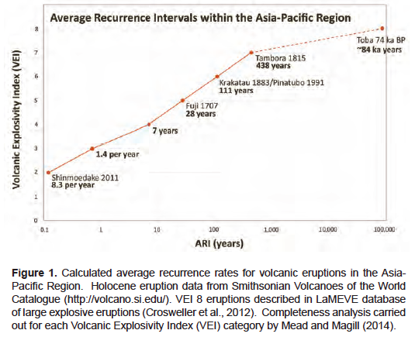
* NEXT

## Seismic hazard analysis: A step-by-step guide

Creating a probabilistic earthquake hazard set for a country of your choice (we will use Italy as an example) requires the following steps:

1 Please note that the Climada module GDP_entity has to be installed for this step.

Download: <https://github.com/davidnbresch/climada_module_GDP_entity>

1 Please note that the Climada module GDP_entity has to be installed for this step.

Download: <https://github.com/davidnbresch/climada_module_GDP_entity>

## Volcano model

We start from a global volcano database and model the volcano’s volcanic ash (or tephra for volcanologists) thickness T in cm as function of distance to eruption center (r, km) and angle (, in radian, North is 0) according to Gonzalez-Mellado and S. De la Cruz-Reyna[7]:

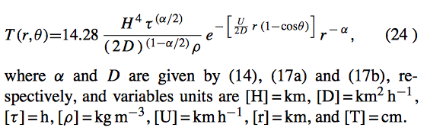

where H is the eruptive column height in km (parameter Cloud_height_km from database[8], indicative[9] range of 6-30 km),  the density of the falling material (kgm-3, indicative value 1100),  the rate determines the rate at which the deposit thickness decays with distance as (H)=2.535−0.051 H, wind velocity U (in km/h, indicative 50-100 km/h most often), duration of the high-intensity phase of the eruption  (in hours, e.g. Pinatubo 1-5h) and D (in km2/h) as follows (to distinguish between event that do and do not penetrate the stratosphere):

D(H)=−4.189 H+114.407, 0<H<Htropopause

D(H)=52.822 H−770.17, Htropopause <H<50, an we use Htropopause=15.5 km

To generate probabilistic events, we just sample some parameters.

## Some definitions:

* 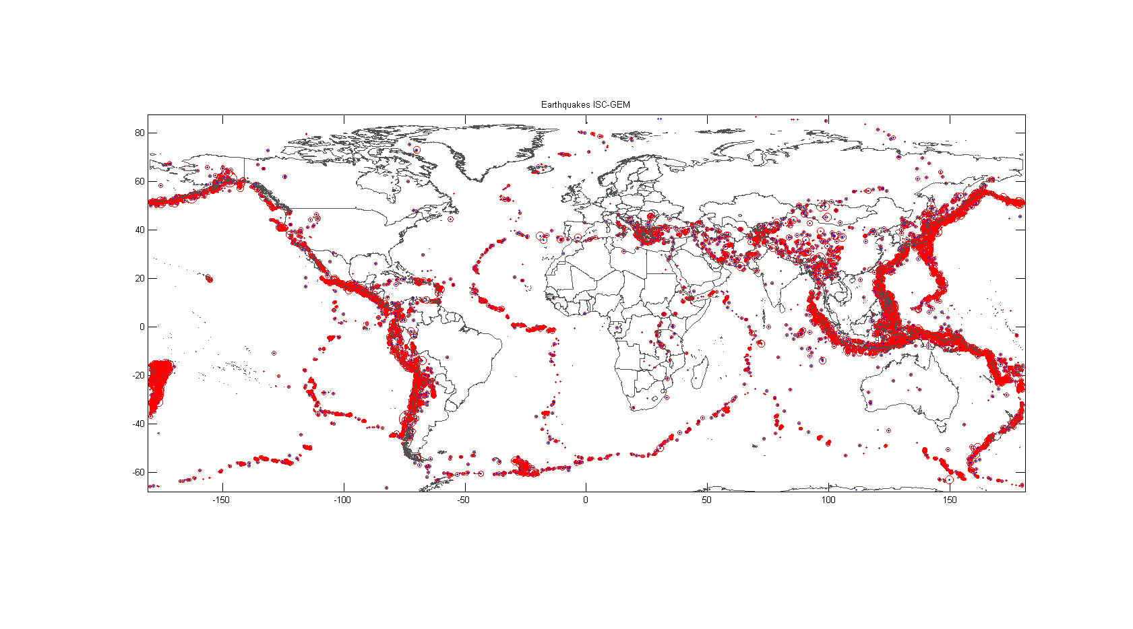**epicenter**: The epicenter is the point on the Earth's surface that is directly above the hypocenter or focus, the point where an earthquake originates.

Figure 1: Global distribution of earthquake epicentres. Earthquakes primarily occur at the boundaries where the tectonic plates converge, diverge, or slide past each other.

Figure created with the command eq_isc_gem_read('',1)

* **Modified Mercalli Intensity (MMI)**: The Mercalli intensity scale is a seismic scale used for measuring the intensity of an earthquake. The scale quantifies the effects of an earthquake on the Earth's surface, humans, objects of nature, and man-made structures on a scale from I (not felt) to XII (total destruction).
* **Richter Magnitude:** The Richter magnitude scale assigns a magnitude number to quantify the energy released by an earthquake. The Richter scale is a base-10 logarithmic scale, which defines magnitude as the logarithm of the ratio of the amplitude of the seismic waves to an arbitrary, minor amplitude.
* **attenuation**: Attenuation describes how seismic waves lose energy as they propagate through the earth, partly for geometric reasons because their energy is distributed on an expanding wave front, and partly because their energy is absorbed by the material they travel through.

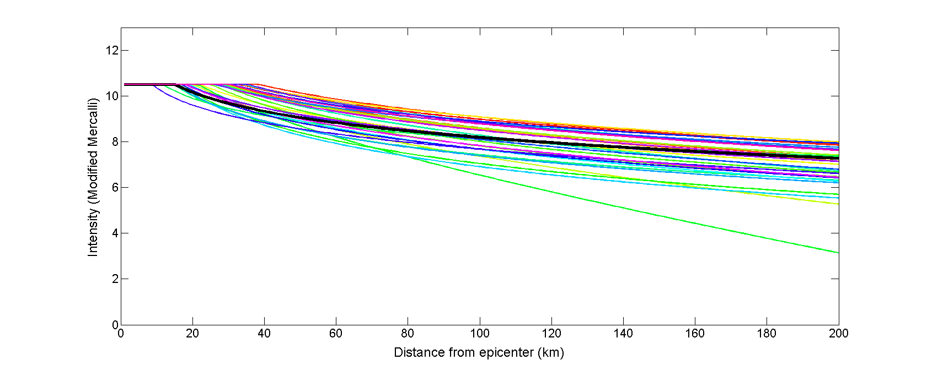

Figure 2: A selection of attenuation curves for different geographic regions, describing the decrease of intensity with increasing distance from the epicentre. Figure created with the command plot_attenuation_parameters

* **earthquake hazard:** The hazard is the intrinsic natural occurrence of earthquakes and the resulting ground motion and other effects (e.g., Tsunamis caused by earthquakes).
* **earthquake risk:** The risk is the danger the hazard poses to life and property. Hence, although the hazard is an unavoidable geological fact, the risk is affected by human actions [2].
* **damage function:** the earthquake damage function (i.e. the relation between MMI and damage inflicted at a given asset) is defined in the damagefunctions tab of the entity template[10], look for peril_ID ‘EQ’.

# Bibliography

|  |  |
| --- | --- |
| [1] | C. Scawthorn and W.-F. Chen, Earthquake Engineering Handbook, CRC Press, 2002. |
| [2] | S. Stein and M. Wysession, An Introduction to Seismology, Earthquakes, and Earth Structure, John Wiley & Sons, 2009. |

1. See <https://github.com/davidnbresch/climada_module_country_risk> and there climada_high_res_entity
2. See <https://github.com/davidnbresch/climada_module_GDP_entity>
3. The ISC-GEM Catalogue contains homogeneous locations and magnitudes with estimates of uncertainty for the period 1900-2009 prepared, where possible, using uniform techniques; see [www.isc.ac.uk/iscgem/index.php](http://www.isc.ac.uk/iscgem/index.php)
4. The Centennial Catalogue is a global catalogue of locations and magnitudes of instrumentally recorded earthquakes from 1900 to 2008, see <http://earthquake.usgs.gov/data/centennial/>
5. The Significant Earthquake Database contains information on destructive earthquakes from 2150 B.C. to the present; see <http://www.ngdc.noaa.gov/nndc/struts/form?t=101650&s=1&d=1>
6. The file NGDC_SignificantVolcanicEvents.xls in ../data/volcanoes is from <http://www.ngdc.noaa.gov/nndc/struts/results?type_15=Like&query_15=&op_30=eq&v_30=&ge_23=&le_23=&op_29=eq&v_29=&type_16=Like&query_16=&le_17=&ge_18=&le_18=&ge_17=&op_20=eq&v_20=&ge_7=&le_7=&bt_24=&st_24=&type_25=EXACT&query_25=None+Selected&bt_26=&st_26=&type_27=EXACT&query_27=None+Selected&type_12=Exact&query_12=&type_11=Exact&query_11=&t=102557&s=50&d=50>
7. A. O. Gonzalez-Mellado and S. De la Cruz-Reyna, 2010: A simple semi-empirical approach to model thickness of ash-deposits for different eruption scenarios. Nat. Hazards Earth Syst. Sci., 10, 2241–2257, 2010, direct: <http://www.nat-hazards-earth-syst-sci.net/10/2241/2010/nhess-10-2241-2010.pdf>
8. For each paramter taken from the volcano database, we sample a reasonable range and make resonable assumptions about dependency between parameters. See code for details.
9. See especially Table 3 (p. 2250) of referenced paper (also provided in ../docs/others) for all indicative values.
10. See climada’s root folder, there ../data/entities/entity_template.xls