ibtracs – an overview [dbresch@ethz.ch](mailto:dbresch@ethz.ch), 20170124

There are still some issues with ibtracs i.e. tracks are ‘cut’ and the dateline issue remains.

climada is able to fix the dateline issue, but **the ‘cut’ tracks need to be fixed in the original data**. Otherwise, the event definition in climada does not work: each track needs to be one event, not least to match with reported damages.

Suggested way forward:

* One global database with only full contiguous tracks in it.
* Dateline rule: tracks shall be contiguous i.e. not show close to +/-360 jumps. The best way to achieve this is by a) counting the nodes on either side of the dateline and b) switching the smaller number of nodes, i.e. if a track consist of three nodes with lon=[177 178 -179] , move to lon=[177 178 181], i.e. =mod([177 178 -179]+360,360). Should this be cumbersome to fix in the original database, it can easily be done in climada while reading the data. The ‘cut’ issue cannot easily be resolved within climada.

Shown are plots with dateline fixed and nodes for tracks with issues as green dots – the ‘cut’ issue is visible, too.

**NA basin**

processing 1338 single track files

1253 tracks ok, 85 not ok (less than 3 nodes, skipped)

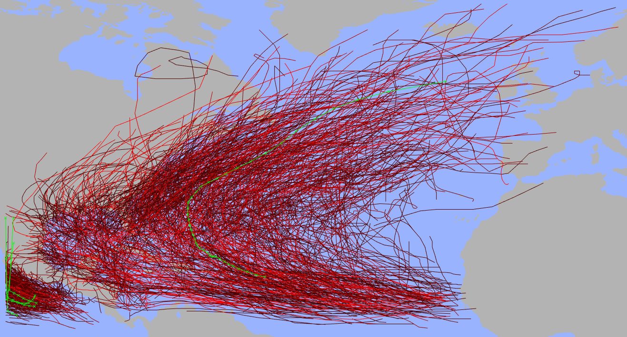

green dots denote nodes with issues, i.e. for track (number:…)

255: nodes too far apart (14>10 degree)

736: nodes too far apart (16>10 degree)

808: dateline fixed (+360)

808: nodes too far apart (11>10 degree)

957: nodes too far apart (11>10 degree)

and a warning (the green dots central NA curving up North):

1167: nodes too far apart (10>10 degree)

Issue here: there are ‘cut tracks’ in the Southeastern part, they ‘belong’ to EP.

EP basin

processing 1378 single track files

1360 tracks ok, 18 not ok (less than 3 nodes, skipped)

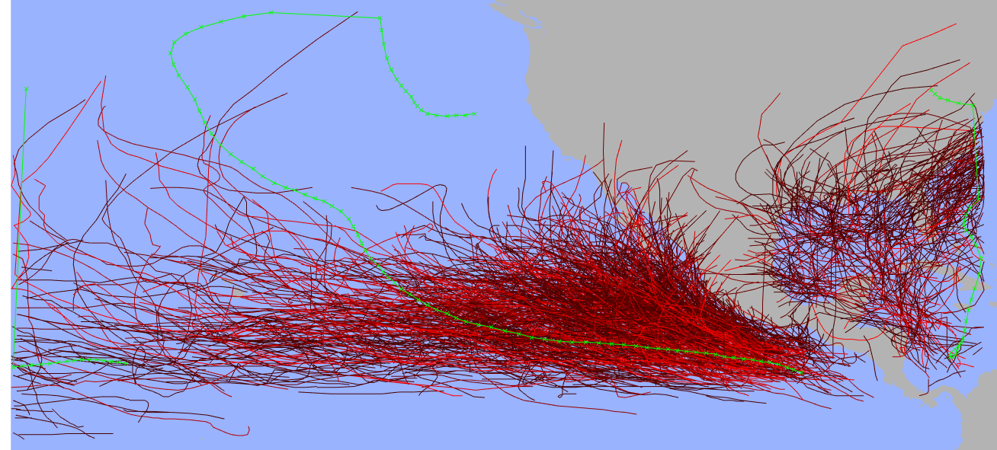

green dots:

850: nodes too far apart (30>10 degree)

933: dateline fixed (+360)

933: nodes too far apart (12>10 degree)

1284: nodes too far apart (10>10 degree)

Issue here: the ‘remnants’ of NA tracks shall be removed

NI basin

processing 255 single track files

252 tracks ok, 3 not ok (less than 3 nodes, skipped)

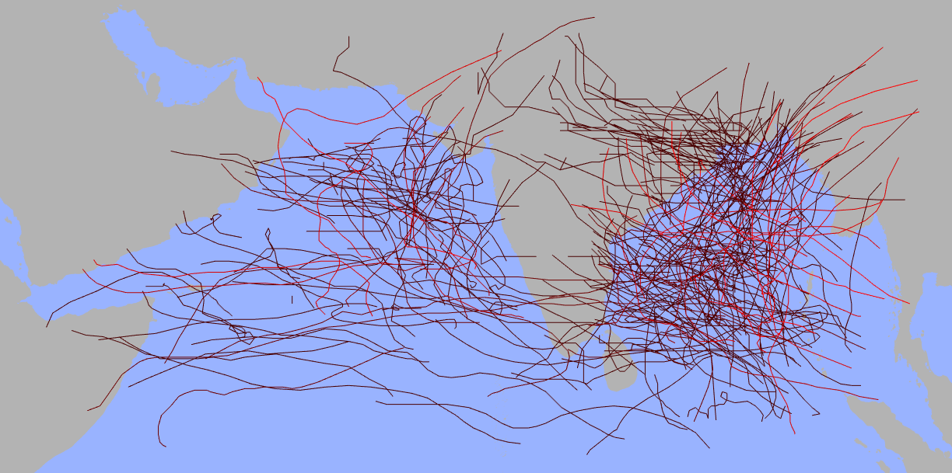

originally 252 tracks: 252 tracks seem ok, 0 tracks rejected

processing SA basin

3 tracks ok, 0 not ok (less than 3 nodes, skipped)



SI basin

739 tracks ok, 11 not ok (less than 3 nodes, skipped)

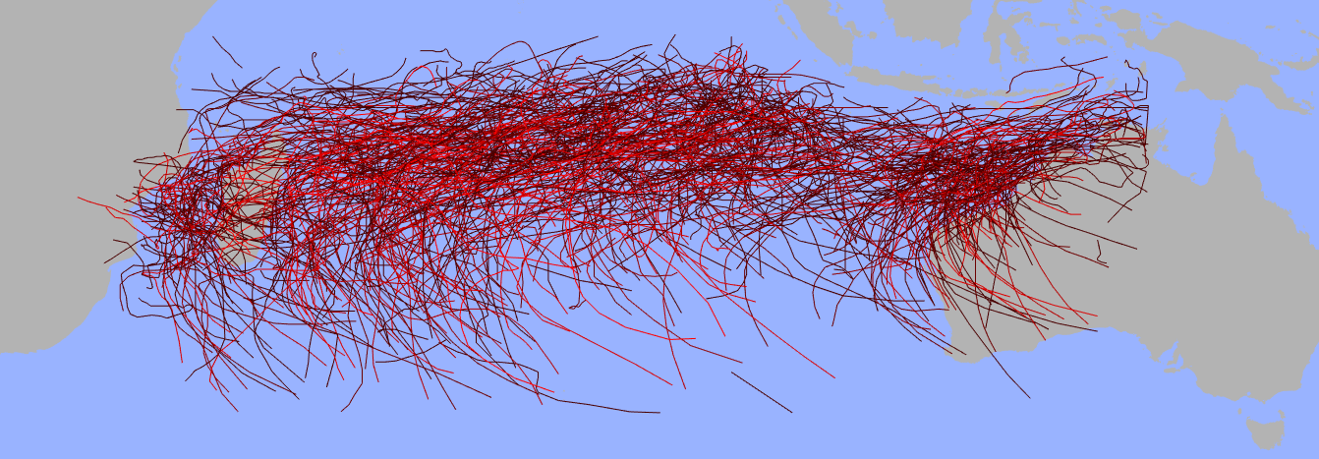

SP basin

500 tracks ok, 12 not ok (less than 3 nodes, skipped)

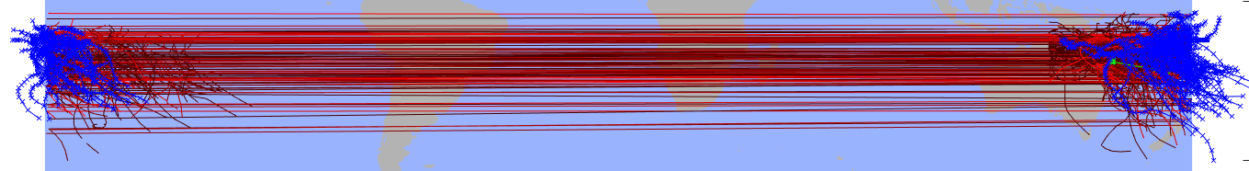

dateline issues fixed:

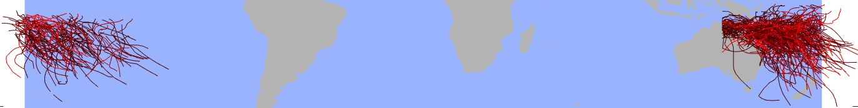

originally 500 tracks: 499 tracks seem ok, 1 track rejected

Issue here: the ‘strange cut’ across Australia

WP basin

2216 tracks ok, 10 not ok (less than 3 nodes, skipped)

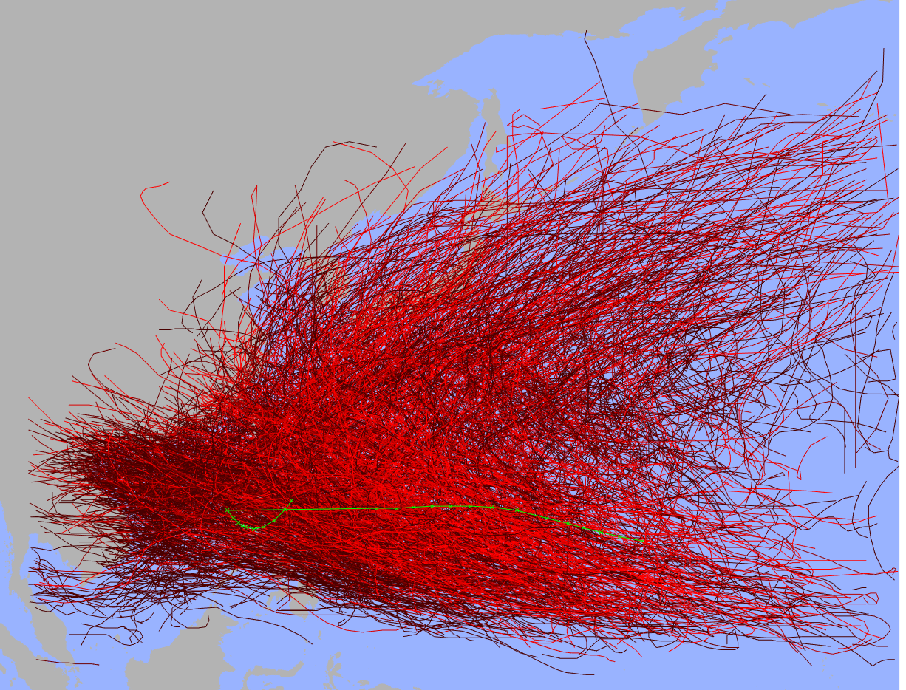

804: dateline fixed (+360)

804: nodes too far apart (14>10 degree)