isimip to climada, some tests for flood [dbresch@ethz.ch](mailto:dbresch@ethz.ch), 20160930

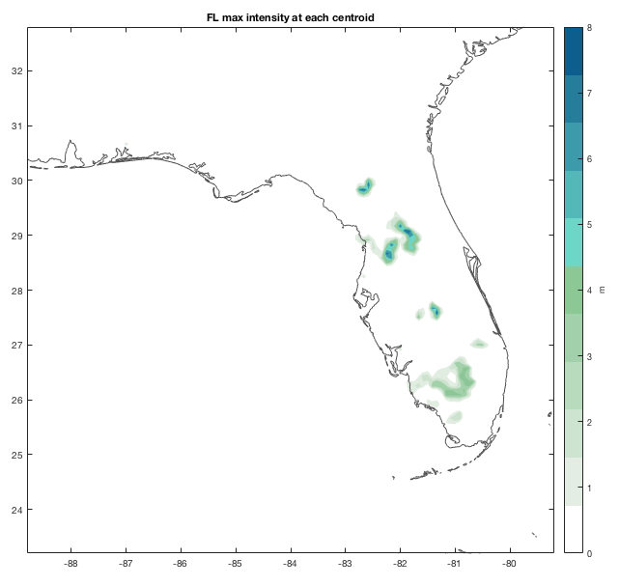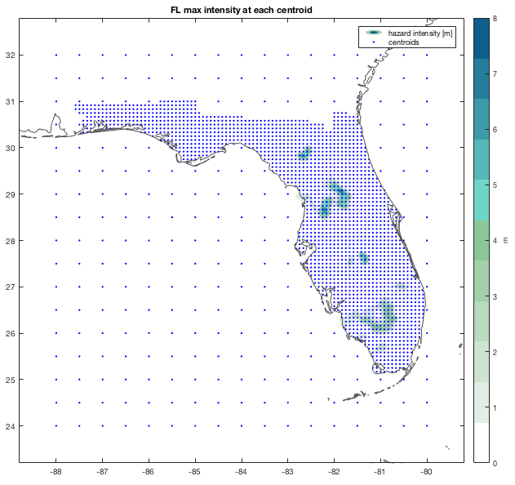

Florida, left: flood footprints of 34 years (max intensity at each centroid). Right pane with dense 10x10km asset centroids and coarse 50x50km grid around shown as blue dots. To generate this from scratch, just two commands are needed:

entity=climada_entity_load('USA_UnitedStates_Florida');

hazard=isimip_flood_load('fldfrc_max.nc','flddph_max.nc','auto',entity,2);

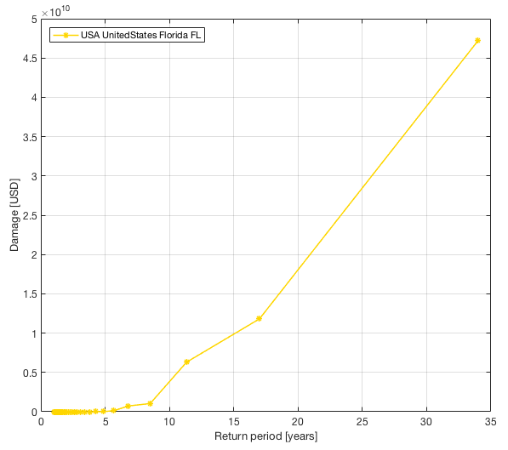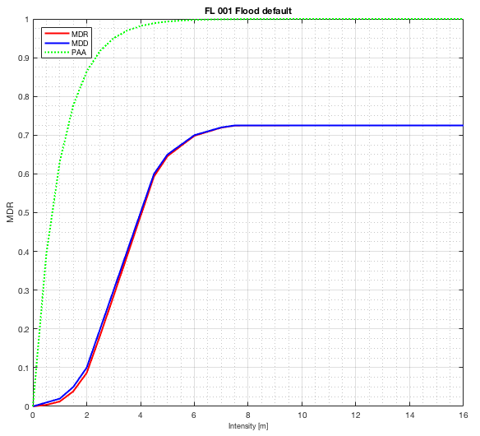

The flood damage calculation for Florida (just to check it works, values *arbitrary* still). Left pane the damage frequency curve, right pane the damage function used.

To generate these two plots, one only needs to type:

EDS=climada_EDS_calc(entity,hazard); % the damage calculation

climada_EDS_DFC(EDS); % the left pane plot

climada_damagefunctions_plot(entity,’FL’); % the right pane plot

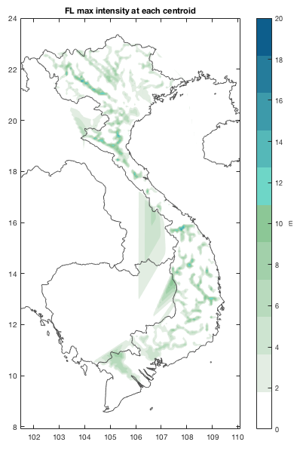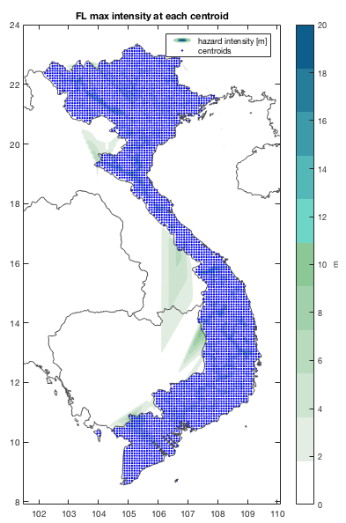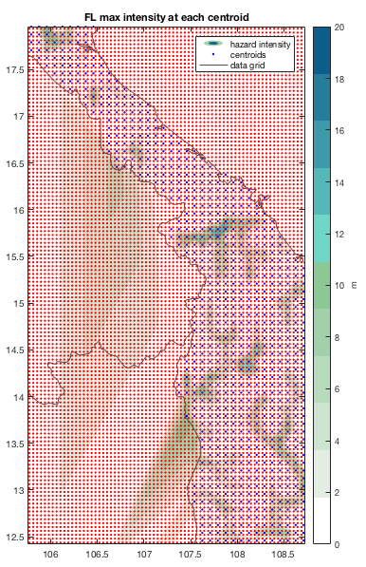

Same as above, for Vietnam, far left: shaded areas outside the country are artefacts of the contouring routine. Centre: the centroids plotted (i.e. only hazard intensities at blue dots are real. Right pane shows the original resolution (red), the flood footprints (greenish colour) and the centroids (blue dots). Again, the large shaded areas are artefact of the contouring routine. To generate this from scratch, just two commands are needed:

entity=climada_nightlight_entity('Vietnam','');

hazard=isimip_flood_load('fldfrc_max.nc','flddph_max.nc','auto',entity,**2**);

Note that above three pictures can be generated by setting the last parameter in the call to 1,2 or 3.

By generating the Vietnam entity with the same ‘buffer’ centroids around as for Florida, the artificial contouring can be much suppressed:

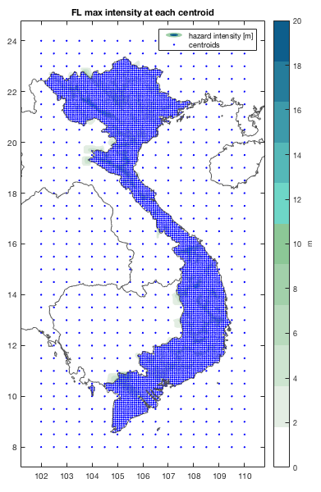

Vietnam, with 50x50km grid outside the country. Note that for flood, the hazard is NOT interpolated to centroids outside the country (i.e. set to zero). Now, the small shaded areas outside of the country border are the result of interpolation between in/outside country points. This is irrelevant for any calculation, as climada only calculates damages at points within the country.

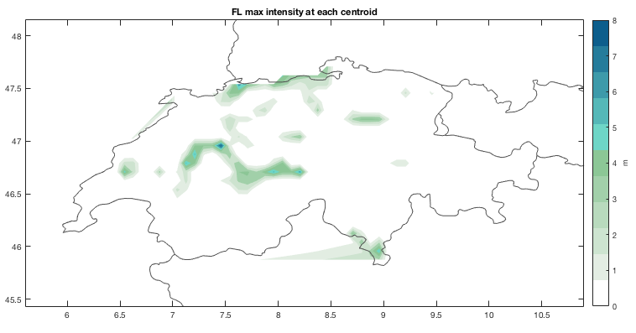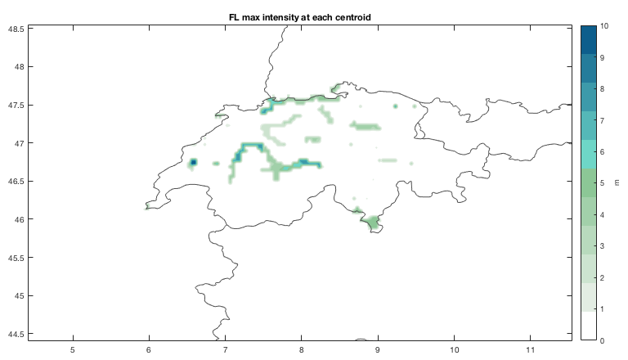

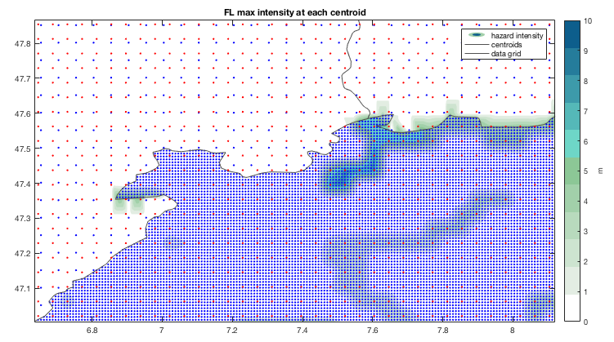

As above, for Switzerland, top left 10x10km, top right 1x1km, bottom detail of 1x1km, blue dots are centroids within Switzerland 1x1km, around 5 times coarser, i.e. 5x5km), red dots are original grid as on netCDF file. Note that in order to generate this from scratch, only two MATAB commands are needed:

p.resolution_km=1;entity=climada_nightlight_entity('CHE','',p);

hazard=isimip_flood_load('fldfrc_max.nc','flddph_max.nc','auto',entity,3);

And, last but not least, for Germany:

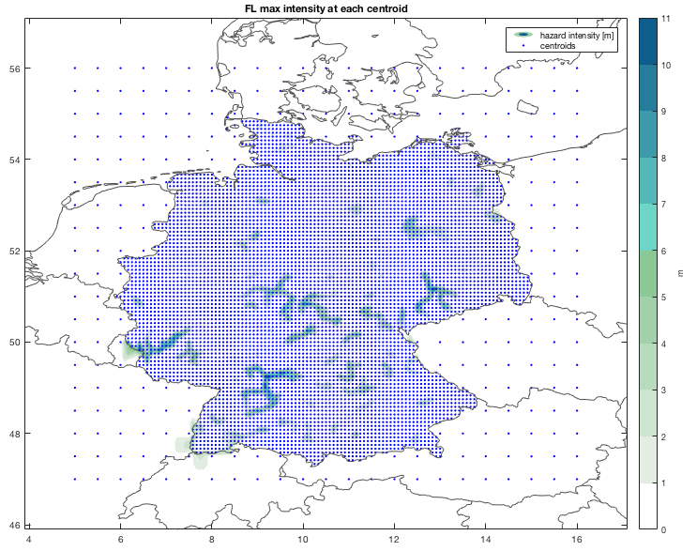

Germany, again 10x10km grid within the country, 50x50 grid around (not used for damage calculations).

entity=climada_nightlight_entity('Germany','');

hazard=isimip_flood_load('fldfrc_max.nc','flddph_max.nc','auto',entity,2);