climada module meteorite[1] 24 Dec 2015

<https://github.com/davidnbresch/climada_module_meteorite>

[david.bresch@gmail.com](mailto:david.bresch@gmail.com)

This module implements a basic meteorite global hazard.

There is only one code: **climada_meteorite_hazard_set**

and **help climada_meteorite_hazard_set**

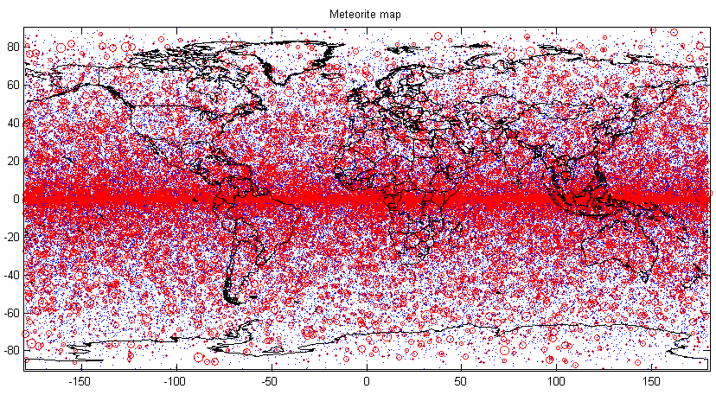

Figure: The basic meterorite events (plotted as blue dot per impact, red circle for magnitude)

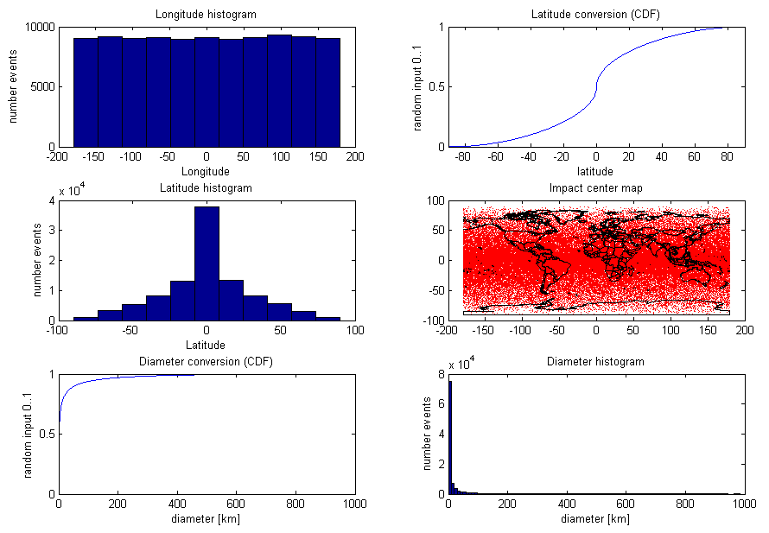

Figure: The panel as produced by the code to check for distribution of key parameters. See code for details.

1. Renamed from climada_module_meteorites 20151224