Manual for the Economics of Climate Adaptation San Salvador

5 November 2015

Lea Mueller,[muellele@gmail.com](mailto:muellele@gmail.com)

Jacob Anz, [j.anz@gmx.net](mailto:j.anz@gmx.net)

Download and setting up:

*climada* is running on Matlab and Octave. Octave is a free an open source version of Matlab. Octave is powerful for calculating damage numbers, however Octave faces some issues with producing figures. Download the following repositories from GitHub:

* *climada* core: <https://github.com/davidnbresch/climada>

(The core module of climada)

* *salvador_demo*: <https://github.com/davidnbresch/climada_module_salvador_demo>

(The functions, hazards and entities for the San Salvador ECA study)

* Depending on the functionality (creation of tropical cyclone hazard or landslide hazard) more module like climada_advanced, climada_flood or climada_tc_hazard_advanced need to be downloaded.

A detailed guide on how to set up *climada* can be found under:

<https://github.com/davidnbresch/climada/blob/master/docs/climada_manual.pdf>

Setting up the working directories

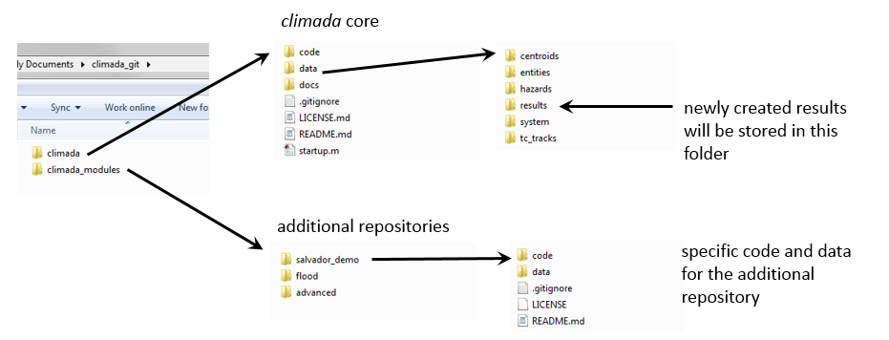

Figure 1: climada folder structure contains of core climada (upper part of the figure) and additional repositories (lower part).

In a first step, the hazards and entities downloaded with the *salvador_demo* module need to be copied in the data and entity folder of the matlab core module (See Fig.1).

Two main functions can be used. Type the following into the command line:

* The function salvador_calc_waterfall('TC') for example produces the waterfall graph for tropical cyclones ('TC'). Remark that 'TC' is only a nametag, the peril need to be choosen in the next step.
* The function salvador_calc_measures('FL_AB1') produces the adaptation bar chart and cost curve for flood.

The nametag 'TC' or 'FL_AB1' is the folder name where the results will be saved starting with the name of the current data, the type of results (e.g. waterfall) and the selected folder name ('TC').

The functions then ask to choose a peril. There are 4 different perils to choose from:

* 'TC' – Tropical cyclone,
* 'FL' – Flood,
* 'LS_acelhuate' – Landslide
* 'LS_las_canas' – Landsilde.

After the peril is chosen, the files asks to select a specific entity:

For each peril, 3 excel (.xls or .xlsx) files need to be specified:

* assets_file (The assets or entity file)
* damfun_file (The damage function file)
* measures_file (The file with the measures)

Modifying inputs:

These input excel files contain the location and the value of the assets, the damagefunctions, cost, location and impact of the measures. All this can be modified by changing the excel input, as long as the filename and the structure of the files are not changed.

The hazard files (in .mat format) are recognized automatically, if not they need to be selected to. When asked for hazards, the first hazard is always the normal hazard, the second one the moderate climate change hazard and the third one the extreme climate change hazard.

*Table1: The listing of the entities and files to select:*

|  |  |  |
| --- | --- | --- |
| Peril | Type | name |
| FL (flood) | Assets | FL_entity_AMSS.xls |
|  | Damagefunction | FL_DamageFunction_150910.xlsx |
|  | Measures 1 | FL_measures_template_for_measures_location_A_B_1.xls |
|  | Measures 2 | FL_measures_template_for_measures_location_A_B_2.xls and  entity_AMSS_urban_planning.xls |
| TC | assets | TC_entity_AMSS_WIND-AMSS_250915_v2.xlsx |
| (tropical | damagefunction | TC_entity_AMSS_WIND-AMSS_250915_v2.xlsx |
| cylone) | measures | TC_entity_AMSS_WIND-AMSS_141015_FINAL_COSTS.xlsx |
| LS | assets | LS_entity_AMSS_DESLIZAMIENTO_ACELHUATE_141015_NEW.xls |
| (Acelhuate) | damagefunction | LS_entity_AMSS_DESLIZAMIENTO_ACELHUATE_141015_NEW.xls |
|  | measures | LS_entity_AMSS_DESLIZAMIENTO_ACELHUATE_141015_NEW.xls |
| LS | assets | LS_entity_AMSS_DESLIZAMIENTO_LAS_CANAS2.xls |
| (las canas) | damagefunction | LS_entity_AMSS_DESLIZAMIENTO_ACELHUATE_141015_NEW.xls |
|  | measures | LS_entity_AMSS_DESLIZAMIENTO_LAS_CANAS2.xls |

*(Remark: The damage function for las canas is specified in the acelhuate excel file.)*

Results

The results are stored in the folder *'results'* in the climada core module

Hazards

It is also possible to modify the hazards, by generating new flood hazards, new storm hazards (climada TC module) and new landslide hazards (in climada flood module) with different frequency, intensity and location. This however exceeds this manual and need advanced matlab and climada user skills.

Remarks:

It is important, that all the files have exactly the name which is used in the matlab scripts, they are case sensitive.

Of course an entirely different folder structure can be used, if the references are set correctly.