*Resolution sensitivity analysis for climada applied to*

*landslides and tropical cyclones in San Salvador*

<https://github.com/davidnbresch/climada_module_salvador_demo> February 2016

Lea Mueller,[lea_mueller@swissre.com](mailto:lea_mueller@swissre.com)

*David Bresc*h*,* david.bresch@gmail.com

# Purpose

Perform sensitivity analysis for different resolutions for two cases, 1) landslides in Las Cañas neighborhood in San Salvador and 2) tropical cyclones in the metropolitan area of San Salvador (AMSS). Analyzed resolutions range from high resolution (~50 meter), mid resolution (~1 km) to low resolution (~10 km).

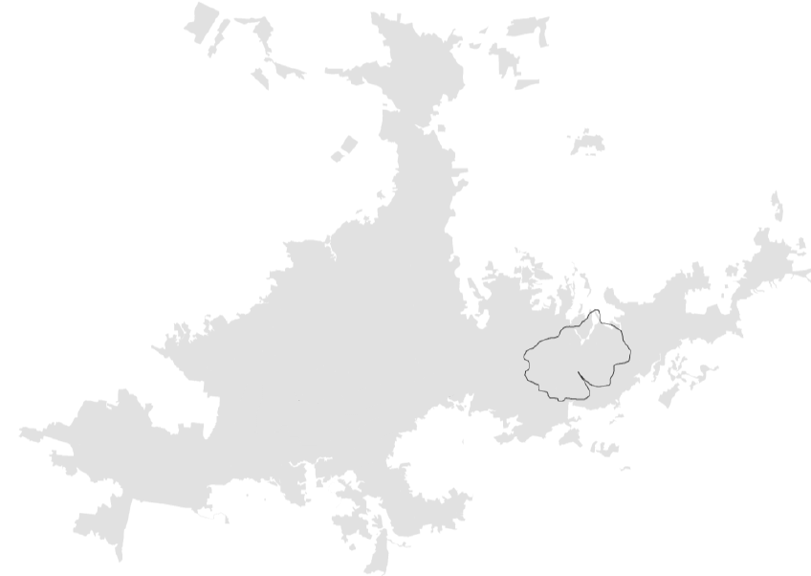

Metropolitan Area of San Salvador (AMSS)

Las Cañas

Figure : Metropolitan Area of San Salvador (AMSS) covers roughly 170 km2 and represents the political, economic and cultural center of El Salvador. Roughly 30% of the Salvadorian population lives in the AMSS. Las Cañas neighborhood is located in the East of San Salvador and covers roughly an area of 8 km2. Source: San Salvador, Vulnerability Report, Team Analysis.

# Results and Conclusions

We compare different results using high, mid and low geographical resolution from two cases, 1) landslides in Las Cañas neighborhood in San Salvador and 2) tropical cyclones in the metropolitan area of San Salvador (AMSS).

The comparison of results from landslides shows that only with a high resolution (~50 meter) accurate results can be achieved. Using mid (~1 km) or even low resolution (~10 km) leads to significantly less accurate results. We overestimate expected damage, while underestimating the benefits of measures. This shows that for an underlying high resolution hazard it is necessary to define the assets on a similar high resolution. The landslide hazard is highly spatially variable and is driven by topography and water accumulation potential.

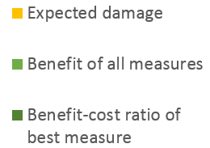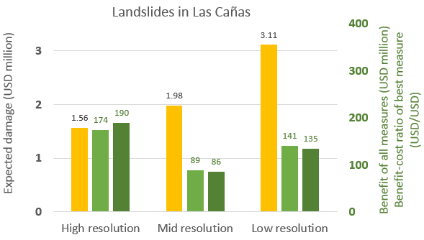

Figure 2: Comparison of expected damage (left y-axis), benefit of all measures and benefit-cost ratio of best measure (right y-axis) for landslides in Las Cañas. Using mid resolution (~1 km) in comparison to high resolution (~50 meter) leads to overestimation of expected damage (USD 1.98 million instead of 1.56) and measures perform weaker. Benefit of all measures is down to USD 89 million instead of 174. Using low resolution (~10 km) the results are even more inaccurate. Expected damage rises to USD 3.11 million, while benefit of all measures and benefit-cost ratio of best measure drops to USD 141 and 135 million, respectively.

The comparison of results from tropical cyclones shows that results are almost not affected by geographical resolution of assets. Using mid (~1 km) or low resolution (~10 km) of assets leads to very similar results, both in terms of expected damage and benefit of measures. Wind intensities from a specific tropical cyclone event are of similar intensities in the entire AMSS region and do not vary very locally. Therefore we can use mid or low resolution in assets and still calculate adequate results.

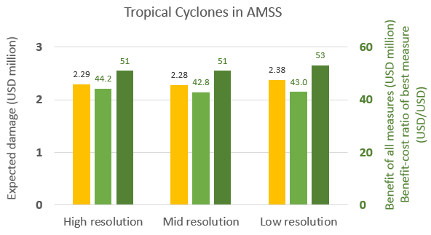

Figure 3: Comparison of expected damage (left y-axis), benefit of all measures and benefit-cost ratio of best measure (right y-axis) for tropical cyclones in AMSS. Using mid resolution (~1 km) or even low resolution (~10 km) leads to very similar and therefore still accurate results. Expected damage varies from USD 2.29 to 2.28 and 2.38 million. Benefit of all measures range from USD 44.2 to 42.8 and 43.0 million. Cost-benefit ratio of the best measure is 51 USD/USD, and 51 and 53, respectively.

# Appendix, all results and maps

## Part 1: Landslides in Las Cañas

Assets, expected damage and benefit: High resolution (~50 meters)

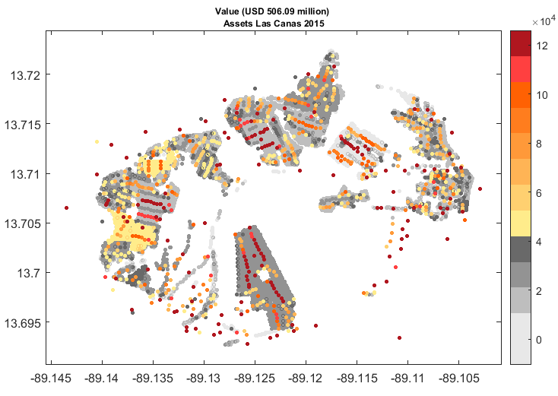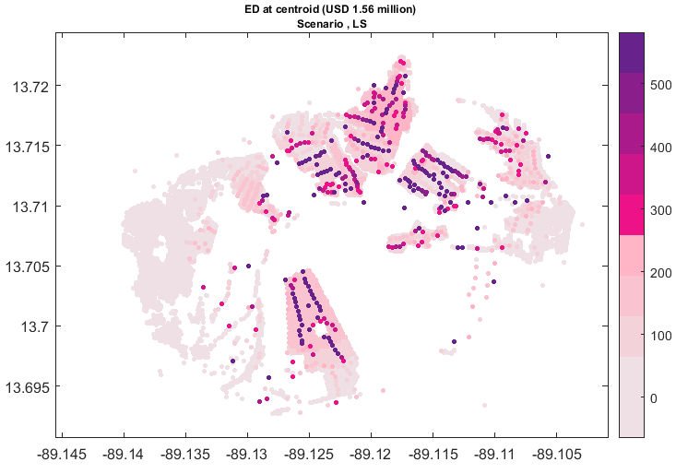

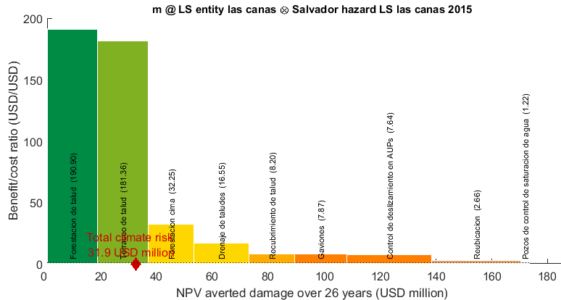[1]

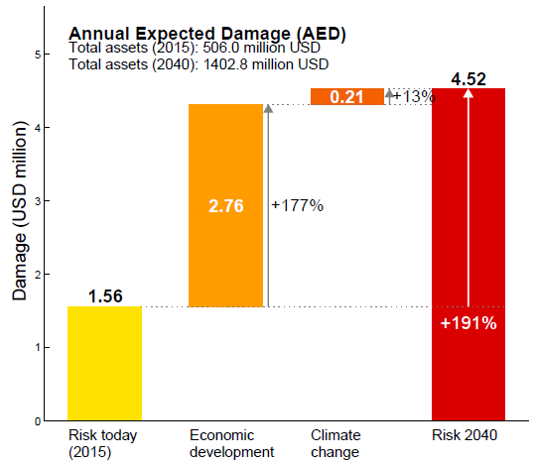 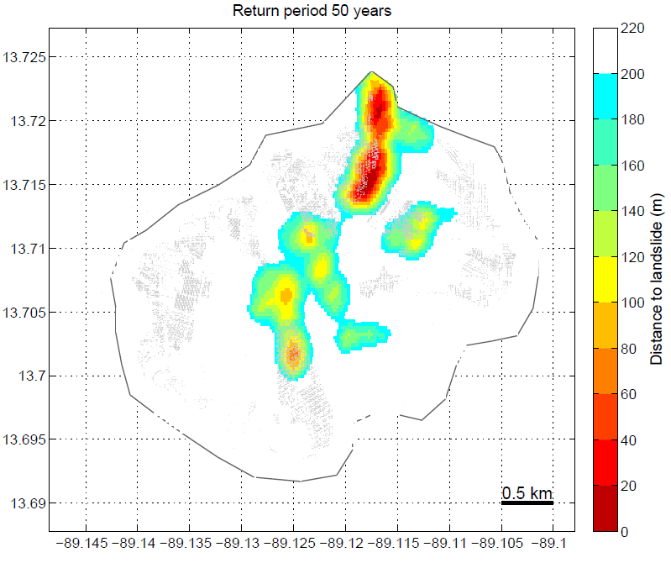

Assets, expected damage and benefit: Mid resolution (~1 km)

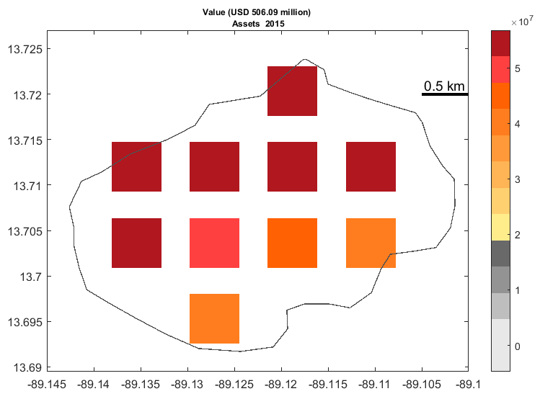 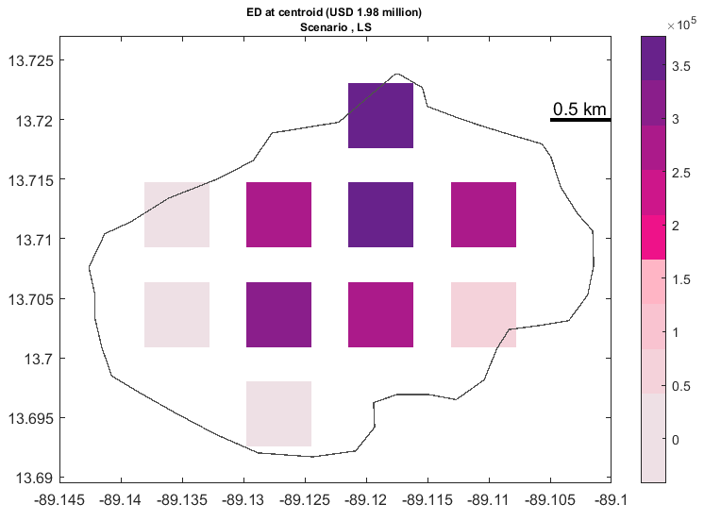

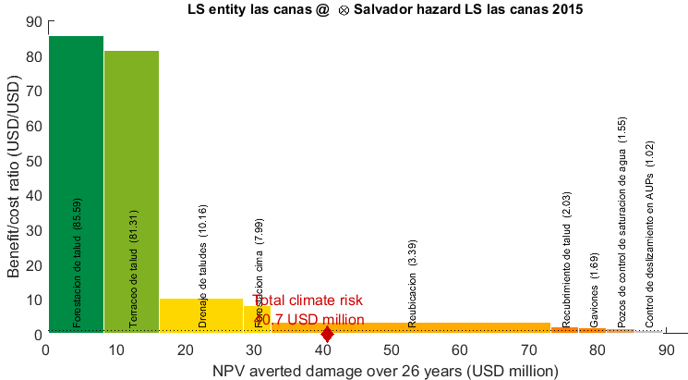

Assets, expected damage and benefit: Low resolution (~10 km)

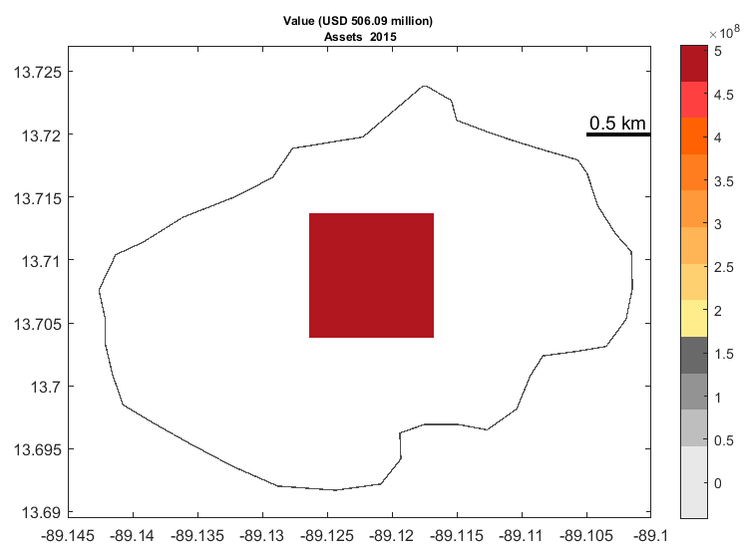 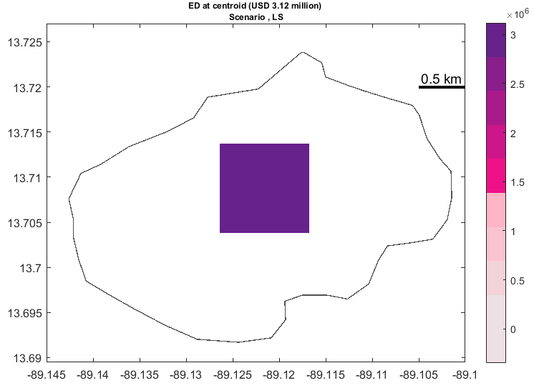

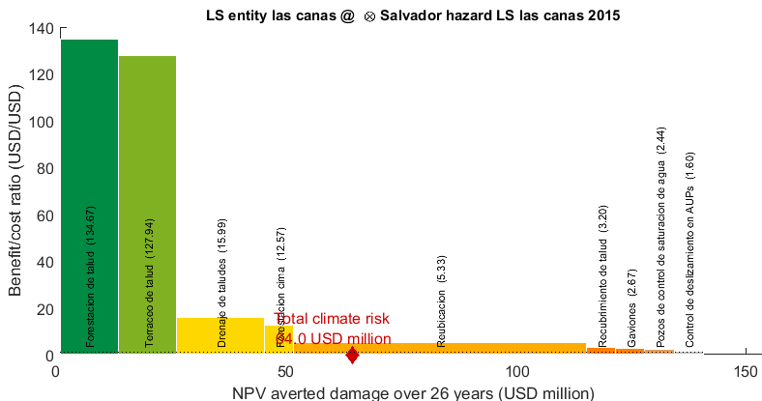

## Part 2: Tropical cyclones

Assets, expected damage and benefit: High resolution (<1 km)

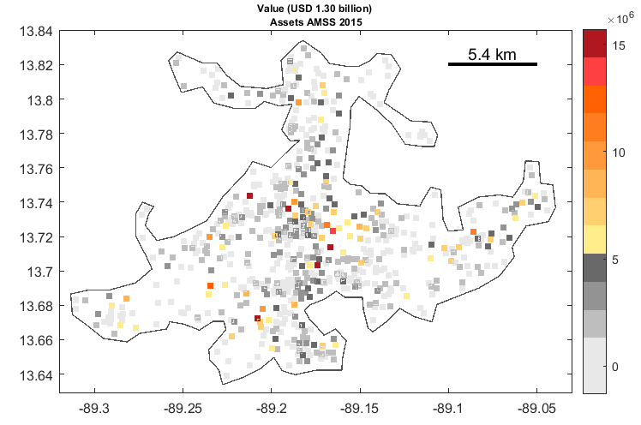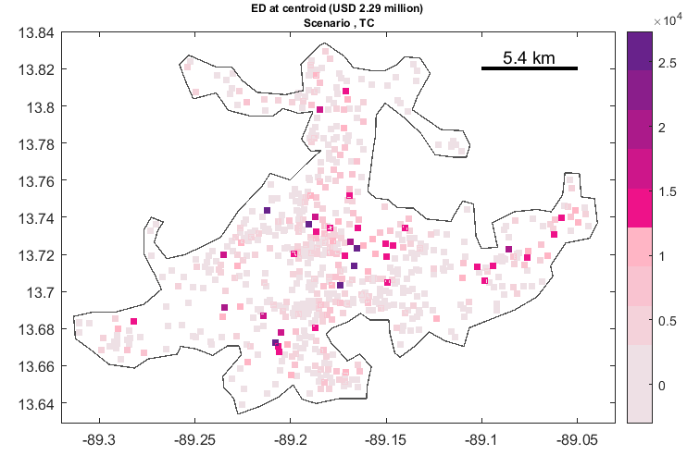

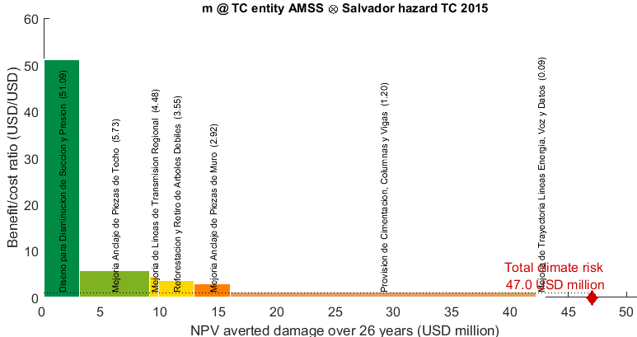[2]

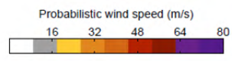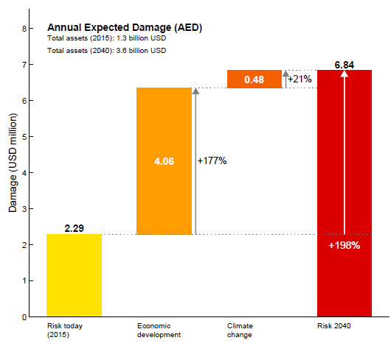 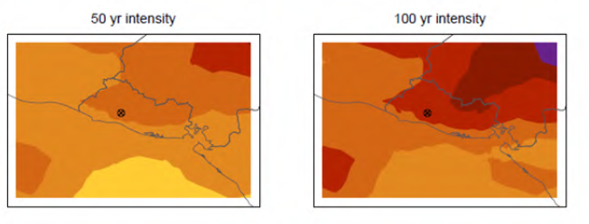

Assets, expected damage and benefit: Mid resolution (~1 km)

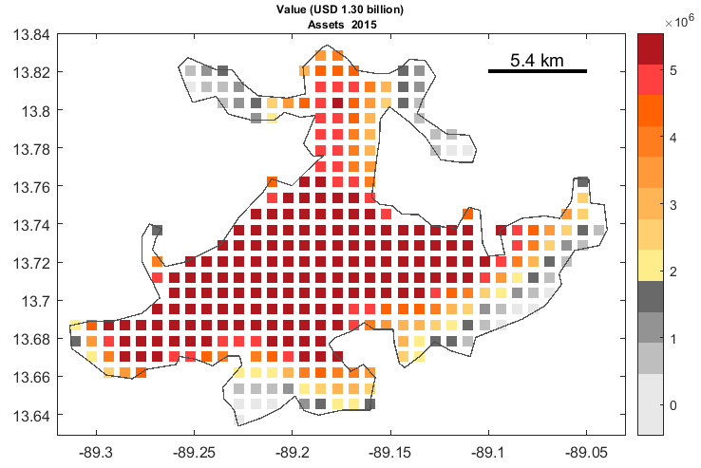 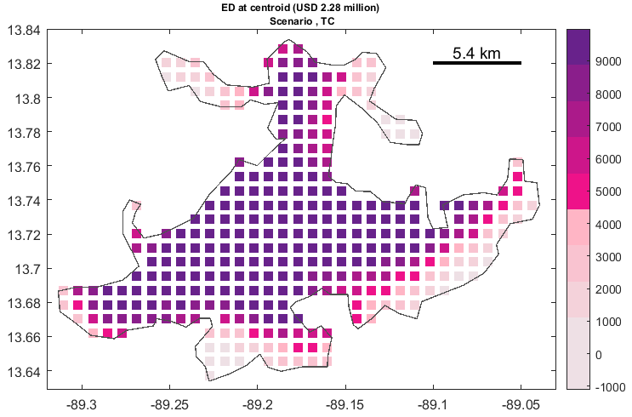

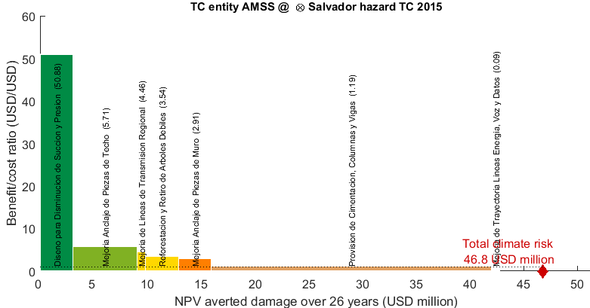

Assets, expected damage and benefit: Low resolution (~10 km)

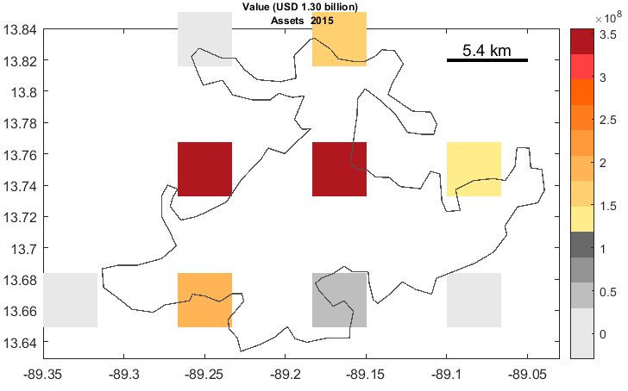 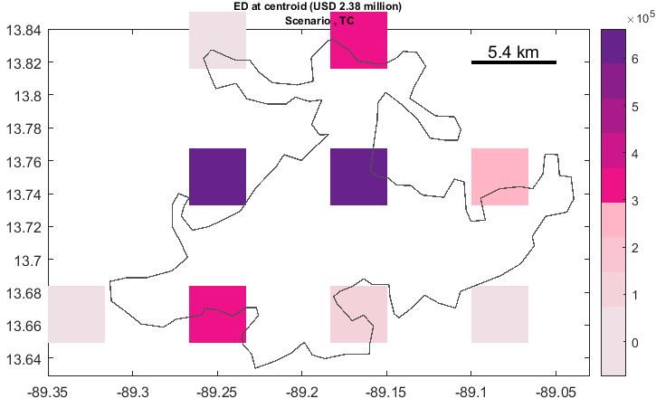

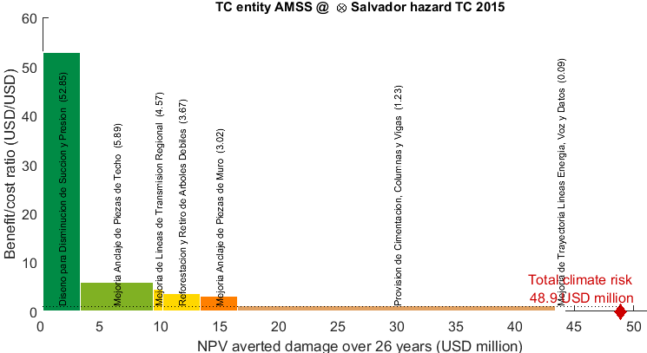

1. The adaptation cost curve is based on today's risk (assets today, landslide hazard today) and therefore does not correspond to the adaptation cost curve shown in the Vulnerability Report, where the curve is based on assets 2040 and landslide hazard 2040 with moderate climate change.
2. The adaptation cost curve is based on today's risk (assets today, tropical cyclone hazard today) and therefore does not corresponds to the adaptation cost curve shown in the Vulnerability Report, where the curve is based on assets 2014 and tropical cyclone hazard 2040 with moderate climate change.