# WISC Storm Severity Index (SSI) Comparison

The ETH / Swiss Re Case Study done in the framework of the WISC project (<https://wisc.climate.copernicus.eu>) compares the Storm Severity Indeces of the historic footprints with the SSI of the synthetic event set (<https://doi.org/10.3929/ethz-b-000269483>).

The numbers of the SSI used in the Case Study do not directly match the numbers published by other partners of the WISC project, mainly the UK Met Office. This document shows that the difference is caused from a different definition of the land-sea-mask to calculate the affected area, the mean gust and as a result the SSI.

Initial difference: The calculated SSI numbers by CLIMADA do not match the reported SSI numbers by the WISC project. The difference would change the order of severity between the different storm events. Figure 1 shows the comparison of SSI, Affected Area and Mean gustspeed calculated by CLIMADA and the reported numbers by WISC.

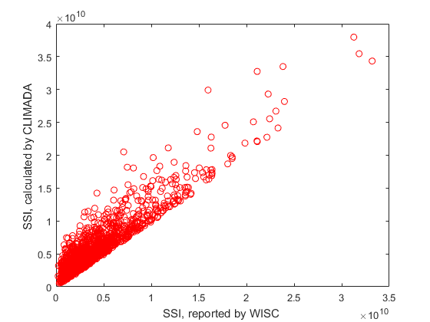

|  |  |
| --- | --- |
| C:\Users\ThomasRoosli\Documents\PhD\WISC_phd\case study new datasets\area_comparison1.png | C:\Users\ThomasRoosli\Documents\PhD\WISC_phd\case study new datasets\gust_comparison1.png |

When CLIMADA numbers where recalculated using the land-sea-mask as reported by WISC, the SSI and Affected Area are matching much better. The Mean gustspeed calculated by CLIMADA still does not match the WISC numbers. As these differences do not affect the order of severity of events between the two methods, it can be ignored for the time being.

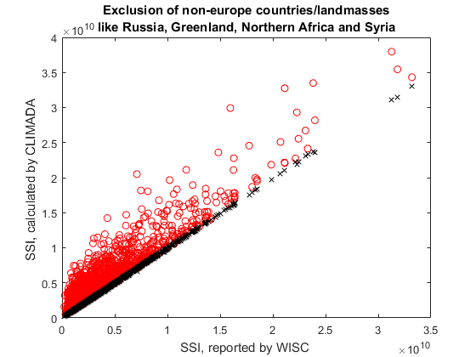

|  |  |
| --- | --- |
| C:\Users\ThomasRoosli\Documents\PhD\WISC_phd\case study new datasets\area_comparison2.png | C:\Users\ThomasRoosli\Documents\PhD\WISC_phd\case study new datasets\gust_comparison2.png |

For more details and to reproduce those results, please consider the function “wisc\_ssi\_calculation.m”.