# WISC: update of the ETH / Swiss Re Case Study

The ETH / Swiss Re Case Study done in the framework of the WISC project (<https://wisc.climate.copernicus.eu>) compares the Storm Severity Indices of the historic footprints and of the synthetic event set with other data sets in science and the insurance industry (<https://doi.org/10.3929/ethz-b-000269483>). One important result is that the original synthetic event set shows lower SSI than other datasets and that the low SSI is explained by a smaller affected area per event. In a risk assessment based on the synthetic event set, the aggregated impacts over large areas would be underrepresented.

The UK Met Office Case Study reacted to this finding and to other user feedback and presented new versions of the synthetic event set (<https://wisc.climate.copernicus.eu/wisc/documents/shared/(C3S_441_Lot3_WISC_SC2-D5.5-CGI-RP-17-0105)%20(UK%20Met%20Office%20Event%20Set%20Case%20Study)%20(1.1).pdf>). The three different versions mainly differ in the conversion from mean wind speed to gust speed. Meaning all contain the same events but with differently calculated values of the gust speeds.

This document includes version 2 and version 3 of the synthetic event set into the analysis of version 1.2 done in the ETH / Swiss Re Case Study. It also includes the updated historic footprints now including events that are more recent.

## Update of Chapter 5.1 Exploration of WISC historic event set and WISC synthetic event set

The SSI (Figure 1) and the Affected Area (Figure 2) of version 1.2 and version 2 of the WISC synthetic event set are still considerably lower than the historic footprints. Especially there are few events missing with SSI higher than ~2.2 * 10^4 a SSI reached in more than 40 historic events. Version 3 of the synthetic event set on the other hand does have a number of such events.

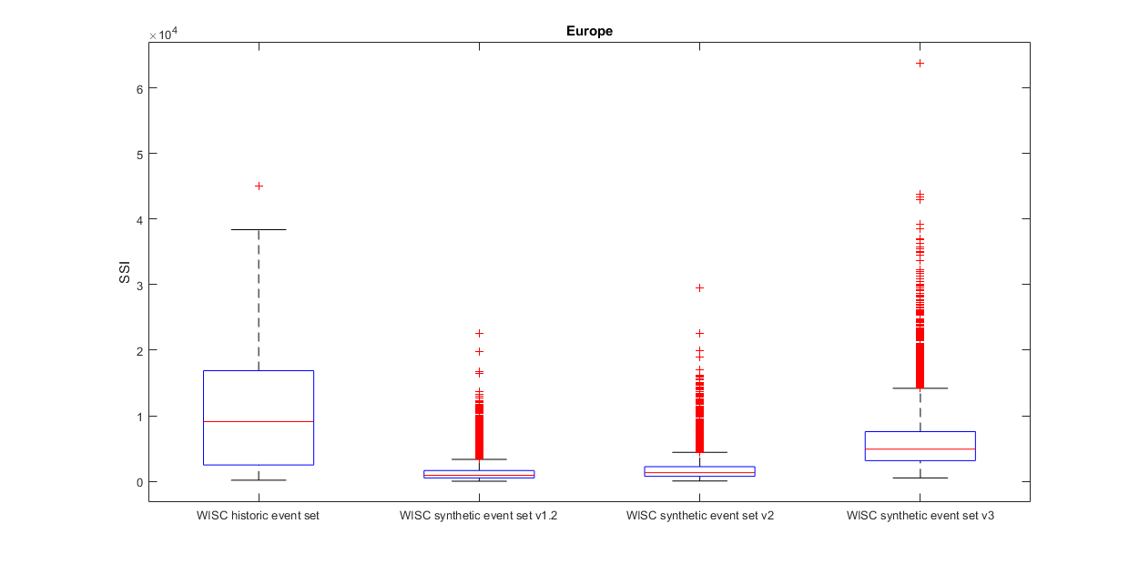

Figure 1: Distribution of Storm Severity Index (SSI) of the WISC historic and synthetic event set version 1.2 (original synthetic event set) and the updated versions version 2 and version 3 (from left to right)

|  |  |
| --- | --- |
|  |  |

Figure 2: The cube of the gust speed and affected area estimation distributions for WISC historic and WISC synthetic event sets. The difference seen in the SSI between the different event sets is mirrored in the distributions of area affected, while the distributions of the cube of the gust speed are similar between all event sets.

## Update of Chapter 5.4 Comparison of Damages

The damage exceedance frequency curve shown in Figure 3 illustrates the same finding as the comparison of SSI. Version 3 of the synthetic event set is more similar to the severity/frequency distribution of the historic event set than version 1.2 (shown in the original study). The aggregated annual damages (Figure 4) are higher for the version 3 of the synthetic event set compared to the historic event set for return periods smaller than 60 years. This is an expected result considering the different number of events in the event sets. The historic event set contains 147 events in 80 years while the synthetic event set contains 7760 events in 130 years. The missing small scale events in the historic event set do not allow a validation of the distribution of all events in the synthetic event set. That is why the aggregated annual damage of cannot be validated by the historic event set.

|  |  |
| --- | --- |
|  |  |

Figure 3: Event Damages of the WISC historic (yellow) and synthetic event set version 3 (orange) in Europe, calculated with the CLIMADA exposure dataset, shown as exceedance frequency curve (left). The same data shown as boxplot in the right panel.

|  |  |
| --- | --- |
|  |  |

Figure 4: Annual Damages of the WISC historic (yellow) and synthetic event set version 3 (orange) in Europe, calculated with the CLIMADA exposure dataset, shown as exceedance frequency curve (left) and same data shown as boxplot in the right panel.

## Conclusions

The version 3 of the synthetic hazard set is showing similar SSI values for rare events compared with the historic event set. We think version 3 to be most promising of the three versions and recommend its use for further comparisons. The much higher number of events per year included in the synthetic event set does not allow a validation of the synthetic event set using only the historic event set as a counter factual. But it is questionable, if the calculated and here shown annual aggregate losses are realistic, they could be overestimated. Compared with the highest event losses in the historic dataset, the median annual aggregate is of the same order of magnitude. As the severest few events are of similar magnitude in damages for the historic event set and the synthetic event set v3, the difference in annual aggregate damage is caused by the many small events in the synthetic event set. It is not known if the gust parameterisation used in the WISC synthetic event set v3 creates too many severe events or if the impact model used in CLIMADA is not well calibrated for less severe events and systematically overestimates their damage.

For more details and to reproduce those results, please consider the function “WISC_new_synthetic_sets_case_study.m”.

Thomas Röösli, 23. November 2018, Zürich

- updated 14. December 2018, Zürich