**WISC in CLIMADA** 20180106

Part of <https://github.com/davidnbresch/climada_module_storm_europe>

David N. Bresch, [dbresch@ethz.ch](mailto:dbresch@ethz.ch)

The CLIMADA[1] winter storm module[2] provides a solid basis to test and further develop the WISC[3] storm catalog[4] (4.4 km spatial resolution, time period 1940-2014). The present document does briefly touch upon some first tests and attempts to further develop this catalog within CLIMADA. Most results (and some intermediate files, too) can be found on the polybox[5].

CLIMADA operates on a variable grid, defined by *centroids*. For most calculations, CLIMADA hence uses just the grid the WISC footprints are provided at (4.4km) for all hazard analytics. Please note that for any impact calculations, CLIMADA does automatically assign each exposure point with the closest hazard centroid (i.e. the closest (variable) grid point of the hazard). This way, CLIMADA can handle irregular and dissimilar grids very elegantly.

In order to import all historic wind field footprints into CLIMADA, use wisc_hazard_set[6]. To generate the hazard set with all historic WISC footprints, just visit <https://wisc.climate.copernicus.eu/wisc/#/help/products>, download C3S_WISC_FOOTPRINT_NETCDF_0100.tgz and unzip into a subfolder named WISC of your local climada_data folder, then run (Figures 1-n) are based upon this data in **hazard**):

wisc_dir=[climada_global.data_dir filesep 'WISC' filesep ...  
 'C3S_WISC_FOOTPRINT_NETCDF_0100'];

**hazard**=wisc_hazard_set([wisc_dir '__both'])

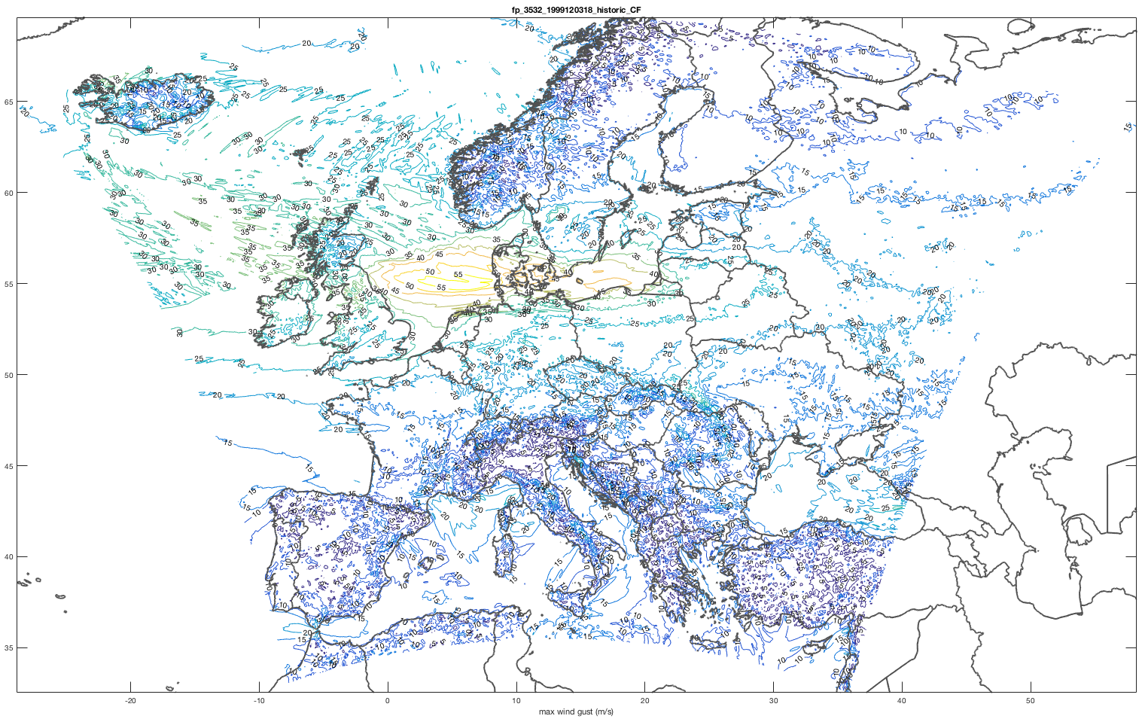

Figure 1a: A single WISC storm footprint (1999120318, Anatol) imported by wisc_hazard_set and plotted as contours (wind speed in m/s, for details, see WISC documentation).

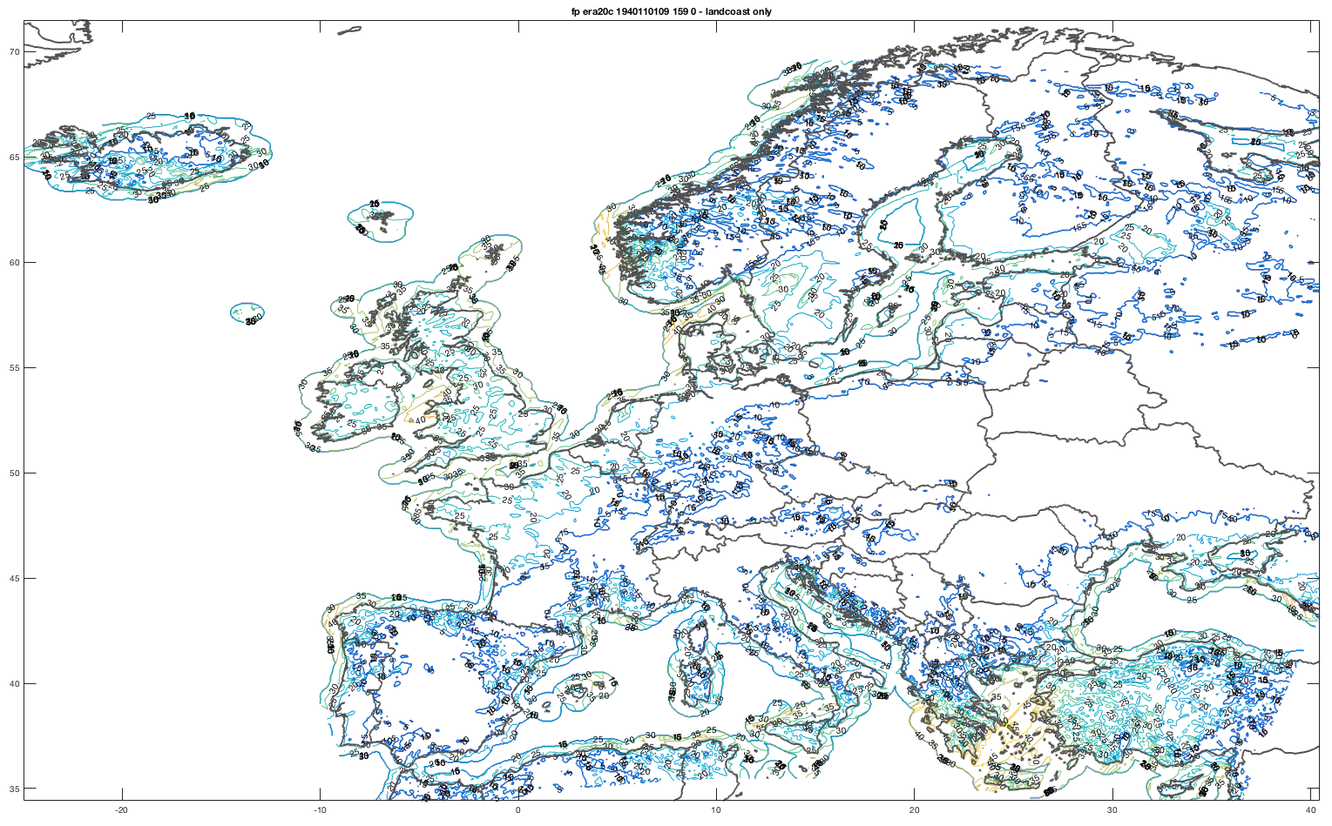

Figure 1b: Same as Figure 1a, but for an event (era20c, 1940110109) only over land plus a coastal buffer (mainly to save memory).

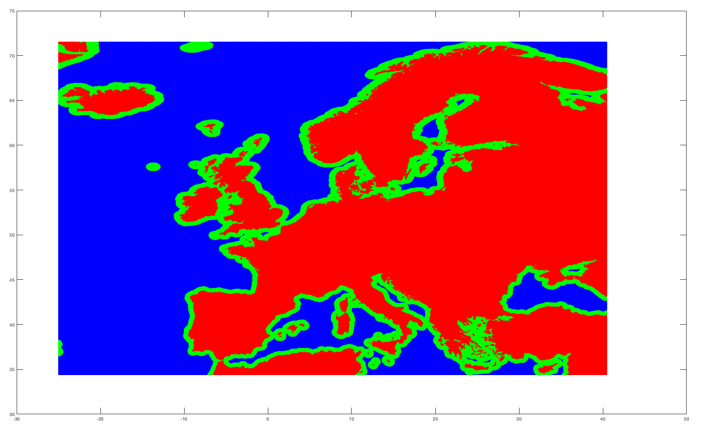

Figure 1c: the land mask (red) with the coastal buffer (green)[7]. Unless stated otherwise, results are shown on land mask plus coastal buffer (red plus green). The coastal buffer mainly serves to allow for nicer contour and other plots. See

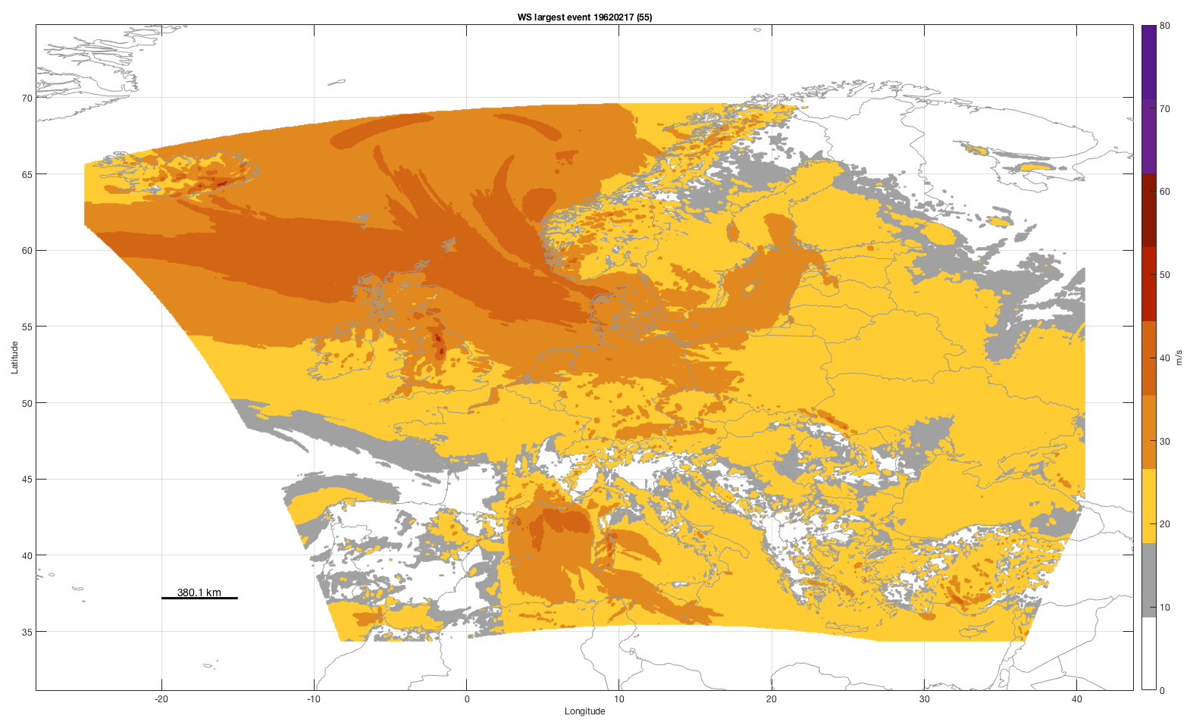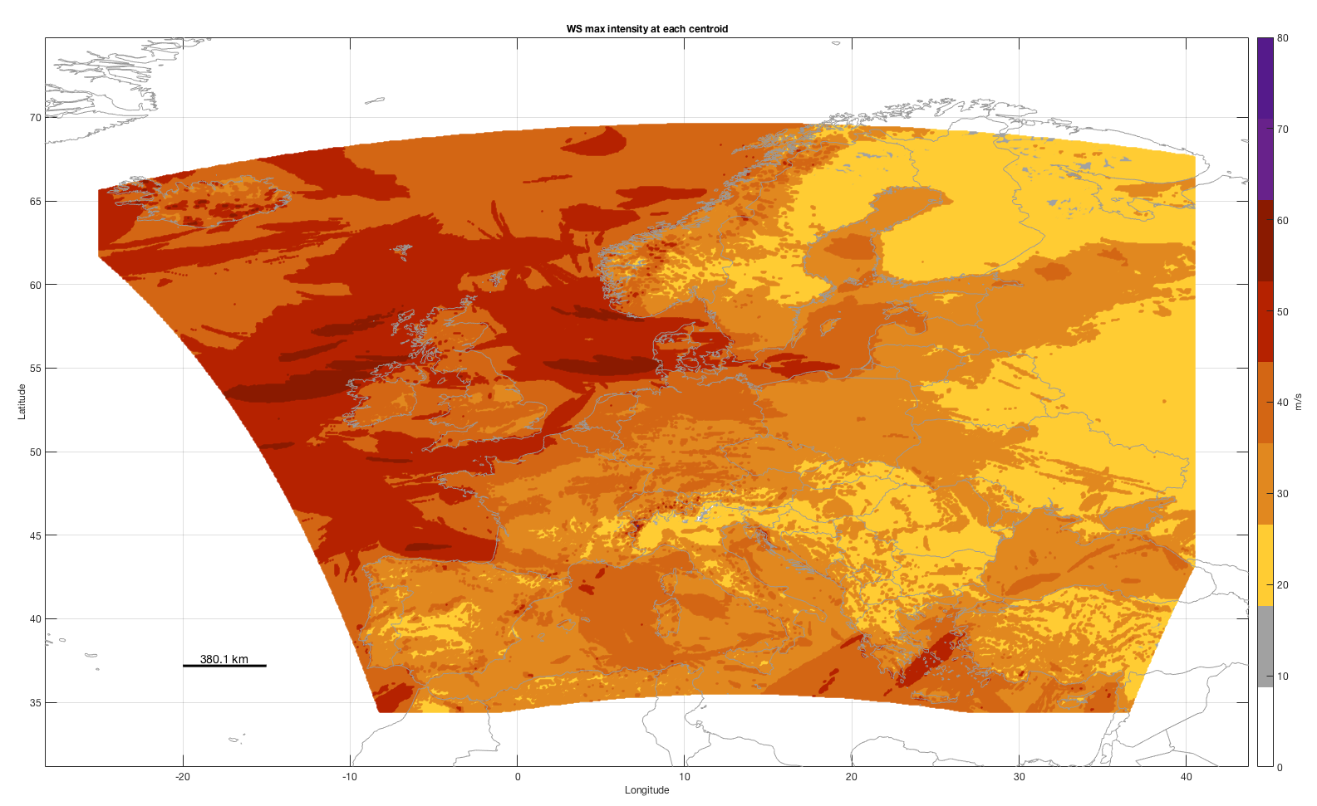

Figure 2: The largest single event (19620217) and the maximum intensity of all historic (era40 and eraint) events at each centroid. Easily produced by the call climada_hazard_map(hazard,-1) for the left and climada_hazard_map(hazard,-1) for the right plot. CLIMADA can obviously render with larger fonts etc. – the plozts were just produced to show best on a large screen…

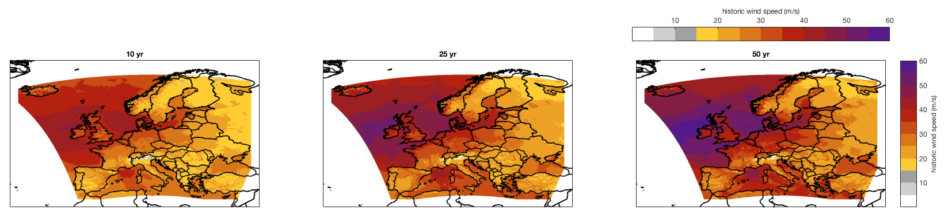

Figure 3a: Once imported into CLIMADA, wind speed return period maps can easily be generated (one line of code, see climada_hazard_stats). Shown are return period maps for 10, 25 and 50 years, wind speed in m/s. The plot has been automatically produced by the call climada_hazard_stats(hazard,[10 25 50]). Note that the color scale shows grey up to wind speeds that hardly lead to any impact (15 m/s) and then aligned with the tick marks up to a max gust of 60 m/s.

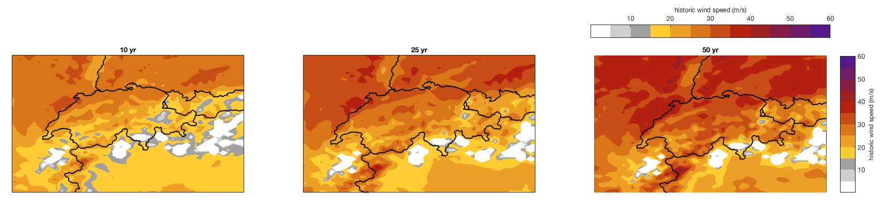

Figure 3b: Same as Fig. 3, just zoomed in for Switzerland.

CLIMADA does allow for an easy generation of a synthetic hazard event set, i.e. storm catalog based on historic events being moved a bit around (see Figure 4) and weakened and intensified. While the moving around allows for an easy way to deal with hazard uncertainty in impact calculations (a single storm might have happened a bit North/South/East/West of the original one, the weakening/intensification does extend the range to include storms which are physically plausible (or possible) but did not happen so far. Obviously, the relative frequencies are adjusted in CLIMADA accordingly.

As for the historic hazard set, the generation of the synthetic set is another one line of CLIMADA code:

hazard=wisc_hazard_set([wisc_dir '__both'],0,'',20)

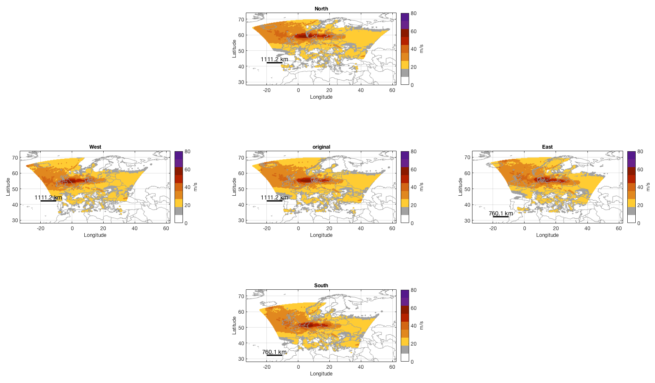

Figure 4: Schematic of the derived spatial ‘siblings’ (in the respective directions) of an original WISC footprint (Anatol, 1999, at the center). The spatial translation is hugely exaggerated (here about 100km) for illustrative purposes only. In the real case, the ‘wiggle’ is by a mere one or two grid points (4.4 or 8.8 km). Generated by wisc_hazard_set.

In order to check whether the synthetic catalog does not under- or overestimate event intensities compared to the historic catalog, we employ storm severity index statistics according to Lamb (1990), as shown in Figure 5. Again, these statistics can easily be generated on any WISC hazard set by simply invoking climada_hazard_ssi(hazard).

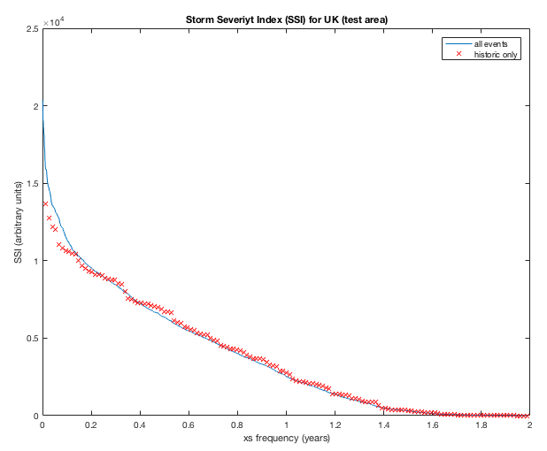

Figure 5: Storm Severity Index (SSI) for both the historic and synthetic set for the United Kingdom.

Similar to the historic set, return period maps can be drawn, but now obviously for much higher return periods, see Figure 6.

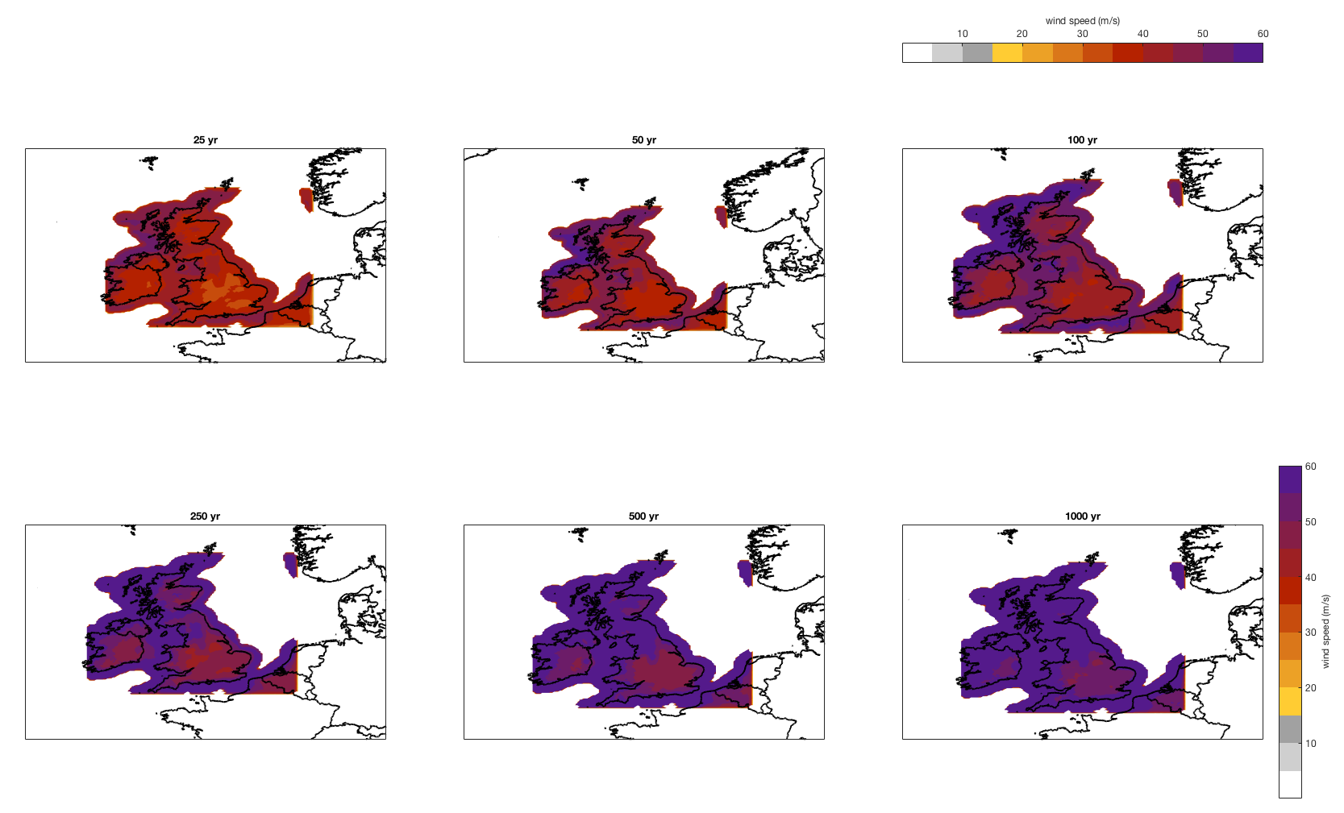

Figure 6: Hazard intensity return period maps for United Kingdom for return periods of 25, 50, 100, 250, 500 and 1000 years.

Last but not least, CLIMADA allows to quantify winter storm impacts, as shown in Fig. 7 for UK.

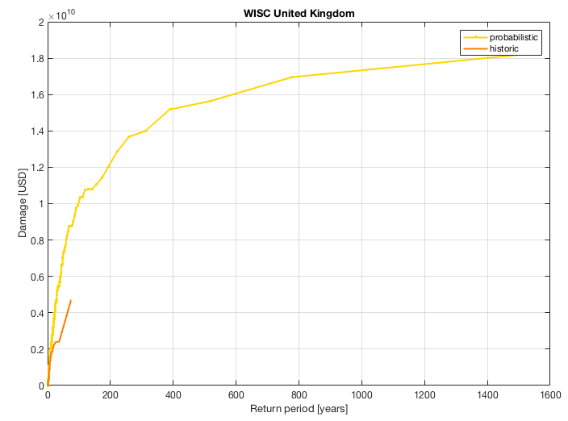

Figure 7: Impact of winter storms on UK, a quantification of UK winter storm risk. Quantification based on a standard asset portfolio for UK, see CLIMADA for details (see climada_entity_country('GBR') for automatic generation of the asset base).

The full European WISC grid has 1.6 million points, restricting to land and coastal buffer only (Fig. 1c) still retains about 600’000 centroids. Calculations on a desktop (even with parallel processing using parpool, but only two workers) get cumbersome. Therefore, we provide scripts to be used with a cluster, usually able to provide order of 24 workers. The script (or batch job) job_WISC_hist.m does generate all results for historic events, the script job_WISC.m does run all the synthetic stuff. While it is not advisable to execute job_WISC on a desktop, on can do so for job_WISC_hist, also for demonstration purposes, by simply typing

run_on_desktop=1; % to test the job on a desktop

job_WISC_hist

To be continued…

1. <https://github.com/davidnbresch/climada>
2. <https://github.com/davidnbresch/climada_module_storm_europe>
3. <https://wisc.climate.copernicus.eu>
4. <https://wisc.climate.copernicus.eu/wisc/#/help/products>
5. <https://polybox.ethz.ch/index.php/s/yO1sCMuSFA2qdGR> and subfolders of the same structure as in CLIMADA. In order to use these files, just copy them to your local CLIAMADA data folder (…/climada_data/hazards … etc.)
6. CLIMADA commands are formatted as Courier New and can usually just be typed into the MATLAB command window once CLIMADA has been started.
7. See the file ../climada_data/WISC/WISC_hazard_plus.mat, it contains the relevant fields (see header of wisc_ws_hazard_set for further details and automatic (re)generation of this data).