Regression models

Davyd

May, 2018

## Executive Summary

You work for Motor Trend, a magazine about the automobile industry. Looking at a data set of a collection of cars, they are interested in exploring the relationship between a set of variables and miles per gallon (MPG) (outcome). They are particularly interested in the following two questions:

“Is an automatic or manual transmission better for MPG” “Quantify the MPG difference between automatic and manual transmissions”

## Load Data

Load required packages, dataset, and convert categorical variables to factors.

library(ggplot2)

## Warning: package 'ggplot2' was built under R version 3.4.4

data(mtcars)  
head(mtcars, n=3)  
dim(mtcars)  
mtcars$cyl <- as.factor(mtcars$cyl)  
mtcars$vs <- as.factor(mtcars$vs)  
mtcars$am <- factor(mtcars$am)  
mtcars$gear <- factor(mtcars$gear)  
mtcars$carb <- factor(mtcars$carb)  
attach(mtcars)

## Exploratory Data Analysis

**See Appendix I** Box plot comparing MPG between Automatic and Manual transmission. The results show a significant increase in MPG for manual transmission when compared to automatic transmission.

### Statistical Inference

T-Test between transmission type and MPG

testResults <- t.test(mpg ~ am)  
testResults$p.value

## [1] 0.001373638

The T-Test rejects the null hypothesis that there is no difference in MPG for both transmission types.

testResults$estimate

## mean in group 0 mean in group 1   
## 17.14737 24.39231

The estimated difference between the two transmission types is 7.24494 MPG in favour of manual transmission.

### Regression Analysis

Fitting the model for the data

fullModelFit <- lm(mpg ~ ., data = mtcars)  
summary(fullModelFit) # results hidden  
summary(fullModelFit)$coeff # results hidden

Since none of the p-values are below 0.05, we cannot conlude that there is any statistical significance.

Selecting variables which are most statistically significant

stepFit <- step(fullModelFit)  
summary(stepFit) # results hidden  
summary(stepFit)$coeff # results hidden

The new model has 4 variables (cylinders, horsepower, weight, transmission). The R-squared value of 0.8659 confirms that this model explains about 87% of the variance in MPG. The p-values also are statistically significantly because they have a p-value less than 0.05. The coefficients conclude that increasing the number of cylinders from 4 to 6 with decrease the MPG by 3.03. Further increasing the cylinders to 8 with decrease the MPG by 2.16. Increasing the horsepower is decreases MPG 3.21 for every 100 horsepower. Weight decreases the MPG by 2.5 for each 1000 lbs increase. A Manual transmission improves the MPG by 1.81.

## Residuals & Diagnostics

Residual Plot

**See Appendix II**

The plots show that:

1. The randomness of the Residuals vs. Fitted plot supports the assumption of independence
2. The points of the Normal Q-Q plot following closely to the line conclude that the distribution of residuals is normal
3. The Scale-Location plot random distribution confirms the constant variance assumption
4. Since all points are within the 0.05 lines, the Residuals vs. Leverage concludes that there are no outliers

sum((abs(dfbetas(stepFit)))>1)

## [1] 0

## Conclusion

There is a difference in MPG between transmission type. A manual transmission will have a slight advantage in MPG. However, weight, horsepower, & number of cylinders are more statistically significant when determining MPG.

## Appendix I

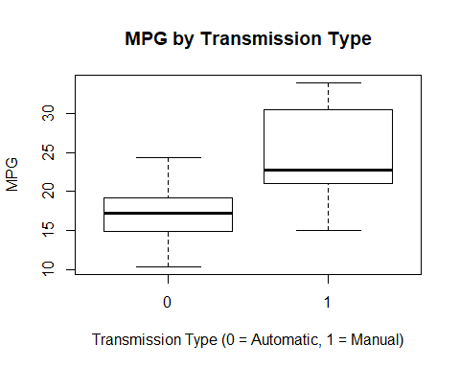

## Appendix II

