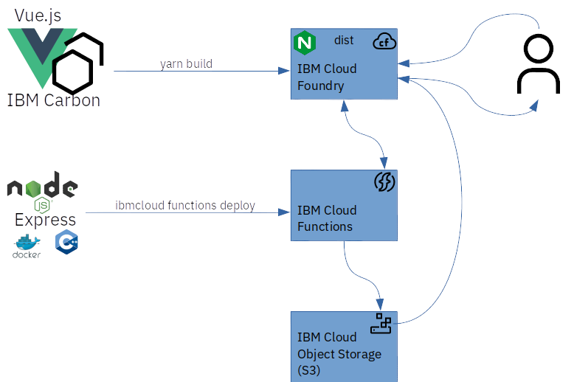
One day in class, my college writing professor plead for no more “dead grandmother” stories. Her point was that lots of kids had experienced loss, but none had a unique angle on the story that would make it interesting to read. I did not have a dead grandmother story at the time but now I do and its also a “How To” that I think Dr. Welt, might like.

When my grandmother passed she left behind a lot of US savings bonds that identified her grandchildren as payable-on-death (POD) beneficiaries. Because I am the youngest and, clearly, the cutest of my siblings, I ended up with most of those bonds. Since then, I have done an extensive survey (of four people) and found that many people from that generation received a portion of their paycheck in the form of US bonds. Fortunately, I found the Savings Bond Wizard application from the US Treasury which I used to organize those bonds and save them in sbw files.

Need to Modernize the App

However, the Savings Bond Wizard app was discontinued in 2008. And, when my mother-in-law recently asked me to sort through some bond data saved in sbw files I couldn’t open the files. As with most things, there is an open-source solution; a GNOME program called GBonds. However, that didn’t work because of conflicting packages requirements. I did manage to get it running in a Docker image and it did successfully import the sbw files but GBonds does not offer a way to export the data. Thus, I had an opportunity to modernize an app.

OK it’s not a monolithic, enterprise WebSphere app but the use case is the same. It also begets the same questions: Do I “lift and shift” by trying to resolve the package issues I ran into with GBonds? Do I “lift and shift” by using the Docker image I created and run that in the cloud with some sort of scheme for exporting the X11 interface? Or do I use a phased strategy https://www.ibm.com/cloud/application-modernization:
- Simplify: containerize the application to reduce costs and simplify operations
- Extend: use APIs for existing applications that are difficult to enable for cloud
- Decompose: use microservices to break down monolithic applications into deployable components
- Refactor: add new microservices to innovate incrementally

The Technical Solution

In this case I simplified the app by making it headless and reducing it to just a csv export. I did that by wrapping the GBonds import code with a little C++ glue to make it available as a CLI. With that function decomposed, I wrapped the CLI in an Node.js/Express microservice and deployed that to the cloud as an IBM Function/OpenWhisk action. And finally I wrote a minimal new cloud-based UI with Vue.js and deployed that as a Cloud Foundry app.

All the code is on GitHub here: https://github.com/davidnixon/sbw2csv and the app is deployed here: https://sbw2csv.us-east.mybluemix.net/#/

