This application was developed with C# .NET Core using Visual Studio 2019, using dependency injection as software pattern.

Install “Microsoft.Extensions.DependencyInjection” package to manage dependency injection

I injected the dependencies at startup of the SafeAutoWin project

I used clean architecture, where all the business rules are in the core (SafeAuto.Core project) and the Driver data is saved in the Infrastructure (SafeAuto.Infrastructure project) where I am saving data in Memory, if then We want to save data in a database we just need to modify the implementation of the new Repository with minimum changes in the core

This application has 3 tiers:

**Front**: It’s a view where you can select a text file with command lines (). Just click “Open File” button to select the file

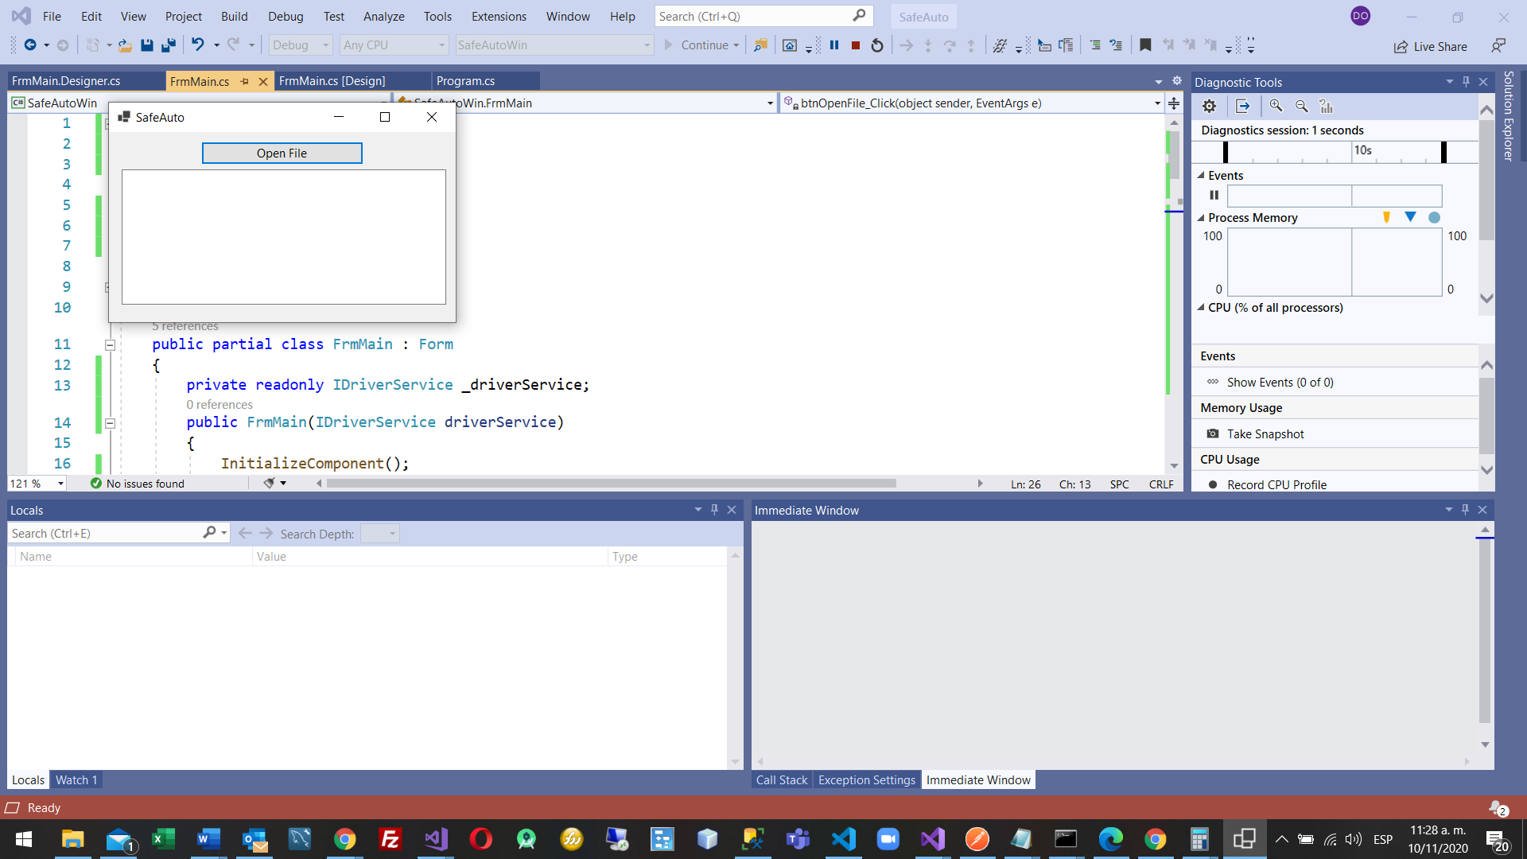

**Core**.- As I used clean architecture, you can see that there is not any dependencies in this tire

**Infrastructure**.- Here I am saving data in memory, if the future the client want to change where the data is saved we just have to add new repository and doing minimum changes in the core and front

I created an interface in the folder Interfaces of the SafeAuto.Core project called IDriverService with 2 methods to resolve the request.

Also I created the repository interface where are methods that I have to implement to storage Drivers, theirs trips and get trips sorted(called IDriverRepository) but its implementation is in the SafeAuto.Infrastructure project

NOTE: I think there is a problem in the example request, you will see Dan trip

Trip Dan 07:15 07:45 17.3.- 30 minutes 17.3 miles, so 34.6 mph  
Trip Dan 06:12 06:32 21.8.- 20 minutes 21.8 miles, so 65.4 mph

Th average of those trips must be 50 mph, but in your example I see 47 mph.

Example:  
Driver Dan   
Driver Alex   
Driver Bob   
Trip Dan 07:15 07:45 17.3   
Trip Dan 06:12 06:32 21.8   
Trip Alex 12:01 13:16 42.0

Expected output:   
Alex: 42 miles @ 34 mph   
Dan: 39 miles @ 47 mph   
Bob: 0 miles