**SCINet LincPass (SmallStepsCLI) Logon Troubleshooting**

*Instructions for configuring LincPass logon: https://scinet.usda.gov/guides/access/login*

If you are getting a “Bad owner or permissions” error (double \\ in path),  
the permissions on the .ssh/ and .step directories are too permissive and allowing Full Access to SYSTEM, Administrators, and others. This is not a problem on an account that has never used ssh on the affected computer.

**Resolution** (*assumes you have completed the LincPass config steps in the above link*):

**Change permissions on the .ssh and .step folders in the user profile**:   
“C:\Users\first.last\.ssh” and “C:\Users\first.last\.step”.   
On each folder disable inheritance, remove any additional users, and restrict access to just the owner. Each folder needs to be set for READ+WRITE permissions for only the owner.

*If you have not completed the LincPass config steps, you need to run the step ca bootstrap command that creates the .step folder.*

This website provided the following steps: [https://windowsreport.com/bad-owner-or-permissions-on-ssh-config/](https://gcc02.safelinks.protection.outlook.com/?url=https%3A%2F%2Fwindowsreport.com%2Fbad-owner-or-permissions-on-ssh-config%2F&data=05%7C02%7Clinda.ballard%40usda.gov%7C8e70364658ce44cf422a08dc2d7f04b9%7Ced5b36e701ee4ebc867ee03cfa0d4697%7C1%7C0%7C638435270778750670%7CUnknown%7CTWFpbGZsb3d8eyJWIjoiMC4wLjAwMDAiLCJQIjoiV2luMzIiLCJBTiI6Ik1haWwiLCJXVCI6Mn0%3D%7C0%7C%7C%7C&sdata=sk5C2c1uSbiM4xJ4o8ZXxP3gPmjdebefP%2Btnj15WgKU%3D&reserved=0)

1. Right-click the **.ssh** folder and click *Properties (repeat 1-12 for .step)*.

[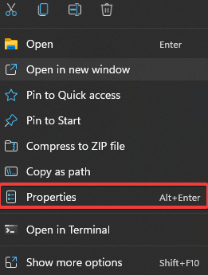](https://cdn.windowsreport.com/wp-content/uploads/2022/04/ssh-file-properties.png)

1. Find and click the **Security** tab and then click *Advanced*.[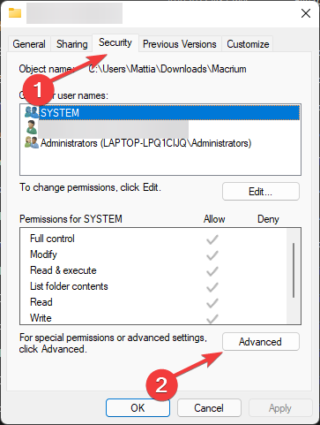](https://cdn.windowsreport.com/wp-content/uploads/2022/04/security-tab-and-then-advanced.png)
2. Click **Disable Inheritance** in the Advanced Security Settings window.[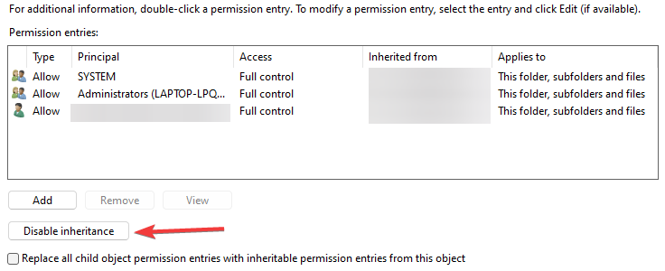](https://cdn.windowsreport.com/wp-content/uploads/2022/04/disable-inheritance.png)
3. A warning popup will appear. Click **Remove all inherited permissions from this object.**

[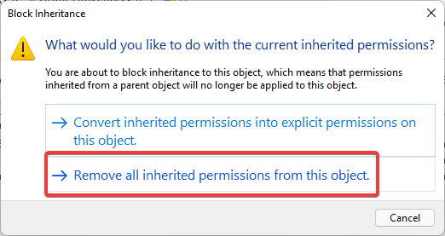](https://cdn.windowsreport.com/wp-content/uploads/2022/04/Remove-all-inherited-permissions-from-this-object.png)

1. Back in the Advanced window, note that all users have been removed.
2. Click the **Add**button.

[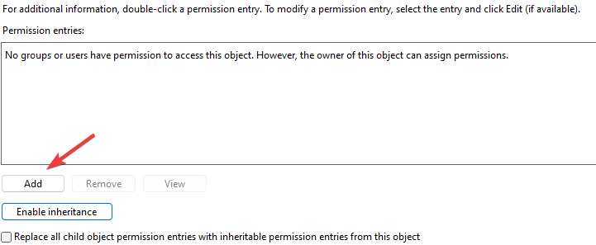](https://cdn.windowsreport.com/wp-content/uploads/2022/04/add-owner.png)

1. Next, click **Select a principal**to bring up the S*elect Users or Groups* window.[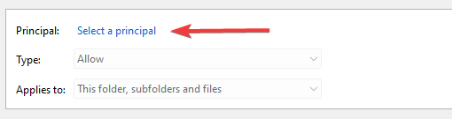](https://cdn.windowsreport.com/wp-content/uploads/2022/04/select-a-principal.png)
2. Type first.last and click Check Names to verify.

[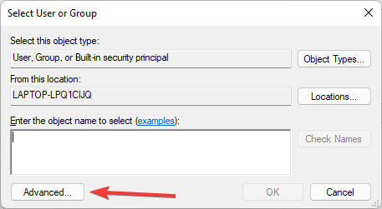](https://cdn.windowsreport.com/wp-content/uploads/2022/04/advance-setting-for-principal.png)

1. Click Ok to Add user’s name.
2. In the Permission Entry window, make sure these Basic Permissions are checked: Read & Execute, List folder contents, Read, **Write**.
3. Click Ok to close Permission Entry window.
4. Click **OK** to close the *Advanced Security Settings* for .ssh window.
5. If you have not restarted the device since installing SmallStepCLI, do it now. Otherwise, Windows will not recognize the step program as “safe” in the path environment (*path is added during SmallStepCLI install*).
6. In PowerShell, run:

step ca bootstrap --ca-url https://step-ca.scinet.usda.gov --fingerprint adb703fd18f176937743b20228d52af7a705d63a0471cd67428660be5fd006bf

NOTE: This command creates the .step folder – if you are just now running it, repeat steps 1-12 to correct the permissions on the new .step folder and all its subdirectories and files.

1. In PowerShell, run

step ssh config --set Provisioner=keycloak --set User=first.last

1. In powershell, ssh to Ceres or Atlas to verify problem is corrected.

ssh [first.last@ceres.scinet.usda.gov](mailto:first.last@ceres.scinet.usda.gov) or ssh [first.last@atlas-login.hpc.msstate.edu](mailto:first.last@atlas-login.hpc.msstate.edu)

Expected behavior:

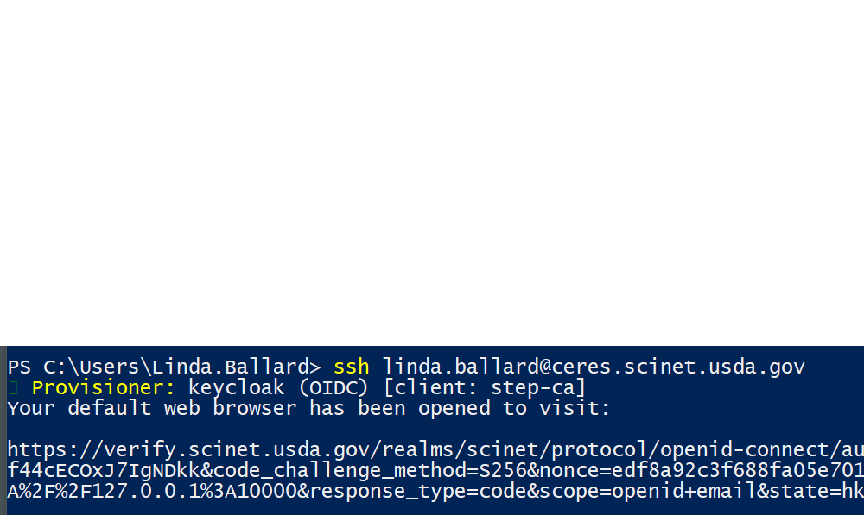

This will open browser for the eAuth logon procedure (like AgLearn, WebTA, etc)