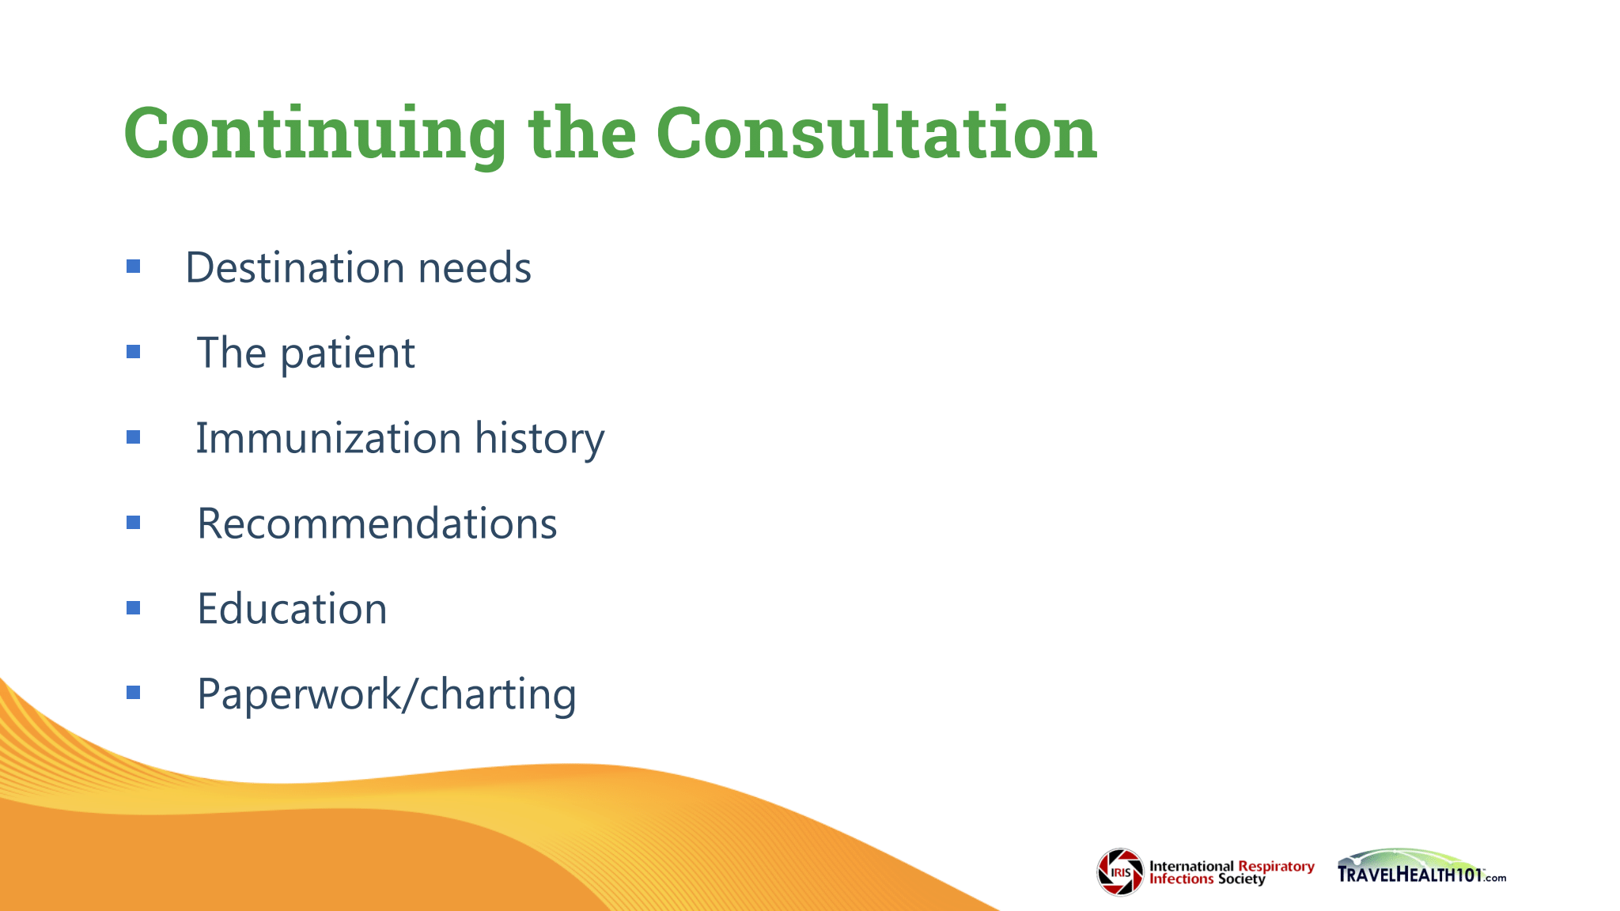

Certificate of Completion

# THIS ACKNOWLEDGES THAT

HAS SUCCESSFULLY COMPLETED

##### **TRAVELHEALTH 101**



*Provider approved by the California Board of Registered Nursing, Provider #17738*

*This document needs to be retained by licensee for a period of four years after the course conclude*

RUTH CARRICO, PhD DNP APRN CIC FSHEA FNAP FAAN

PROGRAM DIRECTOR

INTERNATIONAL RESPIRATORY INFECTIONS SOCIETY

