Arduino版1(D1)

元件:紅外線被動感測 LED DHT11 風扇

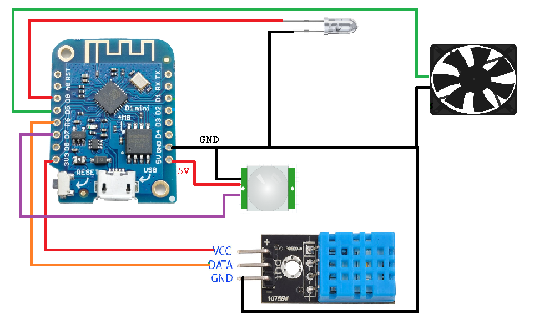

連線IP 192.168.60.201

可以透過192.168.60.201看IOT狀態

透過GET http://192.168.60.201/openfan 打開風扇5秒

透過GET http://192.168.60.201/closefan關閉風扇5秒

透過GET http://192.168.60. 201/openLED 打開LED閃爍5秒

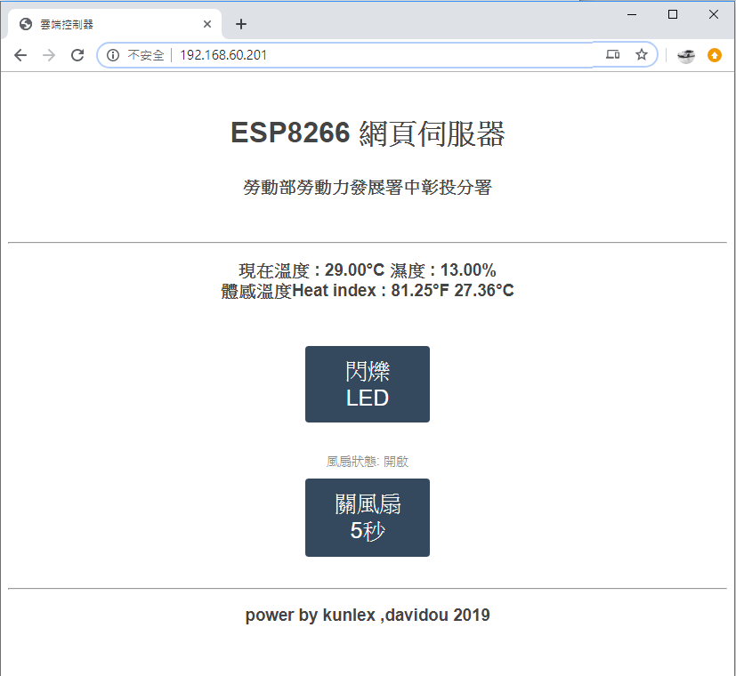

int sensor = D7; //定義紅外線sensor接脚為2

int led = 16; //LED 16是接D0

int fan = D5;

int val = 0; //定義變量儲存傳感器的返回值

int fanState;//風扇開關狀態 0是關 1是開

float h,t,f,hif,hic ;//設在這邊當全域變數

// 開發版選Wemos D1 R1

// 你可能需要安裝下列的函式庫 Arduino libraries:

// - DHT Sensor Library: https://github.com/adafruit/DHT-sensor-library

// - Adafruit Unified Sensor Lib: https://github.com/adafruit/Adafruit_Sensor

#include "DHT.h"

#define DHTPIN D6 // D1 mini的接口請接D6

//切換你的溫溼度感應模組

#define DHTTYPE DHT11 // DHT 11

//#define DHTTYPE DHT22

DHT dht(DHTPIN, DHTTYPE);

#include <ESP8266WiFi.h>

#include <ESP8266WebServer.h>

const char* ssid = "ASUS_iot_2G";

const char* password = "1121314151";

ESP8266WebServer server(80);

void homepage() {

server.send(200, "text/html", SendHTML(fanState));

Serial.println("同學開啟了網頁");

}

void setup()

{

Serial.begin(9600); //設置傳輸鮑率為9600

Serial.println(F("DHTxx test!"));

dht.begin();

pinMode(sensor, INPUT); //設定sensor接脚為輸入狀態

pinMode(led, OUTPUT);

pinMode(fan, OUTPUT);

//初始化網絡

WiFi.mode(WIFI_STA);

WiFi.begin(ssid, password);

WiFi.config(IPAddress(192,168,60,201), // IP位址

IPAddress(192,168,60,254), // 閘道（gateway）位址

IPAddress(255,255,255,0)); // 網路遮罩（netmask）

while (WiFi.status() != WL_CONNECTED) {

delay(500);

Serial.print(".");

}

Serial.println("");

Serial.print("IP Address: ");

Serial.println(WiFi.localIP());

//初始化WebServer

server.on("/", homepage);

server.on("/openfan", handle_openfan);//打開風扇

server.on("/closefan", handle_closefan);//關閉風扇

server.on("/openLED", handle_openLED);//打開LED

server.begin();

Serial.println("HTTP server started");

}

void loop()

{

delay(1000);

//監聽客戶請求並處理

server.handleClient();

// Reading temperature or humidity takes about 250 milliseconds!

// 感測器的感測秒數需要等待超過2秒才會有新的數值 (DHT系列是很慢的感測元件)

h = dht.readHumidity();

// Read temperature as Celsius (the default)

t = dht.readTemperature();

// Read temperature as Fahrenheit (isFahrenheit = true)

f = dht.readTemperature(true);

// Check if any reads failed and exit early (to try again).

if (isnan(h) || isnan(t) || isnan(f)) {

Serial.println(F("Failed to read from DHT sensor!"));

//return;

}

// Compute heat index in Fahrenheit (the default)

hif = dht.computeHeatIndex(f, h);

// Compute heat index in Celsius (isFahreheit = false)

hic = dht.computeHeatIndex(t, h, false);

val = digitalRead(sensor); //讀傳感訊息

if( val== HIGH)

//如果檢測到人移動

{

Serial.println("有人經過");

digitalWrite(led, HIGH);//開燈

}

//如果沒有檢測到人移動

else

{

Serial.println("無人或人靜止不動");

digitalWrite(led, LOW); //關LED

}

Serial.print(F("濕度Humidity: "));

Serial.print(h);

Serial.print(F("% 溫度Temperature: "));

Serial.print(t);

Serial.print(F("°C "));

Serial.print(f);

Serial.print(F("°F 體感溫度Heat index: "));

Serial.print(hic);

Serial.print(F("°C "));

Serial.print(hif);

Serial.println(F("°F"));

if(t>=29){

Serial.print(F("高溫開fan"));

fanState=1;

server.send(200, "text/html", SendHTML(fanState));

digitalWrite(fan, HIGH);

}

if(t<29){

Serial.print(F("低溫關fan"));

fanState=0;

server.send(200, "text/html", SendHTML(fanState));

digitalWrite(fan,LOW );

}

}

void handle_openfan() {//開電扇5秒

fanState=1;

server.send(200, "text/html", SendHTML(fanState));

digitalWrite(fan, HIGH);

Serial.print(F("手動開風扇"));

delay(5000);//手動關風扇停留5秒

}

void handle_closefan() {//關電扇

digitalWrite(fan,LOW );

fanState=0;

Serial.print(F("手動關風扇"));

server.send(200, "text/html", SendHTML(fanState));

delay(5000);//手動關風扇停留5秒

}

void handle_openLED() {//開LED10秒

server.send(200, "text/html", SendHTML(fanState));

digitalWrite(led, HIGH);

delay(100);

digitalWrite(led,LOW );

delay(100);

digitalWrite(led, HIGH);

delay(100);

digitalWrite(led,LOW );

delay(100);

digitalWrite(led, HIGH);

delay(100);

digitalWrite(led,LOW );

delay(100);

digitalWrite(led, HIGH);

delay(5000);//停留5秒

}

String SendHTML(uint8_t fanState){

String ptr = "<!DOCTYPE html> <html>\n";

ptr +="<head><meta name=\"viewport\" content=\"width=device-width, initial-scale=1.0, user-scalable=no\"><meta charset=\"UTF-8\">\n";

ptr +="<title>雲端控制器</title>\n";

ptr +="<style>html { font-family: Helvetica; display: inline-block; margin: 0px auto; text-align: center;}\n";

ptr +="body{margin-top: 50px;} h1 {color: #444444;margin: 50px auto 30px;} h3 {color: #444444;margin-bottom: 50px;}\n";

ptr +=".button {display: block;width: 80px;background-color: #1abc9c;border: none;color: white;padding: 13px 30px;text-decoration: none;font-size: 25px;margin: 0px auto 35px;cursor: pointer;border-radius: 4px;}\n";

ptr +=".button-on {background-color: #1abc9c;}\n";

ptr +=".button-on:active {background-color: #16a085;}\n";

ptr +=".button-off {background-color: #34495e;}\n";

ptr +=".button-off:active {background-color: #2c3e50;}\n";

ptr +="p {font-size: 14px;color: #888;margin-bottom: 10px;}\n";

ptr +="</style>\n";

ptr +="</head>\n";

ptr +="<body>\n";

ptr +="<h1> ESP8266 網頁伺服器</h1>\n";

ptr +="<h3>勞動部勞動力發展署中彰投分署</h3>\n";

ptr +="<hr><h3>現在溫度 : "+ String(t) +"°C 濕度 : "+ String(h) +"% <br> 體感溫度Heat index : "+ String(hif) +"°F "+ String(hic) +"°C</h3>\n";

ptr +="<a class=\"button button-off\" href=\"/openLED\">閃爍LED</a>\n";

if(fanState==1)

{ptr +="<p>風扇狀態: 開啟</p><a class=\"button button-off\" href=\"/closefan\">關風扇5秒</a>\n";}

else

{ptr +="<p>風扇狀態: 關閉</p><a class=\"button button-on\" href=\"/openfan\">開風扇5秒</a>\n";}

ptr +="<hr><h3>power by kunlex ,davidou 2019 </h3>\n";

ptr +="</body>\n";

ptr +="</html>\n";

return ptr;

}