Senegal Performance Indicators

Francisco Rios Casas

10/29/2019

### 1. Introduction

This document highlights the data completeness, data sources, and changes over time for select Outcome Indicators in Senegal. Data for indicators all came from the latest available Progress Update and Disbursement Request forms (PUDRs) for each grant unless indicated otherwise. Global Fund investment in Senegal include one TB (SEN-Z-MOH), one malaria (SEN-M-PNLP), and two HIV grants (SEN-H-ANCS, SEN-H-CNLS).

Most Recent PUDRs available

SEN-Z-MOH_Progress Report_30Jun2019 02 09 2019.xlsx

SEN-M-PNLP_Progress Report_S1 2019 Version finale du 15 Aout 2019.xlsx

PU-SEN-H-CNLS-S1-2019_15082019_finale.xlsx

SEN H ANCS PU (Jan-Juin19), LFA 5Sept19.xlsm

### 2. Data Completeness

For each Outcome Indicator, the grant Principal Recipient (PR) *usually* must establish an indicator “Baseline Value”. This value–when available–can serve as a benchmark for progress reported in subsequent time periods. **However, in the Senegal grants, the use of the baseline value seems to be inconsistently applied as typically around 50% and 75% of indicators in a given PUDR do not include a Baseline Value.**

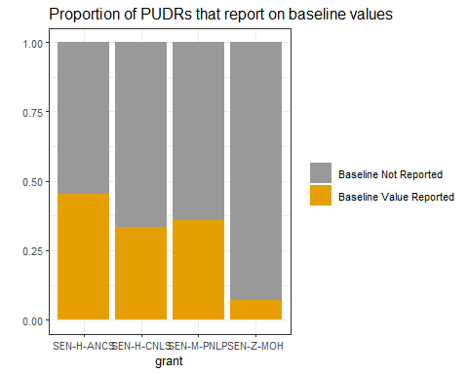

In order to calculate the achievement of an Outcome Indicator for a given grant, it is necessary to have information on (1) the target that was originally set and (2) the result. Only the malaria (SEN-M-PNLP) and tuberculosis grant (SEN-Z-MOH) in Senegal provide sufficient data to understand how well the grants are meeting the goals that were originally established.

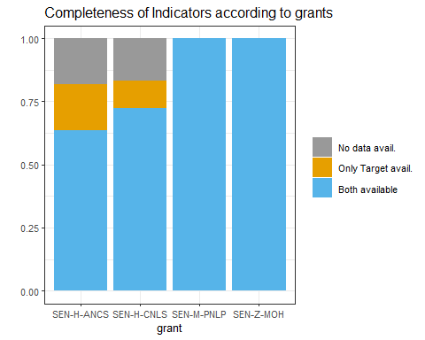

### 3. Data Sources

“Data Sources” are listed in the PUDR to indicate where information reported to the global fund came from. Examples of data sources include reports from the disease-specific National Programs, surveys such as the Demographic Health Survey (DHS), and Health Management Information systems such as DHIS2.

In some cases, the source of information used to establish the target of a goal is different from the source used to provide updates on progress. **In Senegal, the HIV grant to the National HIV Program (CNLS) had indicator sources change the most often: 12 of the 18 indicators in the grant changed sources.**

Grant

Indicators

Different Sources between Baseline and Result

SEN-M-PNLP

14

1

SEN-H-ANCS

11

0

SEN-H-CNLS

18

12

SEN-Z-MOH

14

4

**In the CNLS grant, the Baseline Values were established using reports from the National HIV Program, while the Result Values were obtained from a combination of DHIS2 data, indicators reported directly from the clinics providing services, and from other reports created by the Ministry of Health.**

### 4. Grant Results based on most recent PUDRs

The “Achievement Ratio” is calculated in the PUDR to understand how close to the original target the Outcome Indicator result is. A value of 1.0 or greater means that the Indicators goal has been met or exceeded.

#### 4.1. TB

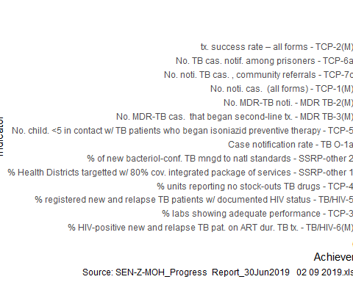

**In the most recent PUDR, the TB grant has reported the lowest performance in the number of reporting units that had no stock-outs of anti-TB drugs. Number of MDR-TB patients that began second line treatment and health district coverage with TB services are the next indicators with the worst performance. Community referrals has also been an area where the indicator results reported have not been meeting the targets set. Section 6 below includes information on progress over time for some of these Indicators.**

#### 4.2. Malaria

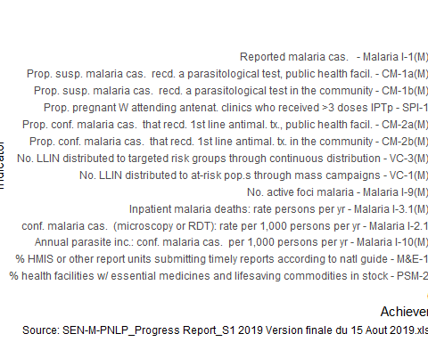

**The Malaria grant has been meeting all of its targets except with regards to the proportion of pregnant women who received at least three doses of IPT.**

#### 4.3. HIV

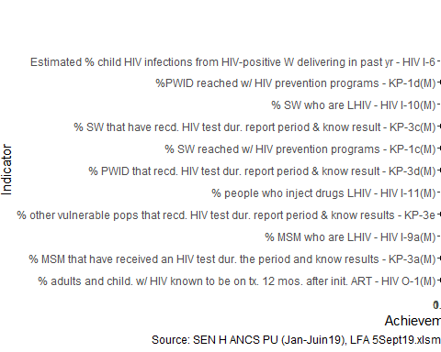

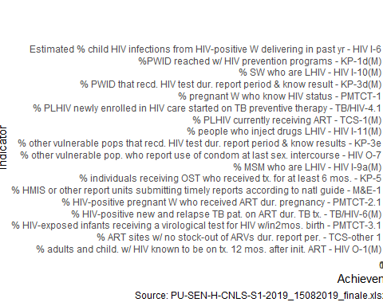

**The HIV ANCS grant has been performing lower than its targets with regards to sex workers. There are also a few Indicators with no updates available.**

**The majority of Indicators between the two HIV grants are different, but in some cases–such as KP-3d(M) testing for HIV among people who inject drugs–both the CNLS and ANCS report different results for the same indicator. The PUDRs for each of the grants also list different targets: while the ANCS grant reports a higher value it also lists a higher target and the CNLS grant lists a lower result but also a much lower target leading to a much higher achievement ratio. Currently, only the ANCS PUDR is LFA-verified however.**

### 5. Agreement between PR, LFA

After each PUDR is submitted by the PR, the LFA will verify the results reported on the Indicators. In many cases they revise the original values provided by the PR.

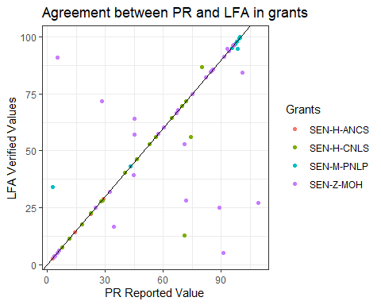

**The most recent LFA-verified PUDRs for this analysis include the following:**

LFA Verified PUDR Files

SEN-Z-MOH PUDR (Juil-Dec18) LFA 19Avr19 MAJ 25apr19.xlsx

SEN M PNLP PUDR (Juil-Dec18) LFA, 10Mai19.xlsx

SEN H ANCS PU (Jan-Juin19), LFA 5Sept19.xlsm

SEN-H-CNLS PUDR (Juil-Dec18) LFA, 9Avr19.xlsx

### 6. Special Analyses

There are data from three of the most recent PUDRs available for this analysis corresponding to the past 3 semesters that the grants have been implemented. The table below highlights how certain indicators of interest in the TB grant have changed over time.

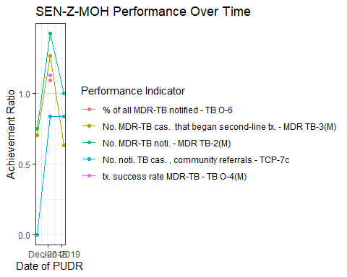

**MDR-TB identification and treatment is an area of large investment by the Global Fund in Senegal and covered in the TB Deep Dive. Progress made in the year 2018 on both of those indicators has somewhat stalled in the first semester of 2019.**

**Although there has been less data available to monitor progress on the treatment and notification of MDR-TB it has been on-track as of the last data available.**

**TB cases identified through community referrals is also an important area of investment in Senegal; this indicator has remained just under-target in the most recent PUDRs.**

Have targets changes between semesters? 