2016

Jimmi Andersen & David Papp

Semester Project fourth Semester

16-12-2016

Project Report For Game-Console

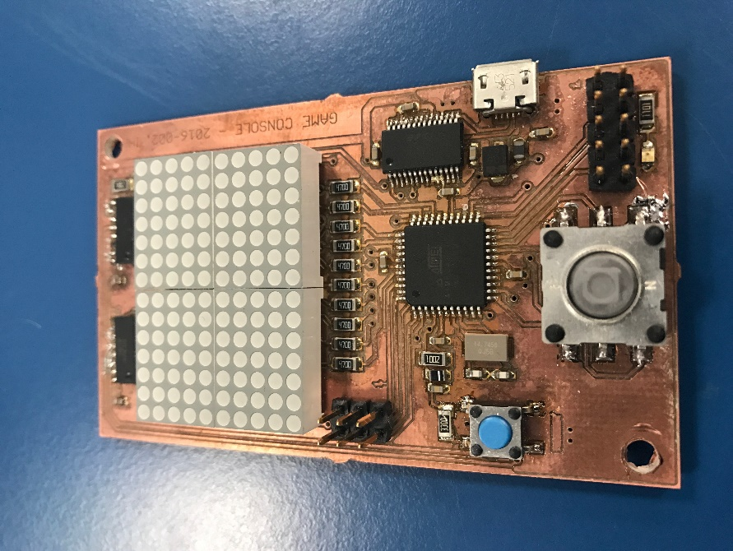

Table of Content.

Abstract. 2

Requirements. 2

Analysis. 2

Design. 2

Test. 2

Implementation. 2

# Abstract.

Putty speed = 115200

# Requirements.

The projects requirements are we must implement a two-player game system using the Game-console board we created in the real-time programming course to do this our system must have at least 3 tasks where two of them must be hard real time tasks we need to have data that are shared between more than one task. The system must use the functionalities of the board like the joystick, Dot-matrix display, and the serial connection to test our board and to make Shure that our system is schedulable we must use R-2R D/A converter to measure the time of the tasks.

Testing our system, we will be using unit testing for testing the software. We will be using an oscilloscope to find the computation time of the tasks. Our system must use the computer as player one and the game board as player two the screen will be the Dot matrix on the game board.

# Analysis.

# Design.

# Test.

# Implementation.