A Brief Review of Opinion: Anti-Zionism = Antisemitism?
~ Gee, I thought “no,” but it looks like opinions among Americans differ

David L. Passmore, https://davidpassmore.net, 10 November 2026

On November 8, 2026, Philly Bike On Your Left, a pro-Palestinian social cycling group, conducted a “Boycott Ride” in center-city Philadelphia to highlight boycotts against restaurants whose owners have hosted fundraisers or made statements in support of “the genocidal, child-killing, ethno-supremacist apartheid state of ‘Israel’.” Organizers said the ride was a nonviolent “protest against…political ideology….[that] perpetuates the genocide of Palestinians.” The strategy, declared Philly Bike On Your Left, was to “exert economic pressure toward social justice aims.”
Supporters asserted that the cycling event protected free speech and drew attention to ongoing deaths and destruction in the West Bank, Gaza, and Lebanon. Detractors said the bike ride was rooted in antisemitism, comparing the event to the “violence of Nazi Fascists” in the November 1938 Kristallnacht, or the Night of Broken Glass, attacks by Sturmabteilung and Schutzstaffel paramilitary forces, Hitler Youth, and German civilians against Jewish-owned stores, buildings, and synagogues. The Philadelphia mayor, Pennsylvania Attorney General, Pennsylvania Governor, the Anti-Defamation League, and other critics issued statements condemning the ride.
To me, conflation of Zionism—support for a Jewish homeland through colonization in the region of Palestine—with Judaism—a monotheistic religion with spiritual, cultural, and legal tradition— seems implicit in critics’ responses to the bike ride. If the social cycling group is anti-Zionist, is it also antisemitic? Can a group be anti-Zionist, but pro-Judaism and pro-Israel? I have no answer to these questions. However, I am interested in American public opinion about the questions as well as the nature of their answers.
In the remainder of this brief essay, I summarize notes that I took during a day’s reading of selected (read that as restricted to limited time available) research and commentary about opinions Americans hold about anti-Zionism and antisemitism. I end with an infographic that visualizes my notes.

a debate defined by high stakes
The debate over whether anti-Zionism is antisemitism carries high political stakes and frequently involves intense emotion. Public figures, commentators, and decision-makers frequently treat the two terms as equivalent. Polling data and political science research present a more complicated picture.
Although political institutions and specific demographic groups connect anti-Zionism with antisemitism, broad public opinion data suggest that attitudes toward Jewish people, Israeli statehood, and Israeli government policy remain distinct. Examining this relationship requires close attention to survey definitions and political context.

how definitions mold public perception
The meaning assigned to ‘Zionism” affects whether people accept or reject the label. A 2022 survey of American Jews found that self-identification varied substantially depending on the definition provided. Fifty-eight percent identified as Zionist when no definition was offered. That figure rose to 70% when Zionism was described as a feeling of attachment to Israel, and to 72% when defined as a belief in a Jewish and democratic state. By contrast, only 10% identified as Zionist when defined as privileging Jewish rights over non-Jewish rights in Israel.
Treating anti-Zionism as a uniform position among American Jews is problematic, it seems. Depending on the definition, the term, anti-Zionism, could refer to opposition to government policies, unequal citizenship, or the rejection of Jewish national self-determination. Various surveys meant to define American public opinion that omit clear terminology might be measuring fundamentally different beliefs.

congressional action & the limits of legislative votes
The U.S. House of Representatives formally equated the two concepts in a December 5, 2023 vote on House Resolution 894. The resolution passed 311–14, with 92 members voting present, declaring that anti-Zionism is antisemitism. This vote shows that a decisive congressional majority endorsed the statement, but it does not directly measure public opinion.
The resolution bundled the declaration with condemnations of antisemitic violence and support for Jewish communities, meaning members voted on the entire nuanced package. Congressional votes reflected the positions as well as strategic choices of political elites rather than a representative survey of voters. Although lawmakers made an explicit connection, the vote did not establish why individual members supported it. Supporters might have regarded the statement as a deliberate claim about Jewish national self-determination rather than a failure to distinguish an ideology from a people.

views within the american jewish community
Survey evidence shows substantial support for the equation, anti-Zionism = antisemitism, among American Jews. In a December 2024 survey of 800 Jewish adults conducted by Public Opinion Strategies for the advocacy organization Jewish Majority, 70% of respondents said anti-Zionist movements were inherently antisemitic. This finding reflects an important perspective within the American Jewish community, although not likely generalizable to the entire U.S. population.
The survey was commissioned by an organization with an explicit position in the debate. Moreover, the question focused on anti-Zionist movements, meaning respondents might have reacted to the conduct and messaging of activist groups rather than after assessing anti-Zionism as an abstract political theory. Some respondents failed to answer every survey item, and no accounting was made for failure to respond to the survey by some members of the target audience.

correlation is not equivalence
National public opinion research indicates that feelings toward Jewish people and views about Israel are correlated in some contexts, without being equivalent. An analysis of the Democracy Fund's VOTER Survey, a representative sample of 6,000 Americans collected in early 2024, alongside the multi-wave 2019–2020 Democracy Fund–UCLA Nationscape survey found that party affiliation strongly shaped the relationship between warmth toward Jewish people and sympathy for Israel.
Among Republicans, sympathy for Israelis over Palestinians rose from roughly 20% among those who rated Jews very unfavorably to nearly 80% among those who rated Jews very favorably. Among Democrats, fewer than 20% expressed greater sympathy for Israelis than Palestinians. The larger Nationscape dataset confirmed that attitudes toward Jewish people were much stronger predictors of Republicans' support for Israel than of Democrats' support. This pattern cautions against treating criticism of Israeli policy or lack of support for its government as automatic evidence of anti-Jewish prejudice.

conclusion: perceiving both overlap & difference
Data show that certain anti-Israel views overlap with antisemitic prejudice. In January 2024, the Anti-Defamation League measured traditional antisemitic stereotypes separately from Israel-related views among 4,143 Americans. The survey found a 0.30 correlation between discomfort voting for a pro-Israel politician and endorsement of anti-Jewish tropes. The belief that Israeli operatives secretly manipulate U.S. policy had a 0.49 correlation with endorsement of those tropes. Respondents who denied that Jews have a right to an independent country were 3.7 times as likely as the average respondent to score in the top quartile of anti-Jewish trope endorsement.
These findings suggest that conspiratorial claims frequently co-occur with antisemitic prejudice. However, they do not support the view that anti-Israel views cause antisemitism or that respondents themselves equate the concepts. The overlap is real, but it does not mean that every critic of Israel holds antisemitic views.

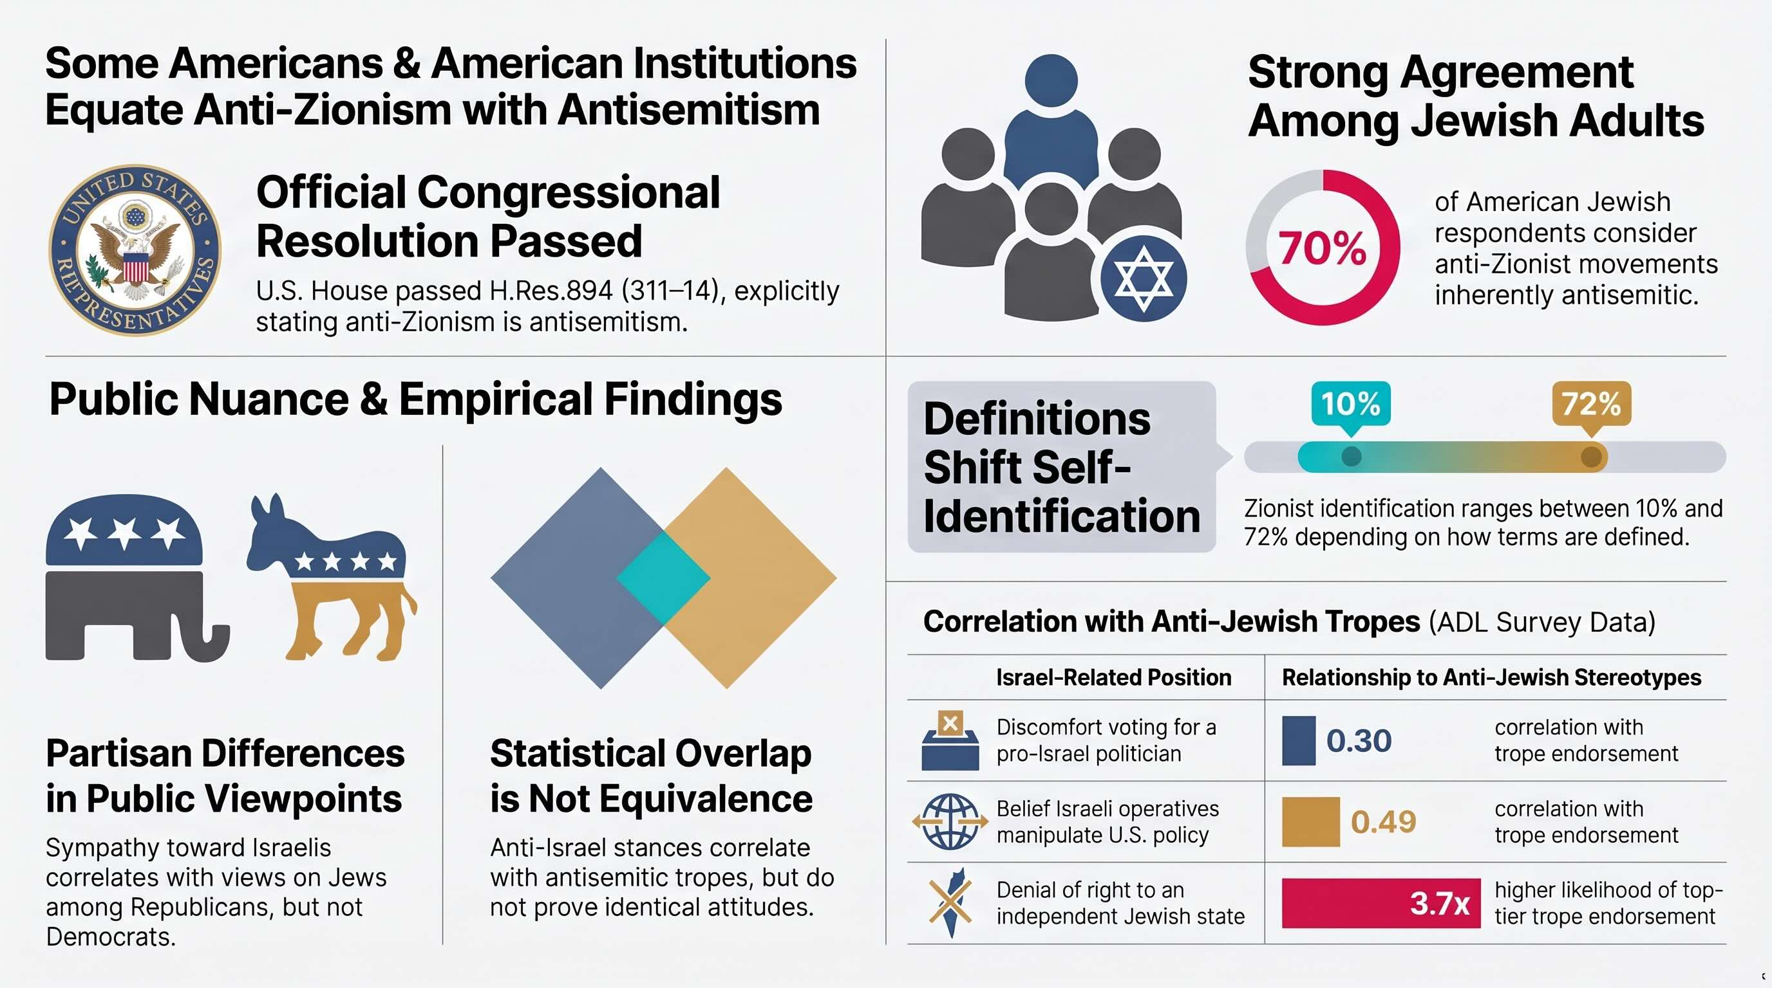
An infographic summarizing my notes from reading selected research and commentary about opinions Americans hold about anti-Zionism and antisemitism.

