**Practice 10 – Human Resources Consultancy**

We work in a Human Resources Consultant company supporting the business consultant team. A common request from our customers from the IT sector is a salary recommendation to be applied to their software development employees.

Therefore, we have been requested to build a Web app with two minimum goals:

1. Exploration of salaries per country and experience
2. Prediction of a salary based on country, experience and education

We have access to an annual survey by Stack Overflow where we can find more than 67K software developers' answers. Part of the survey includes salary, experience, country, full/partial time employee, language, demographic information and so on.

Taking into consideration the request and this amazing survey you should develop your own **Visual Analytics Data Web** with two main parts:

* A Jupyter Notebook to explore the data (i.e. EDA), prepare the data and build a Machine Learning model that predicts the salary of a software employee at least based on **Country**, **Education** and **Experience** variables
* A Streamlit app to explore the data and execute the salary prediction. Try to apply and use all visual resources and capabilities shown in class.

An example of **minimum webapp** may be (for sure you could do more amazing things!!!):

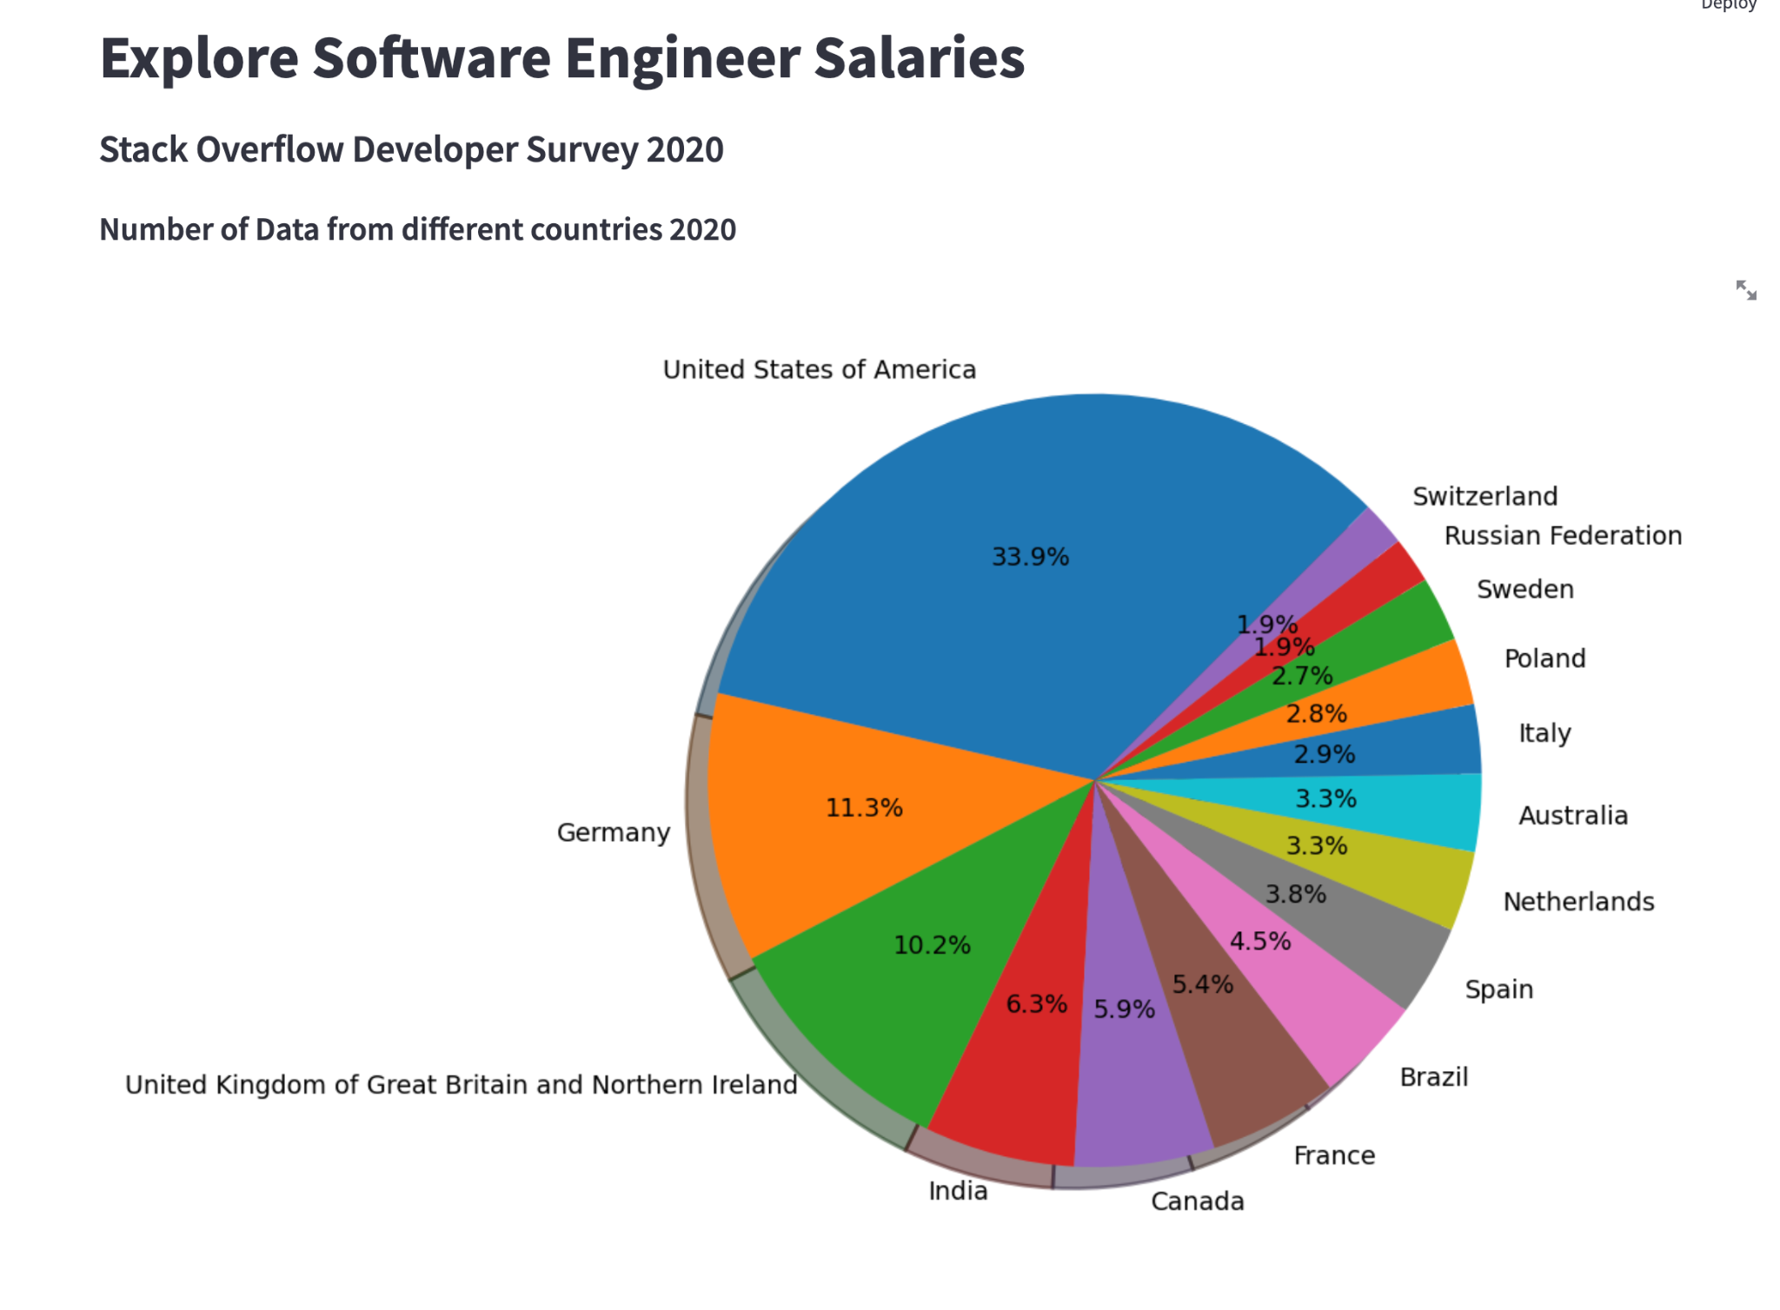

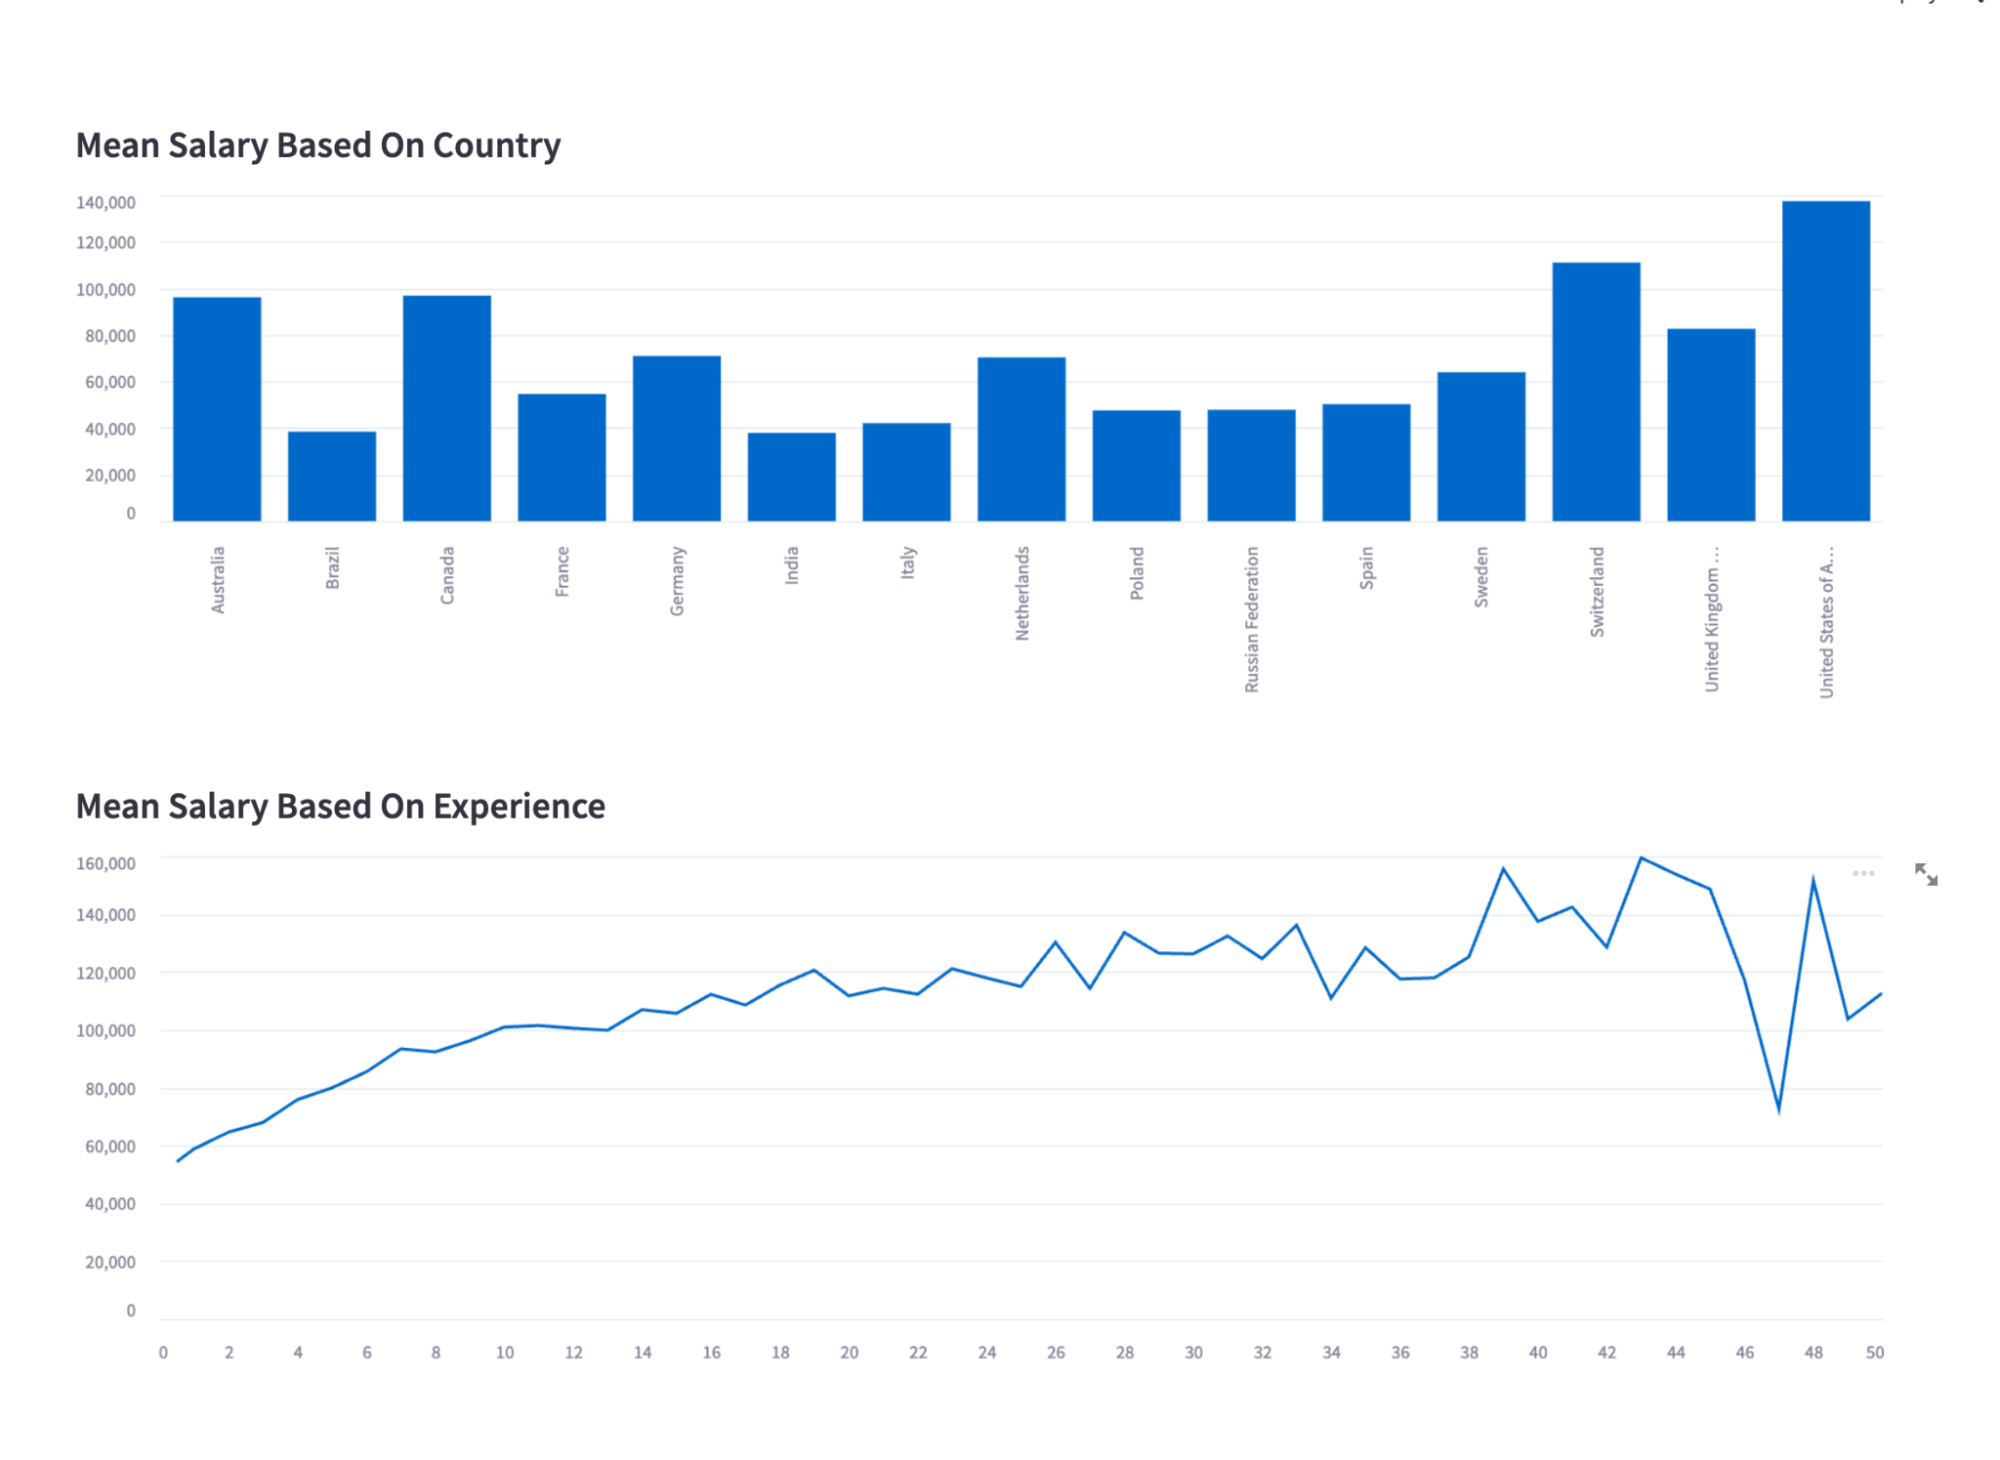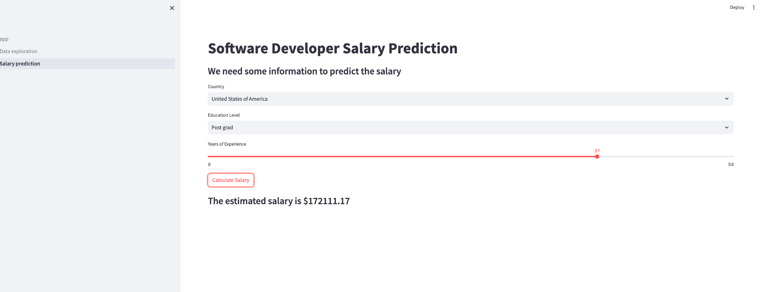

Delivery:

* Delivery date: November, 15th at 23:55
* Delivery content:
  + The salary_exploration_prediction_students.ipynb file with the answers to EX1 to EX12
  + A webapp.zip file that contains the Visual Analytics webapp with all files and folders necessary to run the application.