ForestAssembly: a global dataset of forest species assemblages and their land-use history
Verónica Cruz-Alonso (ORCID: 0000-0002-0642-036X) ¹, Asun Rodríguez-Uña (ORCID: ) ², Michael Curran (ORCID: ) ³, David Moreno-Mateos (ORCID: ) ⁴
¹ Departamento de Biodiversidad, Ecología y Evolución, Universidad Complutense de Madrid, Spain ² ³ ⁴
* Verónica Cruz-Alonso, Universidad Complutense de Madrid, Spain.
Email: veronica.cral@gmail.com

Introduction
The patterns and mechanisms of species coexistence are main topics unresolved and discussed in biological sciences. The natural processes leading to those species assemblages are being modified by local and global human impacts, what diminish our ability to observe and understand those patterns in nature. These unprecedented circumstances in human lifetime, where none corner of the Earth planet is free of human impact, makes essential to study current species assemblages in the light of global change components (land-use, climate, biological invasions, biogeochemical cycles, etc.). Having in mind these circumstances we have compiled a dataset of species assemblages and human impacts they have experienced at biologically-relevant scales.
The long temporal scales that forests need to recover limits our ability to study forest ecosystem reassembly after human impacts because of the difficulty of maintaining long-term observation campaigns. Although exceptional exceptions exist for forests (e.g. see BioTime (1), LTER Network, LOTVS (2)), one common approach is superseding long-term data with space-for-time substitution data. More long-term information would be available in the future, even at large spacial scales (e.g. national forest inventories), but the velocity of changing conditions makes data on long-term forest succession currently needed. Forests are becoming in average younger every year at the global scale (3), meaning that old-growth and undisturbed forests are still being cut. Species assemblages in old forests are unknown under many contexts, and lost for decades to centuries if not forever according to our best estimations (4).
The objective was to compile and make available a dataset of forest species assemblages, i.e., sets of individuals exposed to same sampling efforts in a defined area dependent on the biology of the taxa being examined (5), the context features that condition the observations (i.e., location, taxon type and measurement units) and the use history (age of the assemblage, disturbances and conditions for recovery), and being essential to have an assemblage to compare. Assemblages to compare can be either the best possible conserved assemblage under natural conditions identified by experts in the area or the disturbed assemblage right after the impact ceases.

Methods

Database design
ForestAssembly includes forest species assemblages with different ages. To be considered for ForestAssembly, a source needed to contain species assemblages of any taxa directly sampled in forests or potential forests recovering from human impacts. Riparian/flooded forests can be included but not savannas or shrublands. The forest assemblages needed to (1) be paired to a well-preserved old-growth forest or recently disturbed site assemblage to compare with, (2) have a description of site human uses, including their nature and the time since main uses ceased, (3) have a well-defined location. It rarely includes temporal samples of the same assemblage (but see Buckney and Morrison (1992) - average of measures along time, and Brearley et al. (2004) - repeated measures on same sites).
ForestAssembly was organized in three tables: sources, assemblages and taxa. Sources contains a list of original data sources, with information on the authors and references to find them. Assemblages is a list of the sampled communities its location, the site disturbance history (including human and natural disturbances if any), taxon sampled and the sampling context. Finally, taxa is a list of taxa (from families to species or OTUs) and their occurrence or abundance in the assemblages (Figure 1).
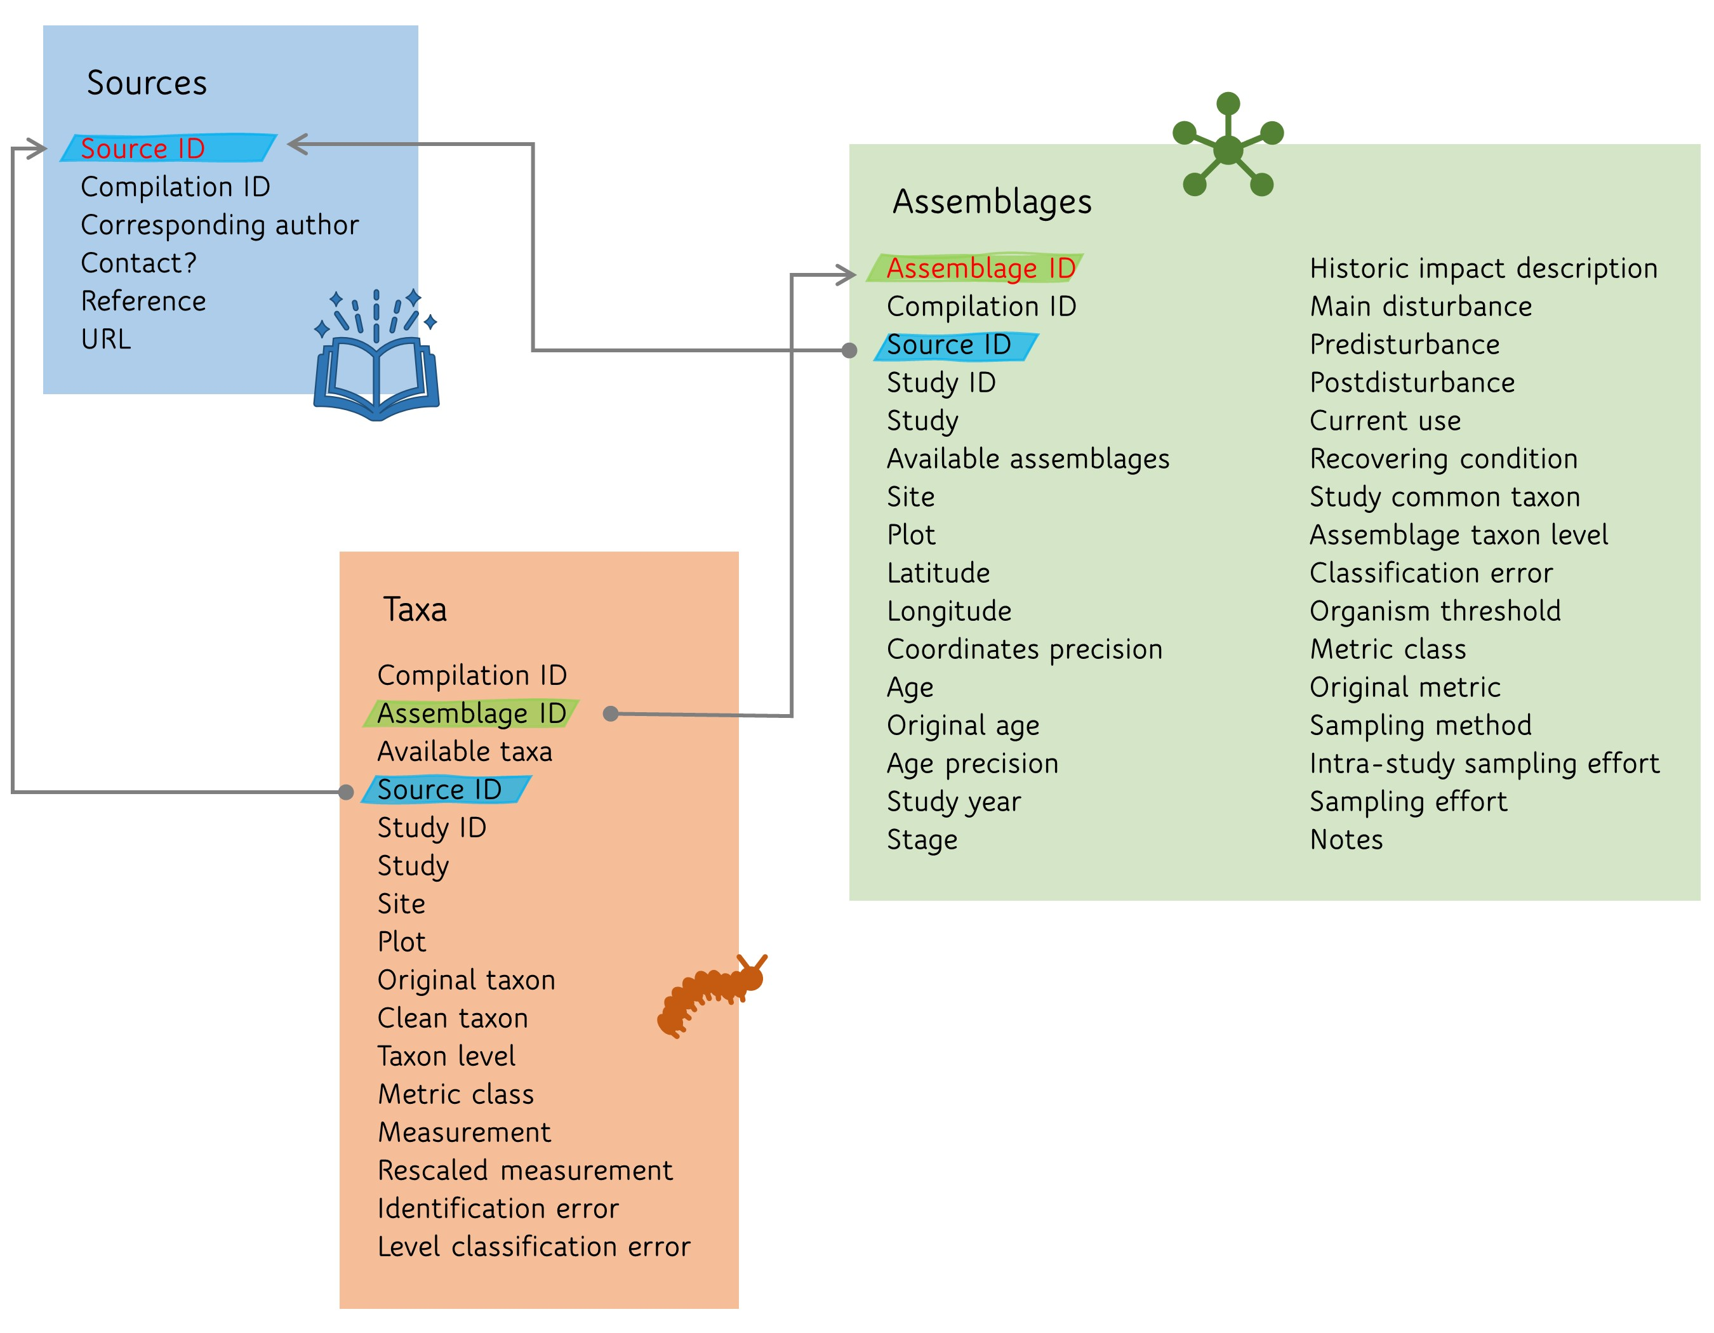
Figure 1: Data base structure including, data sets, fields and relationships among data sets. Unique identifiers are in red
ForestAssembly was conceived to be composed of previous data compilations of species assemblages since it is very time-consuming extract lists of species and their occurrence/abundance from publications. We found six possible compilations (?@tbl-databases) that we further explored to check the suitability to our criteria.
Dataset | Objective | Availability | Inclusion | No. of original sites | No. of selected assemblages | Original geographical coverage | Original temporal coverage | Taxonomic coverage |
|——|—————|——|——|——|——|——|——|——|
(6) | To characterize long-term recovery trajectory, completeness and time with different metrics and human-related drivers (i.e., disturbance type, restoration strategy) | From the corresponding author | Yes | 199 | 351 | World | 50 - - | Terrestrial organisms |
PREDICTS (7) | To model and project how biodiversity in terrestrial communities responds to human activity | Public via www.predicts.org.uk | Yes | 26114 | 5581 | World | 1984 - 2013 | Terrestrial organisms |
(4) | To provide a stronger evidence base for debate on offsets in relation to species convergence to old-growth ecosystems | From the corresponding author | Yes | 1102 | rnrow(curran_sel)` | World | - | Terrestrial organisms |
(8) | To assess the merits of forest restoration approaches, in particular reforesting with tree plantations versus restoring native forests, on deforested land | Public via https://zenodo.org/record/6103053 | Yes | 403 | 403 | World | 1979-2017 | Terrestrial organisms |
2ndFor | To understand the ecology, dynamics, and biodiversity of tropical secondary forests and the ecosystem services they provide | Available for data contributors | No. Access to the data was not possible | - | - | Tropics | - | Trees |
GLOBIO3 (9) | To assess the impacts of environmental drivers on species abundance changes and the effects of various responses or policy options | From corresponding author | No. Overlap with PREDICTS and Curran et al. 2014 (Rob Alkemade pers. comm) | - | - | World | - | Terrestrial organisms |
: Data sets used to create ForestAssembly. *Only for plants {#tbl-databases}

Data curation
From the four selected data sets we only used the accepted sources according to their criteria – although they could contain information of discarded studies in the original tables. However, it can happen that for accepted sources some studies or assemblages were valid for ForestAssembly but not others, or the other way around, some studies or assemblages within a source were extracted and tidied but then discarded in the original data set, but useful for ForestAssembly. As a consequence, the final no. of assemblages per study can differ with the original data set.
(6) data set contained originally a forest recovery trajectory per row, so first step was to transform one line in as many lines as temporal points in the recovery trajectory. All assemblages in this data set were a priori useful for our purposes so we checked manually all studies (48).
PREDICTS (7) contains a data frame with one assemblage and its features per row. We kept studies (1) carried out in forests (using field Habitat_as_described), (2) where the main land use (field Predominant_land use) was not undefined or human-dominated (plantation, pasture, cropland, urban) in all sampled assemblages of the study (i.e. no old-growth or recovering forests were found a priori), (3) had at least one assemblage with numerically defined age (Years_since_fragmentation_or_conversion), (4) where the biodiversity information was at community level (i.e., Diversity_metric_type was not “species richness” but “abundance” or “occurrence”, and there were more than 2 taxon sampled – N_samples -). Those filters retained 6425 assemblages (24.6 % of original number). Each study (n = 195) was checked one by one to ensure that the species assemblages had a community to compare to.
(4) data set has a comparison of two assemblages per row – with information on both assemblages -, so first we split the data set to have one assemblage per row. Then, we kept cases carried out in forests (using field forest). Those filters retained 1039 assemblages (94.3 % of original cases). Each study (n = 153) was checked one by one to ensure that the species assemblages had a community to compare to according to our criteria (i.e. old-growth forest or recently-degraded site), that were forests or potential forests (e.g. not in Sarmiento et al. 2003), and whose methodology was clear and consistent in all assemblages in the study (e.g. not in Liebsch et al. 2007, 2008). Also, (4) discarded some assemblages whose information at taxon level was extracted and that were useful for us (e,g, Aidar, Aravena, Purata, Powers), so we included them. Marin-Spiotta et al. 2007 and Moola and Vasseur 2004 were removed from the data set since they were already included in (6).
(8) abundance data set has a comparison of the abundance of one species between two forest types per row. From this data set we filtered studies that contained comparisons of (1) primary/native forest and secondary forests/native planting/abandoned plantation, and potentially including recovering forest assemblages and a old-growth forest to compare, or (2) monoculture/mixed plantation and abandoned plantation, and potentially including recovering and disturbed assemblages (filter made with fields baseline_forest_type and focal_forest_type). Those filters retained 91 assemblages (22.6 % of original number). Each study (n = 25). From them, XX were already compiled in other data sets (e.g. Katovai 2012, Barlow 2007a (Biological conservation), Barlow 2007b (JAE) for plants), and others did not have old-growth or recently-disturbed forests (e.g. Lugo 1992).
For (6), (4) and (8), we checked the originally compiled (source) matrices at taxon level to complete the assemblage data set. When other metrics were available at the taxon level for each assemblage (e.g. frequency and total abundance) we included new assemblages in our data set based on the other metrics.

Field description and harmonization
- Source ID: “Compilation ID” & “Citation”
- Compilation ID: one of (6) (RU), PREDICTS (PR), (4) (CU), (8) (HU)
- Citation: family name of 1st author & “et al.” & year or family name of 1st author & “and” & family name 2nd author & year. When two sources are similar a letter is added at the end, starting with “a” in the second citation. No special characters except “-”.
- Original citation: citation at the original compilation
- Corresponding author
- Contact?
- Reference: complete reference (authors, year, title, journal, volume, number, pages)
- URL: url of the original source
Assemblages
- Assemblage ID: “Study ID” & “Site” & “Plot”
- Study ID: “Compilation ID” & “Source ID” & “Study”
- Study: a study can be different from other because they consider different organisms within the same source (e.g. Purata 1986), different types of measurements in the same plots or different sampling methodologies. The differentiation by organism is made if the author explicitly did, but if not all organism types will be in the same study (e.g. Romero-Duque et al. 2007 includes all woody species independently if they are trees, shrubs, lianas, etc. and other studies are focused in one of these groups). Different disturbances do not differenciate studies if there is a common reference (e.g. Purata 1996). “Study” comprises all the assemblages that are comparable to the same reference or disturbed assemblage and contains different sites and plots.
- Original study: name of the study at the original compilation
- Available assemblages: number of assemblages per study
- Site: sampling site. For spatially blocked designs where pseudo-replicate information is available, each site may contain different plots.
- Plot: spatial or temporal pseudo-replicates
- Original plot: site or site & plot in the original compilation
- Latitude: latitude of the specific site/plot in WGS84. When it is not available, the column will include the location of the study. When it is not possible to know which coordinates correspond to which plot within a treatment, “Latitude” includes location of the study. When it is not possible to know the exact latitude of some sites/plots those have the location of the study (one case: Buckney and Morrison 1992).
- Longitude: longitude of the specific site/plot in WGS84. When it is not available, the column will include the location of the study. When it is not possible to know which coordinates correspond to which plot within a treatment, “Longitude” includes location of the study. When it is not possible to know the exact longitude of some sites/plots those have the location of the study (one case: Buckney and Morrison 1992).
- Coordinates accuracy: one of “assemblage” or “study”.
- Age: a number with years since disturbance stopped. It is the mean if a range is given, the limit if an interval is given or 1 in “recent”.
- Original age: years since disturbance stopped as reported (e.g. 10-20, > 150, “old-growth”, “active”, “recent”). For PREDICTS, it can happen that (1) the field age has information in the community level table but any information is reported in the source given. In those cases put XX(age)_predicts; (2) age is the duration of the impact. In these cases, we keep the value in “Original age”, but age will be NA.
- Age precision: one of category, exact, maximum, minimum, mean, NA_predicts, other. Category does not contain “Age” (some reference or disturbed assemblages). In PREDICTS, when we do not know the origin of the age, put NA_predicts
- Study year: last year when the field data was taken. If it is not specified it is completed with the year when the paper was sent for publication (XX cases?).
- Stage: is the community identified as a reference/old-growth/primary/mature forest (p.e. Dent 2013), or disturbed site in the original study? Mature and primary forests can be references even when a ongoing disturbance is identified. If not, then it is a recovering stage. Productive plantations can be considered as disturbed states if there is a clear management as a forest crop or recovering if they are abandoned or there is a clear objective to keep the forest.
- Historic impact description: description of historic uses in the area.
- Main disturbance: main disturbance, whose effect is being tested and to which age refers. One of animal farming, burning, cultivation, farming, forest uses, logging, mining, plantation, none or combinations of the previous categories when (1) it can not be distinguished which disturbance suffered each site or plot, (2) the site or plot suffered different disturbances. “None” appears when it is explicitly mentioned that there are not disturbances. Swidden cultivation and other farming cycles are considered as an only disturbance (i.e., not fire + cultivation + grazing) since it is a very specific type of cultivation with short cycles. Commercial plantation and then logging is logging, since plantation is when standing trees are abandoned. Compiled disturbances have been classified through an algorithm in R. Always that “fire-wood” appears in the original compiled disturbance, it is classified as “forest uses” even when it can imply proper cuttings.
- Predisturbance: previous disturbances that could condition the effect of main disturbance (e.g. droughts, logging). Logging is not considered a predisturbance of agriculture unless it is specified that there was a period of wood extraction before farming, but fire can be considered a predisturbance.
- Postdisturbance: disturbances or interventions after main disturbance (e.g. tree planting, wood removal, etc.).
- Current use: uses of the site that can affect the assemblage process (e.g. conservation, extraction of fire wood), but they are not abruptly hamper forest succession. Any logging is considered as a postdisturbance. It is “none” when it is explicitly mentioned that any impact occur in the area
- Recovering condition: one of protection, restoration, use or abandoned, or combinations of the three first categories.
- Study common taxon: the type of organism that is common to all taxa within one study. It is registered as common names (e.g. “trees”, “woody species”, “insects”).
- Assemblage taxon level: taxon level that compose the assemblage (“species”, “family”, etc). It is defined if one taxon level is > 75 % of all the rows for the assemblage. If not, the field may contain “mix” or “no rank”.
- Classification error: percentage of cases by assemblage where “Taxon level” does not fit to “Assemblage taxon level”.
- Organism threshold: threshold for being included in the sampling (in size, detectability, etc). E.g. trees with dbh > 10 cm. When there is not a threshold is NA
- Metric class: one of occurrence, abundance, relative abundance (when abundance is relativized to the total abundance), frequency and relative frequency (see note in script).
- Original metric: original metric used in the source. It includes how the species were registered (e.g. cover even when the data we have is just occurrence). In the case of Importance Value Indices (IVI), it includes the components of the IVI.
- Sampling method: sampling method(s) used in the study. E.g. random plots or quadrats, visual observation (transect or point), systematic search, trapping, nets, etc.
- Intra-study sampling effort: sampling effort rescaled between 0 and 1 within the study – i.e., sampling effort per assemblage / max(sampling effort within a study).
- Sampling effort: number of assemblages sampled aggregated by each row (i.e. what we generally call “assemblage”). It includes temporal and spatial replicates. It refers to a counting of the minimum area/period sampled.
- Notes: any relevant information. E.g. if it is a case of repeated measures through time, if it is a riparian forest (mostly in PREDICTS)
Taxa
- Available taxa: number of taxa included in each assemblage.
- Original taxon: taxonomic name in the original compilation.
- Clean taxon: taxonomic name harmonized with (1) an algorithm created ad hoc for this database, (2) Catalogue of Life 2013 (following Predicts) or other species data bases. Typographic errors and other irregularities are corrected.
- Taxon level: level of the original taxonomic name (family, species, etc.). Classified with an algorithm made in R.
- Measurement: value of occurrence, frequency, relative frequency, abundance or relative abundance.
- Rescaled measurement: measurement corrected according to “Intra-study sampling effort” (just for abundances). Following (7).
- Identification error: percentaje of taxon abundance without a proper taxon name in relation to the abundance of the entire community.
- Level classification error: 0 when level and “Assemblage taxon level” are the same and 1 when they are not.

Results
The final data set includes 1189 forest assemblages.

Geographical coverage
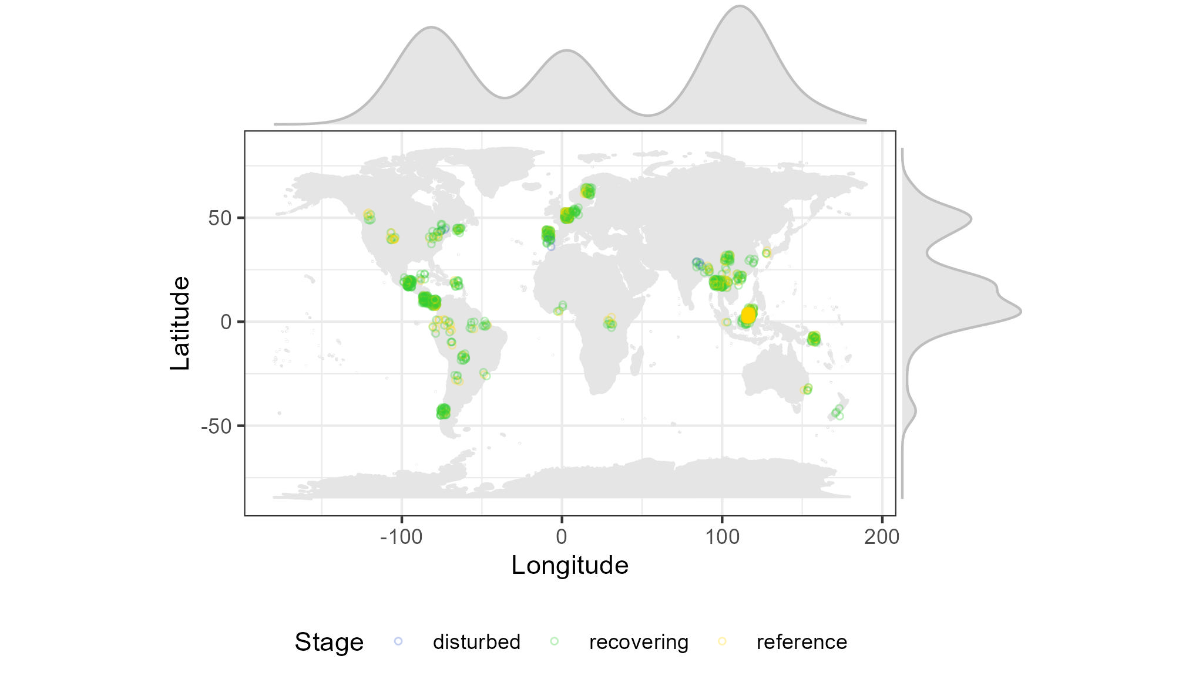
Figure 2: Extent

Temporal coverage

Taxonomic coverage

Disturbances
Land impact has been characterized considering (1) the main disturbance associated to the recovery time given, (2) the land-impact history of the plot including pre- and post- disturbances to the main impact and the conditions (uses) under which the recovery happened. Predisturbances could condition the effect of the main disturbance (e.g. drought before logging) and postdisturbances and land use may condition the assemblage that we observe. Disturbances were classified in 8 types: animal farming, cultivation, farming (when was not specified if it was animal farming or cultivation), logging, plantation (i.e. productive plantations), slash forestry, other forest uses, mining, burning, urban and active restoration. Sometimes it is not specified the type of disturbance per assemblage, but a general description of the land-impact history. In those cases, we included mixed categories in the data set (e.g. burning/farming, farming/logging). Uses that condition the recovery are forest products extraction, protection, recreation

Discussion

Potential uses

References
1. Dornelas M, et al. (2018) BioTIME: A database of biodiversity time series for the Anthropocene. Global Ecology and Biogeography 27(7):760–786.
2. Sperandii MG, et al. (2022) LOTVS: A global collection of permanent vegetation plots. Journal of Vegetation Science 33(2). doi:10.1111/jvs.13115.
3. McDowell NG, Allen CD (2015) Darcy’s law predicts widespread forest mortality under climate warming. Nature Climate Change 5(7):669–672.
4. Curran M, Hellweg S, Beck J (2014) Is there any empirical support for biodiversity offset policy? Ecological Applications 24(4):617–632.
5. Jost L, Chao A, Chazdon RL (2011) Compositional similarity and β (beta) diversity. eds Magurran A, McGill BJ.
6. Rodríguez-Uña A (2021) Measuring the long-term recovery of forest ecosystems after anthropogenic disturbances to improve restoration strategies and outcomes. PhD thesis (bc3 - Basque Centre for Climate Change).
7. Hudson LN, et al. (2014) The PREDICTS database: a global database of how local terrestrial biodiversity responds to human impacts. Ecology and Evolution 4(24):4701–4735.
8. Hua F, et al. (2022) The biodiversity and ecosystem service contributions and trade-offs of forest restoration approaches. Science 376(6595):839–844.
9. Alkemade R, et al. (2009) GLOBIO3: A Framework to Investigate Options for Reducing Global Terrestrial Biodiversity Loss. Ecosystems 12(3):374–390.

