DeePositLabeler – Software Manual

## Overview

This code allows the automatic detection of urine and fecal depositions in the thermal video of rodents during behavioral experiments. The algorithm is described in the paper by Peles D et al., “DeePosit: an AI-based tool for detecting mouse urine and fecal depositions from thermal video clips of behavioral experiments” https://www.biorxiv.org/content/10.1101/2024.06.24.600419v1. The code is available at: <https://github.com/davidpl2/DeePosit> . This document describes the use of the DeePositLabeler annotation tool.

The basic annotation procedure described below is needed for the automatic detection algorithm to process the video. DeePositLabeler also allows for the generation of Ground Truth urine and feces annotations for training and testing. Note that in order to run the automatic detection, you will also need to add videos to the database by listing them in vidsID.csv in the VideoDatabase folder. However, the annotation tool can run on videos that are not listed in vidsID.csv.

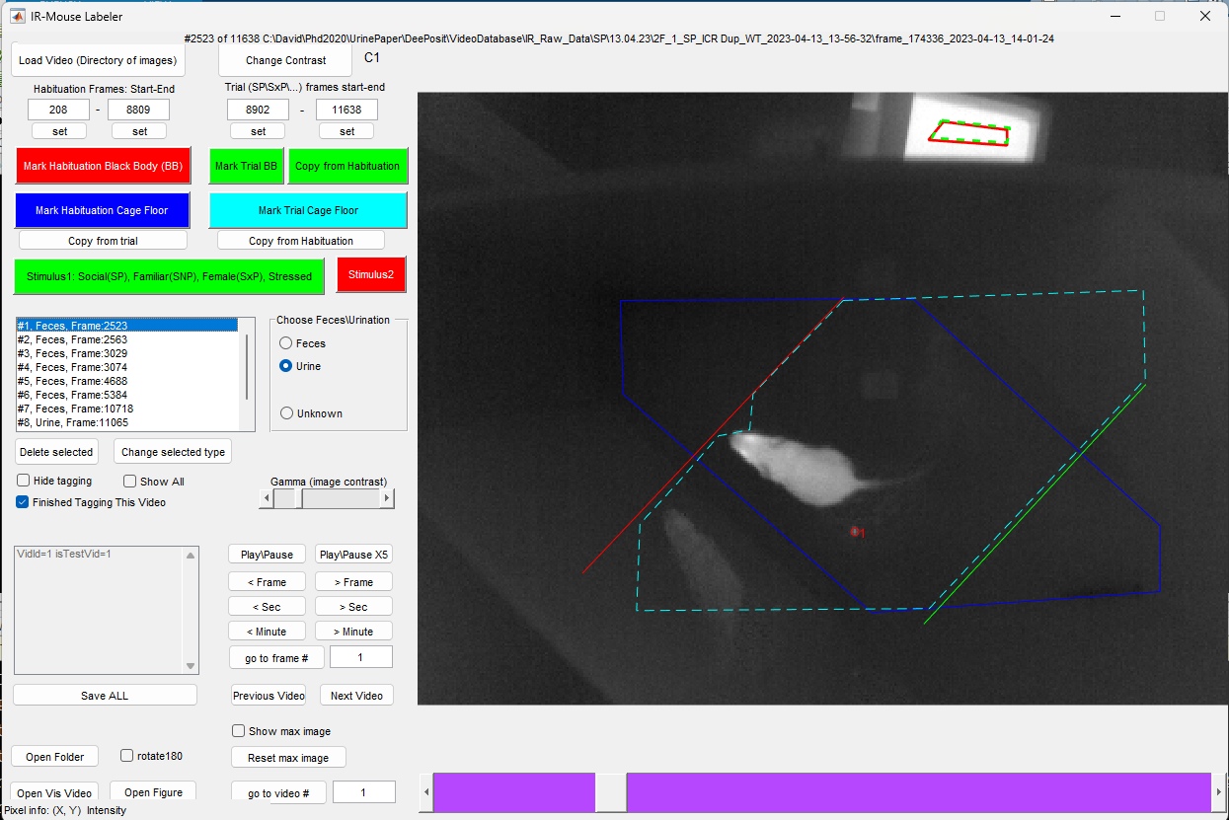

Figure :DeePosit Labeler. A graphical user interface (GUI) for annotation of thermal videos.

## Getting Started:

1. Open Matlab and run DeePositLabeler.m . A graphical user interface (GUI) will be displayed (see Figure 1).
2. To load a video, press on the Load Video button (on the top left of the GUI).
3. Go to the video directory and choose one of the bin files.
4. The first frame in the video should appear in the GUI.
5. You can play/pause the video by pressing the “Play/Pause” button. Pressing on the “Play/Pause X5” will play the video faster.
6. You can navigate to a specific frame by pressing on “>Frame”, “>Sec”, or “>Minute” buttons or by using the “go to frame #” button. The slider below the video window can also be used to reach the desired frame.
7. Note that the frame number and the video folder are shown on the top of the GUI.
8. You can change the contrast by clicking the “Change Contrast” button. There are 6 contrast configurations: C1-C6. Note that the selected configuration is written next to the contrast button. You can further control the display by changing the gamma slider (relevant only for C3-5).

## Basic annotation procedure of a video (required to run the automatic detection of urine and feces)

1. Specifying the first and last frame of the habituation period, and trial period is done by filling in the fields “Habituation Frames: Start-End” and “Trial frames start-end”. You can use the “set” button below each edit box to automatically write the current frame number into this edit box. Note that the start of habituation is the first frame after the mouse is introduced to the arena, the experimenter's hand is not visible, and the arena is inside its final location (no further movement during the habituation). The last frame of the habituation is the last frame before the experimenter's hand is visible again or any movement of the arena is visible. The first frame of the trial is after the stimuli are introduced (and no visible experimenter hand can be seen in the image and no further movement of the arena is visible). Same logic for the last frame of the trial.
2. Marking the black body surface during habituation and trial: Press the “Mark Habituation Black Body (BB)” and then mark a polygon on the image with left mouse clicks. Finish drawing the polygon by left double click. The polygon will have a red line. make sure the polygon is completely inside the 37-degree surface of the black body. Marking the Trial BB is the same, just click on the “Mark Trial BB” to mark it or use the “Copy from Habituation” if the location of the black body is the same in habituation and trial (this is usually the case).
3. Marking the arena floor for the habituation period and for the trial period: press on “Mark Habituation Cage Floor” and mark the floor of the arena on one of the habituation frames. Do the same for the trial period by clicking “Mark Trial Cage Floor”. Note that a double left mouse click is required to finish the polygon annotation.
4. Marking the side of Stimulus1 and Stimulus2 during the trial period: press on “Stimulus1 Social(SP), …” draw a line while holding the left mouse button. The line should mark the border between the arena floor and the triangle that contains stimulus 1. Do the same for stimulus 2 by clicking on the “Stimulus2” button.
5. Click on “Save ALL” button to save these annotations.
6. These are the annotations that are required for running the automatic detection

## Manual labeling of urine and feces (required for generating a training\testing database)

1. These annotations are not required for running the automatic detection. They are needed in order to generate a training\testing database to re-train the classifier or in order to measure automatic detection accuracy by comparing them to the manual annotation.
2. For each urine or feces, go to the first frame in which it is clearly visible.
3. Choose “Urine” or “Feces” from the radio buttons. Choose “Unknown” if you are not able to decide if this is urine or feces. Note that feces usually move during the video, and that might help you decide.
4. Left-click on the center of the urine or feces.
5. To delete a detection, right-click on it.
6. Note the table of urine\feces annotations. If you choose one of the annotations in the table, the current displayed frame will change to the detection frame.
7. You can also delete the detection in the selected line in the table by clicking the “Delete selected” button. Clicking on “Change selected type” will change the type of detection (urine or feces) to the type that is currently selected in the radio buttons.
8. After annotating the video, check the “Finished Tagging this video” checkbox and click on “Save ALL”. The manual annotations of urine and feces will be saved in the video folder in a file named GT_Detections.xlsx.
9. Note that urine annotations are marked with a green circle and feces annotations with a red circle. The number next to the annotation matches the index in the table of annotations.
10. To see all of the annotations from all of the video frames, check the “Show All” checkbox. Otherwise, only annotations that were marked in the currently displayed frame will be shown.

## Some Extras:

1. Hide Tagging – If checked, the annotations will not be shown.
2. Open Folder – Open the current video folder in File Explorer.
3. Rotate 180 – if checked, the image will be rotated in 180 degrees.
4. Show max image – if checked, the max image will be shown instead of the current video image. The max image is initialized to be equal to the current video image and is updated by computing a per-pixel maximum each time a new image is loaded for display. Click on “Reset max image” to reset the max image to be equal to the current video image. The max image sometimes helps in understanding the arena floor shape by showing all the places in the image that the mouse visited.
5. Open Vis Video – if a matching visible light video is specified in vidsId.csv, then it will be opened.
6. Open Figure – the current image will be opened in a separate Matlab figure.
7. Go to video # - this changes the loaded video to the video with the ID specified in the edit box next to this button. The video ID is mentioned in vidsID.csv and should also match the line number in vidsID.csv