OpenPUS
Integration Guide

Table of Contents
1. Introduction 3
1.1. Background 3
1.1.1. Motivation 3
1.2. Objectives of this document 3
1.3. Document layout 3
1.4. Abbreviations 3
2. Architecture 5
2.1. Static Architecture 5
2.1.1. Layered Architecture 5
2.1.2. Hierarchy and components 6
2.2. Dynamic Architecture 7
3. Integration in a onboard computer 9
3.1. Abstraction layers 9
3.1.1. Operating System Abstraction Layer 9
3.1.2. Data Link Abstraction Layer 9
3.2. Integrate the code in your compilation environment 10
4. Adding a new application 11
4.1. Use the template 11
4.2. Add the new app to the configuration 12
4.3. Add the new app to the Maestro 13
4.4. Add the new app to the compilation environment 14
4.5. In the client ; 15
4.6. Compile and run 16

Introduction

Background

Motivation
The author of this software brings extensive experience in developing software for spacecraft payloads and central computers (Command and Data Handling Systems – CDHS). Recognizing the lack of lightweight, user-friendly frameworks for building CCSDS/PUS-compliant software in space applications, they decided to create and share one to support and benefit the broader community.
This framework was developed with the following key advantages in mind:
• Lightweight and resource-efficient
• Simple and easy to learn for new developers
• Open, modular architecture that facilitates the addition of new features
• Easy integration with existing onboard computer systems
• Operating system and peripheral agnostic for maximum portability
• Implemented in the C programming language for broad compatibility and performance
• Stability and safety to an level that is appropriate and robust for satellites operating with a high degree of autonomy in challenging environments.

Objectives of this document
This document is self-contained and serves two primary purposes:
- To provide comprehensive guidance on integrating the OpenPUS framework into the user's onboard computer system
- To explain how users can extend the software by adding custom functionality tailored to the specific requirements of their onboard computer

Document layout
To support these objectives, the document begins by outlining the framework’s architecture (Section 2), helping the user to understand key terminology and the internal workings of the software. It then provides detailed guidelines for integrating the framework into onboard computers (Section 3) and developing custom functionality (Section 4).

Abbreviations
APID – Application Process ID
BSP – Board Support Package
CDHS – Command and Data Handling System
CPU – Central Operating System
HAL – Hardware Abstraction Layer
RAM – Random Access Memory
OS – Operating System
PUS – Packet Utilization Standard
TC – Telecommand
TM - Telemetry

Architecture
This architecture exemplifies a time-triggered, real-time operating system (RTOS) design, where tasks are executed at precise intervals to meet stringent timing requirements. In this case, the Maestro thread serves as the central timing and orchestration unit, ensuring that all components operate within their designated time slots. The watchdog mechanism enhances system reliability by detecting and recovering from execution anomalies.
Such a design is typical in embedded systems for space applications, where deterministic behavior and fault tolerance are paramount.

Static Architecture

Layered Architecture
The OpenPUS framework follows the principle of the layered architecture which is especially beneficial for:
- Isolating hardware-dependent and operating system specific code (e.g., for different OBCs, Operating Systems or sensor interfaces)
- Supporting mission-specific logic while reusing core telemetry/command layers
- Ensuring that safety-critical and mission-critical layers are carefully controlled and segregated.

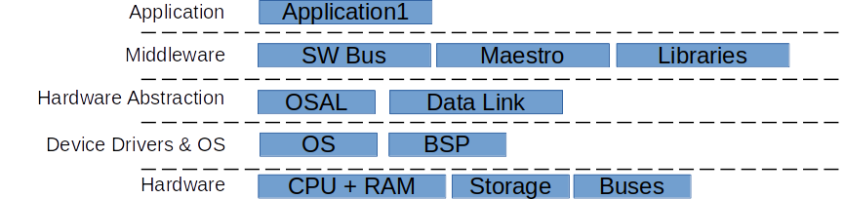Figure 1: Layered Architecture
The layers of the OpenPUS Framework are shown in the Figure 1 :
Hardware – Includes the physical resources of the computer : CPU, RAM, Cache, Storage and interfaces i.e. buses e.g. I2C, Can, SpaceWire etc.
Device Drivers & OS – Includes the Operating and the BSP of the computer which includes all the drivers for the hardware of the computer
Hardware Abstraction – This layer enables the portability of the OpenPUS framewor, It includes components that abstract the OS and the actual onboard computer used. Integration hint : In this Layer there should be a component to abstract each hardware element that is relevant for the application software i.e. : one abstraction component for each bus, storage, file system, etc.
MiddleWare : this layer contains components that are the core of the OpenPUS framework and that support the execution of user appplications. This layer is meant to be fully reusable in different applications.
Application : this layer has the actual application software that meets the software system requirements.
The actual software components of the OpenPUS framework are described in the next section.

Hierarchy and components
- Core
  - Maestro – this component orchestrates/schedules all the functionality of the OpenPUS framework, namely the scheduling of the synchronous tasks, incuding the user application(s) see section 2.2 for the scheduling details.
- SW Bus
  - Router – Contains a Queue for packets and Implements a publish/subscribe to send/them. It uses the PID to distribute the packets to their destinations.

- Application1 – The user application. An example is provided of an application that only receives one type of telecomand, the data in the telecommand is inverted in position and then sent back as telemetry.
- Abstraction
  - OSAL – Isolates the OpenPUS Framework from the operating system.
  - DataLink - Isolates
- Libraries
  - Queue – Implements a LIFO Queue
  - Comparators – Utilities to compare different primitive data types.
  - CRC – CRC generation utils
  - Endian – Endian Conversion Utils
  - CcsdsUtils – Defines the CCSDS Packet(s) structure and provides realated utilities
  - PusUtils – Defines the PUS Packet(s) common structures (i.e. headers) and provides realated utilities

Dynamic Architecture
The orchestration of the threads of the OpenPUS Framework are illustrated in Figure 2.
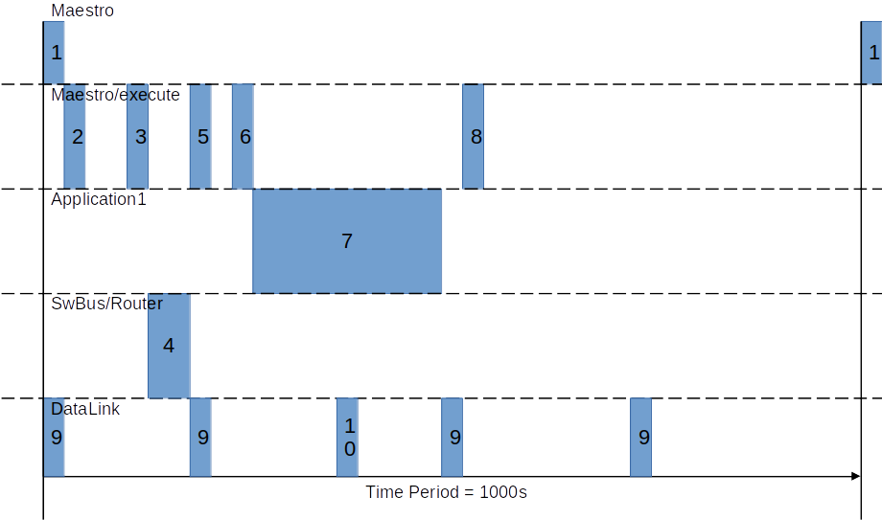Figure 2: Orchestration of the threads
As with most real time systems there is a major execution cycle. In this case the period of the execution cycle is 1 second which can be adjusted by the user if the timings of the other threads is also adjusted.
Description of the functionality of each thread :
- The Maestro simply wakes up every 1 second (1) to wake up the Maestro/execute thread and increment the counter of upTime.
- The Maestro/execute thread is the orchestrator and watchdog of the OpenPUS framework, it orchestrates all other synchronous threads (i.e. threads that are syncrhonised with the period of the Maestro thread) and verifies that their execution occurs within the allocated time slot for them, if they don’t, after a number of consecutive failures, the Maestro will reboot the software. These are the activites of the Maestro/execute thread:
  - (2) When it wakes up, if does nothing, it just waits for the start of the execution slot of the Router
  - (3) When it is time to execute the Router, it simply wakes it up and waits for the end of the time slot attributed to the Router, to check if it finished within its allocated time slot (5)
  - After waiting for the start of the execution slot of Application1 (6), it wakes up Application 1 and waits for the end of the time slot attribtuted to the Application1, to check if it finished within its allocated time slot (8)
  - As there no other applications in this instance, after this the Maestro/execute thread sleeps until it is awaken again by the Maestro thread in the next cycle.
- The Application1 thread runs in its allocated time slot (7), its details are dependent of the users intentions but a common design pattern is :
  - The starts by retrieving the packets from its queue of packets (note that during initialization, the application uses the Subscribe function of the Router to indicate to the Router that it should received all packets that are targeted to the Application ID (APID).
  - It processes the packets e.g. executing telecommands and does it’s processing
  - If the application generates any packet, e.g. a telemetry, it calls the Publish function of the Router.
- The SwBus/Router thread also runs in its allocated slot (4) as orchestrated by the Maestro/execute thread. This thread simply retrieves packets from the Datalink queue, checks their APID and puts them in the queue of each Application accordingly to the APID – note that at initialization, the Applications need to make themselves known to the Router by using the subscribe function.
- The Datalink has 2 parts :
  - An asynchronous thread (10) that runs each time a packet is received, this thread simply adds the packet to the receive queue.
  - (9) The datalink also runs every 250 ms to check its queue of packets to send to the ground, if there are any, it sends the packet through the socket.

Integration in a onboard computer
Infrastructure

Abstraction layers
Right after the user has a simple « hello world« application running in the target computer, the first task is to sort out the abstraction layer. Once the abstraction layer is integrated, the rest of the code can be integrated.

Operating System Abstraction Layer
The user should start by OSAL – Operating System Abstraction Layer. The example provided is for Linux. If the target operating system is not Linux, then every function in the osal.c file needs to be translated to the target operating system. For example for a version of FreeRTOS, the ABOS_ThreadCreate function becomes :
int8_t ABOS_ThreadCreate(FWO_thread_return_t taskFunctionPointer, int8_t * taskName, uint16_t taskStackSize, void * parameters, uint16_t taskPriority, FWO_thread_handle_t* taskHandler)
{
//int8_t status=FWO_ERR_NONE;

// 0 - IDLHE
// 1 - LOW
// 2 - NORMAL
// 3 - HIGH
// 4 - CRITICAL

int8_t ret=xTaskGenericCreate( taskFunctionPointer,
(const signed char *)taskName,
taskStackSize,
parameters,
taskPriority,
taskHandler, NULL, NULL );

return ret;
}
Likewise, the other functions need to be translated to the new target operating system and the new Osal.c and respective header are copied to the development environment and included in the compilation framework.

Data Link Abstraction Layer
The provided data link abstraction layer works with linux sockets, if this is not the case for the target computer, then the user needs to translate this to whatever interface is used : direct interface with a radio, send data to the bus to the radio, etc. Whatever is applicable. It may also be the case that for development and test in the ground, the Telecommands and Telemetry are exchanged via a debug/test interface, for example via a serial interface, if this is the case, then this should also be accounted for in the data link abstraction layer. After this the new DataLink.c and respective header are copied to the development environment and included in the compilation framework.

Integrate the code in your compilation environment
After the abstraction layers compile, the rest of the code can be integrated in the target compilation environment. This is highly dependent on the compilation environment of the target computer, but can be as simple as just coping the OpenPUS source code into the code of a sample « hello world« application that compiles and runs in the target computer.
Once the code is integrated, calls in the main function need to be added, to initialize and start the OpenPUS framework. These calls are akeen of what is found in the server.c
//library initializations
//NA

//abstraction initialization
ABOS_Init(&osal);

//Maestro Initialization and wait
CMAS_Init(&maestro);
ABOS_Sleep(100);

//maestro start
CMAS_Start(&maestro);

//other starts
//NA

//Infinite Cycle
while (maestro.isRunAgain==M_TRUE)
{
//wait
ABOS_Sleep(MAIN_INFINITE_CYCLE_PERIOD_MS);
}
Before compiling and running the code, the user shall also look in the myTypes.h and check if its definitions apply to the target computer. Typically if the endiness of the target computer is different, then only the following definition needs to be changed :
#define IS_LITTLE_ENDIAN (1)

Adding a new application
The OpenPUS framework is designed to be easily integrated into onboard computers and as an open system in the sense that the user can add his owns applications. This section explains how to add a new application.

Use the template
First, copy the template of the application – i.e. the applicationX folder - from the productionLine/templates directory to the server directory
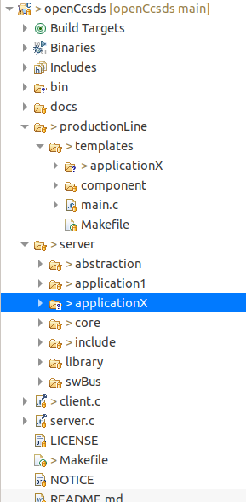

Add the new app to the configuration
Add the APID
Add the APID definition to the server/include/configuration.h file
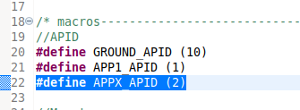
Add the thread definitions for the new application
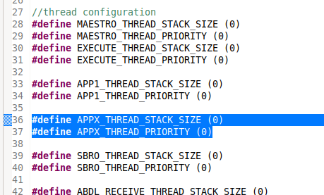
Note, in this case, the thread and priority of the tasks is not used hence the value 0 is used.
Increase the number of apps to 3
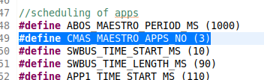
Define the scheduling of the new app
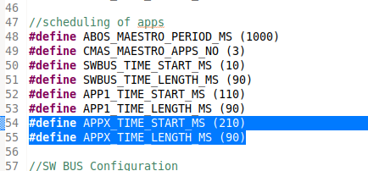
Note : The scheduling of synchronous tasks is managed by the Maestro component accordingly with these definitions. In this case, the duration of the execution cycle is 1 second, the SWBUS app is the first to run from 10ms to 100 ms, APP1 from 110 to 200ms and the new App from 210 to 300.
Add the packet queue size
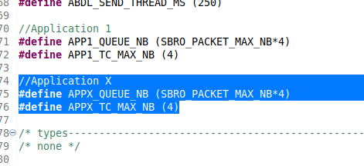

Add the new app to the Maestro
In the CORE_Maestro.h :
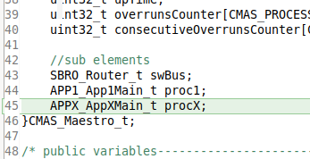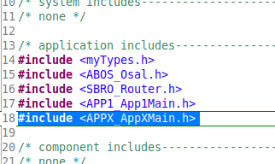
In Maestro.c, add the scheduling information to local variables :
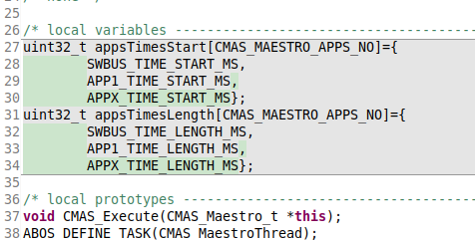
Initialize the new app object along with the other apps
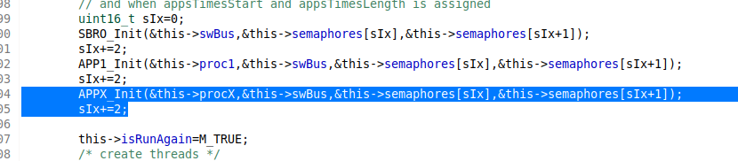
Add the new app to the stop function
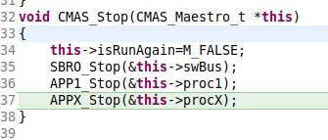

Add the new app to the compilation environment
In Maestro.mk
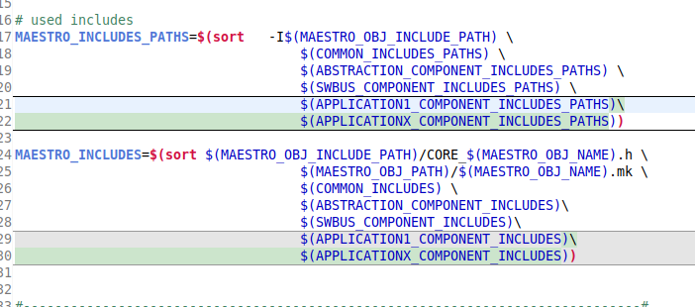
In Makefile

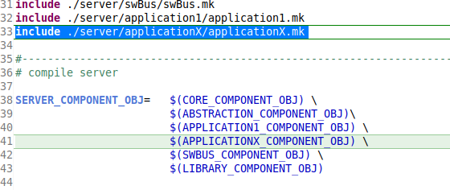

In the client ;
Final in client.c change it, so that the telecommands are sent to the new app APID.

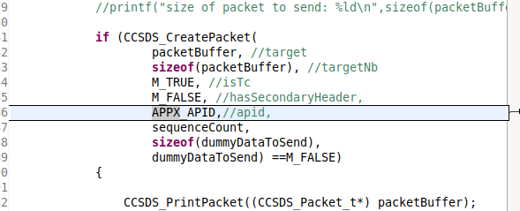

Compile and run
opean a terminal window and do « make clean « and then « make runServer »
open another terminal window and do « make runClient«
you should see that now the return packet will have the data multiplied by 2, instead of inverted order as it was before
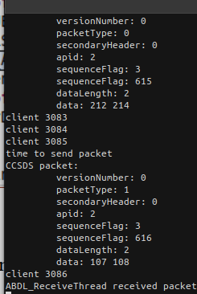

END OF DOCUMENT

