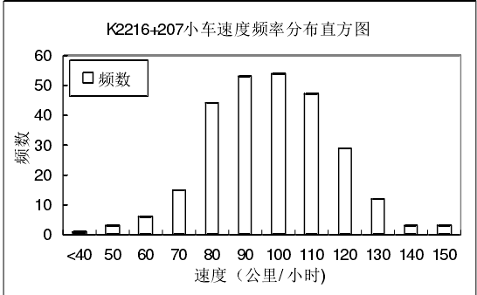

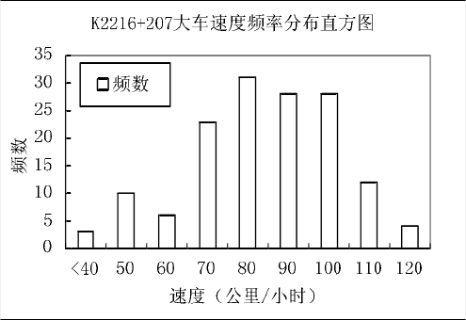

Car Truck

The number of sample 270 145

Mean 92.82 79.18

Standard deviation 18.39 17.63

The relationship between speed limits and operating speed for freeway

Lijin Wang,

Beijing University of technology