HSIFind: A lightweight search service for imaging spectroscopy data
Version 0.9, 2013
David R. Thompson david.r.thompson@jpl.nasa.gov
Alex Smith alexander.smith@jpl.nasa.gov
Zhangfan Xing zhangfan.xing@jpl.nasa.gov

I. Overview
Imaging spectrometers yield rich and informative data products, but interpreting them demands time and expertise. There is a continual need for new algorithms and methods for rapid first-draft analyses to assist analysts during instrument operations. Intelligent data analyses can summarize scenes to draft geologic maps, searching images to direct operator attention to key features. This validates data quality while facilitating rapid tactical decision making to select followup targets. Ideally these algorithms would operate in seconds, never grow bored, and be free from observation bias about the kinds of mineralogy that will be found.

HSIFind is a software package for operator-directed search within imaging spectrometer data. It is a web interface that analysts can use to
- browse multi-channel imaging spectrometer data
- build a library using spectra from libraries or previous images
- search for similar spectra within the image or in other images.
The service is analogous to a search engine capable of finding a match to a user query. The results appear in the form of a map identifying spectral signature matches to the target. Searching within a single image reveals areas of similar reflectance to assist understanding of scene composition. Searching across images can help discover mineral anomalies as well as understand trends in composition on planetary scales.

Just as web search involves more than matching phrases, spectral search is more challenging than simply matching the shape of the spectrum. The background substrate and illumination changes can cause the same signature to appear very different across scenes. Here, the search service uses an adaptive matched-filter approach that compensates for the context and background characteristics of each scene. It searches millions of candidate pixels in less than a second.

II. The algorithm: A matched filter detection approach
Background-matched filters have a long history and wide acceptance in subpixel detection problems. Following [Manolakis 2001], we express the target as a vector t and the test spectrum as a vector x. We compute a background covariance matrix Σ and mean μ using data from the test image. We then invert the covariance using dominant mode rejection and diagonal loading as per [Manolakis 2009]. The matched filter output y approximates the mixing fraction of the target. We compute this quantity by first whitening the background to have unit spherical covariance, and then evaluating the dot product projection of the target and candidate spectra.

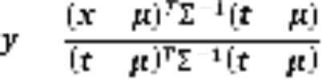

Finally, we compute the Mahalanobis distance m from the target to the background, forming a second score that penalizes large magnitudes orthogonal to the target vector. This indicates potential false positives due to localized artifacts or other non-target anomalies [DiPietro 2010].


Performing this computation for each candidate image pixel yields a map for each query spectrum. The most computationally expensive step of computing the background covariance can be performed offline in advance, resulting in a very efficient and parallelizable procedure.

III. Software system architecture and requirements
The complete software package includes a back-end search algorithm, a web server that presents this search as a service, and client side software for interacting with the service using a URL protocol. Figure 1 shows the basic architectural structure of the system. The HSIFind software has the following dependencies:

- Python 2.5+
- NumPy
- Python Imaging Library (PIL)
- wxPython
- matplotlib
- sampo (bundled with this distribution)
- spectral python (bundled with this distribution)
- A c compiler like GCC

Figure 1 shows the major architectural components. They consist of a user-side javascript client, a web server known as passepartout, and a “back-end” application consisting of a Python wrapper to a fast C binary.

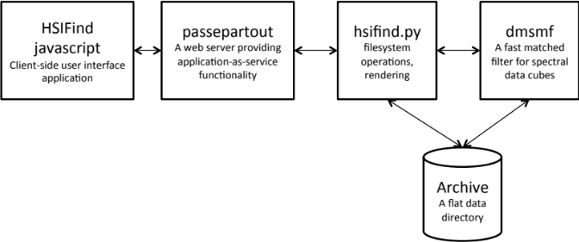
Figure 1: Architecture diagram.

IV. Installation
- Compile the server-side search program "dmsmf." Unzip enter the directory backend/dms/ and run 'make install' This will create a matched filter search routine called "dmsmf" that you should install in your executable search path. You can run it from the command line to test the matched filter search algorithm.

- Configure environment variables. Set the following variables:
HSIFIND_DATA_PATH - the data directory with imaging spectrometer data
HSIFIND_DMSMF - indicates the full filepath to the "dmsmf" binary
PYTHONPATH - this is a colon-separated list of absolute filepaths that tells your python installation where to find the dependencies. Make sure it includes the backend/ subdirectory. If you did not install spectral python separately, also include backend/spectral/ and its subdirectories (backend/spectral/io, backend/spectral/algorithms, backend/spectral/database, backend/spectra/utilities). All directories should be absolute paths, separated by colons.

- Alter the configuration file. The configuration file is hsifind.conf. Make a new configuration file. You should make a new server-side configuration directory to hold hsifind.conf, and modify the configuration file using a text editor so that it points to your version of the (executable) python code "hsifind.py"

- Configure the passepartout server. First make sure you have the following third-party dependencies installed on your system:
- python 2.4 or above
- httpd-2.2.x
- pip-1.2.1
- setuptools-0.6c11

Next, install passepartout to python. If pip is available, simply do
$ pip install passepartout-x.x.x.tar.gz

Otherwise, do:
$ tar zxvf passepartout-x.x.x.tar.gz
$ cd passepartout-x.x.x
$ python setup.py install

- Configure passepartout with Apache httpd. If apache httpd does not supports wsgi (so, cgi will be used), create a file called cgi.passepartout.conf, and place it under apache httpd's conf/ or conf.d/ directory. Be sure to let httpd.conf know its existence. There is conf/cgi.passepartout.conf inside the external directory passepartout-x.x.x/. Please use it as template.

If apache httpd supports wsgi (i.e., mod_wsgi is installed), you’ll want to use this instead. Create a file called wsgi.passepartout.conf, place it under apache httpd's conf/ or conf.d/ directory, and let httpd.conf know its existence. There is conf/wsgi.passepartout.conf inside passepartout-x.x.x.tar.gz, please use it as template.

In either case, make sure environment variable PASSEPARTOUT_APP_CONF_DIR is set to a directory that HSIFind command line applications (tools/scripts) are placed. Finally, heck to make sure that everything is running… restart apache httpd and point your browser to:

http://yourhost:port/service/

You should be able to see a response in JSON that lists all available HSIFind applications.

- Install the browser client javascript where the web server can find it. After setting up the sampo server, you'll want to provide it the javascript code in the client/subdirectory. A README file in that directory explains the process.

- Fill your data directory with imaging spectrometer cubes. Each one should include an ENVI-format header file with the same base filename but appending the suffix ‘.hdr’. The files should be in IEEE 32-bit floating point format.

V. Usage
The figure below shows an example of the search pane that appears in the browser when a user visits an HSIFind-enabled web site. Left side is a “drag to pan” window showing an RGB version of the hyperspectral image. Directly beneath this window is a gallery of thumbnails representing the images available in the data directory. Clicking on a single pixel in the pan/zoom pane causes its spectrum to appear at right, and performs a search in the image. After processing is complete, the left image will be replaced by a map with light areas corresponding to regions where the spectral signal is strongest.
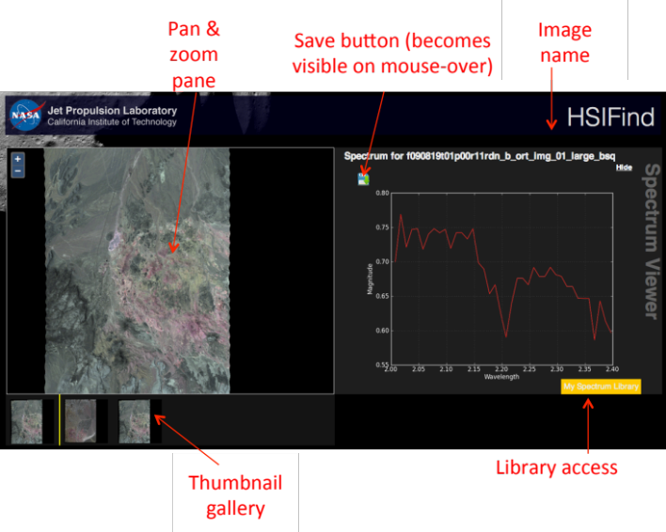
In order to save a spectrum to your library, hold the mouse over the spectrum until a disk icon appears in the upper left. Clicking this icon causes it to be added to the spectral library with a name of your choosing. You can then visit different images, and recover the spectrum by clicking the bright yellow library button at the bottom of the spectrum panel. The figure below shows the library. You can drag and drop these spectra into a new image to search for these saved signals.
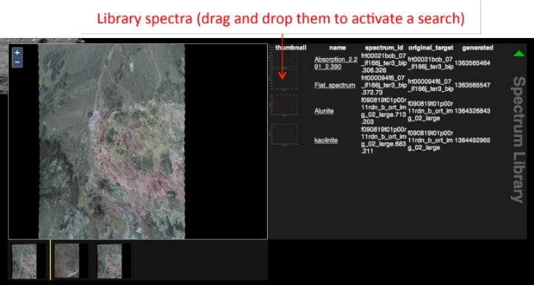

VI. References
[Manolakis 2001] Manolakis, D. G., Siracusa, C., Marden, D., & Shaw, G. A. (2001). Proceedings of SPIE, 4381.
[Manolakis 2009] D. Manolakis, R. Lockwood, T. Cooley, J. Jacobson, Proc. SPIE 7334, pp. 733402, 2009.
[DiPietro 2010] DiPietro, R., Manolakis, D., Lockwood, R., Cooley, T., & Jacobson, J. (2010). Proc. SPIE, 7695.
[Green 1998] Green, Robert O., et al. Remote Sensing of Environment 65.3 (1998): 227-248.

VII. Sponsor Information / Copyright
This software was developed by NASA and the AMMOS MGSS program. Copyright 2013, by the California Institute of Technology. ALL RIGHTS RESERVED. United States Government Sponsorship acknowledged. Any commercial use must be negotiated with the Office of Technology Transfer at the California Institute of Technology. This software may be subject to U.S. export control laws and regulations. By accepting this document, the user agrees to comply with all applicable U.S. export laws and regulations. User has the responsibility to obtain export licenses, or other export authority as may be required before exporting such information to foreign countries or providing access to foreign persons.

