Be forewarned, the database is not intuitive at all. It is very illogical, yet it still works flawlessly. It was mainly used to identify the types of relationships that we would need to accommodate after going public. It was mainly used as a repository for information and would either get updated or inserted in accordance to the filename which is the “primary key”.

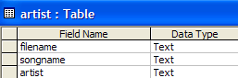

The artist table was a newly added table after we decided to support the search function. This would obviously be included with the next table, but since I designed a whole lot with the lyric table all of my code would have to be changed.

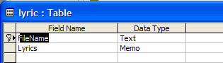

The lyric table contains the filename and a memo field with all of the lyrics. The good part about having the memo is that I am able to easily view that through the initial edit lyrics textarea.

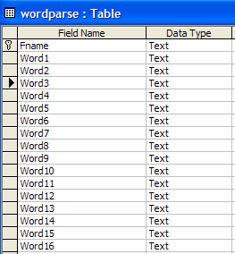

Here’s where things get a little confusing in terms of design and overall sensible ways of design. This table is terrible! There are 250 columns! But I thought of so many different ways to relate one song to hundreds of words. It was a very difficult thing to do. I could have kept all the words in one field and then parsed through some kind of separated value. But trying to parse words like that required a lot more resources. This table and the wordsync table will be redesigned into an XML file that can simply be loaded. This way if a lyric has certain characters (like a comma) and I tried to use a CSV form of parsing, there will not be any errors.

The XML will make this application come together with a community that can trade synced XML files on message boards and other communication mediums.

One final note is in my SQL queries in the karaoke monster code. You might notice the conditional statements reading how many words there are and then updating the database in batches of 100 fields. Well MSACCESS has limitations on the number of updatable fields you can process. So if the saving files look a little sloppy, that’s because they are sloppy along with the database design.

I now know what has to go into a logical design for this tool and will be implemented at a later time.

