Upload.asp

Main page that calls upload class. It writes out javascript functions to output the form, test the environment and upload the MP3. It also records the song name and the artist to the database.

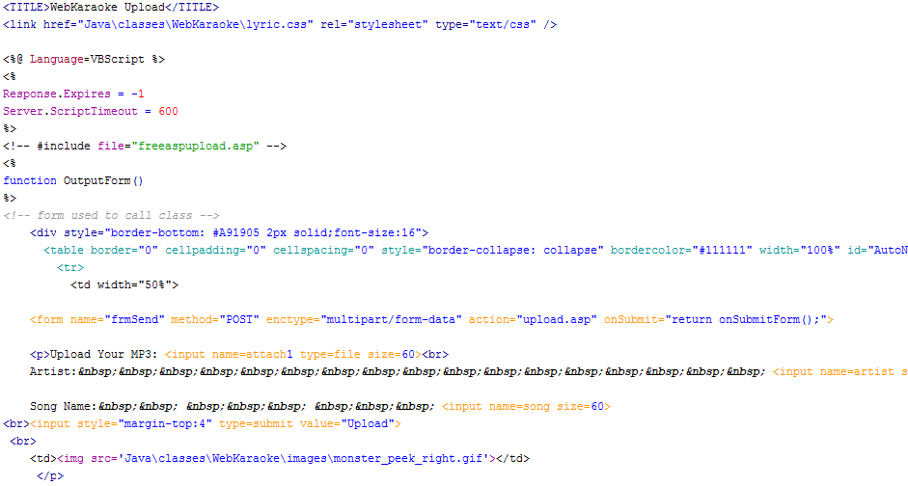
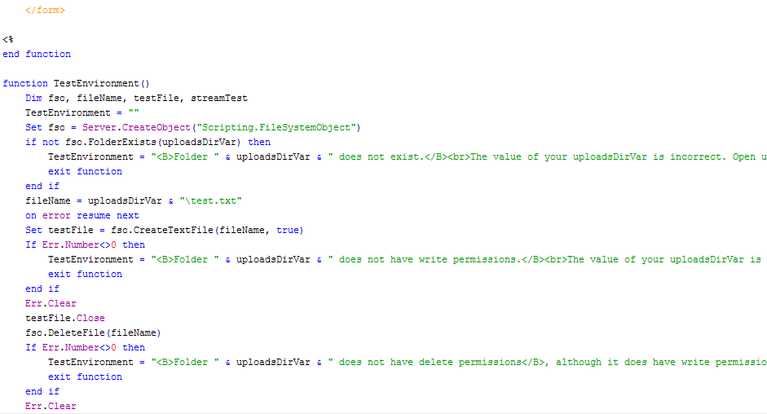

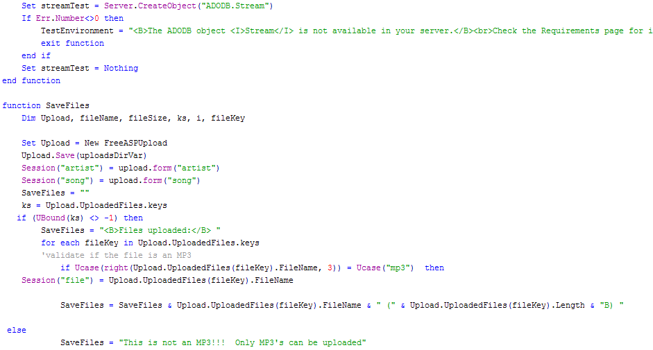
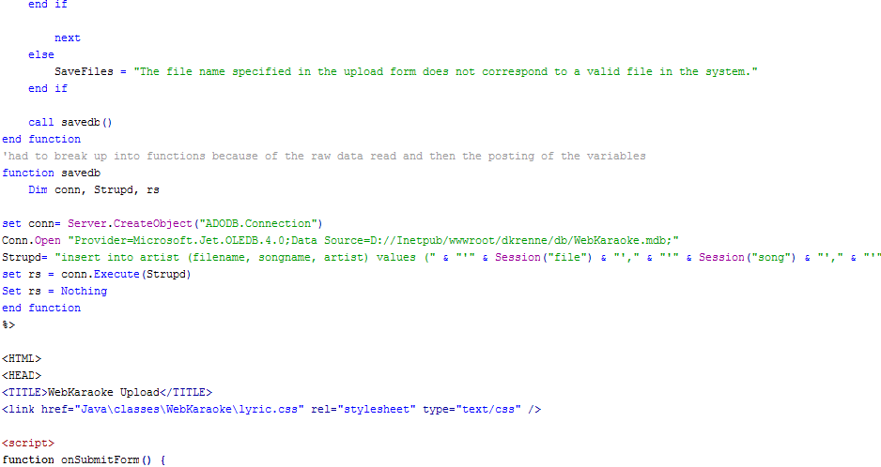

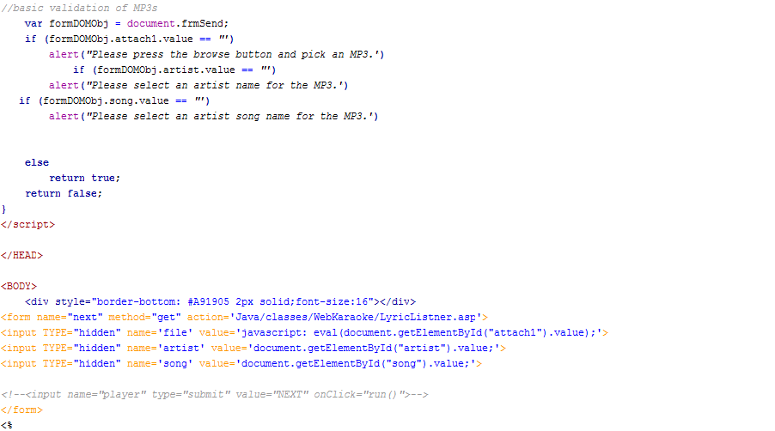

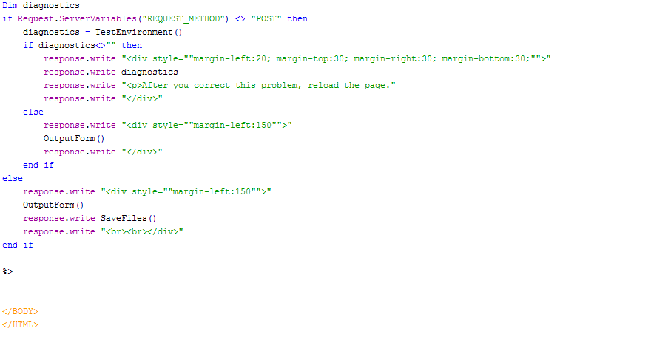

FreeASPUpload.asp

Open source class script used to process the binary information to the server.
(had a difficult time posting and getting variables to a separate asp database script because the server cant have a binary read and a get method on the same page.)

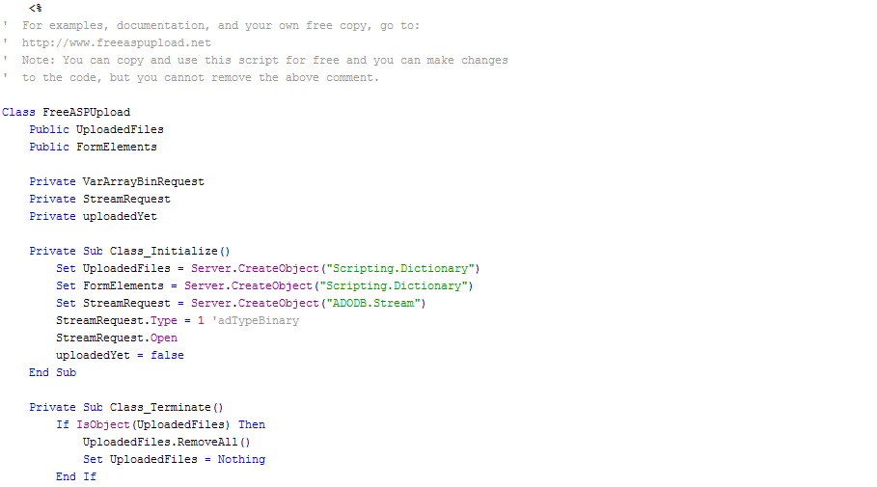
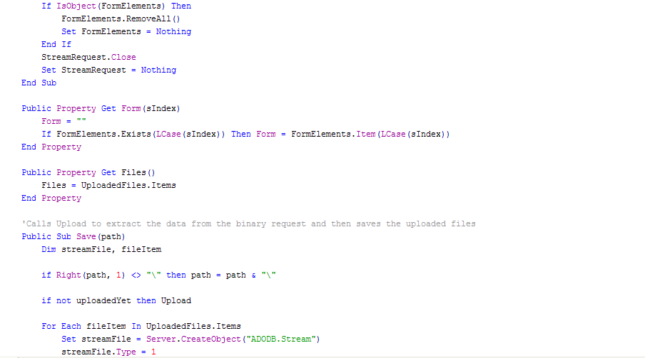

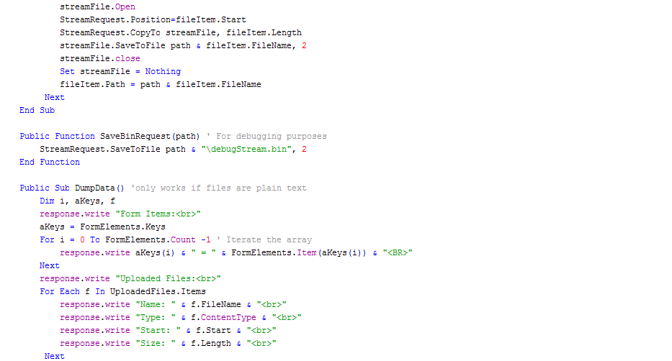
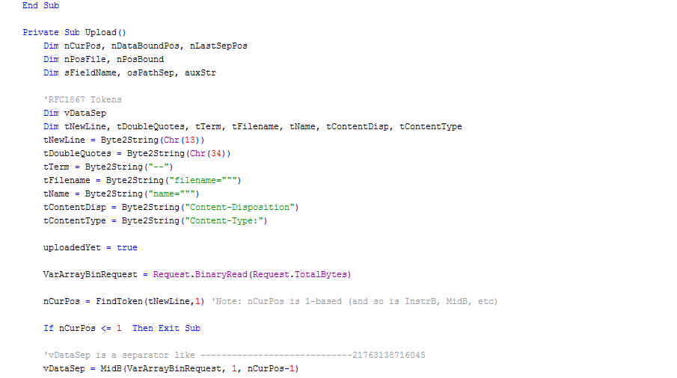

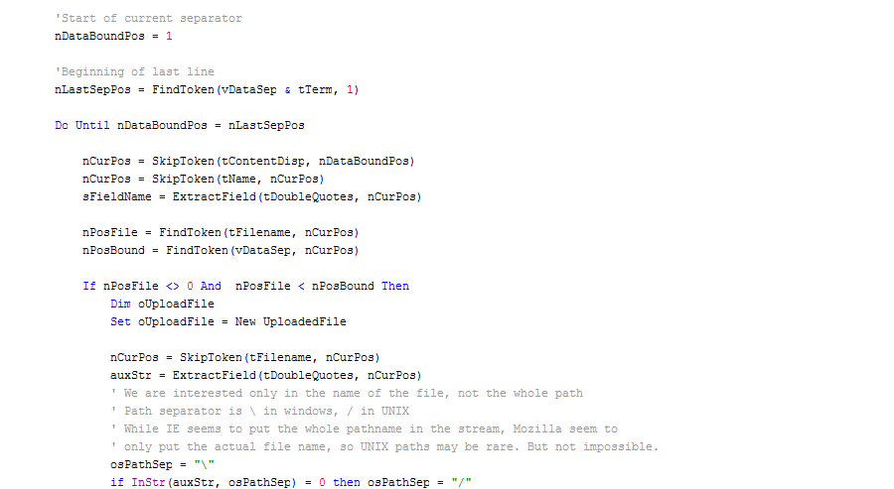
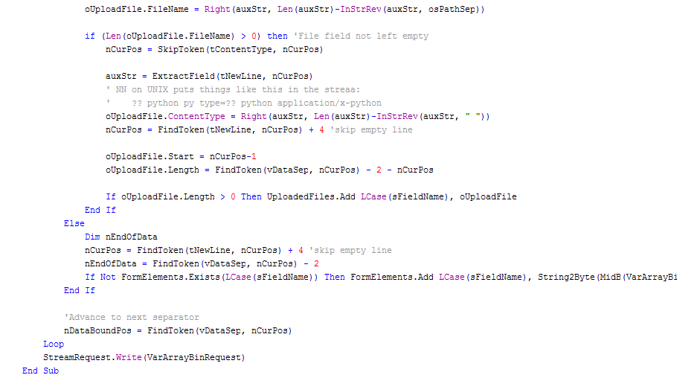

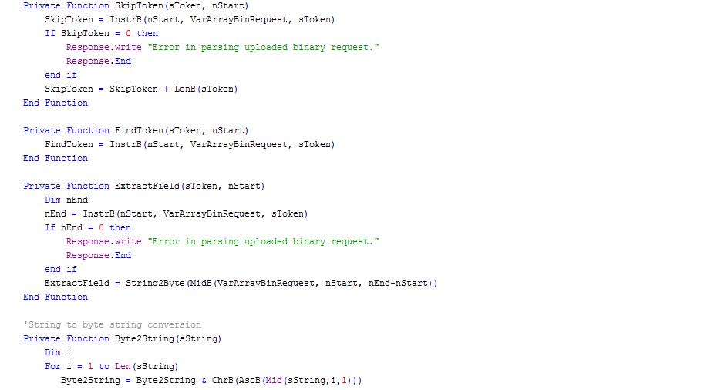
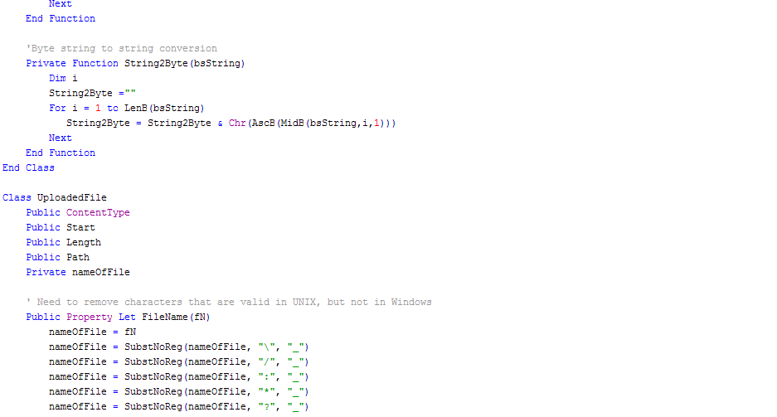

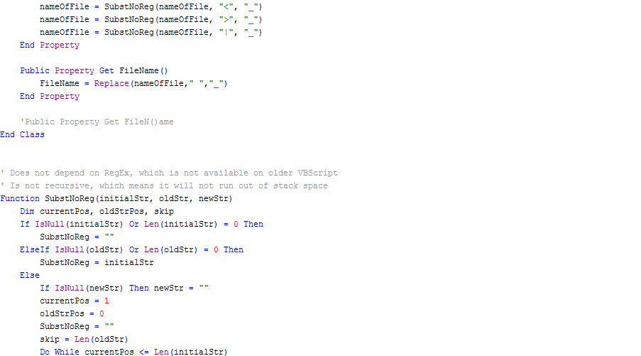
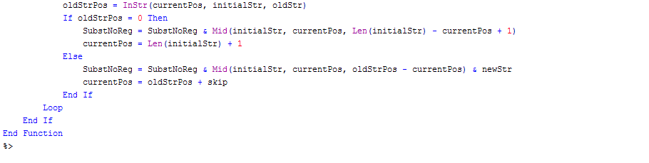

KARAOKE_HEADER.htm

Built in fireworks to apply the hover over buttons, this script loads conditional statements that will load certain framesets. Those calls come after the click of each button. This header grabs information from particular paged frames (like the selected index of an MP3) so it can preload it in a “wizard type” format. Controlling the frames was a difficult task to do while maintaining accessibility from the main flash navigation.

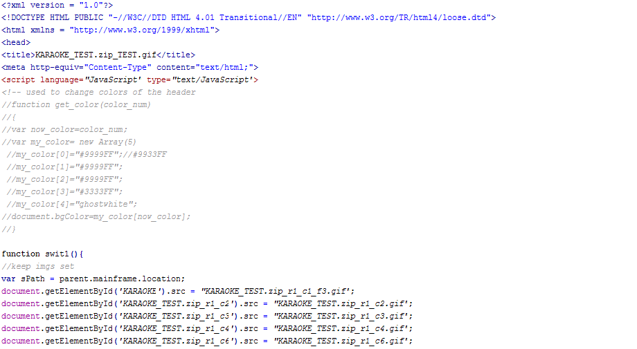
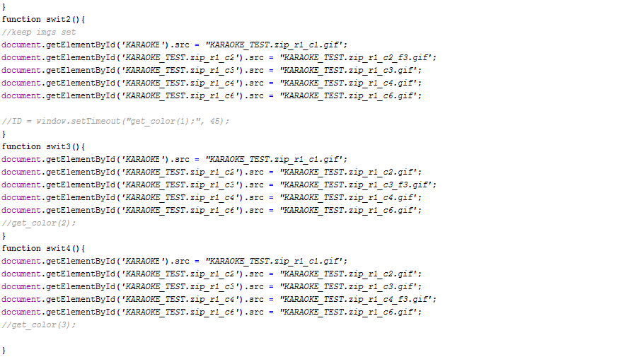

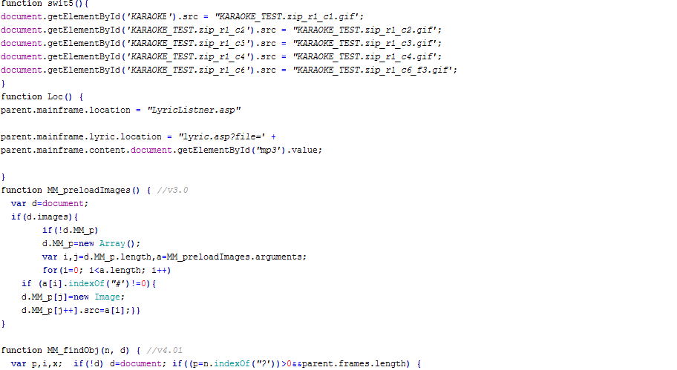
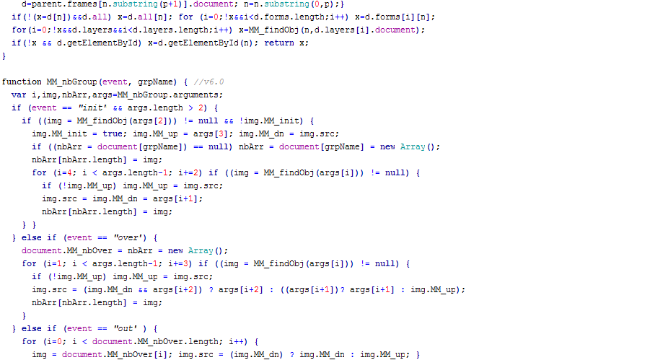

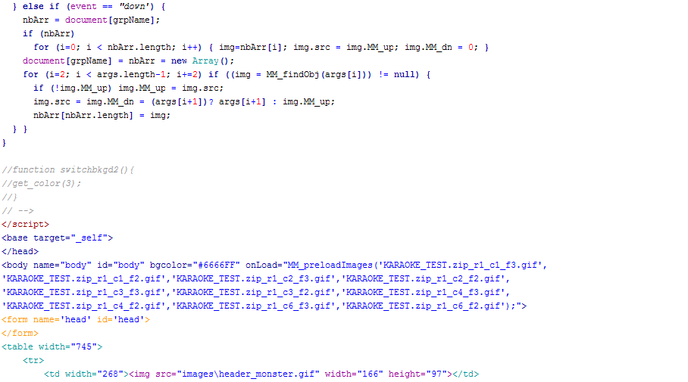
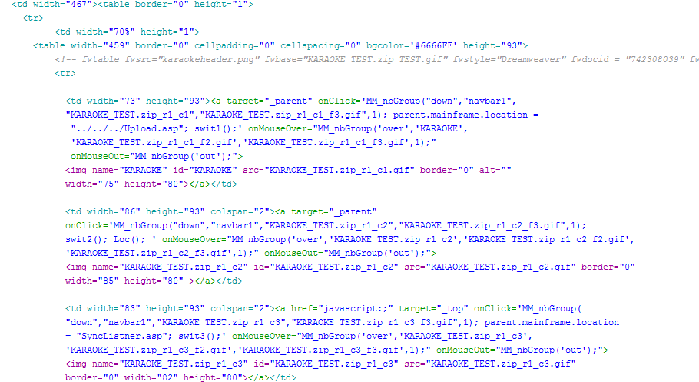

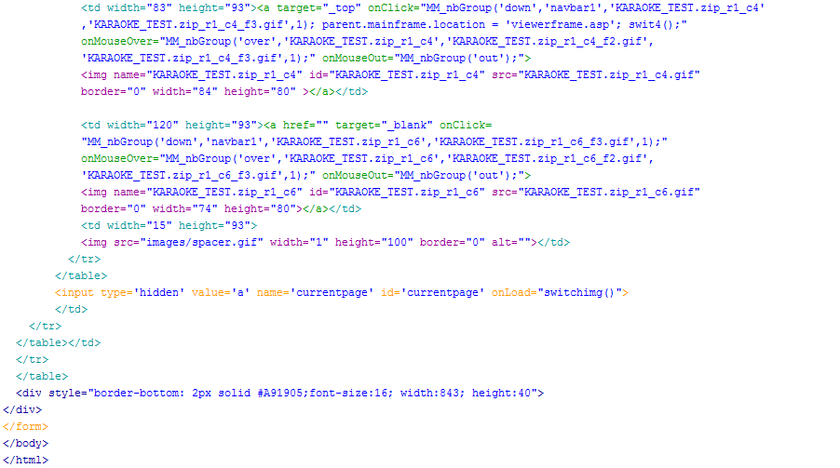

Playerapplet.asp

Primary MP3 functionality is generated from this page. When a user selects a dynamic indexed MP3 and clicks play, it goes through the MP3 function. Finding the right way of setting the file name and starting the player was a difficult task because it required a lot of research on the actual jar files. Also, the jar itself needed to be rebuilt to do a dynamic system.

The other major functionality is the lyric search function. In order to populate a text box on a dynamic action I decided to communicate client-side and server-side information by populating hidden values for each record in the artist table. It gives a hidden value containing the artist and the song name in a format like this:
(filename-“Artist”)(filename-“song”)
From there I parse through the string with a replace function because when you attach to the object you cannot have dashes and underscores. See Appendix D for bugs.

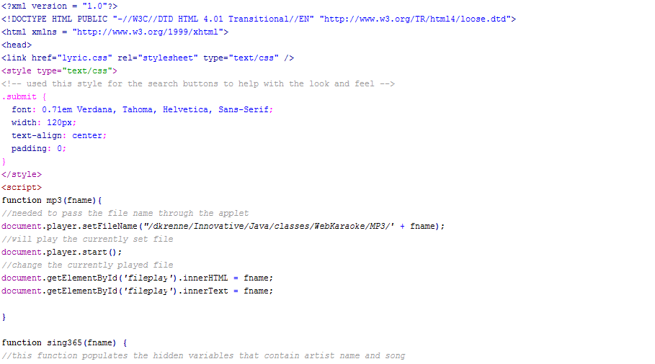

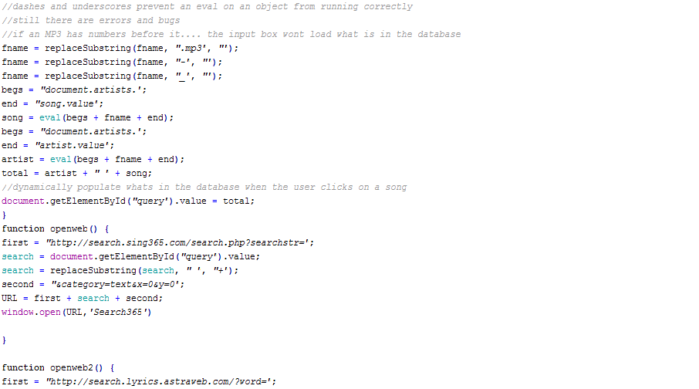
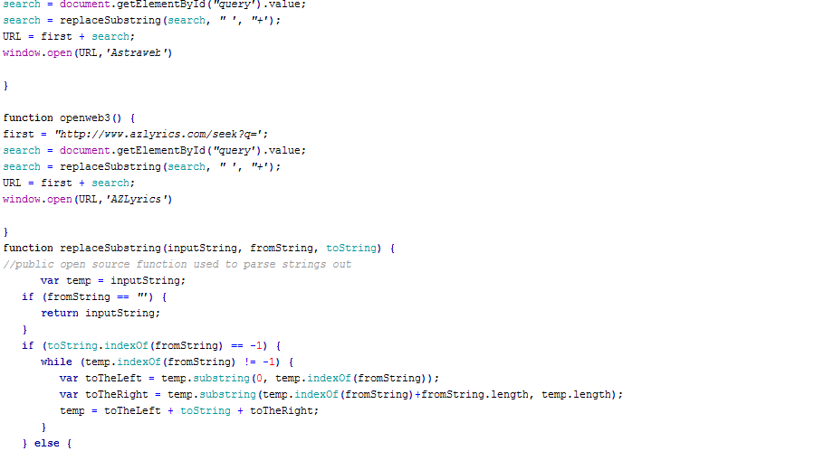

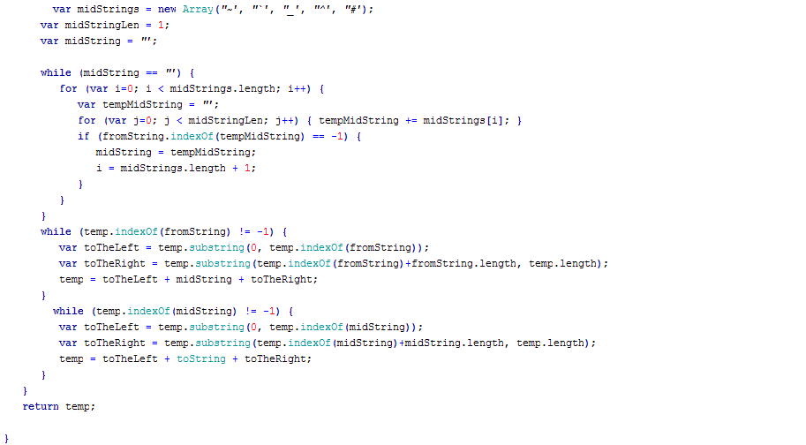
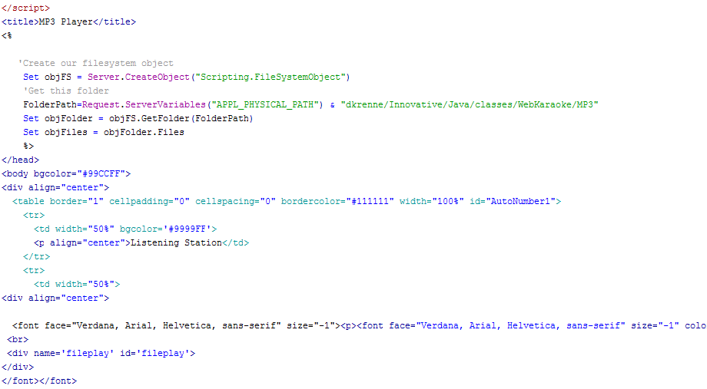

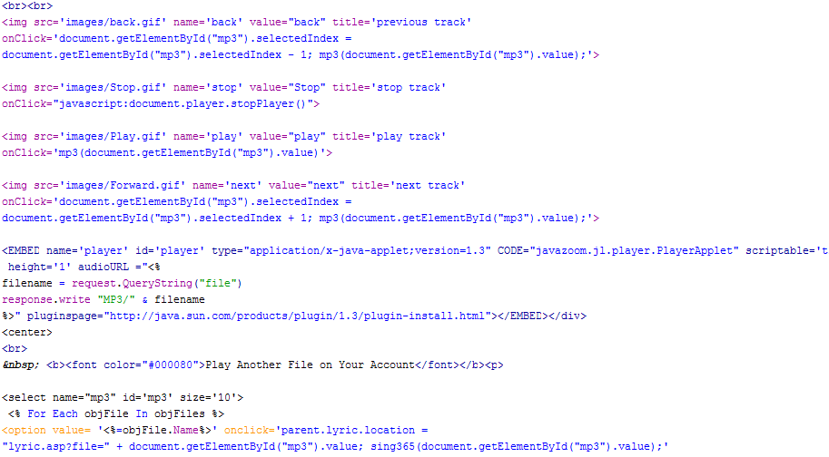

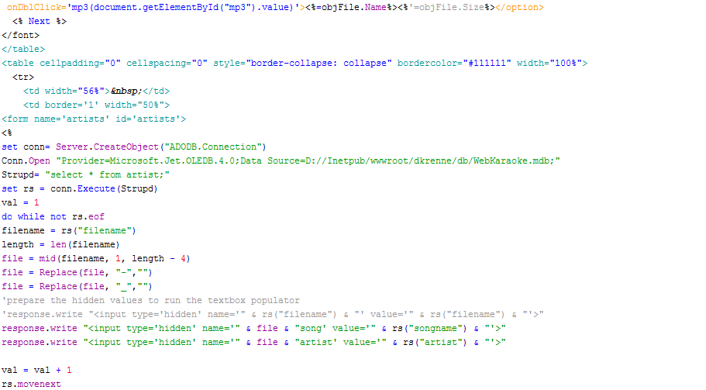
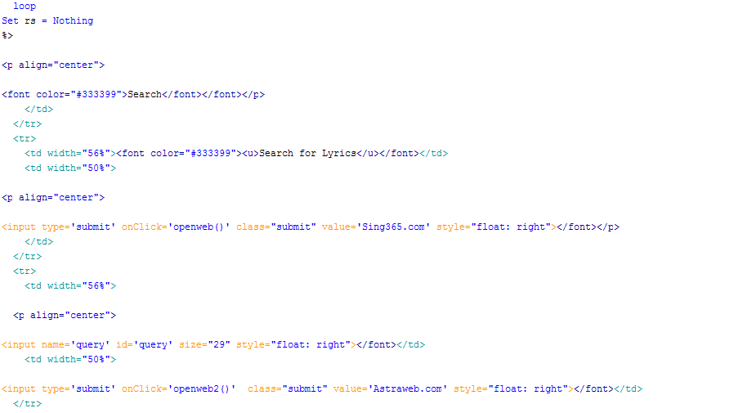
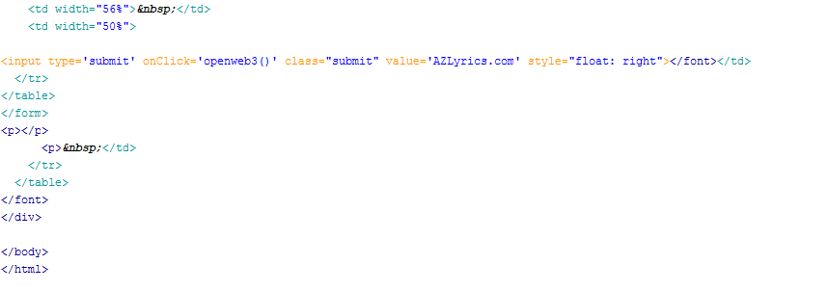
Lyric.asp

Once the player passes arguments across the frame, this page grabs it and queries the database. The interesting thing here was the fact that the information had to be loaded in between the <TEXTAREA> tag. After the page saves successfully, I call upon the syncfromwizard.asp to pull all of the controls onto one page, as opposed to the sync that loads from the main header.

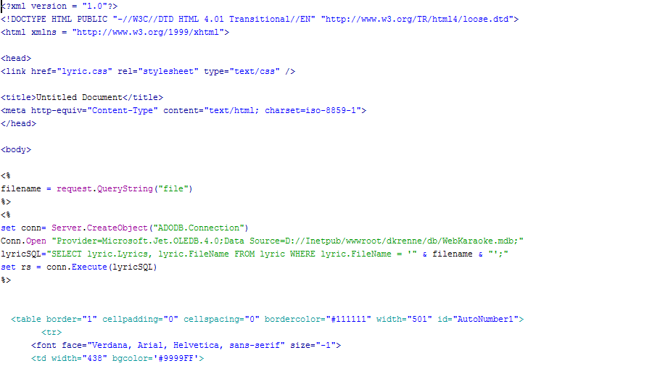
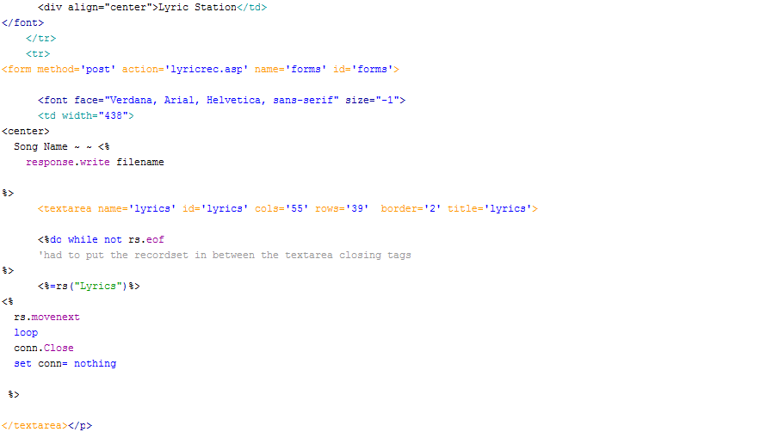

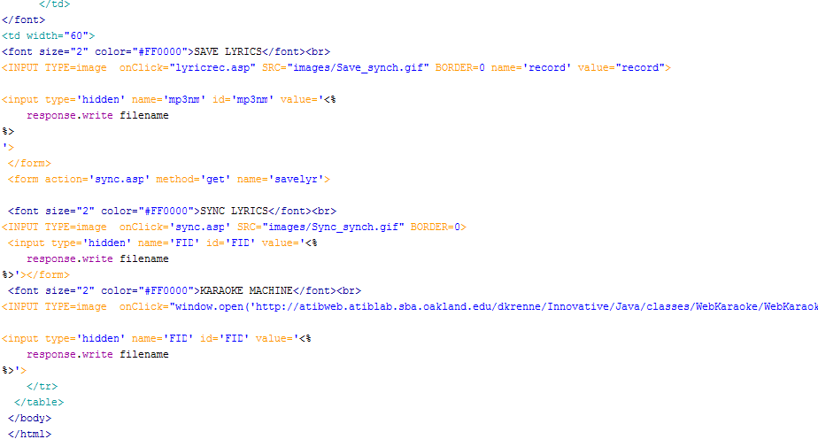
lyricrec.asp

As stated in the database documentation, the database design is quite interesting. The first start of this page records to the lyric table and updates or inserts in accordance to some logical if statements. The if statements are generated with the count variable that checks how many records there are. After that it goes through the necessary updates to the wordparse table.

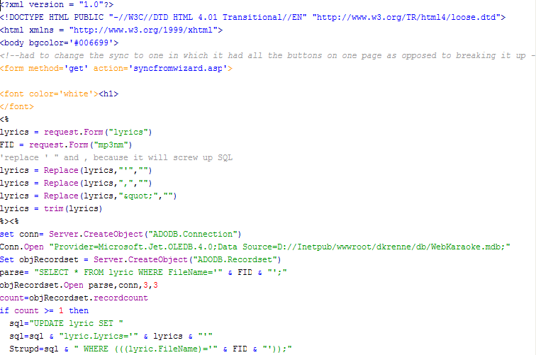
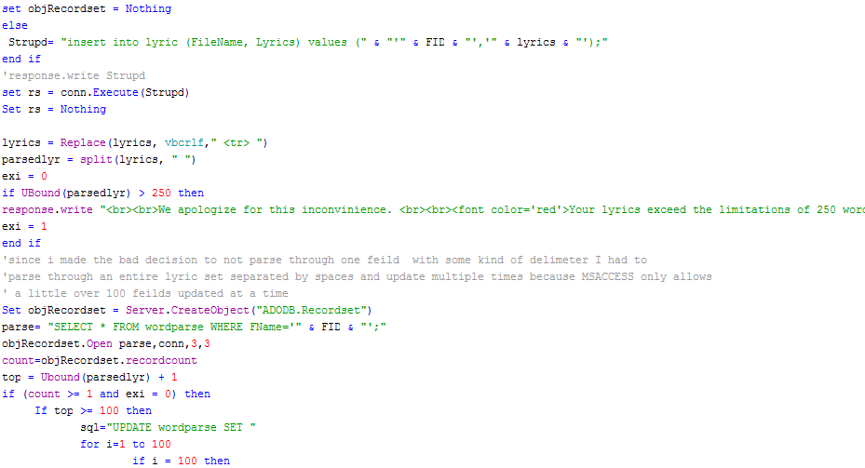
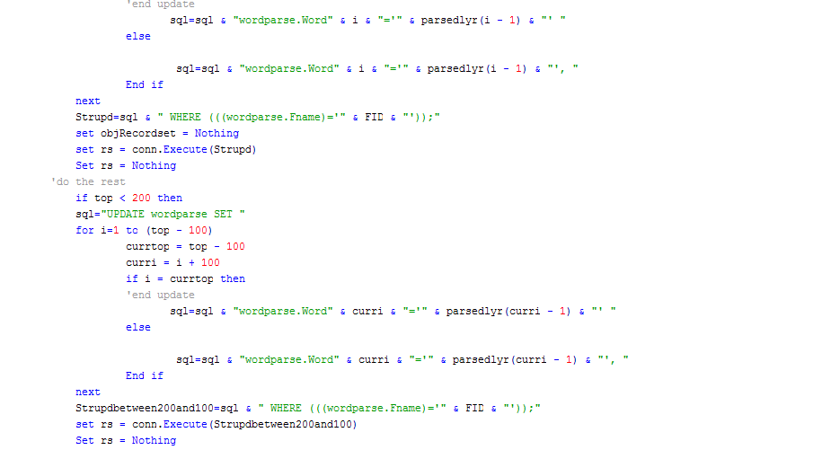

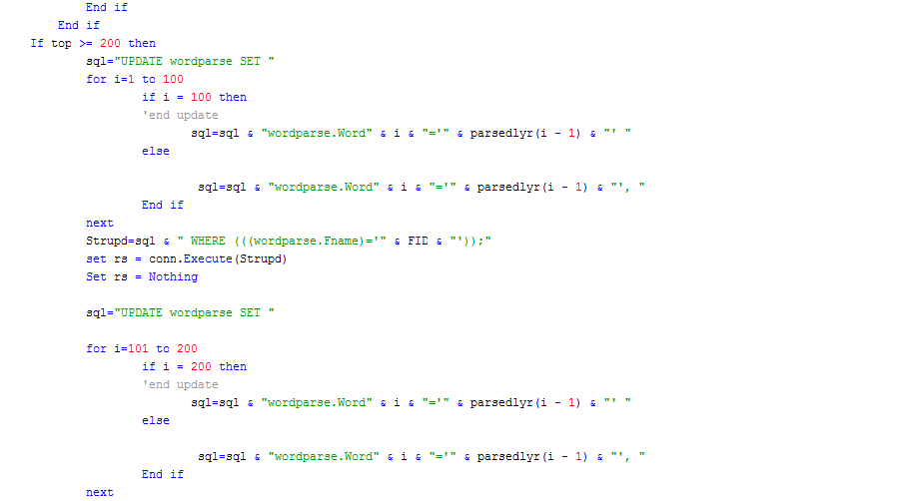
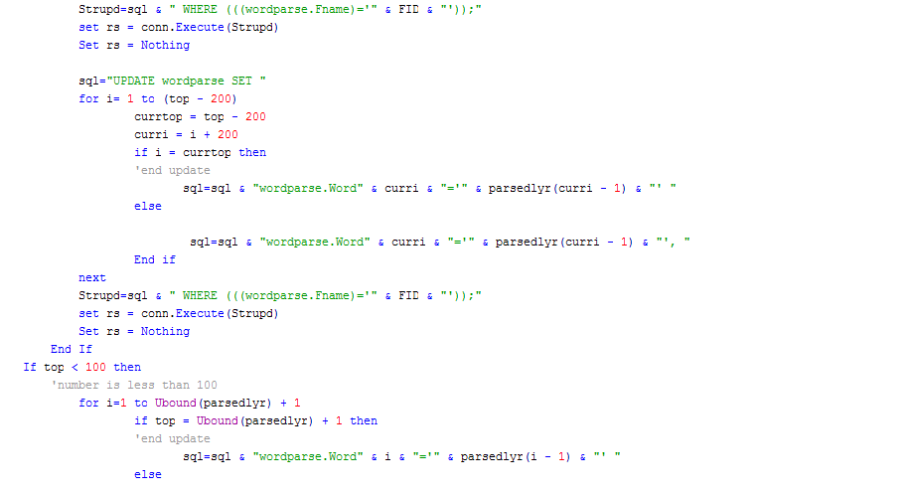

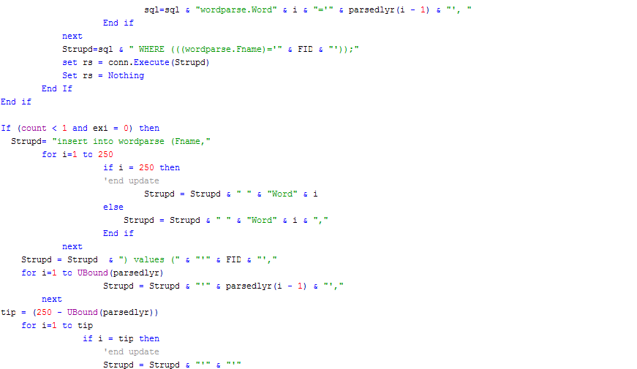
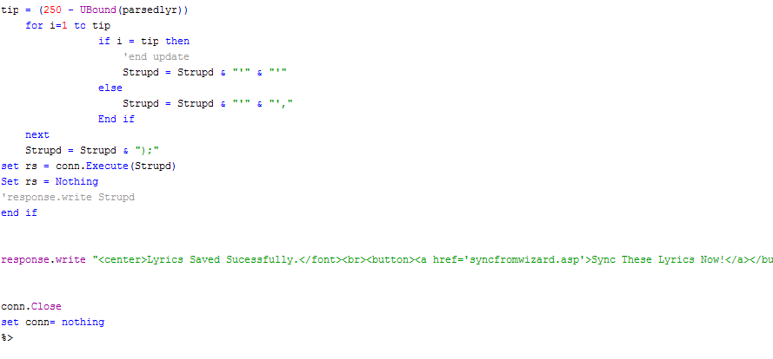

Playerappletsync.asp

This is very similar to the playerapplet.asp. The only thing that has changed is the necessary communication between frames and object.

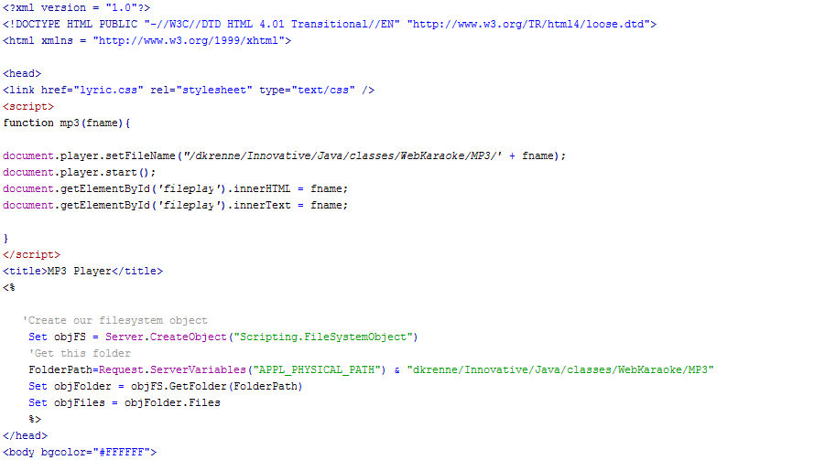
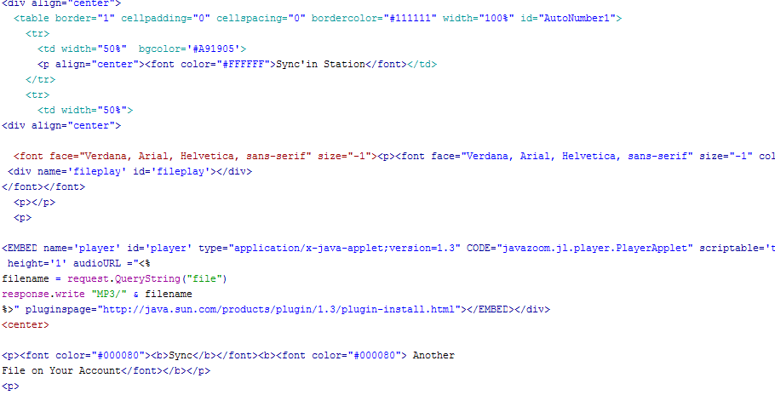

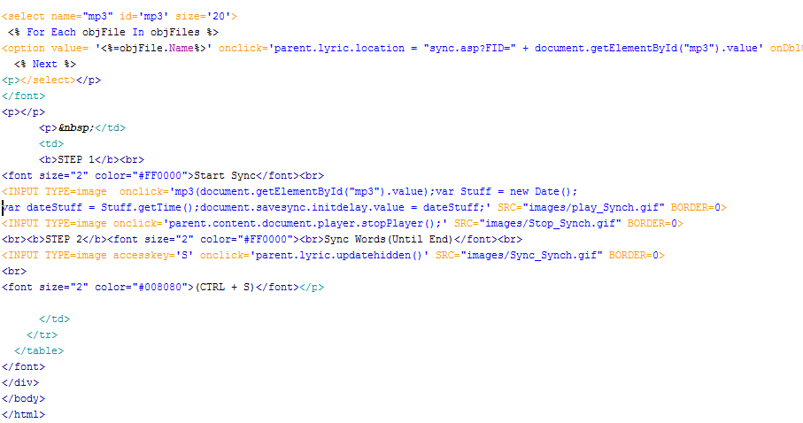

sync.asp

This page loads up lyrics from selected file. Please see commented code on how the duration recorder works.

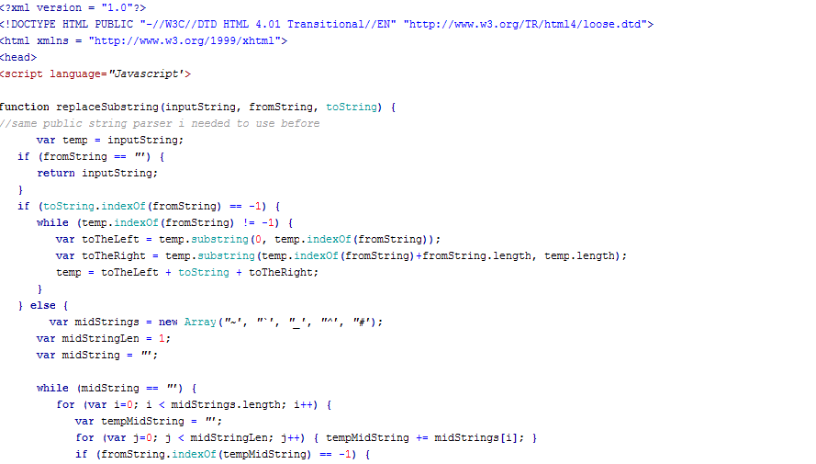

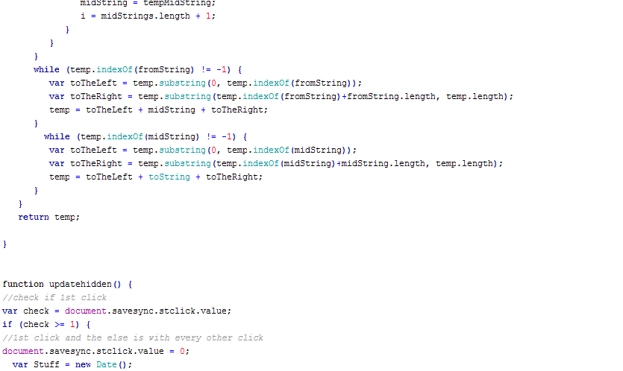
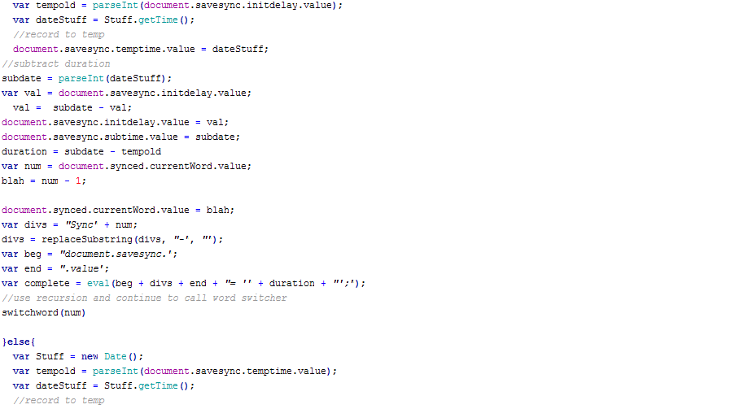

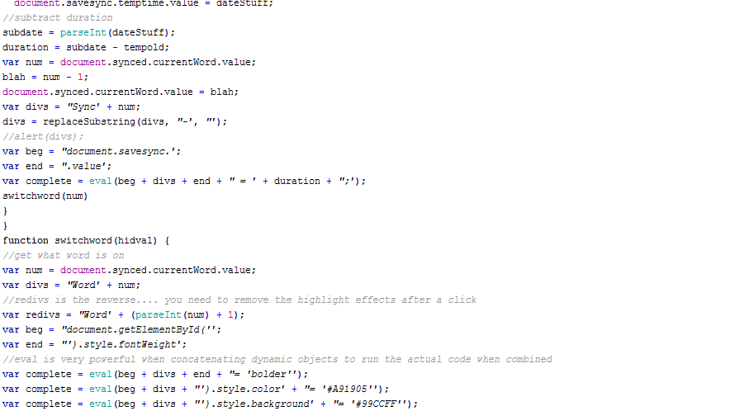
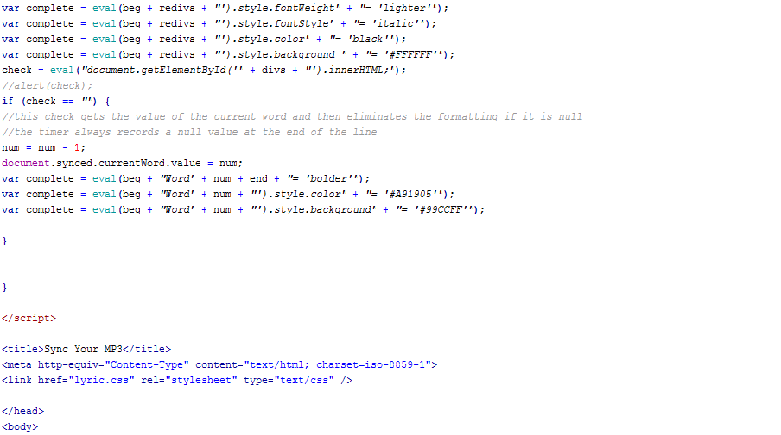

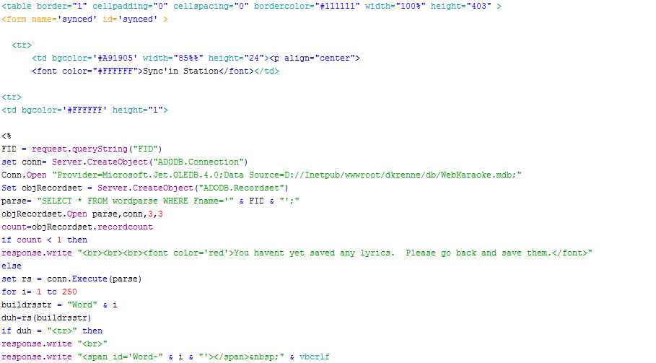
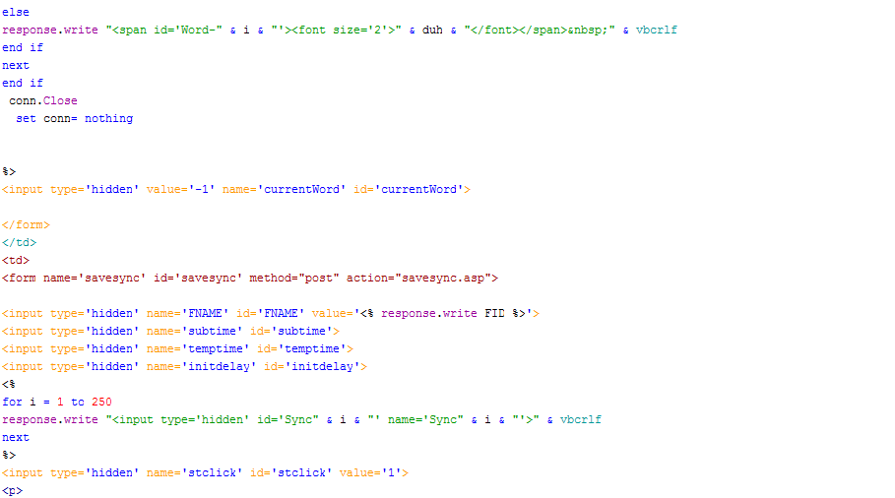
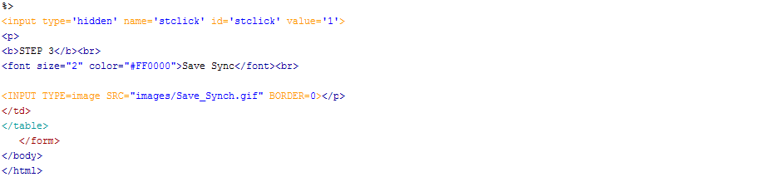

savesync.asp

Very similar to the lyricrec.asp.

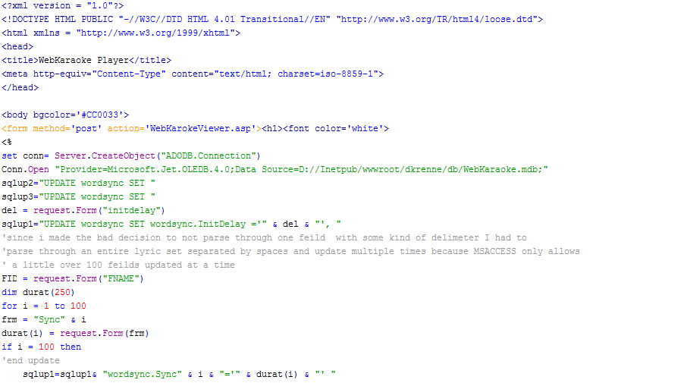
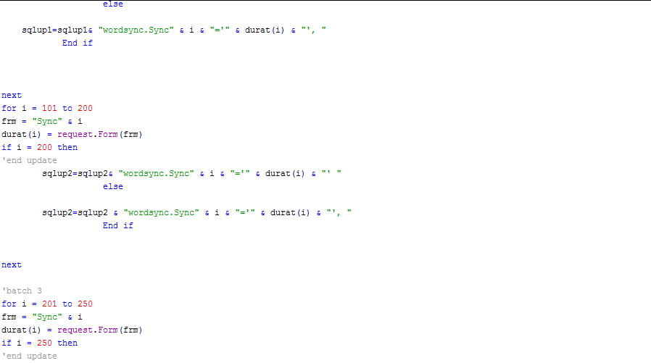

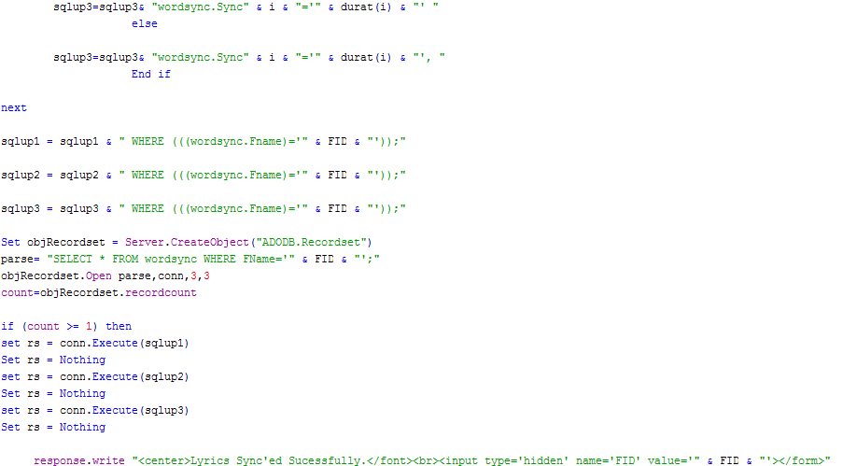
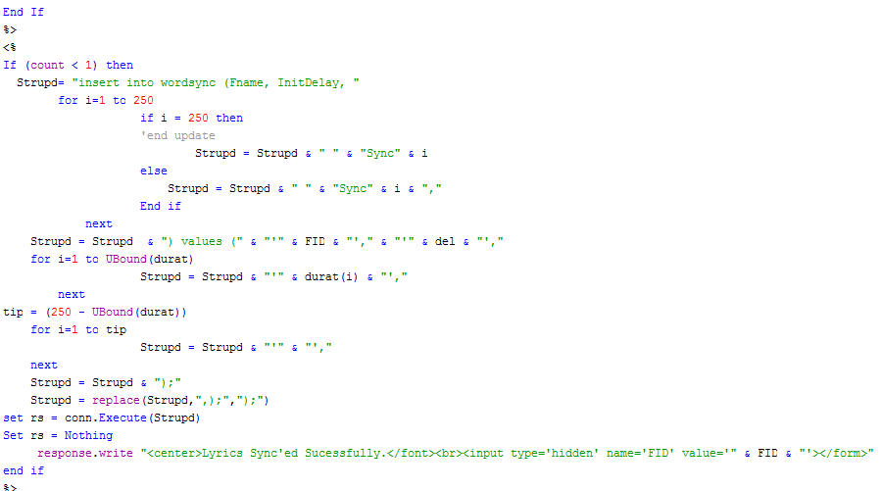

Viewer.asp

We Needed to include karaoke player code on the same page as the MP3 player because I was having some troubles compiling the code to run properly when on separate pages. There is a lot of processing going on with this page.

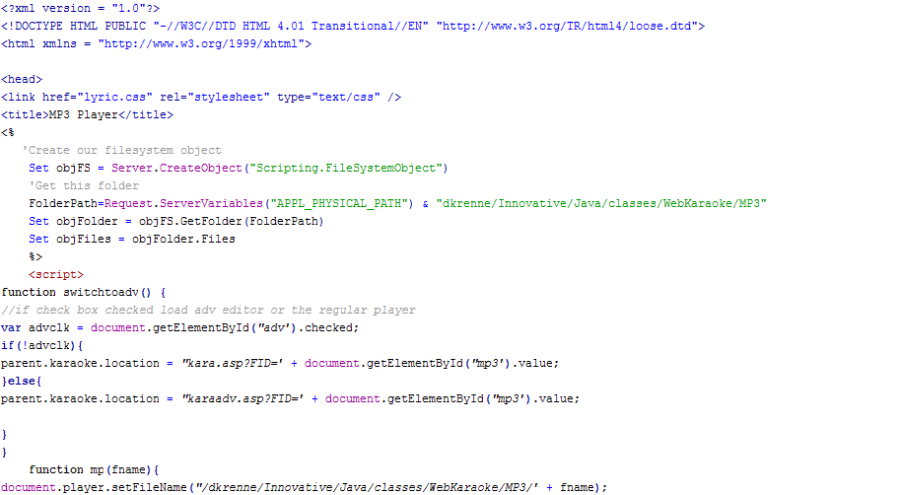

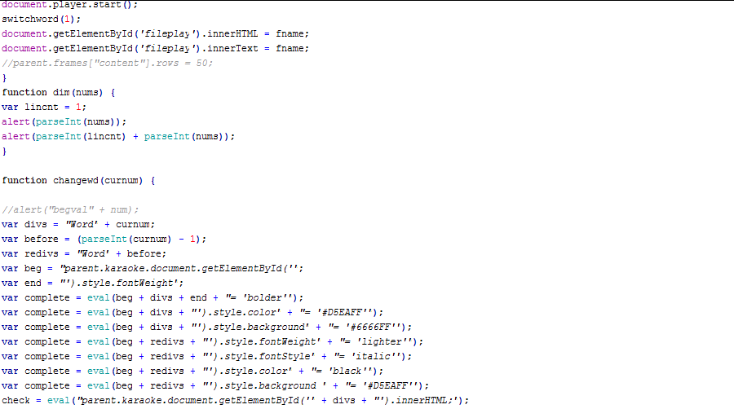
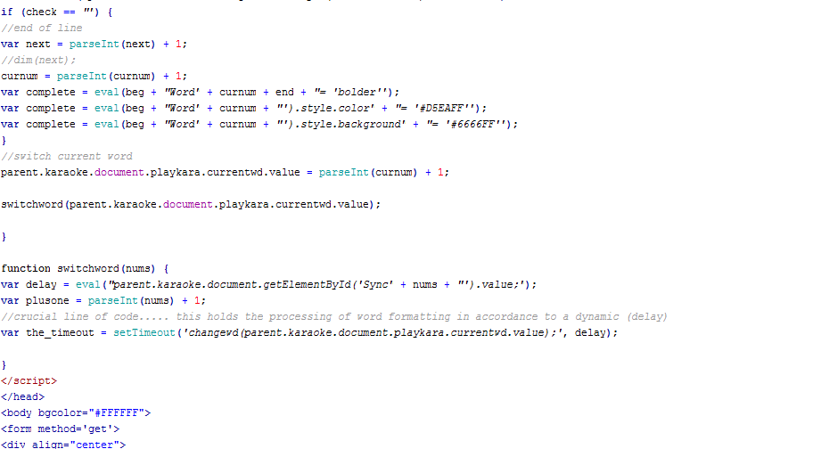
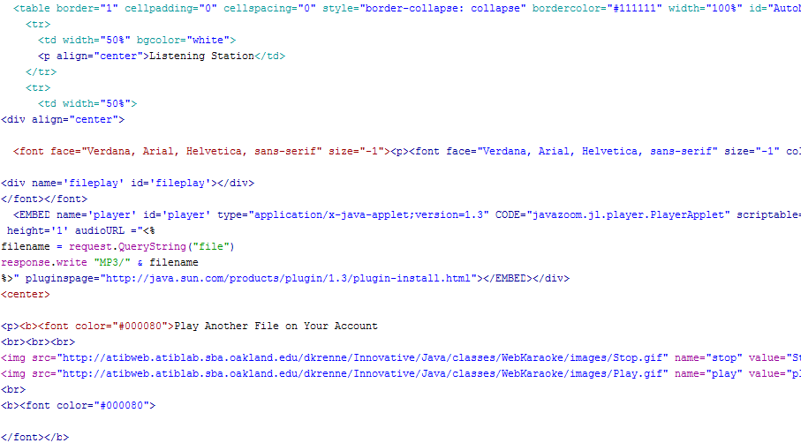
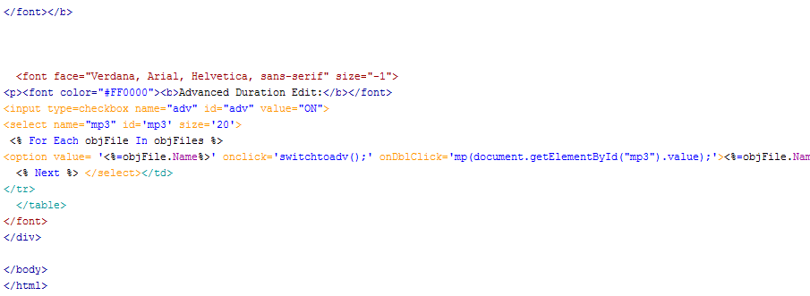

kara.asp

This page writes out the SPAN tags through the database. Also writes out the durations as values of hidden objects.

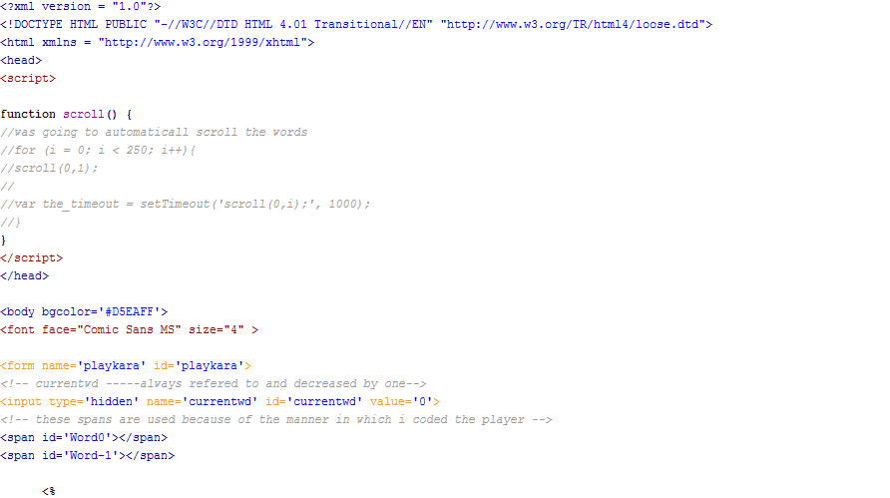
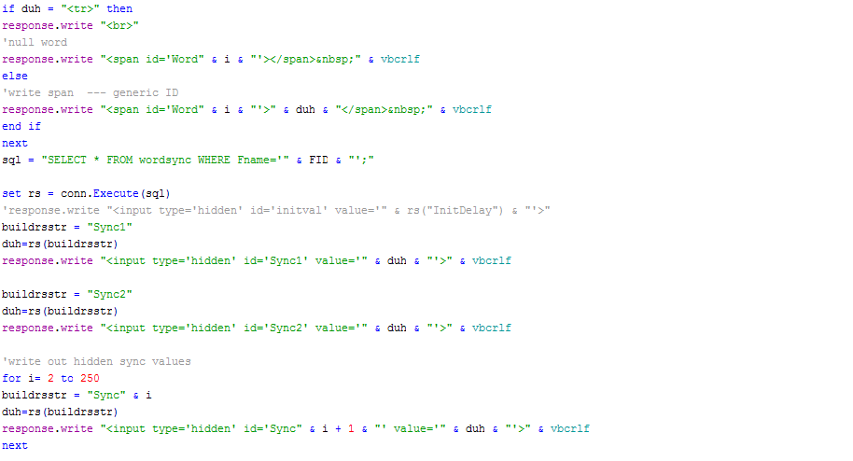

Karaadv.asp

Advanced duration edit

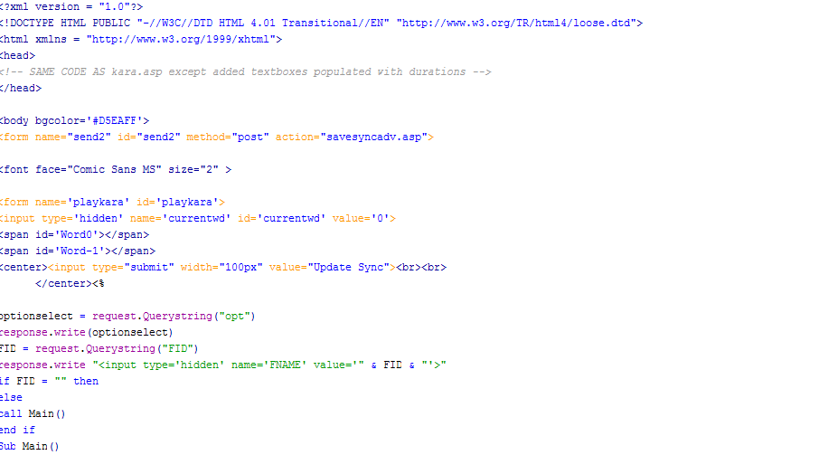
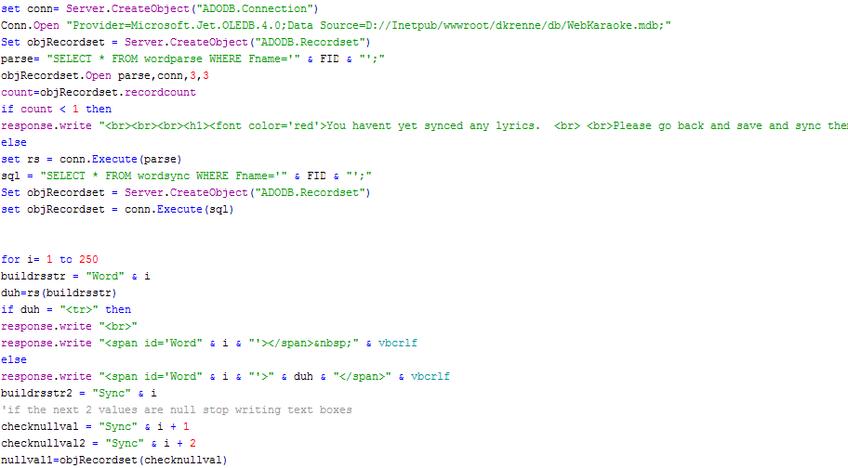

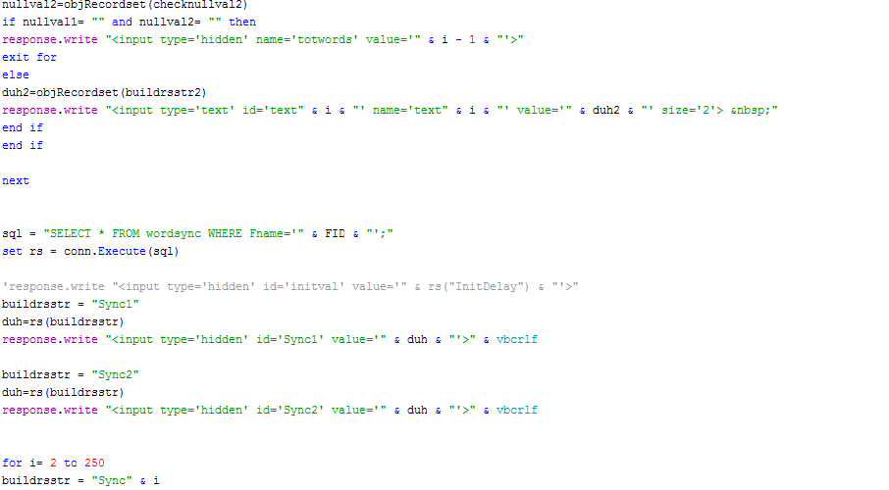
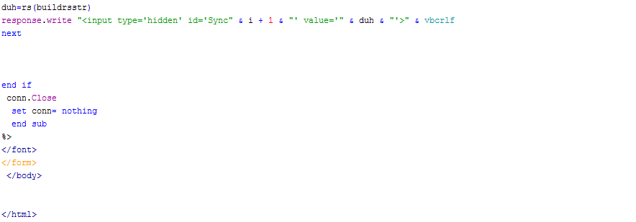

lyric.css

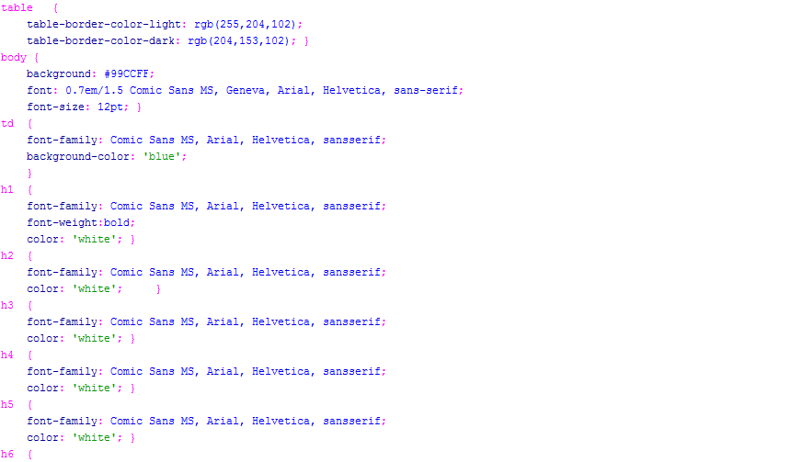
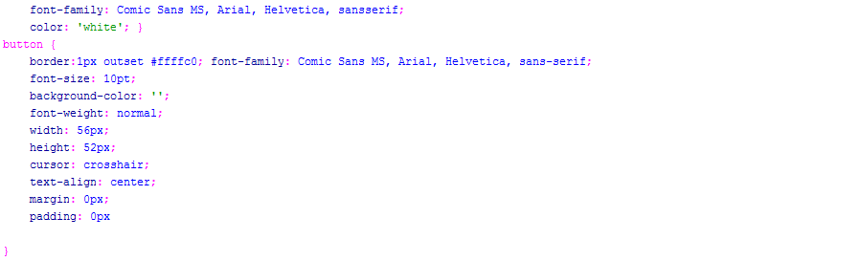

Playerapplet.java

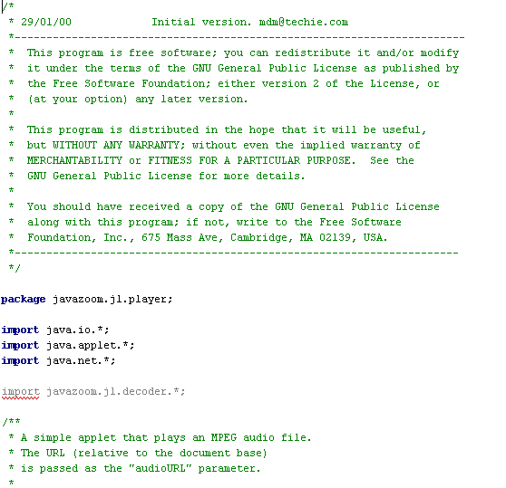
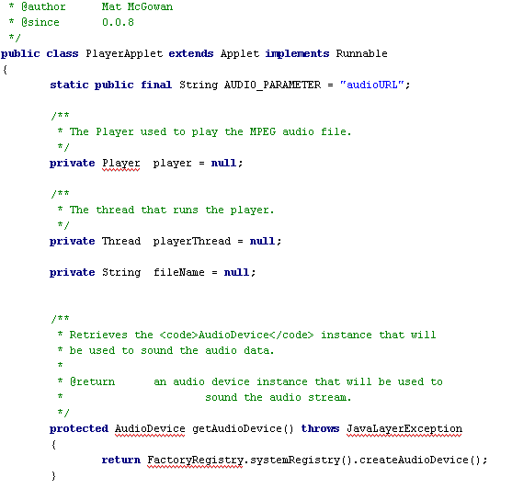
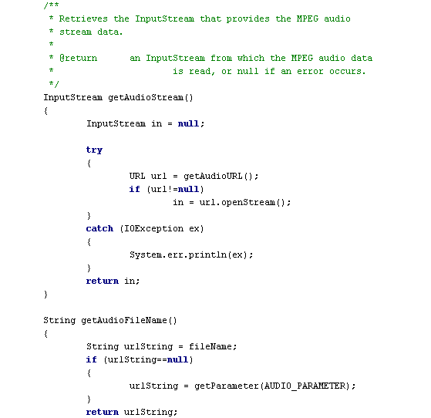
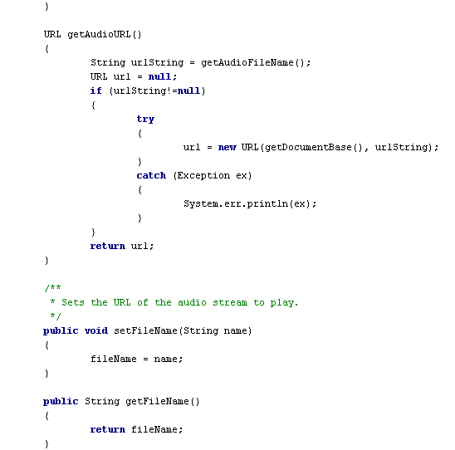

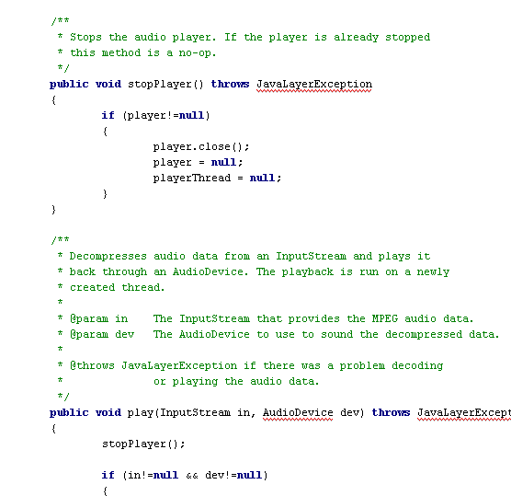
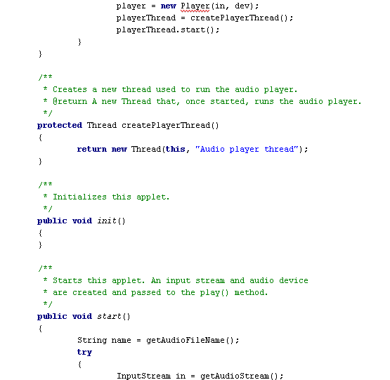

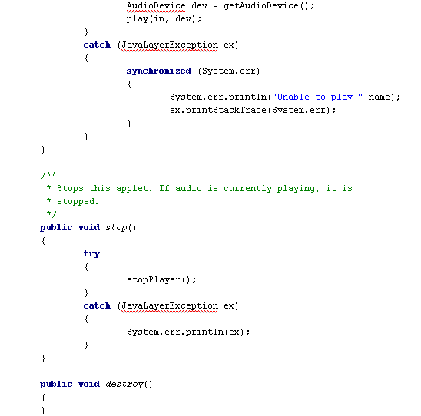
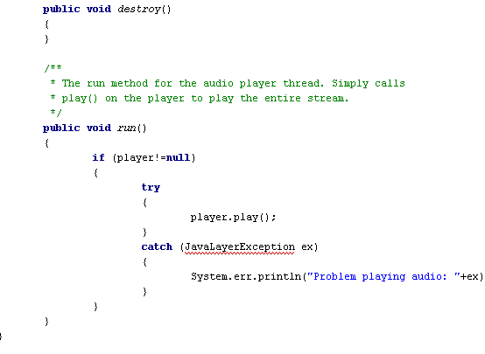

Documents not included in code appendices:

Frames pages:
- KaraokePlayer.asp
- LyricListner.asp
- WebKaraokeViewer.asp
- viewerframe.asp
- Player.asp
Help pages:
- help.asp
- helpcontent.asp
Intro pages:
- index.htm
- karaokeintro2.swf

