Project HELP
Table Of Contents:
- Section 1: Using The Unit Test Tagger
- Section 2: Using the Web Interface
1.0: First download this zip and unpackage into a folder and then run the program.
1.1: When you first run the program, a popup will tell you that you can take new screenshots by holding CTRL plus clicking the middle click.
But in reality you can either HOLD ALT,WIN or SHIFT while doing this action.
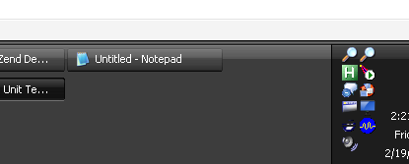
1.2: Here is the popup that was expected in this unit test.
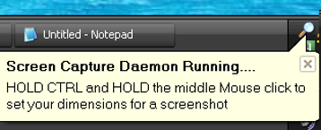
1.3: You can right or left click this icon to get the menu of things to do:
If you compiled your instance to be a web-based MYSQL (Recomended). You can view the web instance at the top of this menu.
Embed a file will upload your selected file to the unit test documentor website or will embed it inside the Rich Text Document.
Copy last file to clipboard is useful when you dont want to tag the item, so you close the Functionality/Unit Test information and just copy it.
Capture entire screen you can do through the context, or can press CTRL or SHIFT or WIN and the PRINT SCREEN button.
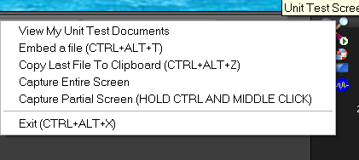
1.4: Start from the TOP LEFT hand corner of the region on your desktop. And then drag your mouse diagonally downward toward the bottom right hand corner of the monitor.
You will notice the screen will have a transparent overlay with the dimensions of your screenshot.
Upon letting go this form will popup.
The required fields are (Project/Functionality and Expected Result).
You can set the additional data as well as Pass/Fail/Set the task to "In Work"
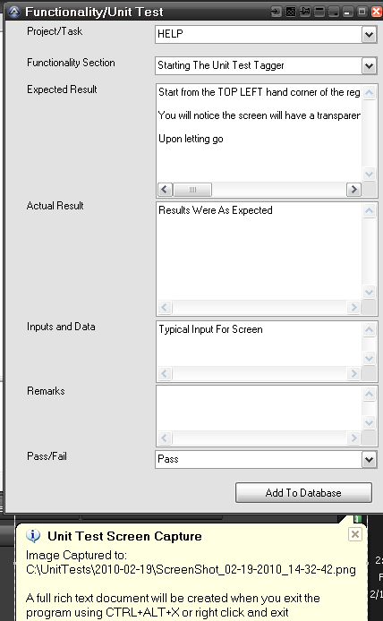
1.5: Each day, your screenshots go into a new folder inside of:
C:\UnitTests
A Temp folder is created when you have your program compiled for local screenshots only.
A tasks.txt file is loaded through the InetGet call to your webserver which serves up your project listings via line ending delimited projects. (This will be fetched each time you take a screenshot)
The UnitTestsScreenCaptures.ini file contains all your settings, screenshot history and functional sections of a project that you are organizing these screens and unit tests.
These screenshots are uploaded to the FTP you define when you compile your version of the program.
MySQL records are inserted as you take the screenshot.
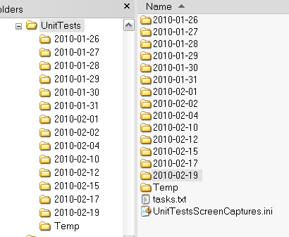

Using the Web Interface
2.1: The web interface (when you click from within the menu on the system tray).
It will pass a USER to the index.php. This essentially logs you in automatically.
There are no passwords in this system as these documents are mostly public anyways.
Just click on your project to view the full unit test document.
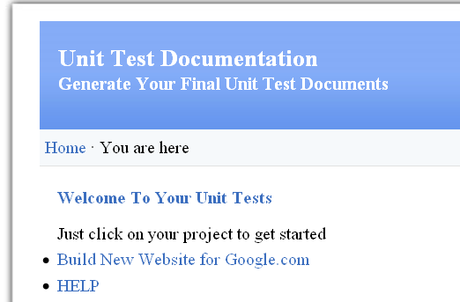
2.2: If you go directly to the interface you will be asked for your username.
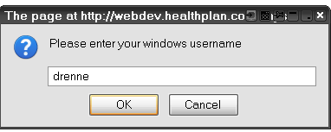
2.3: The main content shows all your information you posted in the popup.
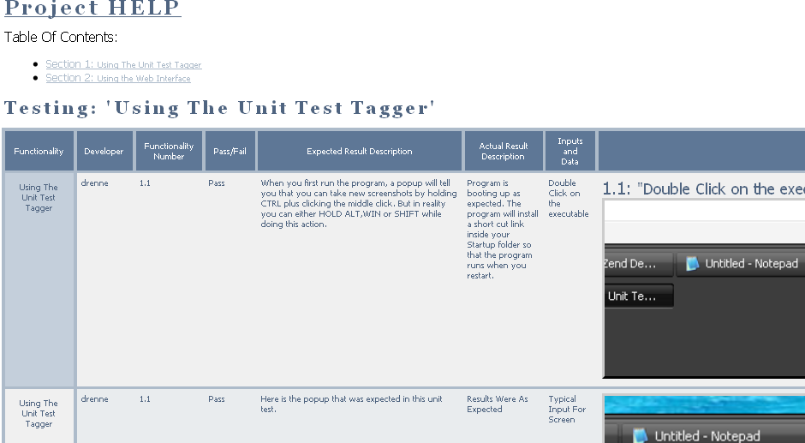
2.4: If you do not have any screenshots matching the username you will see this screen where you can download
the program or view this help file
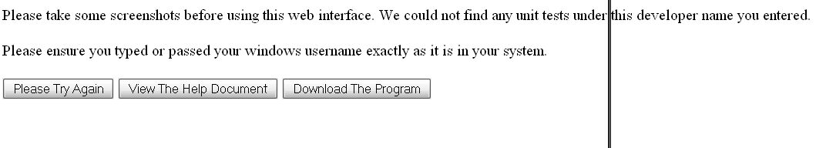
2.5: As you can see in the Table of Contents, it fetches the unique listing of Functionalities that are a part of your
project and groups them.
These links are click-a-ble to jump to each section.
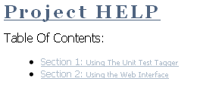
2.6: Embedded files show up as a button to download.
