Middle Plate Sub Assembly
The following are a list of parts needed for this sub-assembly. Items that need to be 3D printed are highlighted in the column named “3D Printed’.

Name | Qty | 3D Printed?
DFRobot Breakout Board | 1 | No
M3x3mm Heat Isert | 10 | No
Voltmeter LCD Disiplay | 1 | No
Adafruit BNO055 IMU | 1 | No
DFRobot 5V Buck Converter | 1 | No
IMU and Buck Holder | 1 | Yes
M3x6mm Hex Cap Screw
M2.5x3mm Heat Inserts | 10
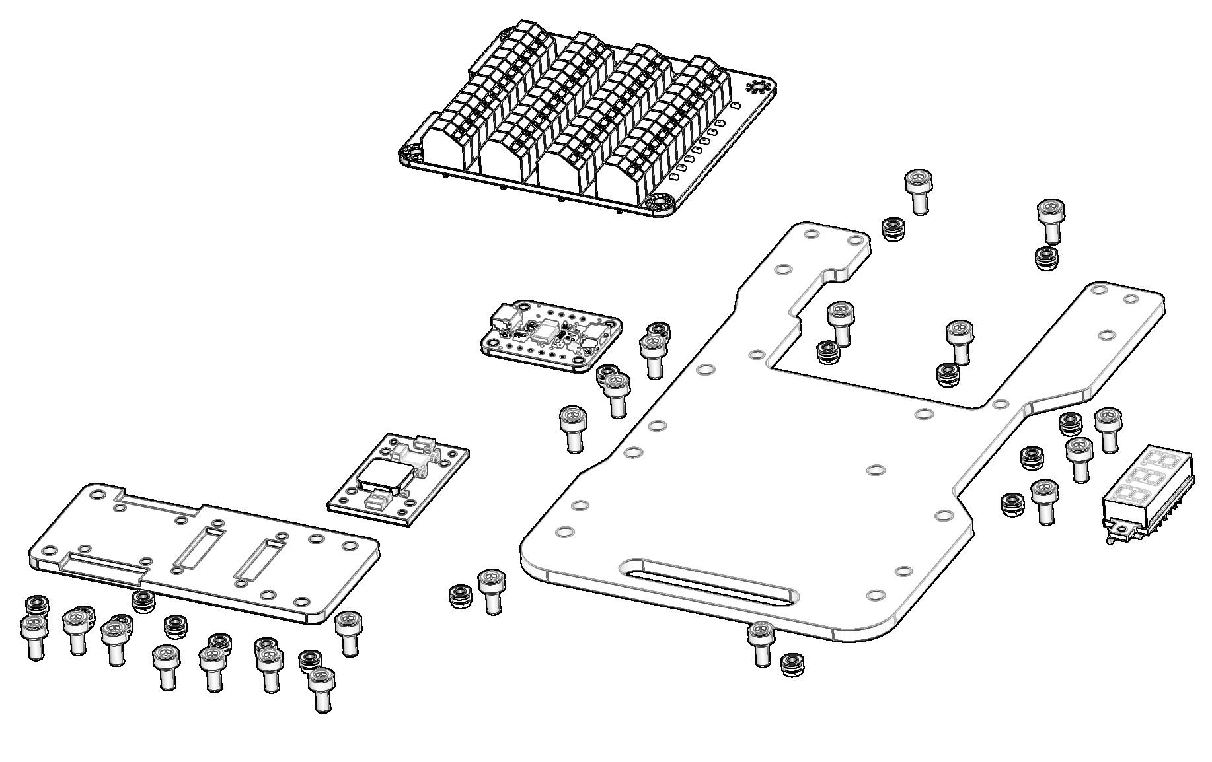

Step 1.
The first step is to install the heat inserts into the appropriate locations on the IMU and Buck Holder. Note that not all holes receive an insert. Those are left open to attach the platform to the vertical pieces on the main chassis.

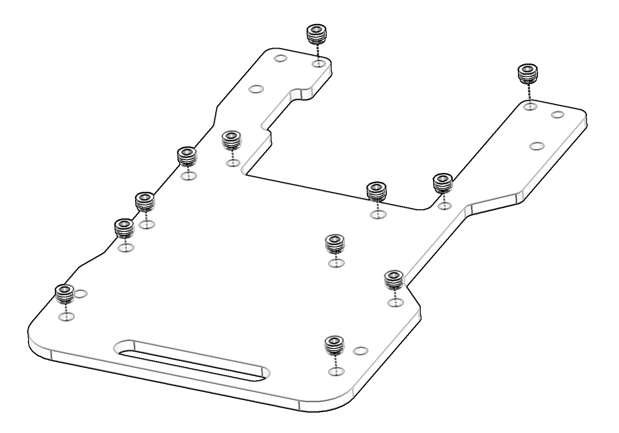

Step 2.
Next, we will place the heat inserts into the appropriate holes for the IMU Holder. These are the M2.5x3mm heat inserts.
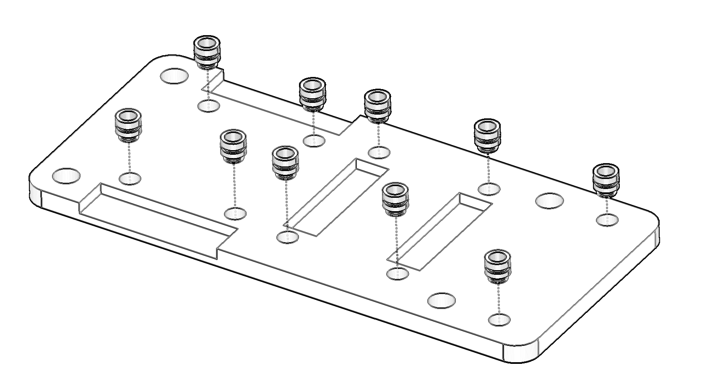

Step 3.

